**Making Location Work for Smart Cities**

The **Open Geospatial Consortium (OGC®)** proposes a **Smart Cities Testbed** to catalyze the marketplace through better location information sharing.

## The future is now

Futuristic scenarios will become reality as integrated standards platforms enable cities' and citizens' information systems to integrate information from GIS, BIM and civil engineering documents and services.

* Citizen Services: optimization of Municipal services using spatial information made available to all platforms: home, office, mobile.
* Disaster and Emergency Management: through response centers equipped with geospatially enabled Common Operational Picture
* Energy and Utilities management through open standards based implementations for Smart Energy, Smart Water Management.
* Urban Maps using the richest 3D city models; sharing data through CityGML and IndoorGML open standards; convergence to a standard for Indoor Venue Maps; interoperability with BIM
* Sensor Webs providing ready access to both Dedicated, operational sensors and to opportunistic and contributed, citizen sensing. Increased situational awareness from fusion of sensor observations.

Spatial information is essential to all scenarios for open governance of cities.

**Bringing quality “Where” information to Smart Cities**

**Trends to urbanization:**

* + More than half of the world lives in cities.
  + Mobile access to the Internet exceeds fixed.
  + Internet connected devices exceed the number of people with internet access.

Townsend*, Smart Cities, 2013*

**Cities are the future of the sustainable world**

“The need is urgent for an integrated, quantitative, predictive, science-based understanding of the dynamics, growth and organization of cities.”

Bettencourt and West, *Nature, p912, v467, 2010*

## Smart Cities Spatial Information Framework

Effective integration of human, physical, and digital systems operating in the built environment holds the promise of improving the quality of life of urban residents, improving the governance of cities and making cities prosperous, inclusive, sustainable and resilient.

Location is a primary method for organizing Smart City services. Communicating anything about location requires standards. This paper addresses the open information technology standards framework that is critical to achieving the benefits of spatial communication for Smart Cities.

The OGC “Smart Cities Spatial Information Framework” White Paper will be used to define an OGC Testbed. The White Paper is publicly available: <http://www.opengeospatial.org/pressroom/papers>.

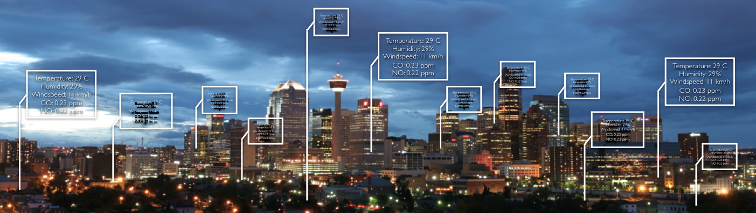

## What’s an OGC Testbed?

OGC Testbeds provide an agile, rapid engineering environment to accelerate development and testing of standards based on real world use cases. Candidate information exchange standards are developed at the same time that OGC vendor members are developing prototype software solutions. The OGC has conducted more than 80 of these international multi-firm R&D experiments in the last 15 years, each based on user-supplied scenarios. OGC testbeds have repeatedly demonstrated success at transitioning research into operations based on open standards.

## What will a Smart City Testbed accomplish?

This testbed will establish a standards-based framework in which all software vendors – from startups to established, global players – can build solutions that leverage shared spatial information. Solutions that combine diverse data products and processing services deliver value that can't be delivered in restricted proprietary environments. Sponsors' and participants' investments would return value for years to come based on the "network effects" that emerge from large open networks of interoperating systems: new markets, innovation, integration, technology convergence and more.

Prototype software owned and operated by testbed participants leads to market opportunities and risk reduction. Participating software companies get a jump on the market; gain early exposure to future standards and trends; and enjoy free publicity and networking.

## How can I be a part of the Testbed?

We encourage **Government agencies** and other **Smart City stakeholders** to consider sponsoring the testbed and contributing real-world requirements to shape the standards and thus shape the technology of the future. **Investors and Incubator organizations** are invited to co-sponsor the Testbed with stakeholders, sharing the development costs, contributing requirements, and encouraging their portfolio companies to participate.

# Why OGC?

The smart city vision depends on easy and ad hoc communication among countless systems, and often what needs to be communicated is spatial: spatial features, phenomena and operations; proximity; street address; spatial overlap or intersection; physical change over time; traffic; sensor (or imaging system) capabilities and orientation; and natural phenomena. In a smart city, communication among thousands of systems – often with access control – needs to be possible. Such communication and control depends on open standards.

Why OGC is the right place:

* OGC has a non-competitive, non-adversarial consensus process that allows professionals with many kinds of experience and expertise to collaborate on the development of standards.
* OGC's proven consensus process takes research results into industry for social benefit
* OGC has existing technology enablers: CityGML, SensorML, SensorThings, KML and other standards, including IndoorGML, coordinated with IFC building model standards from buildingSMART International.
* The OGC approach is well aligned with the open data and open source policies established in many countries. The OGC's consensus process and technology standards contribute to the development of technologies that make government more transparent, more efficient, and more effective.

Previous government investment in OGC testbeds has leveraged nearly $100M of activity that yielded numerous operational systems based on open standards. Government funding of this testbed is positioned to attract investment by foundations and venture capital firms looking to maximize their social and financial returns on pre-market R&D investments. In addition, sponsor funding will be matched in-kind to a considerable extent by innovative companies seeking early access to smart cities markets that are likely to emerge in an environment of widely implemented open standards.