

Compusult
40 Bannister Street
Mount Pearl, Newfoundland, Canada A1N 1W1
Telephone: +1 709 745 7914
Facsimile: +1 709 745 7927

Proposed Contributions
Providing Usability, Functionality and Support to
GEO Portal, Clearinghouse and SBAs
in the

GEO Architecture Implementation Pilot – Phase 2 (AIP-2)

CFP Issuance Date: 26 June 2008
Kickoff Response Due Date: 1 September 2008

Robert Thomas Craig Coffin
rthomas@compusult.net craig@compuslt.net
+1 709 745-7914 x212 +1 709 745-7914 x244

Table Of Contents
1 Overview 3
2 Proposed Contributions 3
2.1 Societal Benefit Area Alignment and Support 3
2.2 Component and Service Contributions 3
2.3 Architecture and Interoperability Arrangement Development 4
3 Description of Responding Organization 4

Compusult Response to the GEOSS AIP-2 CFP

Overview
During the GEO AIP 2007 Compusult provided a GEO Portal and GEOSS Clearinghouse candidate to aid in the development of the GEOSS Initial Operating Capability (IOC). These components were used to support AIP Scenario participation and provide a centralized access point for data and service discovery and user collaboration through standards based interfaces.
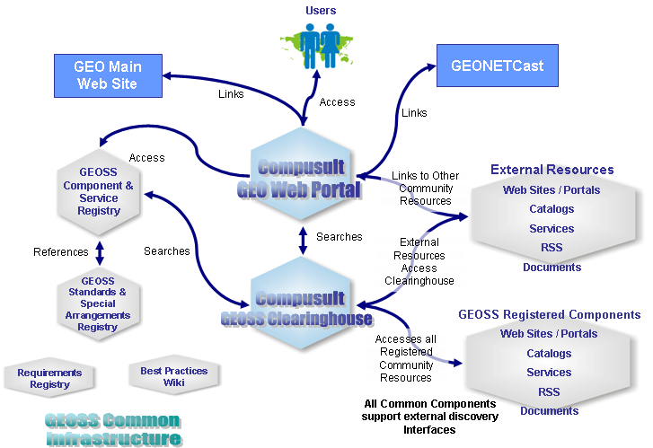
This initial Portal and Clearinghouse have now been incorporated into the GEOSS IOC for further evaluation and expansion of capabilities.
For the GEOSS AIP-2 Compusult is:
- continuing its support of GEOSS by committing to host the portal and clearinghouse until 2010,
- expand the capabilities of the contribution to include more robust standards-based connectivity,
- provide discovery and binding to Sensor Web services, and
- provide increasing SBA and scenario development support.

Proposed Contributions
Compusult will continue to provide and host a GEO Portal and GEOSS Clearinghouse as a key component to the GEOSS. This portal and clearinghouse are based on a combination of Open-source and Compusult’s own Web Enterprise Suite (WES) software, a widely used and established geospatial portal development system. It contains tightly integrated, open standards-based applications and toolkits providing a complete, interoperable, geospatial data portal solution facilitating greater data accessibility, binding, collaboration and improved decision making.
Compusult will continue to attend GEO related workshops, meetings and functions to help promote the use of the current infrastructure and to participate in the continuing evolvement of GEOSS.

Societal Benefit Area Alignment and Support
As outlined in the CFP, the GEO Portal and Clearinghouse play a central role in the SBAs and Scenario development for AIP-2. AS a central access point for data discovery, the GEO Portal and Clearinghouse cut across all nine SBAs. To provide easier discovery of information, we have built custom browsing of data related to each SBA inside the GEO Portal. Improvements in this capability will be implemented during the AIP-2.
Compusult will encourage the use of its GEO Portal for the discovery and binding of geospatial data products and services for all scenarios to be implemented for this pilot. It is Compusult’s intension to provide independent mini Web Portals for each Scenario that will enable better collaboration and functionality.
Each mini portal will have its own look and feel and will be independently managed.

Component and Service Contributions
The GEO Web Portal and GEOSS Clearinghouse components we are providing are based on a Service Oriented Architecture (SOA) and support Open Geospatial Consortium/ISO interoperability specifications and open-standards allowing seamless connections to EO data and services. In addition, the entire J2EE, standards-based portal framework provided by Compusult is entirely based on Open Source software. This portal framework is based on the world’s leading open source portal platform (Liferay) now going into its tenth year of development. Information Technology and Portal Standards subscribed to in the WES/Open Source platform include: JSR-168, SOAP, J2EE, XML, WSDL, Java, RDBMS and J2ME.

The fully functional initial deployment of the Compusult GEO Portal and GEOSS Clearinghouse can be tried by going to http://www.geowebportal.org .

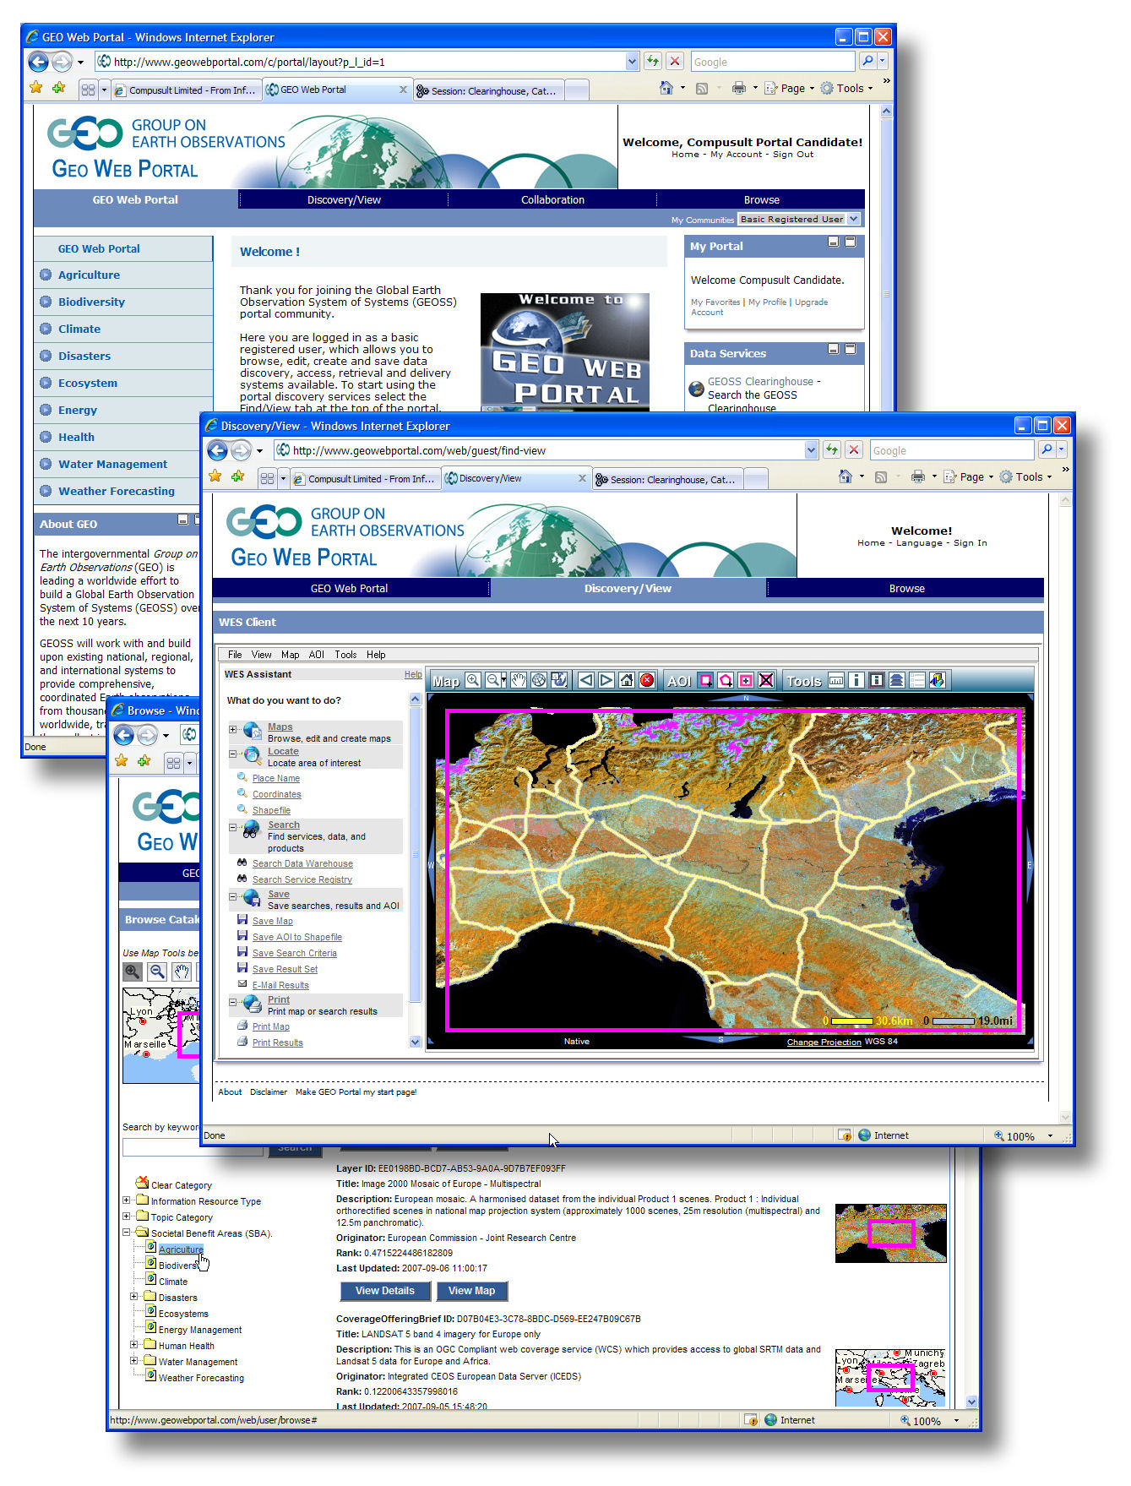
In short, this GEO Web Portal and GEOSS Clearinghouse provide:
- GEO Data Discovery
Search, manage and discover geospatial data from disparate data sources and community portals. Direct access to data pertaining to each of the nine Societal Benefit Areas (SBA) is provided through a dedicated SBA Browser facility.
- GEOSS Clearinghouse - Publish data and services to the GEOSS Clearinghouse supporting OGC catalogue 2.0.2 specifications. All Components and services Registered in the GEOSS Registry are harvested into the GEOSS Clearginghouse.
- GEO Data Access/Portrayal
Access, preview and retrieve distributed and/or disparate geospatial data and services through a lightweight mapping client not requiring special plug-ins or downloads. Google Earth integration and NASA WorldWind can provide alternative client portrayal interoperability.
- GEO Collaboration Suite
Document management including check in/check out, meta data, and versioning. Document file formats may be converted at the time of upload. Discussion Forums, Blogs, Image Library, RSS Clients, Community Calendars, Mail, and many other portlets are included.
- GEO Content Management
Integrated Web-based content management allowing users and SBA Communities to create, edit, and publish information, as well as templates for one click changes in layout. The system has built in workflow, article versioning, search, and meta-data. Employs easy navigation control, nested portlets and integrated site map.
- GEO User Management
End users can belong to managed ‘Groups’ or ‘Communities’ providing geo-data access control and customized user environments. These Communities can be based on SBA and/or cross cutting functional areas. Users can dynamically access and customize their information and services. Each Community can have dedicated control over its content through the included Content Management System.
- GEO Data Delivery – Order and Deliver data products and services to end users including e-commerce capabilities.
Compusult is very committed to this project and understands the long term value of such a system to the global community. As a demonstration of this commitment, during AIP-2, Compusult will be adding additional functionality to the current GEO Portal we have provided. This will include:
- SensorWeb Integration
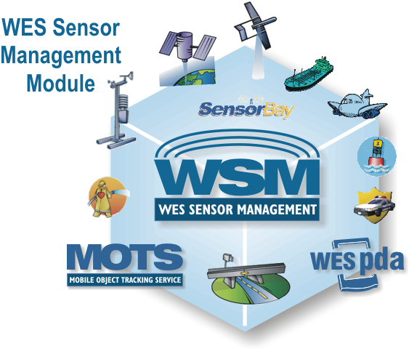
Compusult has recently introduced a Sensor Web module to its WES software that is based on the recently adopted OGC Sensor Web specifications. This module provides the capability to catalog and bind to Sensor Observation Services. During the AIP-2, Compusult will offer this cataloging capability to all providers and scenario participants who have SOS. Once these SOS are registered in the GEOSS Registry, the clearinghouse will then harvest these services and provide the ability to bind directly to the sensor providing live data retrieval.
In addition to the above, will also be performing the following upgrades to the Portal and/or Clearinghouse:
- Greater Integration with Google Earth, Google Maps, Google Text Search and NASA’s World Wind
- Catalog upgraded to support CSW 2.0.2
- Easier Style Management for a faster Customized Look and Feel
- More flexible Security
- Metric Tracking - users, searches etc.
- Additional Online Computer Based Training
- Greater Collaboration Capabilities through:
  - Message Boards
  - Document Library
  - Active calendar
  - Map Annotation
  - Image Library
  - Language Translator
- Improved User Management
  - Communities of Interest
  - Dedicated Collaboration Tools
- A More advanced Content Management System
  - WIKI Interfaces
  - Journal Interfaces

Infrastructure Hosting Commitment:
Compusult has committed to host the portal and clearinghouse service until 2010 at a minimum through our hosting facilities. This commitment includes:
- Provide a multi server load balanced architecture.
- 99% guaranteed availability through our high availability data centre.
- Hardware infrastructure is dedicated exclusively to GEO Portal project.

Architecture and Interoperability Arrangement Development
During the AIP-2, Compusult will continue to work with service and component providers to ensure interoperability with both the Portal and Clearinghouse. We will make support personnel available to help in this function.

Description of Responding Organization
Compusult has participated in the GEOSS AIP process since its beginning and will continue to support this initiative. We will be attending the kick-off meeting in Boulder and will continue to attend any meetings and workshops that helps promote the access and interoperability of information related to the Societal Benefit Areas
Company Overview
Compusult, is a privately held company incorporated in 1985 and in continuous operation for over 23 years. It is an information technology company providing its own world leading, interoperable, GIS portal solutions and many other value-added products and services such as custom software, systems integration and consulting services. These products and services are marketed to government, business, technical and scientific sectors with great success, ensuring a well established client base. Compusult currently operates out of its head office in Mount Pearl, Newfoundland, Canada and maintains a staff of over 50 full-time employees. Compusult has a branch office in Halifax, Nova Scotia, Ottawa, Ontario and has recently opened a subsidiary, Compusult Systems, Inc. in the Washington D.C. area.
Since inception, Compusult has continuously expanded its client base, revenues, and personnel qualifications and expertise. During the past decade, we have focused on the design, development and delivery of data warehousing, standards-based, GIS Portal solutions and other applications and services to U.S., Canadian and international clients. The company’s key contracts over the past five years have primarily involved the implementation of systems that provide GIS data warehousing, cataloguing, discovery, metadata management and Web-based browser services for large holdings of on-line data and data products. These projects have been completed for clients, such as the National Geospatial-Intelligence Agency (NGA), Natural Resources Canada, GeoEye (formerly Space Imaging), and the EROS Data Center of the U.S. Geological Survey (USGS). In each case, Compusult’s premier product, Web Enterprise Suite, has played a key role in delivering complete solutions within short time frames exceeding client expectations.
One of our current large scale portal projects is the replacement for the Canadian GeoConnections Discovery Portal (GDP). Compusult has been tasked to develop the new GDP providing a gateway to millions of geospatial data products. It acts as the single point of entry for users to search, view and obtain geospatial data and services without having to know where, or how the data is stored and how services can be accessed.
Through standards-based protocols the GDP will be built using Compusult's Web Enterprise Suite allowing enhanced discovery, access and download of geospatial information. It is based on open standards and specifications ensuring the infrastructure are interoperable with other infrastructures across Canada and around the world including the GEO Portal. Once completed, the GCP will be the primary point of access to the Canadian Geospatial Data Infrastructure and represents one of the most progressive implementations of this type of Geospatially enabled portals.
Compusult has over twelve years experience in the design, development and implementation of standards-based, interoperable, geo-spatial applications and has completed many recent projects deploying Web-based tools for discovery, visualizing, retrieving and publishing geospatial data from GIS databases, air photos or satellite imagery libraries.
Technical Capabilities Summary
Compusult has developed strong technical capabilities and a high degree of versatility through the experience of its personnel in successfully completing various scientific and technical contracts to deliver information technology solutions. As a result of our training and experience, we provide expertise in the following areas:
- Geospatial Portal Development and Deployment
- Geomatics and Geographic Information Systems
- Internet and World Wide Web Applications and Services
- Data Warehouse and Data Clearinghouse Design and Implementation
- Web based Document Management Systems
- Systems Integration
- Software Development
- Assistive Technologies and Workplace Accommodation for Persons with Disabilities
- Data Communications
- Automatic Identification and Data Collection (AIDC) Technologies
- Speech Technologies, including Text-To-Speech and Voice Recognition Applications
- Electronic Product Design, Development, and Manufacturing
- Real-time Image Analysis, Machine Vision and OCR Applications
- Local and Wide Area Network Design and Implementation
- User Interface Development
- Numerical Modeling and Simulation

Certifications and Affiliations
Compusult is affiliated with many professional and trade associations. A selected listing is shown in the following table:
Organization | Affiliation
Open Geospatial Consortium (OGC) | Technical Committee Member  Active participant in the Web Mapping Test bed projects and specifications. Active contributor to the OGC Catalog Implementation specification and Sensor Web Imitative
Canadian Geospatial Data Infrastructure (CGDI) GeoConnections Access Group | Technical Advisory Board Member
Alliance for Marine Remote Sensing (AMRS) | Member
Canadian Centre for Marine Communications (CCMC) | Member
Global Spatial Data Infrastructure (GSDI) Association | Full Member
United States Geospatial Intelligence Foundation (USGIF) | Technical Committee Member
Canadian Association of Defence and Security Industries (CADSI) | Member

Research and Development
The company’s present research and development capability has evolved as a result of experience gained through contract work for several clients in applications software development and systems integration. These contracts have enabled Compusult to become highly skilled in software design and development and preparation of technical documentation.
Compusult invests significantly in research and development in Web-enabled database access; on-line Internet services; geomatics and geographic information systems; data communications and networks; assistive technologies; and physical environmental applications. Some of our efforts have been supported by the OGC, CANARIE Inc., Industry Canada, and the National Research Council of Canada.

