Community Standard Justification: 20-093r1
I3S – Indexed 3D Scene Layers Version 1.2 Update
TITLE: I3S - Indexed 3D Scene Layers Update
CONTRIBUTOR
Name: Keith Ryden

Organization: Esri Inc.
Address: 380 New York Street
Redlands CA

Phone: 909-793-2853 x 1212
Email: kryden@esri.com

DATE: November 20, 2020 (20-093)
DATE: December 15, 2020 (20-093r1)

Contents
1. Introduction 3
2. Background of proposed submission 3
3. Details of the 1.2 Submission 4
3.1 Node Paging 4
3.2 Geometry compression 5
3.3 Advanced Materials Definition 5
3.4 Editorial Updates 5
3.5 I3S 1.7 Improvement Examples 5
3.5.1 Performance Improvement: 6
3.5.2 Reduced Client-Side memory footprints: 7
3.5.3 Improved Material Definitions 8
3.5.4 Geometry Payload size reduction 9
4. Deliverables 9
5. Legal Notes 10
6. Supporting member(s) 10
7. Examples of evidence of implementation of the proposed submission 11
8. OGC Document References 11
9. Change Log 11

Introduction
The Indexed 3D Scene Layers (I3S) delivery format is used to stream 3D geospatial content to mobile, web and desktop clients. In September 2016, I3S was submitted to the OGC for consideration under the Community Standards track. I3S was formally adopted as an OGC Community Standard on August 8, 2017. In May 2019, the OGC Members approved a work item to revise the I3S Community Standard. I3S Version 1.1 was approved by the OGC Members in January 2020.

This document presents the justification for submission of the next revision to the OGC I3S Community Standard for consideration by the OGC Technical Committee (TC). This justification forms the basis for TC review and vote to approve initiation of a Work Item to update the OGC I3S Community Standard to version 1.2.

The proposed revisions for I3S version 1.2 include:

- Introduction of paged node access pattern – which significantly reduces the client-server traffic by bundling individual node metadata resources into compact pages of nodes.
- Introduction of a more compact geometry layout for 3D Object and Integrated Mesh layers binary geometry payloads – using a well-known quantization encoding (Draco).
- Introduction of an advanced material definitions property such as physically based materials.
- More optimal selection strategy – standardizes on Oriented Bounding Boxes (OBBs) based node selection criterion.
- Editorial updates/corrections.

NOTE: These new enhancements are based on the Esri I3S version 1.7 product release (https://github.com/Esri/i3s-spec). The Esri I3S version 1.7 specification is backwards compatible with I3S Version 1.6. For the sake of clarity, this document refers to the new work item as the proposed OGC I3S Version 1.2 Community Standard.

Background of proposed submission
The initial non-OGC I3S specification was publicly released in July 2015 as an open specification for streaming large, heterogeneous geospatial data sets with 3D content. 3D content can include discrete 3D objects, large continuous meshes, 3D vector points, point clouds, and other content. This content may exist across enterprise systems comprised of server components, cloud hosted components, and a variety of client software from desktop to web and mobile applications. An I3S payload supports storage and transmission of very large data sets that may consist of millions of discrete 3D objects with attributes as well as integrated surface meshes that may cover many thousands of square kilometers of the Earth’s surface.

The reader is referred to the original OGC I3S Community Standard (CS) Work Item Justification document [OGC 16-133R1] at https://portal.opengeospatial.org/files/?artifact_id=71232&version=2 for a detailed discussion of the original I3S submission to the OGC, including motivation, scope, and evidence of implementation. Version 1.0 of the OGC I3S CS is a snapshot of selected approved features from the living community I3S specification. The snapshot date was February 24, 2017. The original source can be viewed at https://github.com/esri/i3s-spec.

The reader is also referred to the OGC I3S CS Work Item Justification document for the first revision to the I3S CS: [OGC 16-133R3] at https://portal.ogc.org/files/?artifact_id=83277&version=1. Version 1.1 of the OGC I3S CS is a snapshot of selected approved features from the community I3S specification. The snapshot date was June 2019. The primary enhancements for the OGC I3S version 1.1 Community Standard included:
- Addition of the Point Cloud Scene Layer type
- For existing layer types, the addition of:
  - Oriented Bounding Boxes
  - Attribute Domain Rules
  - Service Update Timestamp
  - Index hash table for improved performance
- Editorial updates/corrections

OGC Working Groups that may have special interest in the material presented include:
- 3DIM DWG
- CDB SWG
- Perspective Imagery DWG
- Point Cloud DWG

Details of the 1.2 Submission

Node Paging
A major improvement being submitted to the OGC for version 1.2 of the CS is node paging. Previously, clients received one node per request. In the new version, the nodes are grouped into pages. Clients can determine which node pages are needed and request only the necessary pages. This significantly reduces server-client traffic and improves performance.

Specifically, in earlier versions, each node was stored individually as a 3DNodeIndexDocument, causing the tree traversal performance to be negatively impacted due to the large number of small resource requests required. For version 1.2 many nodes are packed into a single resource called a node page. These node pages are created by representing the tree as a flat array of nodes where internal nodes reference their children by their array indices.

I3S creators are free to use any ordering (e.g. breadth first, depth first) of the nodes into a flat array of nodes. The ID for a node is an integer that represents the index of the node within this flattened array.

Due to the addition of node pages, the shared resources class has been deprecated. The primarily components of the shared resource class, which are texture and material information, are now available in the 3D Scene Layer Resource. However, since the proposed I3S 1.2 CS is backwards compatible, the shared resource component of a node is still included in the specification, even though it is not utilized by newer client application accessing the proposed CS. The presence of the shared resource class in I3S 1.2 guarantees that older client application based on OGC I3S Version 1.1 will still be able to consume the same I3S resource.

Geometry compression

The next major enhancement is support for Draco geometry compression. Draco is an open source library for compressing 3D geometries. Draco supports compressing geometry attributes creating more compact nodes, which in turn provides a smaller payload, increasing performance. More specifically, Draco is a library for compressing and decompressing 3D geometric meshes and point clouds. It is intended to improve the storage and transmission of 3D graphics. The Draco encoder and decoder APIs are now available in C++ and Javascript and are provided as an open source solution by Google under an Apache 2.0 license.

Advanced Materials Definition

Another key enhancement for version 1.2 is support for advanced materials. The material definition is now feature compatible with glTF materials. glTF defines materials using a common set of parameters that are based on widely used material representations from Physically-Based Rendering (PBR). Specifically, glTF uses the metallic-roughness material model. Using this declarative representation of materials enables a glTF file to be rendered consistently across platforms.

The materialDefinitions object are feature-compatible with glTF material with the following exceptions. I3S material colors properties (baseColorFactor, emissiveFactor etc.) are assumed to be in the same color space as the textures, most commonly sRGB while in glTF they are interpreted as linear. glTF has separate definitions for properties like strength for occlusionTextureInfo and scale for normalTextureInfo. Further I3S has only one texture definition with factor that replaces strength and scale.

Editorial Updates

These are appropriate, additions and clarifications to improve the usability and readability of the I3S document.

I3S 1.7 Improvement Examples

The proposed submission for I3S 1.2 brings significant performance and quality improvements over the existing standard. Below are some performance numbers and images showing the improved performance.

Performance Improvement:

Click on the image below or here to see a performance comparison video showing reduced loading times:

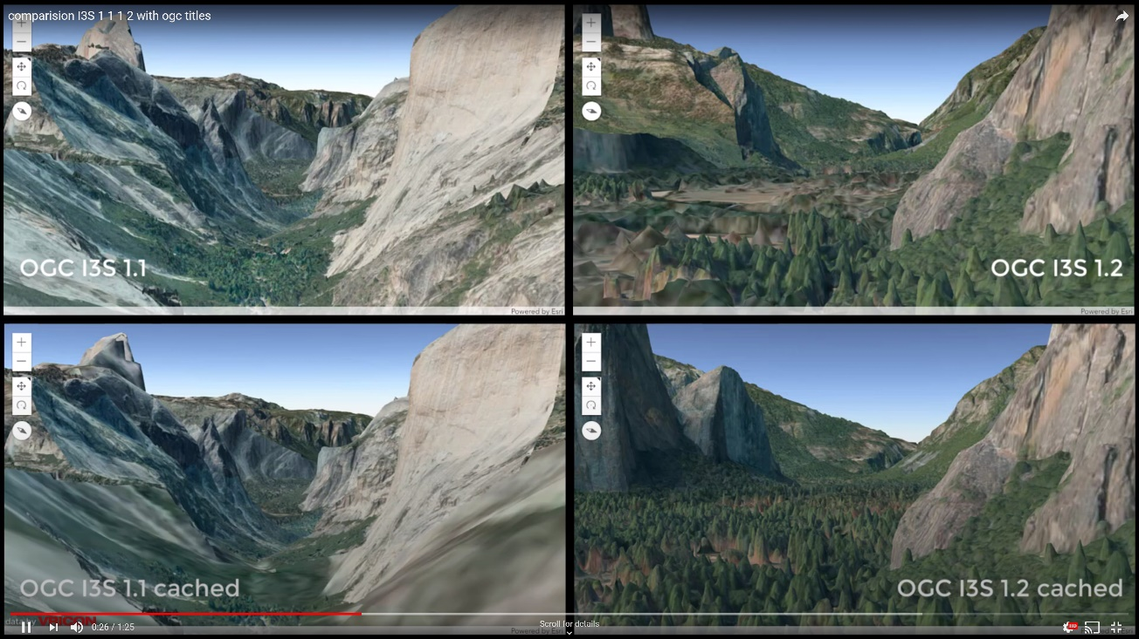
Multimedia 1: This video/snapshot shows I3S OGC 1.1 community standard compared to the proposed OGC I3S 1.2 CS. In the snapshot image above and the video link, the videos/images on the left column correspond to I3S OGC 1.1 CS whereas the videos/images on the right column correspond to the proposed OGC I3S 1.2 CS. Furthermore, the OGC I3S 1.1 and OGC I3S 1.2 captions indicate the performance measurement was taken without any client-side browser caching; conversely the OGC I3S 1.1 Cached and OGC I3S 1.2 Cached captions indicate browser caching was permitted. Data provided by Vricon.

Table 1. below shows the loading improvement factors for Scene Layers in the Proposed OGC I3S 1.2 community standard over I3S OGC 1.1 CS. Note that the gains shown below are using the ArcGIS JS API as a client application and might vary based on client application implementation.

Test case | Loading Improvement factor |  |  | Layer Type | Layer Size* | Textured
Test case | Min | Avg | Max | Layer Type | Layer Size* | Textured
Spain, Pirineos | 2.0 | 3.0 | 3.6 | Integrated Mesh | Large | Yes
Washington | 1.8 | 3.4 | 5.6 | Integrated Mesh | Medium | Yes
San Francisco | 1.7 | 2.5 | 3.4 | 3D Object | Large | Yes
San Diego | 2.0 | 2.5 | 3.2 | 3D Object | Medium | Yes
New York | 1.9 | 2.6 | 3.7 | 3D Object | Large | No
Zurich | 1.5 | 1.9 | 2.3 | 3D Object | Medium | No
Vancouver | 1.7 | 2.5 | 4.3 | 3D Object | Medium | No
Manhattan | 1.3 | 2.7 | 5.9 | 3D Object | Small | No
France | 2.5 | 3.2 | 4.6 | 3D Object | Huge | No

Table. 1 – Loading Improvement factors of the Proposed OGC I3S 1.2 over I3S OGC 1.1 Community Standard. These improvements were measured using the ArcGIS JS API client application.
* Small (<5GB), Medium (5 – 20GB), Large (20 – 50 GB) and Huge (Over 50GB).

Reduced Client-Side memory footprints:

A Live Application demonstrating the proposed OGC 3S 1.2 Improvements for client-side memory reduction:
In the example/live app below the client-Side memory usage reduction is about 31% on average.

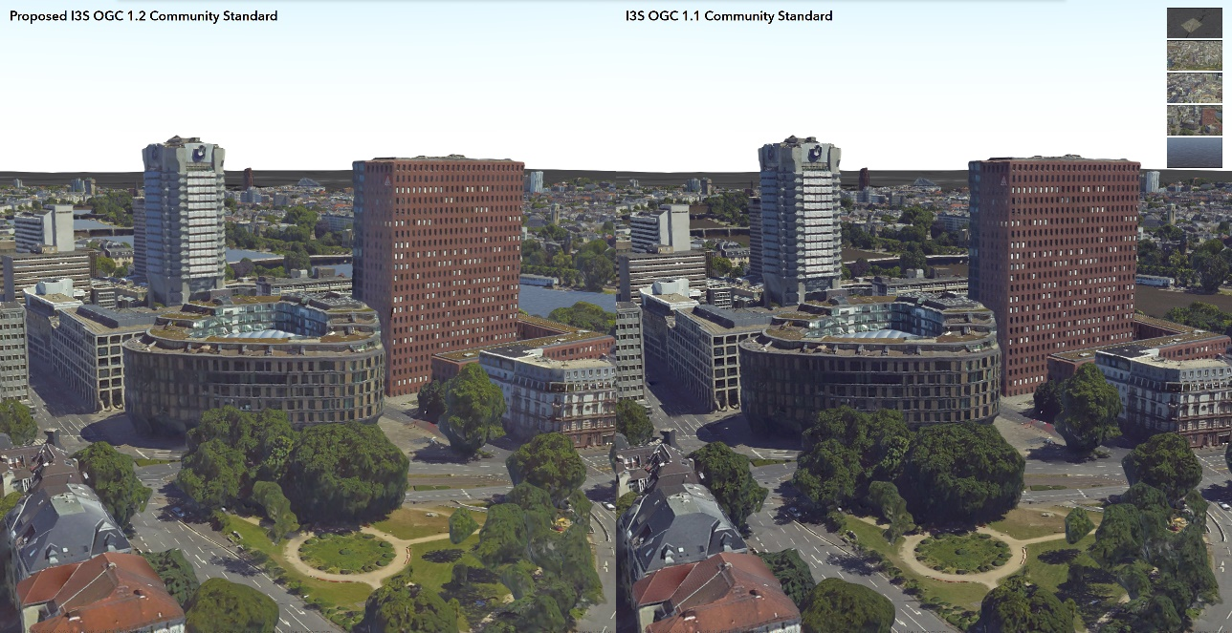
Data by Aerowest.

Improved Material Definitions

I3S improved material definitions enables I3S layers to support advanced material properties such as PBR as shown below. Click here for a video representation.
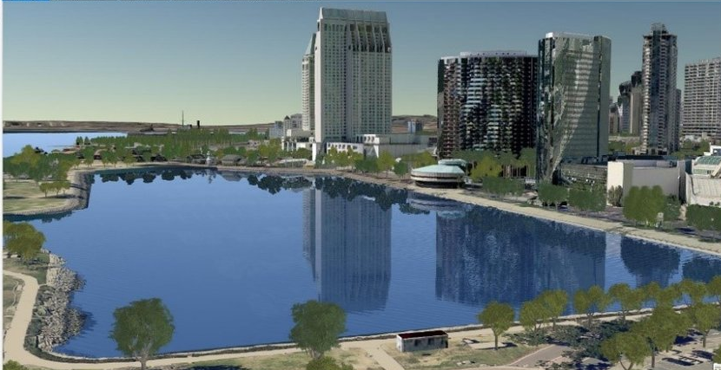

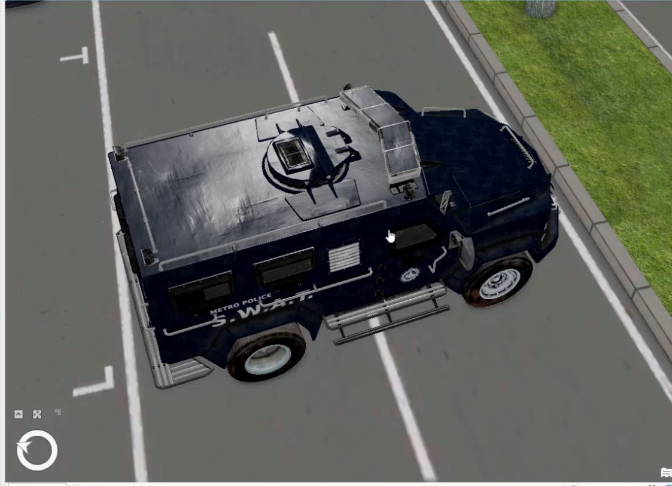

Geometry Payload size reduction

The proposed OGC I3S 1.2 community standard version has a geometry payload that’s ~85% smaller compared to OGC I3S 1.1 CS. Such a reduction in the geometry payloads is attained by using Draco compression that gets decoded client side on runtime. This enables I3S 1.2 to stream content across the wire more efficiently compared to previous versions.

Table 2: Shows the reduction in geometry payload and number of requests in I3S 1.2 versus I3S 1.1. Three test cases each with 4/5 bookmarks (static views) were compared between I3S 1.1 CS and the Proposed I3S 1.2, created from the same source data. The “Number of Requests” columns are filtered to show only geometry requests.

Deliverables
This project will result in a revision and update to the OGC Indexed 3D Scene Layer CS document. The following deliverables will be generated over the life of the project:

- Work Item Justification document for updating the OGC Indexed 3D Scene Layers Standard (this document), to be approved by the OGC Technical Committee before commencement of further work.
- An updated Indexed 3D Scene Layers Standard document for public comment that contains the additional features described above.
- A Presentation to the OAB reviewing the changes in the Indexed 3D Scene Layers Standard document. The objective is to seek approval to release the document for public comment.
- A document collecting and responding to public comments on the updated Indexed 3D Scene Layers Standard document.
- Final revision of the Indexed 3D Scene Layers Standard document based on public comment.
- A presentation to the TC reviewing updated Indexed 3D Scene Layers Standard document in preparation for adoption vote.

Legal Notes

The submitters agree to abide by the OGC TC Policies and Procedures and OGC Intellectual Property Rights Policy (http://www.opengeospatial.org/ogc/policies) during the processing of this submission.
The submitters have granted the Open Geospatial Consortium (OGC) a nonexclusive, royalty-free, paid up, worldwide license to copy and distribute this document and to modify this document and distribute copies of the modified version under a Creative Commons ShareAlike (CC BY-SA) license. This is the agreement under which the current version of the Indexed 3D Scene Layer Standard is licensed.

The submitters reference the following patent: United States Patent 9,002,126, Limited Error Raster Compression (LERC). This compression is one of the Point Cloud compressions defined in the Indexed 3D Scene Layer Point Cloud type. A full description of the compression and open source implementation can be found at https://github.com/esri/lerc. LERC is available under an Apache License. The Apache License provides a perpetual, worldwide, non-exclusive, no-charge, royalty-free, irrevocable patent license (see the Apache License Clause 3 Grant of Patent License).

Supporting member(s)

Name | Organization
Keith Ryden | Esri
Carl Reed | Carl Reed and Associates
Gordon Plunkett | Esri Canada
Anneley Hadland | Helyx Secure Information Systems Ltd
Jerome St. Louis | Ecere
Jeongeun Lee | Korea Land and Geospatial Informatix Corporation
Steven Sha | GeoScene (YiZhiRui) Information Technology Co. Ltd.
Cesar Suarez,  Hermann Brassard | Presagis
Clemens Portele | Interactive Instruments
Volker Coors | Hochschule für Technik Stuttgart
Dean Hintz | Safe Software
Howard Butler | Hobu Inc.
Ib Green | Unfolded

OGC invites other interested organizations to contact Keith Ryden (kryden@esri.com) to be added to the list of supporting members. The Supporting Members table will be updated periodically.

Examples of evidence of implementation of the proposed submission

In addition to the original examples of I3S Community Standard implementations at versions 1.0 and 1.1, the following are some additional examples of implementations of the proposed OGC I3S version 1.2:

- Vis.gl: A framework for webGL powered large-scale data vis, has started supporting consuming OGC I3S 1.1 standard for meshpyramids profile, via its deck.gl & loaders.gl modules in early March 2020.
- npx converter: An open-source standalone converter utility that converts OGC 3D Tiles 1.0 Community Standard to I3S GitHub 1.7 version and vise-versa. This converter will work in converting OGC 3D Tiles content from file and Cesium ion sources to both I3S services and Scene Layer Packages (SLPK). The tool is now publicly available @ vis.gl/loaders.gl repo.
- Vis.gl (loader.gl & deck.gl) is now working on consuming I3S GitHub version 1.7 for meshpyarmid profiles. Availability, early Q1, 2021.
- GeoScene 2.0 provides I3S data construction, Enterprise services, and client applications to create, host, visualize and process I3S data as defined in the I3S 1.7 specification.
- Presagis is also working on consuming I3S GitHub version 1.7 in Cesium.js and making it publicly available as an open-source module. Availability early Q1, 2021.
- nFrames, a Mesh & photogrammetry content provider, has been shipping their SURE 4.1 software since early April 2020 with I3S 1.7 output. They have documented this as the first commercial company to ship I3S 1.7 in their “What’s new” document released back in April.

OGC invites other interested organizations to contact Keith Ryden (kryden@esri.com) to be added to the list of implementations. Implementations list will be updated periodically.

Example Services and applications Implementing the proposed OGC I3S 1.2 CS

- An example of a 3D Object I3S 1.2 CS service (untextured 3D Object Scene Layer)

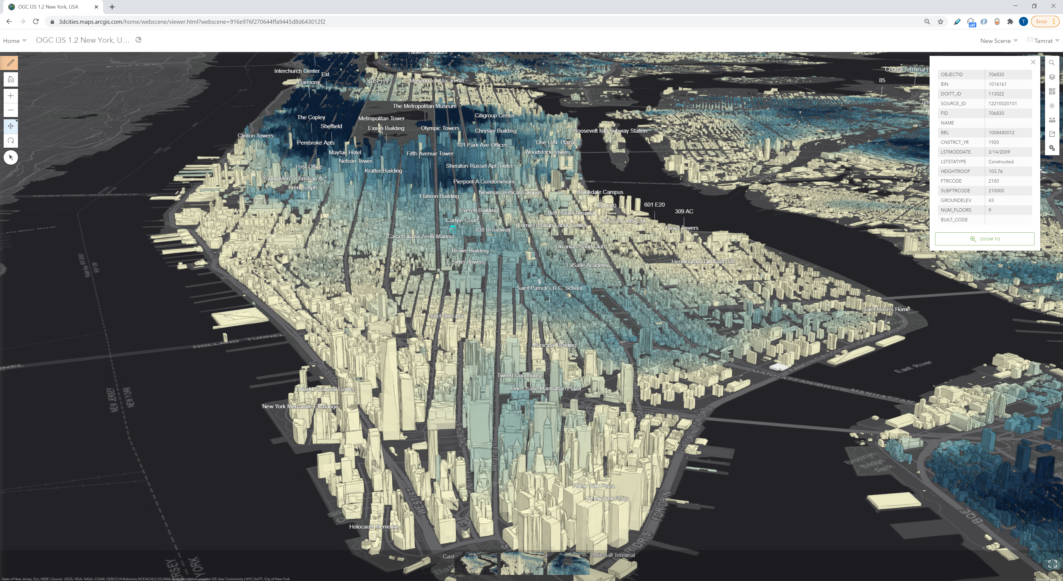

https://3dcities.maps.arcgis.com/home/webscene/viewer.html?webscene=916e976f270644ffa9445d8d643012f2

- An example of a 3D Object I3S 1.2 CS service (textured & untextured 3D Object Scene Layer)

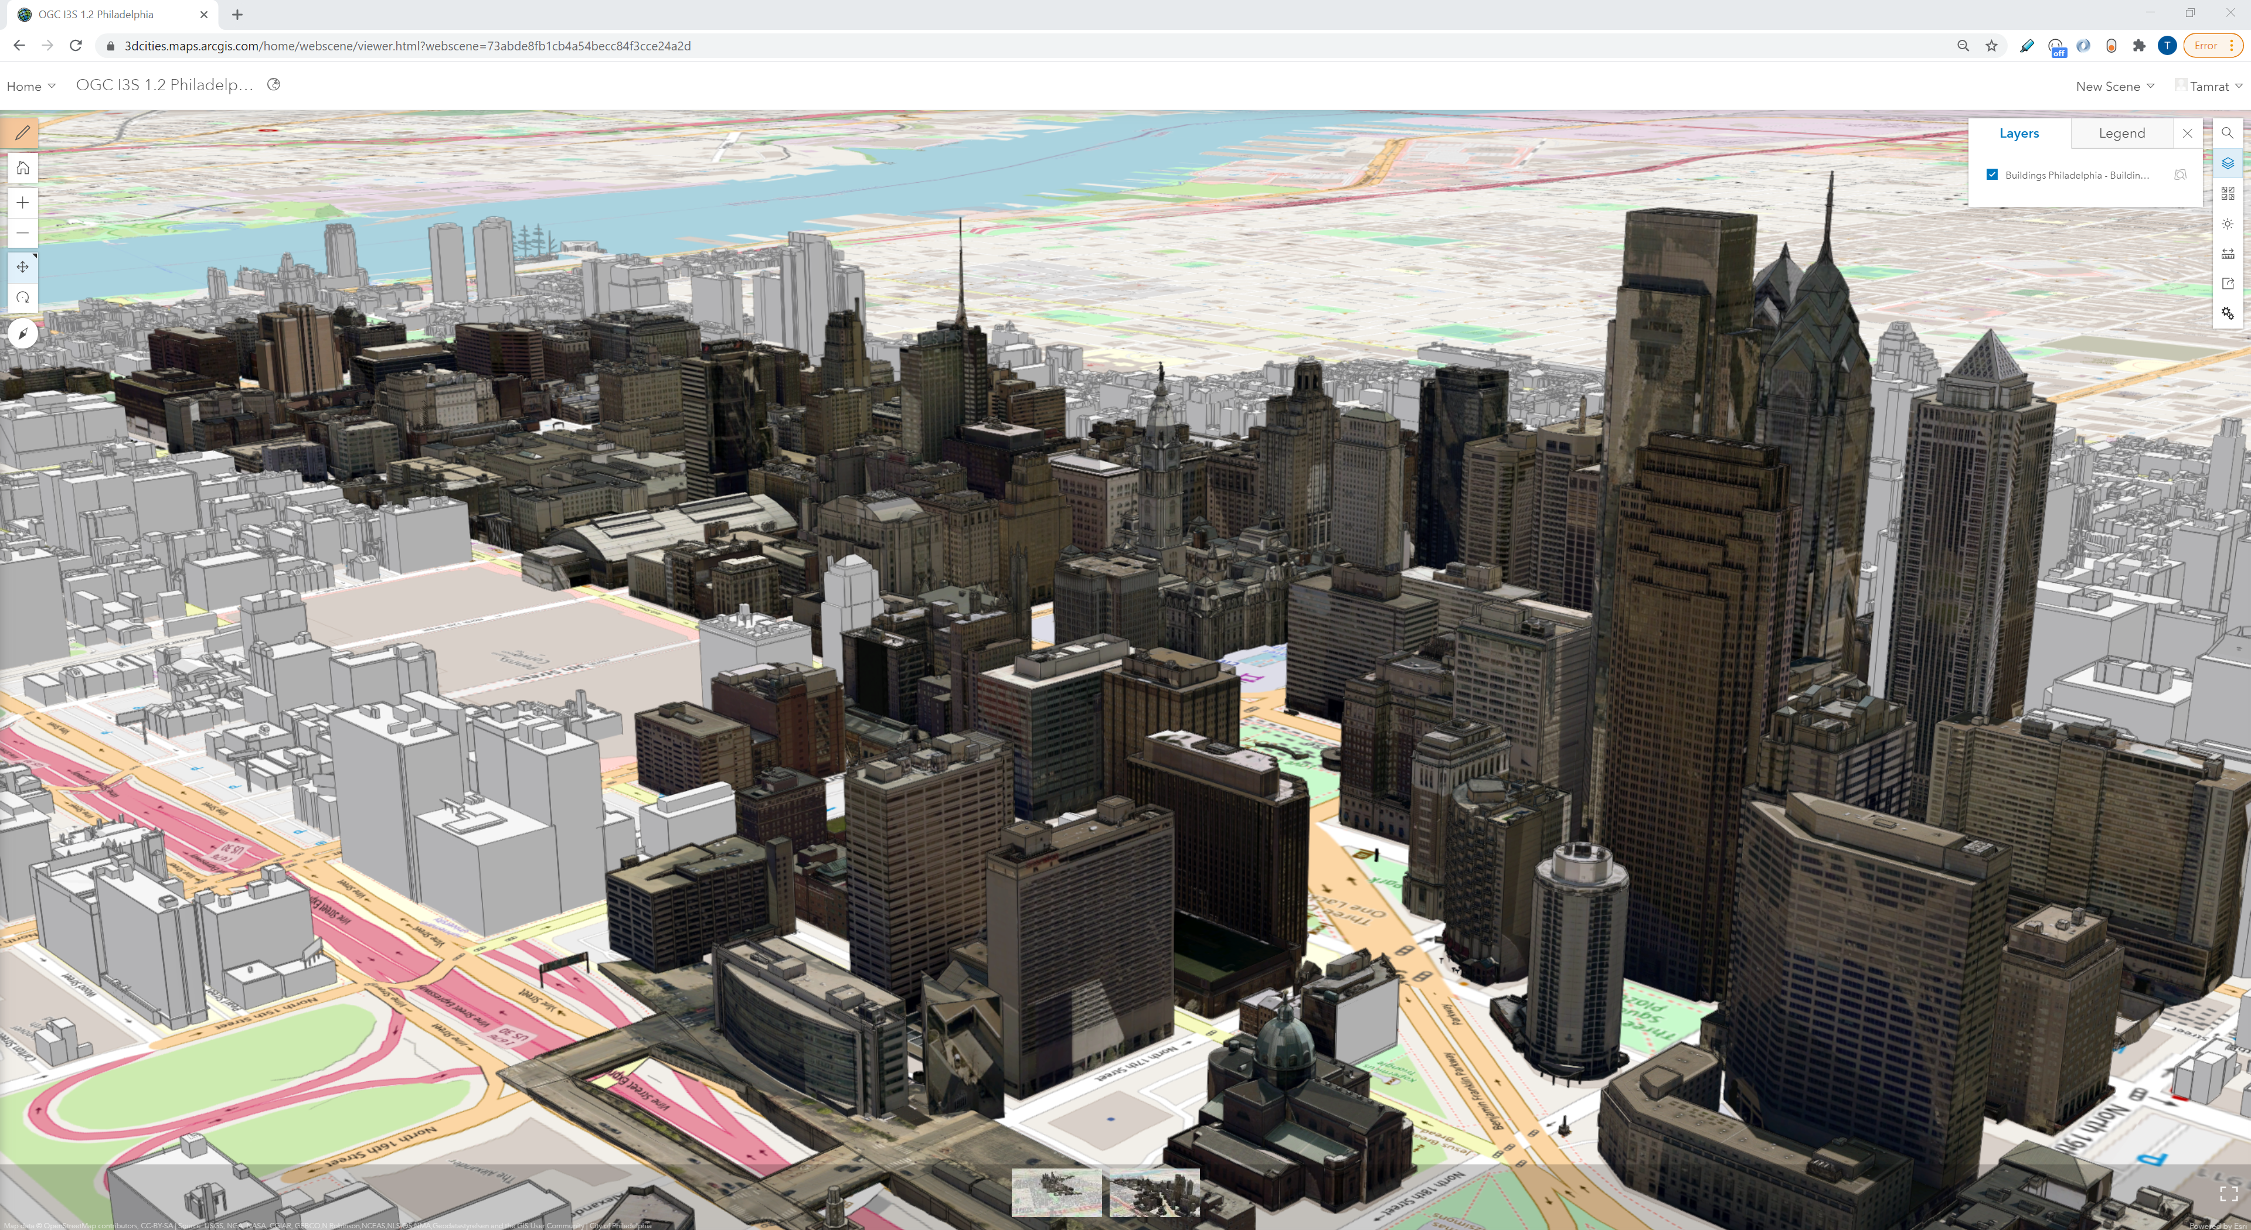

https://3dcities.maps.arcgis.com/home/webscene/viewer.html?webscene=73abde8fb1cb4a54becc84f3cce24a2d

- An example of an Integrated Mesh I3S 1.2 CS service.

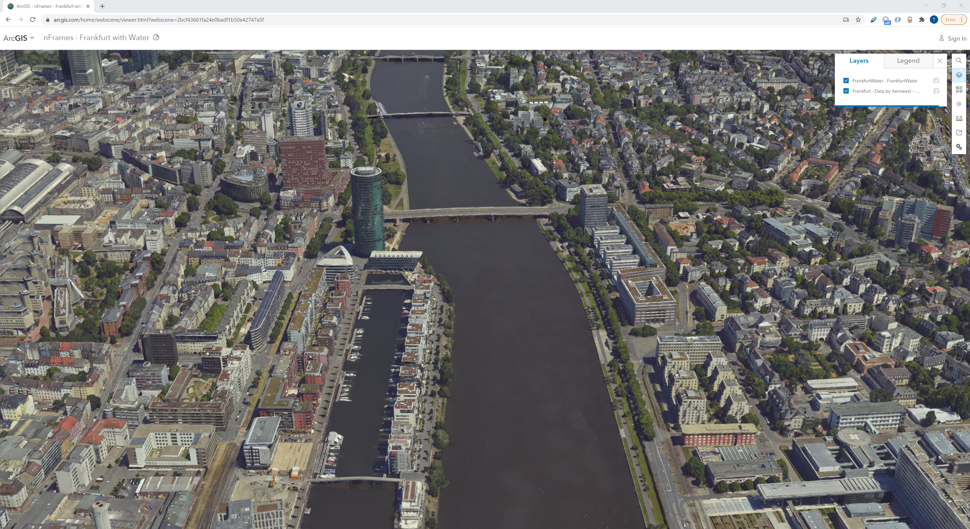

https://www.arcgis.com/home/webscene/viewer.html?webscene=2bcf43661fa24e0badf1b50e42747a5f

- A Live Application demonstrating the proposed OGC 3S 1.2 Improvements for client-side memory reduction: In the example/live app below the client-Side memory usage reduction is about 31% on average.

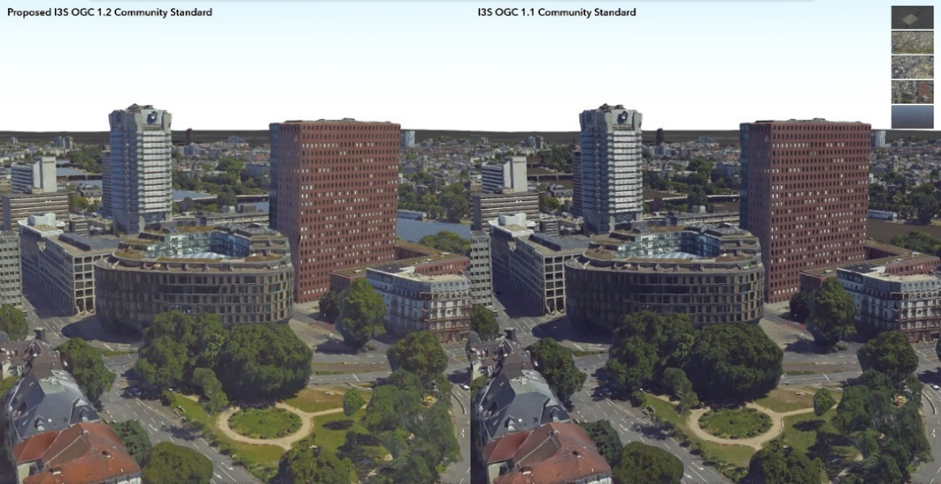

OGC Document References
OGC Testbed-14: Point Cloud Data Handling Engineering Report http://docs.opengeospatial.org/per/18-048r1.html#_summary

OGC Testbed-13: 3D Tiles and I3S Interoperability and Performance ER http://docs.opengeospatial.org/per/17-046.html

OGC 3D Data Container Engineering Report https://docs.ogc.org/per/20-029.htmlOOGC 3D Data Container and Tiles API Pilot Summary Engineering Report https://docs.ogc.org/per/20-031.html

Change Log
Document Version | Date | Comments
20-093 | 2020-11-20 | Initial document upload to pending
20-093r1 | 2020-12-15 | Update submitters, example links, editorial updates

Please note that the content at that location will be updated with the new elements of the I3S Specification as indicated in this justification document. However, since the I3S “sandbox” is maintained in a GitHub repository, the original 2017 content used for the snapshot will always be available for review.

