Open Geospatial Consortium
Submission Date: 2020-07-20
Approval Date:
Publication Date:
External identifier of this OGC® document: http://www.opengis.net/doc/AS/dggs/2.0
Internal reference number of this OGC® document: 20-040r1
Category: Standard
Editor: Robert Gibb, Matt Purss
Abstract Specification Topic 21 - Discrete Global Grid Systems - Part 1 Core Reference system and Operations and Equal Area Earth Reference System

Copyright notice
Copyright © 2020 Open Geospatial Consortium
To obtain additional rights of use, visit http://www.opengeospatial.org/legal/
Note
Attention is drawn to the possibility that some of the elements of this document may be the subject of patent rights. The Open Geospatial Consortium shall not be held responsible for identifying any or all such patent rights.
Recipients of this document are requested to submit, with their comments, notification of any relevant patent claims or other intellectual property rights of which they may be aware that might be infringed by any implementation of the standard set forth in this document, and to provide supporting documentation.
Warning
This document is an OGC Member approved international standard. This document is available on a royalty free, non-discriminatory basis. Recipients of this document are invited to submit, with their comments, notification of any relevant patent rights of which they are aware and to provide supporting documentation.
Document number: 20-040r1
Document type: OGC® Abstract Specification
Document subtype:
Document stage: Published
Document language: English

License Agreement
Permission is hereby granted by the Open Geospatial Consortium, (“Licensor”), free of charge and subject to the terms set forth below, to any person obtaining a copy of this Intellectual Property and any associated documentation, to deal in the Intellectual Property without restriction (except as set forth below), including without limitation the rights to implement, use, copy, modify, merge, publish, distribute, and/or sublicense copies of the Intellectual Property, and to permit persons to whom the Intellectual Property is furnished to do so, provided that all copyright notices on the intellectual property are retained intact and that each person to whom the Intellectual Property is furnished agrees to the terms of this Agreement.
If you modify the Intellectual Property, all copies of the modified Intellectual Property must include, in addition to the above copyright notice, a notice that the Intellectual Property includes modifications that have not been approved or adopted by LICENSOR.
THIS LICENSE IS A COPYRIGHT LICENSE ONLY, AND DOES NOT CONVEY ANY RIGHTS UNDER ANY PATENTS THAT MAY BE IN FORCE ANYWHERE IN THE WORLD.
THE INTELLECTUAL PROPERTY IS PROVIDED “AS IS”, WITHOUT WARRANTY OF ANY KIND, EXPRESS OR IMPLIED, INCLUDING BUT NOT LIMITED TO THE WARRANTIES OF MERCHANTABILITY, FITNESS FOR A PARTICULAR PURPOSE, AND NONINFRINGEMENT OF THIRD PARTY RIGHTS. THE COPYRIGHT HOLDER OR HOLDERS INCLUDED IN THIS NOTICE DO NOT WARRANT THAT THE FUNCTIONS CONTAINED IN THE INTELLECTUAL PROPERTY WILL MEET YOUR REQUIREMENTS OR THAT THE OPERATION OF THE INTELLECTUAL PROPERTY WILL BE UNINTERRUPTED OR ERROR FREE. ANY USE OF THE INTELLECTUAL PROPERTY SHALL BE MADE ENTIRELY AT THE USER’S OWN RISK. IN NO EVENT SHALL THE COPYRIGHT HOLDER OR ANY CONTRIBUTOR OF INTELLECTUAL PROPERTY RIGHTS TO THE INTELLECTUAL PROPERTY BE LIABLE FOR ANY CLAIM, OR ANY DIRECT, SPECIAL, INDIRECT OR CONSEQUENTIAL DAMAGES, OR ANY DAMAGES WHATSOEVER RESULTING FROM ANY ALLEGED INFRINGEMENT OR ANY LOSS OF USE, DATA OR PROFITS, WHETHER IN AN ACTION OF CONTRACT, NEGLIGENCE OR UNDER ANY OTHER LEGAL THEORY, ARISING OUT OF OR IN CONNECTION WITH THE IMPLEMENTATION, USE, COMMERCIALIZATION OR PERFORMANCE OF THIS INTELLECTUAL PROPERTY.
This license is effective until terminated. You may terminate it at any time by destroying the Intellectual Property together with all copies in any form. The license will also terminate if you fail to comply with any term or condition of this Agreement. Except as provided in the following sentence, no such termination of this license shall require the termination of any third party end-user sublicense to the Intellectual Property which is in force as of the date of notice of such termination. In addition, should the Intellectual Property, or the operation of the Intellectual Property, infringe, or in LICENSOR’s sole opinion be likely to infringe, any patent, copyright, trademark or other right of a third party, you agree that LICENSOR, in its sole discretion, may terminate this license without any compensation or liability to you, your licensees or any other party. You agree upon termination of any kind to destroy or cause to be destroyed the Intellectual Property together with all copies in any form, whether held by you or by any third party.
Except as contained in this notice, the name of LICENSOR or of any other holder of a copyright in all or part of the Intellectual Property shall not be used in advertising or otherwise to promote the sale, use or other dealings in this Intellectual Property without prior written authorization of LICENSOR or such copyright holder. LICENSOR is and shall at all times be the sole entity that may authorize you or any third party to use certification marks, trademarks or other special designations to indicate compliance with any LICENSOR standards or specifications.
This Agreement is governed by the laws of the Commonwealth of Massachusetts. The application to this Agreement of the United Nations Convention on Contracts for the International Sale of Goods is hereby expressly excluded. In the event any provision of this Agreement shall be deemed unenforceable, void or invalid, such provision shall be modified so as to make it valid and enforceable, and as so modified the entire Agreement shall remain in full force and effect. No decision, action or inaction by LICENSOR shall be construed to be a waiver of any rights or remedies available to it.
None of the Intellectual Property or underlying information or technology may be downloaded or otherwise exported or reexported in violation of U.S. export laws and regulations. In addition, you are responsible for complying with any local laws in your jurisdiction which may impact your right to import, export or use the Intellectual Property, and you represent that you have complied with any regulations or registration procedures required by applicable law to make this license enforceable.
Suggested additions, changes and comments on this standard are welcome and encouraged. Such suggestions may be submitted using the online change request form on OGC web site: http://portal.opengeospatial.org/public_ogc/change_request.php
Contents
i. Abstract ix
ii. Keywords ix
iii. Preface x
iv. Submitting Organizations x
v. Submitters x
vi. Foreword x
vii. Introduction xi
1. Scope 1
2. Conformance 1
3. Normative references 1
4. Terms and definitions 1
5. Conventions 9
5.1. Universal Resource Identifiers 9
5.2. Unified Modelling Language notation 9
5.3. Attribute and Association role status 9
5.4. Abbreviated terms 9
6. DGGS Specifications Overview 10
6.1. Package overview 10
7. Common Spatio-temporal Classes Package 11
7.1. Common Spatio-temporal Classes Overview 11
7.2. Zone and Temporal Geometry 12
7.3. Zone and Temporal reference systems using identifiers package 20
8. DGGS Core Reference System and Functions Package 31
8.1. DGGS Core Reference System and Functions 31
8.2. DGGS Core Reference system using discrete geometry with zonal identifiers 31
8.3. DGGS Core Functions 38
9. DGGS Equal Area Earth Reference System Package 53
9.1. DGGS Equal Area Earth Reference System 53
Annex A (normative) Abstract Test Suite 68
A.1. Conformance Common Spatio-temporal Classes Modules 68
A.2. Core Package 69
A.3. Equal Area Earth Reference system Package 73
Annex B (informative) Equal Area Discrete Global Grid System Theory 77
Annex C (informative) Background to DGGS 81
C.1. DGGS as a Digital Information Medium 81
C.2. History 81
C.3. Global Grid Taxonomy 82
C.4. Criterion 83
C.5. A Digital Spatial Reference System 83
C.6. Application 84
Annex D (informative) Temporal geometry, topology, and temporal referencing by named periods — Context for modelling 85
D.1. General 85
D.2. Geometry and Topology 85
D.3. Referencing by named periods 85
Annex E (informative) Requirements cross-walk from Topic 21 v1.0 to v2.0 86
Annex F (informative) Revision History 89
Bibliography 92

List of Tables
Table 1 x
Table 2 — Elements of Temporal Geometry::Duration class 14
Table 3 — Elements of Temporal Geometry::EdgeT class 15
Table 4 — Elements of Temporal Geometry::Instant class 15
Table 5 — Elements of Temporal Geometry::Interval class 15
Table 6 — Elements of Temporal Geometry::NodeT class 15
Table 7 — Elements of Temporal Geometry::TemporalGeometricCollection class 15
Table 8 — Elements of Temporal Geometry::TemporalGeometricComplex class 16
Table 9 — Elements of Temporal Geometry::TemporalGeometricPrimitive class 16
Table 10 — Elements of Temporal Geometry::TemporalGeometry class 16
Table 11 — Elements of Temporal Geometry::TemporalTopologicalComplex class 17
Table 12 — Elements of Temporal Geometry::TemporalTopologicalPrimitive class 17
Table 13 — Elements of Temporal Geometry::TemporalTopology class 17
Table 14 — Elements of Zone Geometry::ZoneCompoundGeometry class 18
Table 15 — Elements of Zone Geometry::ZoneCompoundTopology class 19
Table 16 — Elements of Zone Geometry::ZoneGeometry class 19
Table 17 — Elements of Zone Geometry::ZoneSimpleGeometry class 19
Table 18 — Elements of Zone Geometry::ZoneSimpleTopology class 20
Table 19 — Elements of Zone Geometry::ZoneTopology class 20
Table 20 — Elements of LocationS::LocationS class 21
Table 21 — Elements of Period::Period class 23
Table 22 — Elements of Period::PeriodClass class 24
Table 23 — Elements of Period::PeriodIdentifier class 24
Table 24 — Elements of Period::TemporalReferenceSystemUsingPeriodIdentifiers class 24
Table 25 — Elements of Zone::RSUsingZonalIdentifiers class 28
Table 26 — Elements of Zone::RSUsingZonalIdentifiersCompound class 28
Table 27 — Elements of Zone::RSUsingZonalIdentifiersPrimitive class 28
Table 28 — Elements of Zone::ZonalIdentifier class 29
Table 29 — Elements of Zone::ZonalIdentifierComplex class 29
Table 30 — Elements of Zone::ZonalIdentifierPrimitive class 29
Table 31 — Elements of Zone::Zone class 29
Table 32 — Elements of Zone::ZoneClass class 30
Table 33 — Elements of Zone::ZoneClassComplex class 30
Table 34 — Elements of Zone::ZoneClassPrimitive class 30
Table 35 — Elements of Zone::ZoneCompound class 30
Table 36 — Elements of Zone::ZonePrimitive class 31
Table 37 — Elements of Core RS using zonal identifiers with structured geometry::Cell class 33
Table 38 — Elements of Core RS using zonal identifiers with structured geometry::DGG_ReferenceSystem class 33
Table 39 — Elements of Core RS using zonal identifiers with structured geometry::DGG_ReferenceSystemType class 34
Table 40 — Elements of Core RS using zonal identifiers with structured geometry::DiscreteGlobalGrid class 34
Table 41 — Elements of Core RS using zonal identifiers with structured geometry::GlobeGeometry class 35
Table 42 — Elements of Core RS using zonal identifiers with structured geometry::DGG_GridConstraint class 35
Table 43 — Elements of Core RS using zonal identifiers with structured geometry::DGG_RefinementStrategy class 35
Table 44 — Elements of Core Quantisation Functions::DataAssignmentProcess class 40
Table 45 — Elements of Core Quantisation Functions::DGG_Observation class 40
Table 46 — Elements of Core Quantisation Functions::QuantisationContext class 40
Table 47 — Elements of Core Quantisation Functions::QuantizationFunctions class 41
Table 48 — Elements of Core RS using zonal identifiers with structured geometry::Quantisation class 41
Table 49 — Elements of Core Query Functions::refinementLevelRange class 46
Table 50 — Elements of Core Query Functions::ZoneQuery class 46
Table 51 — Elements of Core Query Functions::RelativePosition enumeration 47
Table 52 — Elements of Interoperation::InteroperationFunctions class 48
Table 53 — Elements of Interoperation Query::QueryComponents class 50
Table 54 — Elements of Interoperation Query::QueryFunctions class 50
Table 55 — Elements of Interoperation Query::QueryResult class 50
Table 56 — Elements of Interoperation Query::QueryType class 51
Table 57 — Elements of Interoperation Broadcast::BroadcastFunctions class 52
Table 58 — Elements of Interoperation Broadcast::BroadcastType class 52
Table 59 — Elements of Interoperation Broadcast::TranslationType class 53
Table 60 — Elements of Reference System::EA_DGG_ReferenceSystem class 57
Table 61 — Elements of Reference System::EA_GlobeGeometry class 58
Table 62 — Elements of Reference System::EA_ReferenceSystemType class 58
Table 63 — Elements of Equal Area Earth DGG Reference System::EA_SurfaceInterpolation class 59
Table 64 — Elements of Tessellation::EA_BaseUnitPolyhedron class 61
Table 65 — Elements of Tessellation::EA_DiscreteGlobalGrid class 61
Table 66 — Elements of Tessellation::EA_DiscreteGlobalGridTessellation class 62
Table 67 — Elements of Tessellation::EA_InitialDiscreteGlobalGrid class 62
Table 68 — Elements of Tessellation::EA_PolyhedralTessellation class 62
Table 69 — Elements of Tessellation::EA_RefinedDiscreteGlobalGrid class 63
Table 70 — Elements of Cell::EA_BoundaryData class 65
Table 71 — Elements of Cell::EA_Cell class 66
Table 72 — Elements of Cell::EA_Zone class 67
Table 73 — Elements of Equal Area Earth DGG Cell::EA_BoundaryType class 67
Table A.1 — Categories of conformance 68
Table A.2 — Categories of conformance 69
Table A.3 — Categories of conformance 73
Table E.1 — Requirements cross-walk from Topic 21 v1.0 to v2.0 86
Table E.2 — Requirements cross-walk from Topic 21 v2.0 to v1.0 87
Table F.1 89
List of Figures
Figure 1 — Referencing by identifiers with structured geometry xii
Figure 2 — DGGS Package Diagram 11
Figure 3 — Context for Temporal Geometric Primitives 13
Figure 4 — Context for Temporal Geometric and Topology to ISO 19107 14
Figure 5 — Components of ZoneGeometry and ZoneTopology 18
Figure 6 — Context for LocationS 21
Figure 7 — Context for Temporal Periods and Reference Systems 23
Figure 8 — Primitives of ZonalIdentifier 25
Figure 9 — Primitives of Zone 26
Figure 10 — Primitives of ZoneClass 26
Figure 11 — Primitives of Reference system Using Zonal Identifiers 27
Figure 12 — Reference system Using Zonal Identifiers 27
Figure 13 — DGGS Core Reference system using zonal identifiers with structured geometry 32
Figure 14 — Quantization function 39
Figure 15 — Examples of parent, child, and sibling query operations 43
Figure 16 — Query Function 45
Figure 17 — Interoperation functions 48
Figure 18 — Interoperation Query 49
Figure 19 — Interoperation Broadcast 52
Figure 20 — Context for Equal Area Earth Reference System 55
Figure 21 — Equal Area Earth Reference System Tessellations 56
Figure 22 — Equal Area Earth Reference System Cells 57
Figure B.1 — Regular polyhedra (top) and their corresponding initial equal area tessellation (bottom) after [[9], Fig 2] 77
Figure B.2 — Comparison of a grid (in this case radial) represented on both (a) curved and (b) planar surfaces. 78
Figure B.3 — Planar square grid with nested child cells. 78
Figure B.4 — Square grid with nested child cells on curved surfaces. 79
Figure B.5 — Tessellations of the Earth to equal-area cells. 79
Figure B.6 — Using Morton space filling curve for defining. 80
Figure C.1 — Global Grid Taxonomy (after Fig. 4 in [10]). 82
Figure C.2 — Examples of DGGS based on the mapping of the faces of Platonic solids to the surface model of the Earth: 83

List of Recommendations
Requirement 1: 17
Requirement 2: 20
Requirement 3: 21
Requirement 4: 25
Requirement 5: 31
Requirement 6: 36
Requirement 7: 36
Requirement 8: 36
Requirement 9: 37
Requirement 10: 37
Requirement 11: 37
Requirement 12: 37
Requirement 13: 38
Requirement 14: 38
Requirement 15: 38
Requirement 16: 41
Requirement 17: 48
Requirement 18: 51
Requirement 19: 53
Requirement 20: 59
Requirement 21: 59
Requirement 22: 60
Requirement 23: 60
Requirement 24: 60
Requirement 25: 60
Requirement 26: 63
Requirement 27: 64
Requirement 28: 65
Requirement 29: 65

i. Abstract
This Abstract Specification lays the foundations for Discrete Global Grid Systems (DGGS). It defines Common classes for spatio-temporal geometry, topology, and reference systems using identifiers, a DGGS Core Reference system as a reference system using zonal identifiers with structured geometry that may be spatio-temporal, a suite of DGGS Core Functions, and it specifies Equal Area Earth DGGS. The OGC DGGS Abstract Specification supports the specification of standardized DGGS infrastructures that enable the integrated analysis of very large, multi-source, multi-resolution, multi-dimensional, distributed geospatial data. Interoperability between OGC DGGS implementations is anticipated through implementation standards, and extension interface encodings of OGC Web Services.

ii. Keywords
The following are keywords to be used by search engines and document catalogues.
ogcdoc, OGC document, Discrete Global Grid System, DGGS, Digital Earth, DGGS-core, Spatial Reference System, Global Data Structure, Geographic Information Systems, DE-9IM, standard, specification

iii. Preface
This document is consistent with the first edition (2020) of ISO 19170-1, Geographic Information — Discrete Global Grid Systems Specifications — Core Reference System and Operations, and Equal Area Earth Reference System. ISO/DIS 19170-1:2020 was prepared by Technical Committee ISO/TC 211, Geographic information/Geomatics, in close collaboration with the Open Geospatial Consortium (OGC). It replaces the first OGC edition published as document 15-104r5.
Attention is drawn to the possibility that some of the elements of this document may be the subject of patent rights. The Open Geospatial Consortium shall not be held responsible for identifying any or all such patent rights.
Recipients of this document are requested to submit, with their comments, notification of any relevant patent claims or other intellectual property rights of which they may be aware that might be infringed by any implementation of the standard set forth in this document, and to provide supporting documentation.

iv. Submitting Organizations
The following organizations submitted this Document to the Open Geospatial Consortium (OGC):
- Manaaki Whenua – Landcare Research New Zealand
- Geoscience Australia
- Joint Research Centre (JRC)
- Pangaea Innovations Pty Ltd
- Peking University Collaborative Innovation Center for Geospatial Big Data
- University of Calgary

v. Submitters
All questions regarding this submission should be directed to the editor or the submitters:
Table 1
Name | Representing | OGC member
Robert Gibb | Manaaki Whenua – Landcare Research New Zealand | Yes
Joseph Bell | Geoscience Australia | Yes
Peter Strobl | Joint Research Centre (JRC) | Yes
Matthew Purss | Pangaea Innovations Pty Ltd | Yes
Fuhu Ren | Peking University Collaborative Innovation Center for Geospatial Big Data | Yes
Faramarz Samavati | University of Calgary | Yes
Perry Peterson | University of Calgary | Yes

vi. Foreword
ISO (the International Organization for Standardization) is a worldwide federation of national standards bodies (ISO member bodies). The work of preparing International Standards is normally carried out through ISO technical committees. Each member body interested in a subject for which a technical committee has been established has the right to be represented on that committee. International organizations, governmental and non-governmental, in liaison with ISO, also take part in the work. ISO collaborates closely with the International Electrotechnical Commission (IEC) on all matters of electrotechnical standardization.
The procedures used to develop this document and those intended for its further maintenance are described in the ISO/IEC Directives, Part 1. In particular the different approval criteria needed for the different types of ISO documents should be noted. This document was drafted in accordance with the editorial rules of the ISO/IEC Directives, Part 2, Revision 8, 2018, (see www.iso.org/directives).
Attention is drawn to the possibility that some of the elements of this document may be the subject of patent rights. ISO shall not be held responsible for identifying any or all such patent rights. Details of any patent rights identified during the development of the document will be in the Introduction and/or on the ISO list of patent declarations received (see www.iso.org/patents).
Any trade name used in this document is information given for the convenience of users and does not constitute an endorsement.
For an explanation on the voluntary nature of standards, the meaning of ISO specific terms and expressions related to conformity assessment, as well as information about ISO’s adherence to the World Trade Organization (WTO) principles in the Technical Barriers to Trade (TBT) see the following URL: www.iso.org/iso/foreword.html.
This document was prepared by Technical Committee ISO/TC {technical-committee-number}, {technical-committee}, in close collaboration with the Open Geospatial consortium (OGC).
Any feedback or questions on this document should be directed to the user’s national standards body. A complete listing of these bodies can be found at www.iso.org/members.html.
This second OGC edition replaces the first edition (OGC 15-104r5), which has been technically revised.
The changes in this edition compared to the previous OGC edition are:
- separation into DGGS Core and a specification for Equal Area Earth DGGS;
- explicit handling of Dynamic vs Static datums for Equal Area Earth DGGS;
- remodelling of the Core to incorporate new editions of ISO 19107, ISO 19111 & ISO 19112;
- remodelling of the Core reference system to more explicitly include metadata elements;
- extension of the Core to support up to three spatial dimensions;
- extension of the Core to support up to one temporal dimension;
- extension of the Core to support DGGS reference systems with conformal, or axis aligned cells;
- additional modelling of temporal geometry and temporal reference systems sufficient for spatio-temporal DGGS, introducing the concept of a zone as a region of space-time equivalent to a location or an era;
- change in name from ‘DGGS Reference Frame’ to ‘Referencing using zonal identifiers with structured geometry’, due to the inclusion of the non-spatial geometry, and reference systems, spatio-temporal zones and the new capabilities in ISO 19107, ISO 19111 & ISO 19112.
- remodelling of algebraic functions, to extensions of ISO 19107 Query
Further details are given in Annex D [annexd] and Annex E [annex-e].
In accordance with the ISO/IEC Directives, Part 2, 2018, Rules for the structure and drafting of International Standards, in International Standards the decimal sign is a comma on the line. However the General Conference on Weights and Measures (Conférence Générale des Poids et Mesures) at its meeting in 2003 passed unanimously the following resolution: “The decimal marker shall be either a point on the line or a comma on the line.” In practice, the choice between these alternatives depends on customary use in the language concerned. In the technical areas of geodesy and geographic information it is customary for the decimal point always to be used, for all languages. That practice is used throughout this document.

vii. Introduction
Spatial and temporal referencing systems described elsewhere in ISO TC211 fall into two categories
- referencing by coordinates (ISO 19111:2019)
- referencing by identifiers (geographic in ISO 19112:2019 & ordinal era in ISO 19108:2002)
In spatial referencing by identifiers, an extent is required, but the extent may be as simple as a bounding box, so it need not be well defined and formal geometry is sometimes not defined, but instead follows societal whim. In temporal referencing the topology of ordinal era’s are known, but the start and finish times are often only known very approximately and are not required by the data model.
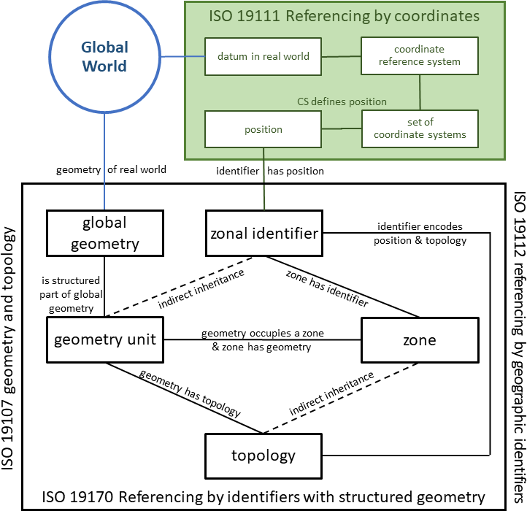
Figure 1 — Referencing by identifiers with structured geometry
DGGS introduces a third category, referencing by identifiers with structured geometry. DGGS geometry is highly structured and drives the formal tessellation of region of space-time addressed by the DGGS. This is illustrated in Figure 1. Coordinate reference systems (Clause 4.7) are tied to the real world via a datum Clause 4.10 that specifies the association of the real world to the CRS in terms of its dimensions and orientation. DGGS describe the dimensions and orientation of their Global World in terms of a single parent global geometry. Each reference system defines units of geometry that are tessellated fractions of their parent global geometry. The region occupied by each unit of geometry is called a zone (Clause 4.52). Each zone is given a unique name, called a zonal identifier (Clause 4.51). Each zonal identifier is associated with a representative spatio-temporal position in a base coordinate reference system defined by a datum for the DGGS’s Global World. Best practice is for a zonal identifier to be an encoding of both its position and its topology. Referencing by identifiers with structured geometry gives rise to Reference systems using zonal identifiers with structured geometry. Geographic information is inherently four-dimensional and includes time. So, a unified spatio-temporal data model for coordinate systems, geometry, topology, identifiers and reference systems using identifiers is a pre-requisite for spatio-temporal DGGS.
In this document, the approach taken to specify a spatio-temporal data model is to start with the data model for spatio-temporal coordinate system and associated coordinate reference systems specified in ISO 19111 (ISO 19111:2019), and use that data model to extended both spatial geometry and topology (ISO 19107:2019), and spatial identifiers and reference systems using identifiers (ISO 19112:2019), to specify a consistent set of Common Spatio-temporal Classes for geometry, topology, identifiers, and reference systems using identifiers. In this spatio-temporal data model, the spatio-temporal scope is constrained to spatial classes that are invariant through all time, and to temporal classes that are invariant throughout space. While this approach excludes certain spatio-temporal situations — such as the geometry of a constant mass of gaseous fluids under changing pressure and temperature, it is flexible enough for a very large body of social and environmental modelling. So for instance, though oceanic, climate and weather modelling need different characteristics, determined by both scientific and performance reasons, and operate outside a DGGS, the results coming from these environmental models could still be stored in DGGS for efficient use with other data.
This part of ISO 19170 specifies a consistent set of Common Classes for Spatio-temporal (CC-ST) data modelling, a Discrete Global Grid Systems (DGGS) Core data model built on the Common Spatio-temporal Classes, and a DGGS Equal Area Earth Reference System (EAERS) data model. The Common classes, DGGS Core, and Equal Area Earth Reference System (EAERS) each have their own conformance classes with their associated specifications and requirements.
The Core comprises Reference System (RS), and Functions for Quantization, Topological Query and Interoperability.
The Core Reference system is a reference system using zonal identifiers with structured geometry located in its real world by coordinates in a base coordinate reference system. The Core Reference system is designed to support: temporal, surface, volumetric and spatio-temporal DGGS; DGGS with different grid constraints; DGGS with different refinement strategies, and DGGS on either the Earth or other celestial bodies.
The DGGS Equal Area Earth RS is a specialisation of the Core RS. It describes a Reference System, comprising a base unit polyhedron, a discrete hierarchical sequence of global grids of equal-area cells each with a unique identifier located on a geodetic coordinate reference system Clause 4.20, that is typically a geographic coordinate reference system Clause 4.21. This standard does not prescribe any specific Earth surface model, base polyhedron or class of polyhedra, but is intended to allow for a range of options that produce DGGS with compatible and interoperable functional characteristics.
This standard anticipates:
- Part 2 –- 3D Equal Volume Earth Reference System.
- Part 3 –- Spatio-temporal Earth Reference System.
- Part 4 –- Axis Aligned Reference System with all zone edges parallel to the base CRS’s axes.
- Specification for a DGGS-API to formalise client-server, and server-server operations, both between DGGS systems and between DGGS and non-DGGS systems.
- Creation of a register system for DGGS definitions analogous to the register for Coordinate Reference Systems (CRS).
- Additions to other specifications, such as standards for OGC Web-Service (OWS) 05-042r2 architectures, spatial features and data formats to support DGGS data structures.

Abstract Specification Topic 21 - Discrete Global Grid Systems - Part 1 Core Reference system and Operations and Equal Area Earth Reference System

1. Scope
This part of ISO 19170 supports the definition of:
- a Discrete Global Grid System Core comprising
  - a reference system using zonal identifiers with structured geometry, and
  - functions providing import, export and topological query,
- Common Classes for spatio-temporal geometry, topology, zones, and zonal identifiers based on ISO 19111 coordinate systems. The spatio-temporal scope is constrained to
  - spatial elements that are invariant through all time, and
  - temporal elements that are invariant across all space.
- Equal Area Earth Reference System for DGGS.

2. Conformance
This standard defines a single requirements class, core, of http://www.opengis.net/spec/dggs/1.0/req/core with a single pertaining conformance class, core, with URI http://www.opengis.net/spec/dggs/1.0/conf/core.
Conformance with this standard shall be checked using all the relevant tests specified in Annex A (normative) of this document. The framework, concepts, and methodology for testing, and the criteria to be achieved to claim conformance are specified in the OGC Compliance Testing Policies and Procedures and the OGC Compliance Testing web site.
All requirements-classes and conformance-classes described in this document are owned by the standard(s) identified.

3. Normative references
The following documents are referred to in the text in such a way that some or all of their content constitutes requirements of this document. For dated references, only the edition cited applies. For undated references, the latest edition of the referenced document (including any amendments) applies.
ISO: ISO 8601-1:2019, Date and time – Representations for information interchange – Part 1: Basic rules. International Organization for Standardization, Geneva (2019).
ISO: ISO 19107:2019, Geographic information – Spatial schema. International Organization for Standardization, Geneva (2019).
ISO: ISO 19111:2019, Geographic information – Referencing by coordinates. International Organization for Standardization, Geneva (2019).
ISO: ISO 19112:2019, Geographic information – Spatial referencing by geographic identifiers. International Organization for Standardization, Geneva (2019).
ISO: ISO 19115-1:2014, Geographic information – Metadata – Part 1: Fundamentals. International Organization for Standardization, Geneva (2014).
ISO: ISO 19123:2005, Geographic information – Schema for coverage geometry and functions. International Organization for Standardization, Geneva (2005).
ISO: ISO 19156:2011, Geographic information – Observations and measurements. International Organization for Standardization, Geneva (2011).

4. Terms and definitions
For the purposes of this document, the following terms and definitions apply.
This document uses the terms defined in Sub-clause 5.3 of 06-121r9, which is based on the ISO/IEC Directives, Part 2, Rules for the structure and drafting of International Standards. In particular, the word “shall” (not “must”) is the verb form used to indicate a requirement to be strictly followed to conform to this standard.
4.1. boundary
set that represents the limit of an entity
Note 1 to entry: Boundary is most commonly used in the context of geometry, where the set is a collection of points or a collection of objects that represent those points. In other domains, the term is used metaphorically to describe the transition between an entity and the rest of its domain of discourse.
[SOURCE: ISO 19107:2019, Clause 4.6]
4.2. cell
<DGGS> spatial, spatio-temporal or temporal unit of geometry with dimension greater than 0, associated with a unique zonal identifier (Clause 4.51)
Note 1 to entry: All cells within a DGGS share the dimensionality of the DGGS, and DGGS with dimensionality of 0, are not supported.
Note 2 to entry: Cells are the primary container for storing and retrieving data within a DGGS implementation.
Note 3 to entry: DGGS may instantiate cells by reference to their zonal identifier (Clause 4.51), for instance in databases or through tile nomenclature, and by their geometry, for instance through membership of a grid.
Note 4 to entry: The zonal identifier (Clause 4.51) of a cell provides the coordinates of a representative position for the cell, and all feature geometry is represented by sets of cells.
4.3. cell refinement
<DGGS> process of subdividing parent cells (Clause 4.33) into descendant child cells (Clause 4.4) using a specified refinement ratio (Clause 4.38) and suite of refinement strategies
Note 1 to entry: Iterative application of cell refinements creates a hierarchy of descendant discrete global grids (Clause 4.12).
Note 2 to entry: Cell refinement methods may result in child cells that each have a single parent or that have multiple parents.
4.4. child cell
<DGGS> immediate descendant of a parent cell
Note 1 to entry: child cells are either within a single parent cell (Clause 4.33) or overlapped by multiple parent cells
4.5. class
description of a set of objects that share the same attributes, operations, methods, relationships, and semantics
Note 1 to entry: A class may use a set of interfaces to specify collections of operations it provides to its environment. The term was first used in this way in the general theory of object-oriented programming, and later adopted for use in this same sense in UML.
[SOURCE: ISO 19103:2015, Clause 4.27, modified — Note 1 to entry has been added from ISO 19117:2012, 4.2]
4.6. compound coordinate reference system
coordinate reference system (Clause 4.7) using at least two independent coordinate reference systems (Clause 4.7)
Note 1 to entry: Coordinate reference systems (Clause 4.7) are independent of each other if coordinate values in one cannot be converted or transformed into coordinate values in the other.
[SOURCE: ISO 19111:2019, Clause 3.1.3]
4.7. coordinate reference system
coordinate system that is related to an object by a datum (Clause 4.10)
Note 1 to entry: Geodetic and vertical datums are referred to as reference frames.
Note 2 to entry: For geodetic and vertical datums (Clause 4.10), the object will be the Earth. In planetary applications, geodetic and vertical reference frames may be applied to other celestial bodies.
[SOURCE: ISO 19111:2019, Clause 3.1.9]
4.8. coordinate system
set of mathematical rules for specifying how coordinates are to be assigned to points
[SOURCE: ISO 19111:2019, Clause 3.1.11]
4.9. data type
specification of a value (Clause 4.49) domain with operations allowed on values in this domain
Note 1 to entry: Data types include primitive predefined types and user-definable types. All instances of a data type lack identity.
Example
Integer, Real, Boolean, String, Date (conversion of a date into a series of codes).
[SOURCE: ISO 19103:2015, Clause 4.14, modified — Note 1 to entry has been added from ISO 19156, 4.3]
4.10. datum
reference frame
parameter or set of parameters that realize the positions of the origin, the scale, and the orientation of a coordinate system (Clause 4.8)
[SOURCE: ISO 19111:2019, Clause 3.1.15]
4.11. datum ensemble
group of multiple realizations of the same terrestrial or vertical reference system that, for approximate spatial referencing purposes, are not significantly different
Note 1 to entry: Datasets referenced to the different realizations within a datum ensemble may be merged without coordinate transformation.
Note 2 to entry: ‘Approximate’ is for users to define but typically is in the order of under 1 decimetre but may be up to 2 metres.
Example
“WGS 84” as an undifferentiated group of realizations including WGS 84 (TRANSIT), WGS 84 (G730), WGS 84 (G873), WGS 84 (G1150), WGS 84 (G1674) and WGS 84 (G1762). At the surface of the Earth these have changed on average by 0.7 m between the TRANSIT and G730 realizations, a further 0.2 m between G730 and G873, 0.06 m between G873 and G1150, 0.2 m between G1150 and G1674 and 0.02 m between G1674 and G1762).
[SOURCE: ISO 19111:2019, Clause 3.1.16]
4.12. discrete global grid
<DGGS> set of cells (Clause 4.2) at the same refinement level (Clause 4.37), that uniquely and completely cover a globe
Note 1 to entry: the set of cell zonal identifiers (Clause 4.51) comprising a discrete global grid form a single Zone Class with its associated refinement level (Clause 4.37).
Note 2 to entry: the configuration of the set of cells comprising a discrete global grid satisfy at least one grid constraint in the DGG_GridConstraint codelist
4.13. discrete global grid system
DGGS
integrated system comprising a hierarchy (Clause 4.26) of discrete global grids (Clause 4.12), spatio-temporal referencing (Clause 4.42) by zonal identifiers (Clause 4.51) and functions for quantization (Clause 4.36), zonal query (Clause 4.50), and interoperability (Clause 4.28)
4.14. duration
non-negative quantity of time equal to the difference between the final and initial instants (Clause 4.29) of a time interval (Clause 4.30)
Note 1 to entry: The duration is one of the base quantities in the International System of Quantities (ISQ) on which the International System of Units (SI) is based. The term “time” instead of “duration” is often used in this context and also for an infinitesimal duration.
Note 2 to entry: For the term “duration”, expressions such as “time” or “time interval” are often used, but the term “time” is not recommended in this sense and the term “time interval” is deprecated in this sense to avoid confusion with the concept of “time interval”.
Note 3 to entry: The exact duration of a time scale unit depends on the time scale used. For example, the durations of a year, month, week, day, hour or minute, may depend on when they occur [in a Gregorian calendar, a calendar month can have a duration of 28, 29, 30, or 31 days; in a 24-hour clock, a clock minute can have a duration of 59, 60, or 61 seconds, etc.]. Therefore, the exact duration can only be evaluated if the exact duration of each is known.
Note 4 to entry: This definition is closely related to NOTE 1 of the terminological entry “duration” in IEC 60050-113:2011, 113-01-13.
[SOURCE: ISO 8601-1:2019, Clause 3.1.1.8]
4.15. dynamic coordinate reference system
coordinate reference system (Clause 4.7) that has a dynamic reference frame (Clause 4.16)
Note 1 to entry: Coordinates of points on or near the crust of the Earth that are referenced to a dynamic coordinate reference system may change with time, usually due to crustal deformations such as tectonic motion and glacial isostatic adjustment.
Note 2 to entry: Metadata for a dataset referenced to a dynamic coordinate reference system should include coordinate epoch information.
[SOURCE: ISO 19111:2019, Clause 3.1.19]
4.16. dynamic reference frame
dynamic datum
reference frame (Clause 4.10) in which the defining parameters include time evolution
Note 1 to entry: The defining parameters that have time evolution are usually a coordinate set.
[SOURCE: ISO 19111:2019, Clause 3.1.20]
4.17. error budget
<metric> statement of or methodology for describing the nature and magnitude of the errors which affect the results of a calculation
[SOURCE: ISO 19107:2019, Clause 4.35, modified — Note 1 to entry has been removed]
4.18. feature
abstraction of real-world phenomena
Note 1 to entry: A feature may occur as a type or an instance. In this document, feature instance is meant unless otherwise specified.
[SOURCE: ISO 19101-1:2014, Clause 4.1.11, modified — Note 1 to entry has been added from ISO 19156, 4.6]
4.19. feature type
class (Clause 4.5) of features (Clause 4.18) having common characteristics
[SOURCE: ISO 19156:2011, Clause 4.7]
4.20. geodetic coordinate reference system
three-dimensional coordinate reference system (Clause 4.7) based on a geodetic reference frame and having either a three-dimensional Cartesian or a spherical coordinate system
Note 1 to entry: In this document a coordinate reference system (Clause 4.7) based on a geodetic reference frame and having an ellipsoidal coordinate system is geographic.
[SOURCE: ISO 19111:2019, Clause 3.1.13]
4.21. geographic coordinate reference system
coordinate reference system (Clause 4.7) that has a geodetic reference frame and an ellipsoidal coordinate system
[SOURCE: ISO 19111:2019, Clause 3.1.35]
4.22. geographic identifier
spatial reference (Clause 4.41) in the form of a label or code that identifies a location (Clause 4.31)
Example
“Spain” is an example of a label (country name); “SW1P 3AD” is an example of a code (postcode).
[SOURCE: ISO 19112:2019, Clause 3.1.2]
4.23. geometric primitive
geometric object representing a single, connected, homogeneous (isotropic) element of space
Note 1 to entry: Geometric primitives are non-decomposed objects that present information about geometric configuration. They include points, curves, surfaces, and solids. Many geometric objects behave like primitives (supporting the same interfaces defined for geometric primitives) but are actually composites composed of some number of other primitives. General collections may be aggregates and incapable of acting like a primitive (such as the lines of a complex network, which is not connected and thus incapable of being traceable as a single line). By this definition, a geometric primitive is topological open, since the boundary points are not isotropic to the interior points. Geometry is assumed to be closed. For points, the boundary is empty.
[SOURCE: ISO 19107:2019, Clause 4.50]
4.24. globe
<DGGS> celestial body
Note 1 to entry: In this document globe is used in its most general form to refer to any celestial body that may be referenced by a DGGS. When a specific body, such as the Earth is referred to, an explicit term is used.
4.25. grid
network composed of two or more sets of curves in which the members of each set intersect the members of the other sets in an algorithmic way
Note 1 to entry: The curves partition a space into grid cells.
[SOURCE: ISO 19123:2005, Clause 4.1.23]
4.26. hierarchy
<DGGS> organization and ranking of successive levels of cell refinement (Clause 4.3) of discrete global grids (Clause 4.12)
4.27. initial discrete global grid
<DGGS> discrete global grid tessellation created by circumscribing a defined path along the chosen surface model of the Earth between the vertices of the scaled base unit polyhedron
4.28. interoperability
capability to communicate, execute programs, or transfer data among various functional units in a manner that requires the user to have little or no knowledge of the unique characteristics of those units
Note 1 to entry: in this standard interoperability specifically refers to functions that initiate and process transfers of data from a DGGS system.
4.29. instant
<DGGS> temporal geometry primitive representing a point in time
Note 1 to entry: On temporal coordinate systems as specified in (Clause 4.46), the temporal geometric primitives (Clause 4.23) instant and interval (Clause 4.30) are the equivalent of points and lines as specified in (ISO 19107:2019).
4.30. interval
<DGGS> temporal geometry primitive representing a line in time
Note 1 to entry: On temporal coordinate systems as specified in (Clause 4.46), the temporal geometric primitives (Clause 4.23) instant (Clause 4.29) and interval are the equivalent of points and lines as specified in (ISO 19107:2019).
4.31. location
particular place or position
Note 1 to entry: A location identifies a geographic place.
Note 2 to entry: In the context of DGGS, locations have dimension greater than one, and so are not points.
Example
“Madrid”, “SW1P 3AD”.
[SOURCE: ISO 19112:2019, Clause 3.1.3, modified — Note two has been added and an additional example provided]
4.32. observation
act of measuring or otherwise determining the value (Clause 4.49) of a property
[SOURCE: ISO 19156:2011, Clause 4.11]
4.33. parent cell
<DGGS> cell in a higher refinement level of discrete global grid with immediate descendants
Note 1 to entry: parent cells either overlap or contain their child cells (Clause 4.4).
4.34. period
<DGGS> particular era or span of time
Note 1 to entry: Periods are intervals (Clause 4.30) named with a period identifier (Clause 4.35)
4.35. period identifier
<DGGS> temporal reference in the form of a label or code that identifies a period (Clause 4.34)
Note 1 to entry: Period identifiers are the temporal equivalent of geographic identifiers (Clause 4.22) as specified in (ISO 19112:2019)
4.36. quantization
<DGGS> function assigning data from external sources to cell values
4.37. refinement level
<DGGS> numerical order of a discrete global grid (Clause 4.12) in the tessellation sequence
Note 1 to entry: The tessellation with the smallest number of cells has a refinement level = 0.
4.38. refinement ratio
<DGGS> ratio of the number of child cells to parent cells
Note 1 to entry: A positive integer ratio n refinement of DGGS parent cells yield n times as many child cells as parent cells.
Note 2 to entry: For a two-dimensional DGGS (as defined in this document) this is the surface area ratio.
Note 3 to entry: In DGGS literature [10] the term aperture has been used instead of refinement ratio. Refinement ratio is preferred because it is clearer in meaning to audiences outside the early DGGS community.
4.39. sibling cell
<DGGS> cell in a discrete global grid with the same parent cell (Clause 4.33)
Note 1 to entry: all the child cells (Clause 4.4) of a parent cell (Clause 4.33) are each others’ sibling cells (Clause 4.39).
4.40. simple
<topology, geometry> homogeneous (all points have isomorphic neighborhoods) and with a simple boundary
Note 1 to entry: The interior is everywhere locally isomorphic to an open disc in a Euclidean coordinate space of the appropriate dimension D^{n} = {P|‖P‖ < 1.0}. The boundary is a dimension one smaller. This essentially means that the object does not intersect nor touch itself. Generally used for a curve that does not cross not touch itself with the possible exception of boundary points. Simple closed curves are isomorphic to a circle.
[SOURCE: ISO 19107:2019, Clause 3.84]
4.41. spatial reference
system for identifying position in the real world
Note 1 to entry: This may take the form of a label, code or coordinate tuple.
[SOURCE: ISO 19111:2019, Clause 3.1.56]
4.42. spatio-temporal reference
system for identifying position in the real world that may include time
Note 1 to entry: This may take the form of a label, code or coordinate tuple.
4.43. spatio-temporal coordinate reference system
compound coordinate reference system (Clause 4.7) in which one constituent coordinate reference system (Clause 4.7) is a spatial coordinate reference system (Clause 4.7) and one is a temporal coordinate reference system (Clause 4.47)
[SOURCE: ISO 19111:2019, Clause 3.1.59]
4.44. static coordinate reference system
coordinate reference system (Clause 4.7) that has a static reference frame (Clause 4.45)
Note 1 to entry: Coordinates of points on or near the crust of the Earth that are referenced to a dynamic coordinate reference system do not change with time.
Note 2 to entry: Metadata for a dataset referenced to a static coordinate reference system does not require coordinate epoch information.
[SOURCE: ISO 19111:2019, Clause 3.1.61]
4.45. static reference frame
static datum
reference frame (Clause 4.10) in which the defining parameters exclude time evolution
[SOURCE: ISO 19111:2019, Clause 3.1.62]
4.46. temporal coordinate system
<geodesy> one-dimensional coordinate system where the axis is time
[SOURCE: ISO 19111:2019, Clause 3.1.64]
4.47. temporal coordinate reference system
coordinate reference system (Clause 4.7) based on a temporal datum
[SOURCE: ISO 19111:2019, Clause 3.1.63]
4.48. tessellation
partitioning of a space into a set of conterminous subspaces having the same dimension as the space being partitioned
Note 1 to entry: A tessellation composed of congruent regular polygons or polyhedra is a regular tessellation. One composed of regular, but non-congruent polygons or polyhedra is a semi-regular tessellation. Otherwise the tessellation is irregular. Tessellations on curved surfaces cannot be congruent, so all tessellations in DGGS are either semi-regular or irregular.
Example
Graphic examples of tessellations may be found in Figures 11, 13, 20, and 22 of ISO 19123:2005.
[SOURCE: ISO 19123:2005, Clause 4.1.39, modified — Note 1 to entry has been modified and new notes to entry have been added.]
4.49. value
element of a type domain
Note 1 to entry: A value considers a possible state of an object within a class (Clause 4.5) or type (domain).
Note 2 to entry: A data value is an instance of a datatype, a value without identity.
Note 3 to entry: A value can use one of a variety of scales including nominal, ordinal, ratio and interval, spatial and temporal. Primitive datatypes can be combined to form aggregate datatypes with aggregate values, including vectors, tensors and images.
[SOURCE: ISO/IEC 19501:2005, Clause 5, modified — The notes to entry from ISO 19156, 4.18 have been included]
4.50. zonal query
<DGGS> geometry or topology function using a cell’s zonal identifiers (Clause 4.51) to specify geometry
Note 1 to entry: ISO 19107:2019 specifies a suite of geometry and topology functions in the Query2D and Query3D classes, where geometry elements used in each function’s parameters are described by sets of coordinates. In DGGS all geometry can be referenced as sets of cells (Clause 4.2) represented solely by a list (or set) of their zonal identifiers (Clause 4.51). This standard specifies zoneQuery to implement the operations in both Query2D and Query3D using zonal identifiers (Clause 4.51) to reference each operation’s source and target geometry.
4.51. zonal identifier
<DDGS> spatio-temporal reference (Clause 4.42) in the form of a label or code that identifies a zone (Clause 4.52)
Note 1 to entry: A zonal identifier may be a geographic identifier (Clause 4.22), period identifier (Clause 4.35), or a compound of the two.
4.52. zone
<DGGS> particular region of space-time
Note 1 to entry: The primitives of zone are location (Clause 4.31) and period (Clause 4.34).
Note 2 to entry: A zone may be either a single zonal primitive or a compound zone comprising one location (Clause 4.31) and one period (Clause 4.34).
Note 3 to entry: Zones may be spatial, temporal, or spatio-temporal, and may be regions of space-time associated with any celestial body.

5. Conventions

5.1. Universal Resource Identifiers
The normative provisions in this specification are denoted by the URI
http://www.opengis.net/spec/dggs/2.0
All requirements and conformance tests that appear in this document denoted by partial URIs are relative to this base.

5.2. Unified Modelling Language notation
In this document, the conceptual schema for describing discrete global grid systems are presented in the Unified Modeling Language (UML). ISO 19103 Conceptual schema language presents the specific profile of UML used in this document.
In the UML diagrams in this document, color indicates classes from other standards. The use of color for each standard is consistent across all diagrams. Each diagram has a key to the standards referred to in that diagram and their colors.

5.3. Attribute and Association role status
In this document conceptual schema in Clauses 6…8 are defined by tables. In these tables:
- attributes and association roles are given an Obligation status
M: mandatory — this attribute or association role SHALL be supplied.
C: conditional — this attribute or association role SHALL be supplied if the condition (given in the description) is true. It MAY be supplied if the condition is false.
O: optional — this attribute or association role MAY be supplied.
- the Maximum Occurrence column in the tables indicates the maximum number of occurrences of attribute values that are permissible, with * indicating no upper limit.
- non-navigable associations are not included in the UML diagrams or tables.
The tables provide a summary of the UML diagrams, in particular association roles, attributes, operations, and constraints that are inherited from another class unchanged are not described in the tables. In the event of any discrepancies between the UML diagrams and text, the UML shall prevail.

5.4. Abbreviated terms
CRS | coordinate reference system
DE-9IM | Dimensionally Extended nine-Intersection Model
DGGS | Discrete Global Grid System
EAERS | Equal Area Earth Reference System
HPC | High Performance Computing
HPD | High Performance DATA
ICT | Information and Communications Technology
ISEA | Icosahedral Equal Area
ISEA3H | Icosahedral Equal Area refinement ratio 3 Hexagons
ISO | International Organization for Standardization
OGC | Open Geospatial Consortium
OWS | OGC Web Service
rHEALPix | rearranged Hierarchical Equal Area isoLatitude Pixelization

6. DGGS Specifications Overview

6.1. Package overview
The specification for discrete global grid systems is described in this document in the form of a UML model with supplementary defining tables and text. The UML model for the Common Spatio-temporal Classes contains three UML packages, the DGGS Core contains four UML packages, and the Equal Area Earth DGGS contains one further UML package, as shown in Figure 2.
- Common Spatio-temporal Classes Package contains
  - Zone and Temporal Geometry,
  - Zone and Temporal Reference systems using identifiers, and
- DGGS Core Package contains
  - Core Reference system using zonal identifiers with structured geometry
  - Core Functions,
- DGGS Equal Area Earth Reference system Package contains
  - DGGS equal area earth reference system.
Each box represents a package and contains the package name. Each arrowed line shows the dependency of one package upon another package (at the head of the arrow). The Common Spatio-temporal Classes, DGGS Core and DGGS Equal Area Earth Reference system are in turn dependent on packages in five other ISO standards, and these are also shown in Figure 2.
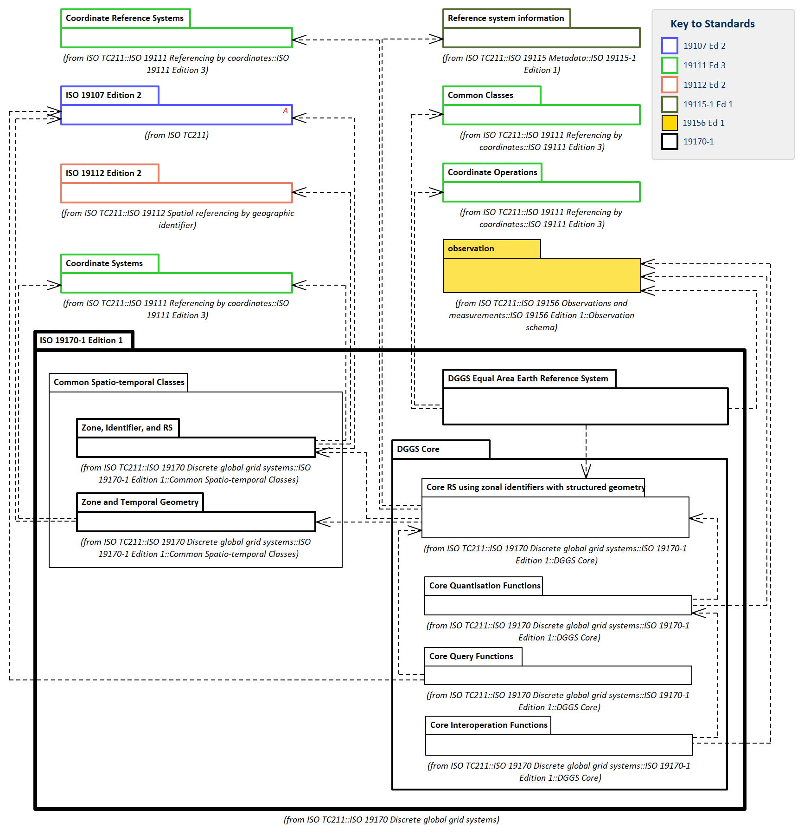
Figure 2 — DGGS Package Diagram
Conformance classes for the modules in Common Spatio-temporal Classes, the DGGS Core, and the DGGS Equal Area Earth Reference system are described in Annex A.
One product conformance class is also defined for Equal Area Earth DGGS, that brings the module together as a system.

7. Common Spatio-temporal Classes Package

7.1. Common Spatio-temporal Classes Overview
This Clause specifies the common classes to support temporal and spatio-temporal geometry, topology, zones, zonal identifiers, zonal query, and reference systems using temporal or zonal identifiers.
These classes are defined here in a way that they may be used in any context needing an internally consistent set of temporal and spatio-temporal classes for use with spatial classes from ISO 19107, 19111 and 19112. They are further specialised in the DGGS Core for use in DGGS. In this restricted model for spatio-temporal systems, the spatio-temporal scope is constrained to spatial classes that are invariant through all time, and to temporal classes that are invariant throughout space.
The Common Spatio-temporal Classes are organised in two packages with five modules:
- Zone and Temporal Geometry comprises
  - temporal geometry and topology module
  - zonal geometry and topology module
- Zone and Temporal reference systems using identifiers comprises
  - spatial location module
  - temporal reference systems using period identifiers module
  - reference system using zonal identifiers module
In each package separate spatial and temporal classes are defined first, followed by spatio-temporal classes that bring temporal with spatial classes tegether.

7.2. Zone and Temporal Geometry

7.2.1. Temporal geometry and topology module

7.2.1.1. Context and data model
Temporal geometry is geometry constrained to one of the temporal coordinate systems (Clause 4.46), defined by TemporalCS in ISO 19111 (ISO 19111:2019). Temporal geometry primitives instant and interval implement the temporal analogues of point and line respectively in ISO 19107 (ISO 19107:2019). All geometry has topology, and the temporal topology primitives nodeT and edgeT implement the temporal analogues of node and edge respectively. These are shown in Figure 3.
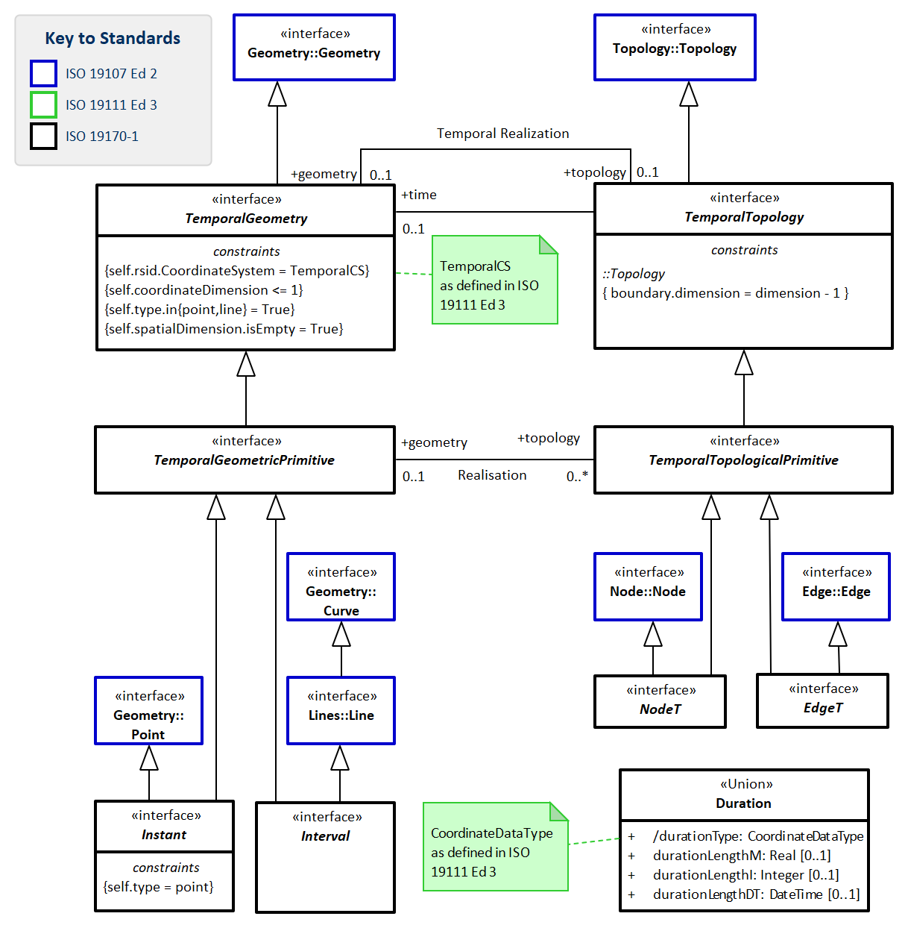
Figure 3 — Context for Temporal Geometric Primitives
Temporal interfaces paralleling the spatial geometry and topology interface structure are built from these temporal primitives. Each temporal interface has the same meaning and semantics as their equivalent spatial interface, with the constraint that all temporal interfaces are constrained to the same coordinate system as their temporal primitives. Figure 4 shows the spatial classes on the left and their temporal equivalents on the right.
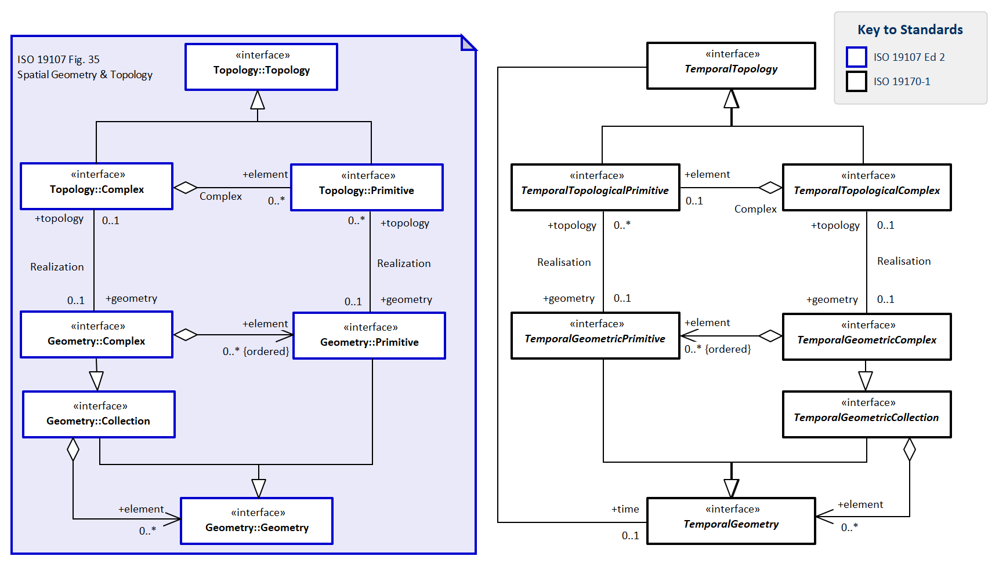
Figure 4 — Context for Temporal Geometric and Topology to ISO 19107

7.2.1.2. Defining tables
- Table 2 Elements of Temporal Geometry::Duration
- Table 3 Elements of Temporal Geometry::EdgeT
- Table 4 Elements of Temporal Geometry::Instant
- Table 5 Elements of Temporal Geometry::Interval
- Table 6 Elements of Temporal Geometry::NodeT
- Table 7 Elements of Temporal Geometry::TemporalGeometricCollection
- Table 8 Elements of Temporal Geometry::TemporalGeometricComplex
- Table 9 Elements of Temporal Geometry::TemporalGeometricPrimitive
- Table 10 Elements of Temporal Geometry::TemporalGeometry
- Table 11 Elements of Temporal Geometry::TemporalTopologicalComplex
- Table 12 Elements of Temporal Geometry::TemporalTopologicalPrimitive
- Table 13 Elements of Temporal Geometry::TemporalTopology
Table 2 — Elements of Temporal Geometry::Duration class
Name: | Duration
Definition: | Duration implements Length on a Temporal Coordinate System
Stereotype: | Union
Associations: | (none)
Public attributes: | Name | Definition | Derived | Obligation | Maximum occurence | Data type
 | durationLengthDT | length of time for Duration of type DateTime |  | C | 1 | DateTime
 | durationLengthI | length of time for Duration of type Integer count |  | C | 1 | Integer
 | durationLengthM | length of time for Duration of type Real measure |  | C | 1 | Real
 | durationType | Type of unit of measure for time | true | M | 1 | CoordinateDataType
Constraints: | (none)

Table 3 — Elements of Temporal Geometry::EdgeT class
Name: | EdgeT
Definition: | topological temporal edge  1-dimensional topological primitive
Stereotype: | Interface
Inheritance from: | TemporalTopologicalPrimitive
Abstract: | true
Associations: | (none)
Public attributes: | (none)
Constraints: | (none)

Table 4 — Elements of Temporal Geometry::Instant class
Name: | Instant
Definition: | Instance implements Point geometry on a Temporal Coordinate System
Stereotype: | Interface
Inheritance from: | TemporalGeometricPrimitive
Abstract: | true
Associations: | (none)
Public attributes: | (none)
Constraints: | self.type = point

Table 5 — Elements of Temporal Geometry::Interval class
Name: | Interval
Definition: | Interval implements Line geometry on a Temporal Coordinate System
Stereotype: | Interface
Inheritance from: | TemporalGeometricPrimitive
Abstract: | true
Associations: | (none)
Public attributes: | (none)
Constraints: | (none)

Table 6 — Elements of Temporal Geometry::NodeT class
Name: | NodeT
Definition: | topological temporal node  0-dimensional topological primitive, its boundary being empty.
Stereotype: | Interface
Inheritance from: | TemporalTopologicalPrimitive
Abstract: | true
Associations: | (none)
Public attributes: | (none)
Constraints: | (none)

Table 7 — Elements of Temporal Geometry::TemporalGeometricCollection class
Name: | TemporalGeometricCollection
Definition: | Temporal Geometric Collection implements geometric Collection for Temporal Geometry
Stereotype: | Interface
Inheritance from: | TemporalGeometry
Generalisation of: | TemporalGeometricComplex
Abstract: | true
Associations: | Association with: | Obligation | Maximum occurence | Provides:
 | TemporalGeometry (feature type) | C | * | element
Public attributes: | (none)
Constraints: | (none)

Table 8 — Elements of Temporal Geometry::TemporalGeometricComplex class
Name: | TemporalGeometricComplex
Definition: | Temporal Geometric Complex implements geometric Complex for Temporal Geometry
Stereotype: | Interface
Inheritance from: | TemporalGeometricCollection
Abstract: | true
Associations: | Association with: | Obligation | Maximum occurence | Provides:
 | TemporalGeometricPrimitive (feature type) | C | * | element
 | TemporalTopologicalComplex (feature type) | C | 1 | topology
Public attributes: | (none)
Constraints: | (none)

Table 9 — Elements of Temporal Geometry::TemporalGeometricPrimitive class
Name: | TemporalGeometricPrimitive
Definition: | Temporal Geometric Primitive implements geometric Primitive for Temporal Geometry
Stereotype: | Interface
Inheritance from: | TemporalGeometry
Generalisation of: | Instant, Interval
Abstract: | true
Associations: | Association with: |  |  | Obligation | Maximum occurence | Provides:
 | TemporalTopologicalPrimitive (feature type) |  |  | C | * | topology
Public attributes: | Name | Definition | Derived | Obligation | Maximum occurence | Data type
 | spatialDimension | dimension of its spatial geometry component |  | M | 1 | Integer
 | temporalDimension | dimension of its temporal geometry component |  | M | 1 | Integer
Constraints: | (none)

Table 10 — Elements of Temporal Geometry::TemporalGeometry class
Name: | TemporalGeometry
Definition: | Temporal Geometry implements 1D Geometry on a Temporal Coordinate System
Stereotype: | Interface
Inheritance from: | ZoneSimpleGeometry
Generalisation of: | TemporalGeometricCollection, TemporalGeometricPrimitive
Abstract: | true
Associations: | Association with: | Obligation | Maximum occurence | Provides:
 | TemporalTopology (feature type) | C | 1 | topology
Public attributes: | (none)
Constraints: | self.coordinateDimension <= 1
 | self.rsid.CoordinateSystem = TemporalCS
 | self.spatialDimension.isEmpty = True
 | self.type.in{point,line} = True

Table 11 — Elements of Temporal Geometry::TemporalTopologicalComplex class
Name: | TemporalTopologicalComplex
Definition: | Temporal Topological Complex implements topological Complex for Temporal Topology
Stereotype: | Interface
Inheritance from: | TemporalTopology
Abstract: | true
Associations: | Association with: | Obligation | Maximum occurence | Provides:
 | TemporalTopologicalPrimitive (feature type) | C | 1 | element
 | TemporalGeometricComplex (feature type) | C | 1 | geometry
Public attributes: | (none)
Constraints: | (none)

Table 12 — Elements of Temporal Geometry::TemporalTopologicalPrimitive class
Name: | TemporalTopologicalPrimitive
Definition: | Temporal Topological Primitive implements topological Primitive for Temporal Topology
Stereotype: | Interface
Inheritance from: | TemporalTopology
Generalisation of: | EdgeT, NodeT
Abstract: | true
Associations: | Association with: | Obligation | Maximum occurence | Provides:
 | TemporalGeometricPrimitive (feature type) | C | 1 | geometry
Public attributes: | (none)
Constraints: | (none)

Table 13 — Elements of Temporal Geometry::TemporalTopology class
Name: | TemporalTopology
Definition: | Temporal Topology implements 1D Topology for Temporal Geometry
Stereotype: | Interface
Inheritance from: | ZoneSimpleTopology
Generalisation of: | TemporalTopologicalComplex, TemporalTopologicalPrimitive
Abstract: | true
Associations: | Association with: | Obligation | Maximum occurence | Provides:
 | TemporalGeometry (feature type) | C | 1 | geometry
 | TemporalGeometry (feature type) | C | 1 | time
Public attributes: | (none)
Constraints: | (none)

Requirement 1:
www.opengis.net/spec/DGGS/2.0/req/cc/temporal/geometry
The common classes for temporal geometry and topology SHALL conform to the data model in Figure 3…Figure 4 and defining tables in Table 2…Table 13. .

7.2.2. Zonal geometry and topology module

7.2.2.1. Context and data model
Referring to Figure 5, ZoneGeometry is either a primitive of ZoneSingleGeometry or a compound of two ZoneSingleGeometry primitives — one spatial one temporal.
Zones exhibit topology of the same spatio-temporal dimension as their geometry.
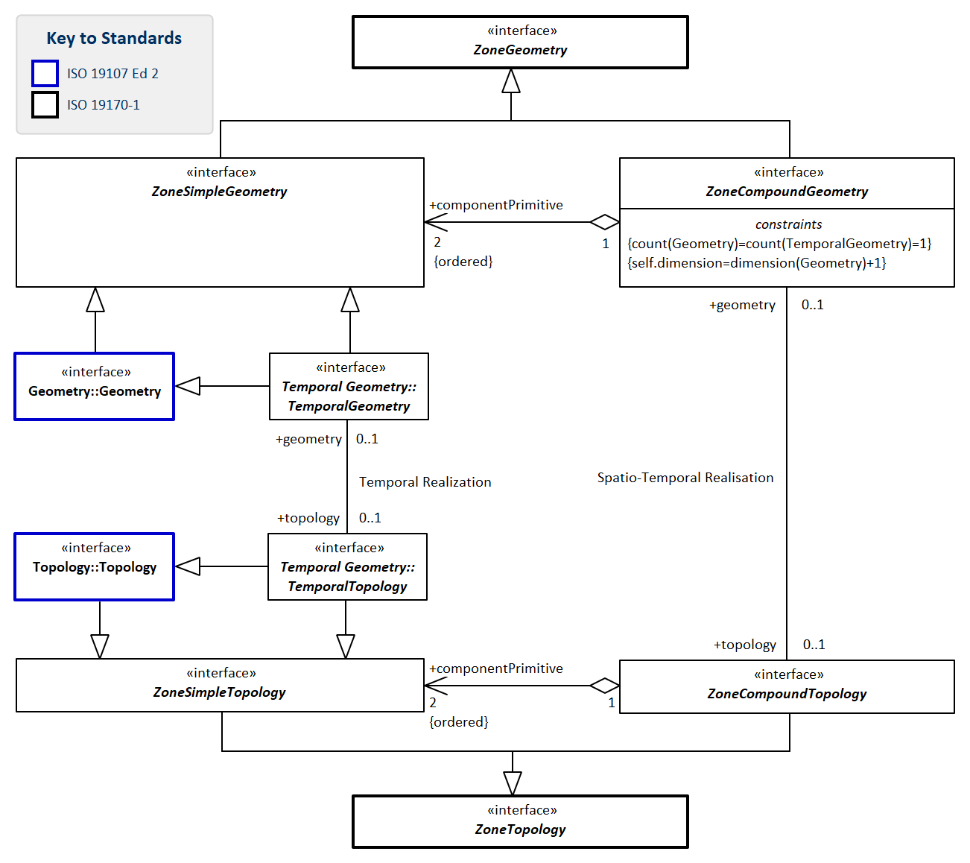
Figure 5 — Components of ZoneGeometry and ZoneTopology

7.2.2.2. Defining tables
- Table 14 Elements of Zone Geometry::ZoneCompoundGeometry
- Table 15 Elements of Zone Geometry::ZoneCompoundTopology
- Table 16 Elements of Zone Geometry::ZoneGeometry
- Table 17 Elements of Zone Geometry::ZoneSimpleGeometry
- Table 18 Elements of Zone Geometry::ZoneSimpleTopology
- Table 19 Elements of Zone Geometry::ZoneTopology
Table 14 — Elements of Zone Geometry::ZoneCompoundGeometry class
Name: | ZoneCompoundGeometry
Definition: | ZoneCompoundGeometry is a Compound of two ZoneSimpleGeometry elements, comprising one 1D, 2D or 3D spatial geometry and one 1D temporal geometry. This is analogous to an ISO 19111 Compound set of orthogonal space time axes comprising a set of orthogonal spatial axes and one temporal axis orthogonal to the spatial axes. ZoneCompoundGeometry has ZoneCompoundTopology.
Stereotype: | Interface
Inheritance from: | ZoneGeometry
Abstract: | true
Associations: | Association with: | Obligation | Maximum occurence | Provides:
 | ZoneSimpleGeometry (feature type) | M | 2 | componentPrimitive
 | ZoneCompoundTopology (feature type) | C | 1 | topology
Public attributes: | (none)
Constraints: | count(Geometry)=count(TemporalGeometry)=1
 | self.dimension=dimension(Geometry)+1

Table 15 — Elements of Zone Geometry::ZoneCompoundTopology class
Name: | ZoneCompoundTopology
Definition: | ZoneCompoundTopology exhibits both spatial topology with respect to the spatial component of its geometry and temporal topology with respect to the temporal component of its geometry
Stereotype: | Interface
Inheritance from: | ZoneTopology
Abstract: | true
Associations: | Association with: | Obligation | Maximum occurence | Provides:
 | ZoneSimpleTopology (feature type) | M | 2 | componentPrimitive
 | ZoneCompoundGeometry (feature type) | C | 1 | geometry
Public attributes: | (none)
Constraints: | (none)

Table 16 — Elements of Zone Geometry::ZoneGeometry class
Name: | ZoneGeometry
Definition: | ZoneGeometry is a ZoneSimpleGeometry or a ZoneCompoundGeometry. It is the root geometry for all spatio-temporal geometry
Stereotype: | Interface
Generalisation of: | ZoneCompoundGeometry, ZoneSimpleGeometry
Abstract: | true
Associations: | (none)
Public attributes: | Name | Definition | Derived | Obligation | Maximum occurence | Data type
 | spatialDimension | topological dimension of the spatial geometry component |  | M | 1 | Integer
 | temporalDimension | dimension of the temporal geometry component |  | M | 1 | Integer
 | topologicalDimension | sum dimension of topological primitive |  | M | 1 | Integer
Constraints: | (none)

Table 17 — Elements of Zone Geometry::ZoneSimpleGeometry class
Name: | ZoneSimpleGeometry
Definition: | ZoneSimpleGeometry is a 1D, 2D or 3D spatial geometry that is invariant over all time, OR a 1D temporal geometry invariant over all space. A ZoneSimpleGeometry has topology appropriate for its geometry.
Stereotype: | Interface
Inheritance from: | ZoneGeometry
Abstract: | true
Associations: | (none)
Public attributes: | (none)
Constraints: | (none)

Table 18 — Elements of Zone Geometry::ZoneSimpleTopology class
Name: | ZoneSimpleTopology
Definition: | ZoneSimpleTopology is a 1D, 2D or 3D spatial topology that is invariant over all time, OR a 1D temporal topology that is invariant over all space.
Stereotype: | Interface
Inheritance from: | ZoneTopology
Abstract: | true
Associations: | (none)
Public attributes: | (none)
Constraints: | (none)

Table 19 — Elements of Zone Geometry::ZoneTopology class
Name: | ZoneTopology
Definition: | ZoneTopology is a ZoneSimpleTopology or a ZoneCompoundTopology
Stereotype: | Interface
Generalisation of: | ZoneCompoundTopology, ZoneSimpleTopology
Abstract: | true
Associations: | (none)
Public attributes: | (none)
Constraints: | (none)

Requirement 2:
www.opengis.net/spec/DGGS/2.0/req/cc/zone/geometry
The common classes for zonal geometry and topology SHALL conform to the data model in Figure 5 and defining tables in Table 14…Table 19. .

7.3. Zone and Temporal reference systems using identifiers package

7.3.1. Spatial Location module

7.3.1.1. Context and data model
ISO 19112 (ISO 19112:2019) describes spatial refencing by geographic identifiers, locations and location classes. - spatial location interface as specialisation of Location and period interface as its temporal equivalent cf Figure 6,
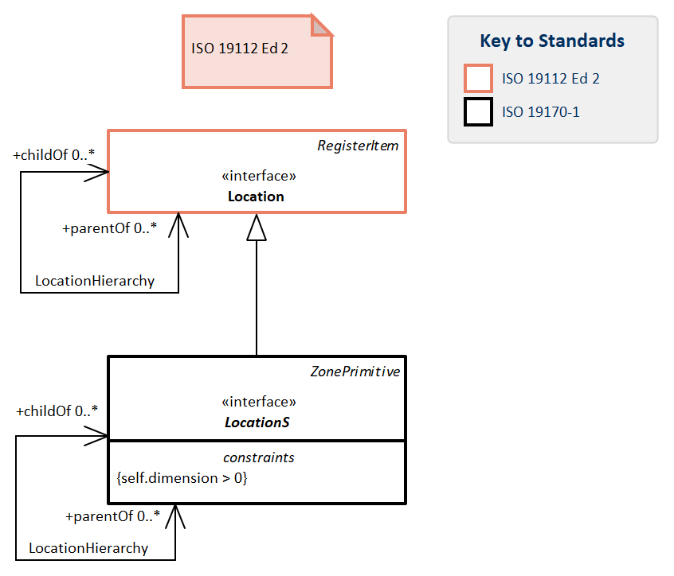
Figure 6 — Context for LocationS

7.3.1.2. Defining tables
- Table 20 Elements of LocationS::LocationS
Table 20 — Elements of LocationS::LocationS class
Name: | LocationS
Definition: | particular place or position  Note: unlike a Location as specified in (<<ISO19112>>), all LocationS are owned and defined by their ReferenceSystem and not by an independent authority.
Stereotype: | Interface
Inheritance from: | ZonePrimitive
Abstract: | true
Associations: | Association with: |  |  | Obligation | Maximum occurence | Provides:
 | LocationS (feature type) |  |  | C | * | childOf
 | LocationS (feature type) |  |  | C | * | parentOf
Public attributes: | Name | Definition | Derived | Obligation | Maximum occurence | Data type
 | coordinateTuple | point within the extent of the spatial location |  | M | 1 | DirectPosition
 | extent | spatial extent of the location | true | M | 1 | EX_Extent
 | identifier | identifier of the spatial location |  | M | 1 | GeographicIdentifier
Constraints: | self.dimension > 0

Requirement 3:
www.opengis.net/spec/DGGS/2.0/req/cc/spatial/location
The common classes for spatial location SHALL conform to the data model in Figure 6 and defining tables in Table 20.

7.3.2. Temporal reference systems using period identifiers module

7.3.2.1. Context and data model
Semantically we define a period as the temporal equivalent of a location, and zone as the spatio-temporal class that may be either a location of a period or a compound of the two.
Referring to Figure 7 showing the spatial classes on the left and the temporal classes on the right, we note these are augmented by:
- period identifier data-type as the temporal equivalent of geographic identifier,
- period interface as its temporal equivalent cf Figure 7,
- period class interface as the temporal equivalent to location class, and
- temporal reference system using period identifiers interface as the temporal equivalent of spatial reference using geographic identifiers.
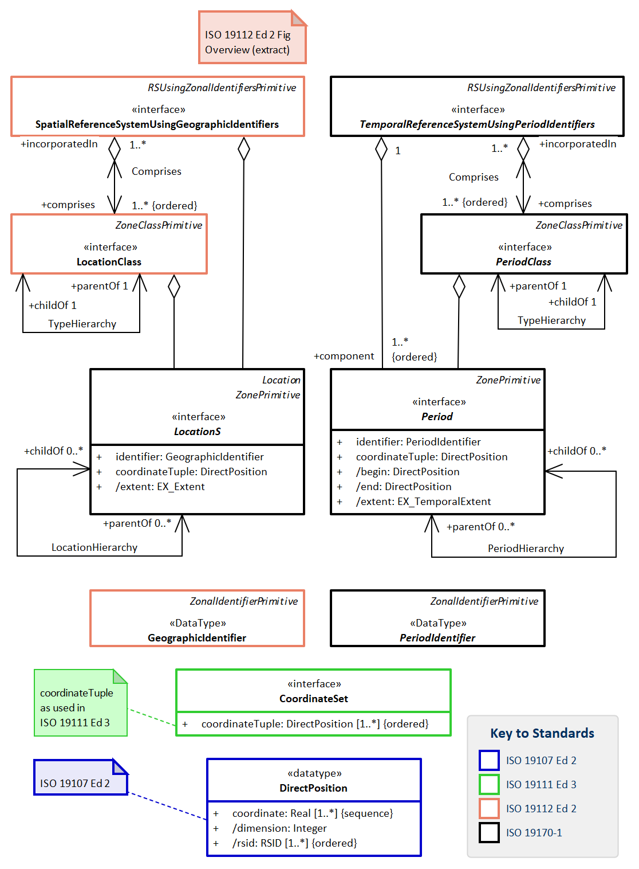
Figure 7 — Context for Temporal Periods and Reference Systems

7.3.2.2. Defining tables
- Table 21 Elements of Period::Period
- Table 22 Elements of Period::PeriodClass
- Table 23 Elements of Period::PeriodIdentifier
- Table 24 Elements of Period::TemporalReferenceSystemUsingPeriodIdentifiers
Table 21 — Elements of Period::Period class
Name: | Period
Definition: | particular time span or era between two instants
Stereotype: | Interface
Inheritance from: | ZonePrimitive
Abstract: | true
Associations: | Association with: |  |  | Obligation | Maximum occurence | Provides:
 | Period (feature type) |  |  | C | * | childOf
 | Period (feature type) |  |  | C | * | parentOf
Public attributes: | Name | Definition | Derived | Obligation | Maximum occurence | Data type
 | begin | instant at the beginning of the period | true | M | 1 | DirectPosition
 | coordinateTuple | position within the extent of the period |  | M | 1 | DirectPosition
 | end | instant at the end of the period | true | M | 1 | DirectPosition
 | extent | temporal extent of the period | true | M | 1 | EX_TemporalExtent
 | identifier | identifier of the period |  | M | 1 | PeriodIdentifier (data type)
Constraints: | (none)

Table 22 — Elements of Period::PeriodClass class
Name: | PeriodClass
Definition: | categorization of periods
Stereotype: | Interface
Inheritance from: | ZoneClassPrimitive
Abstract: | true
Associations: | Association with: | Obligation | Maximum occurence | Provides:
 | PeriodClass (feature type) | M | 1 | childOf
 | TemporalReferenceSystemUsingPeriodIdentifiers (feature type) | M | * | incorporatedIn
 | PeriodClass (feature type) | M | 1 | parentOf
Public attributes: | (none)
Constraints: | (none)

Table 23 — Elements of Period::PeriodIdentifier class
Name: | PeriodIdentifier
Definition: | Temporal reference in the form of a label or code that identifies a period
Stereotype: | DataType
Inheritance from: | ZonalIdentifierPrimitive
Abstract: | true
Associations: | (none)
Public attributes: | (none)
Constraints: | (none)

Table 24 — Elements of Period::TemporalReferenceSystemUsingPeriodIdentifiers class
Name: | TemporalReferenceSystemUsingPeriodIdentifiers
Definition: | A temporal reference system based on period identifers.
Stereotype: | Interface
Inheritance from: | RSUsingZonalIdentifiersPrimitive
Abstract: | true
Associations: | Association with: | Obligation | Maximum occurence | Provides:
 | Period (feature type) | M | * | component
 | PeriodClass (feature type) | M | * | comprises
Public attributes: | (none)
Constraints: | (none)

Requirement 4:
www.opengis.net/spec/DGGS/2.0/req/cc/temporal/rsupi
_The common classes for reference systems using period identifiers SHALL conform to the data model in Figure 7 and defining tables in Table 21…Table 24.

7.3.3. Reference system using zonal identifiers module

7.3.3.1. Context and data model
Semantically zones are the spatio-temporal equivalent of the period and spatial location classes, and along with them the following classes are established.
- zonal identifier,
- zone,
- zone class, and
- reference system using zonal identifiers.
Referring to Figure 8, a Zonal Identifier is either a Zonal Identifier primitive or a compound of two Zonal Identifier primitives — one Geographic Identifier and one Period Identifier.
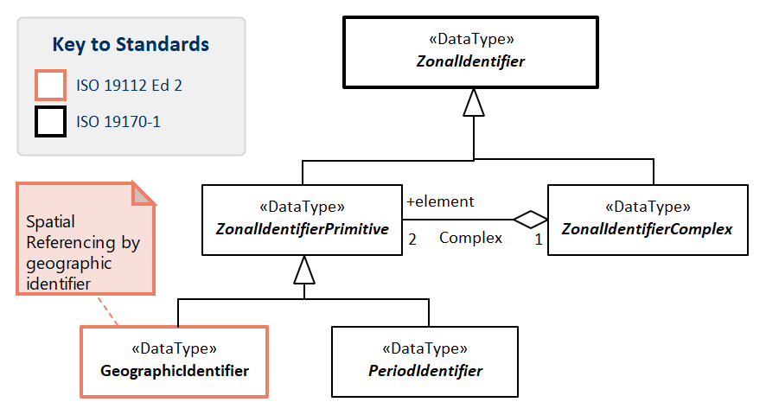
Figure 8 — Primitives of ZonalIdentifier
Referring to Figure 9, a Zone is either a Zone primitive or a compound of two Zone primitives — one Location Class and one Period Class.
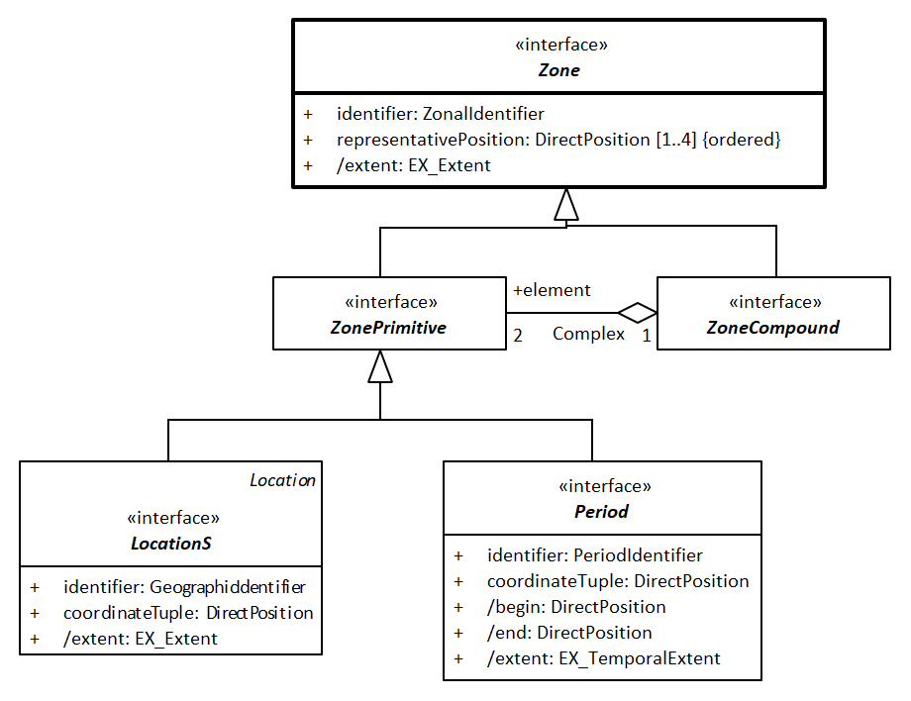
Figure 9 — Primitives of Zone
Referring to Figure 10, a Zone Class is either a Zone Class primitive or a compound of two Zone Class primitives — one Location Class and one Period Class.
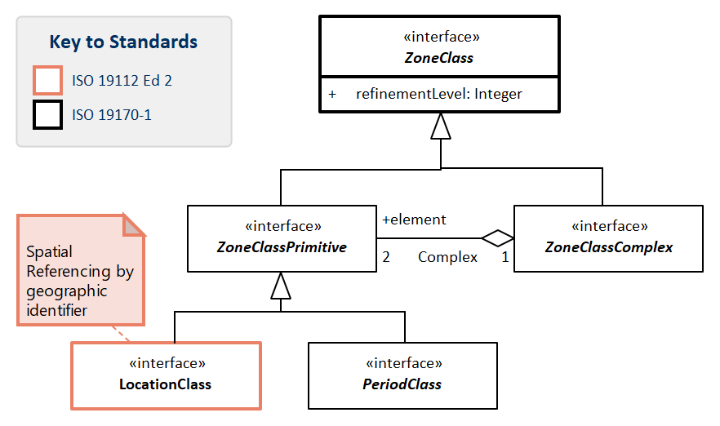
Figure 10 — Primitives of ZoneClass
Referring to Figure 11, a Reference system using Zonal Identifiers is either a Reference system using Zonal Identifiers primitive or a compound of two of its primitives — one spatial reference system using zonal identifiers and one temporal reference system using period identifiers.
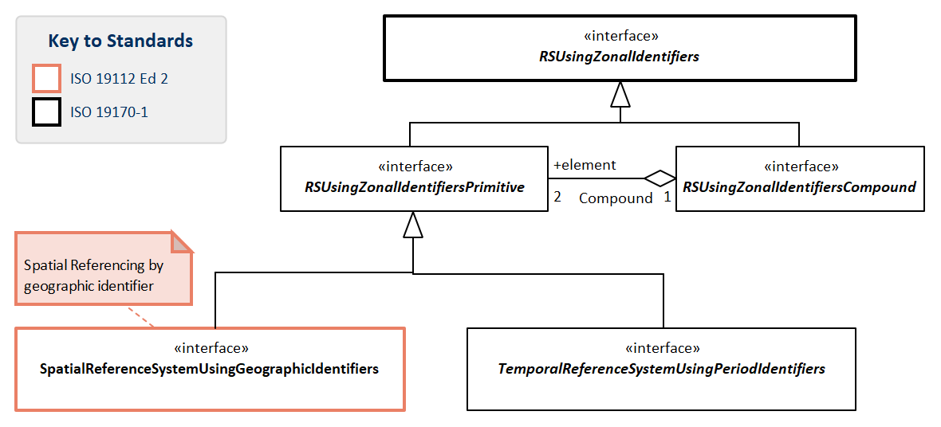
Figure 11 — Primitives of Reference system Using Zonal Identifiers
Referring to Figure 12, Zone, Zonal Identifiers, ZoneClass come together to form a Reference System using zonal identifiers.
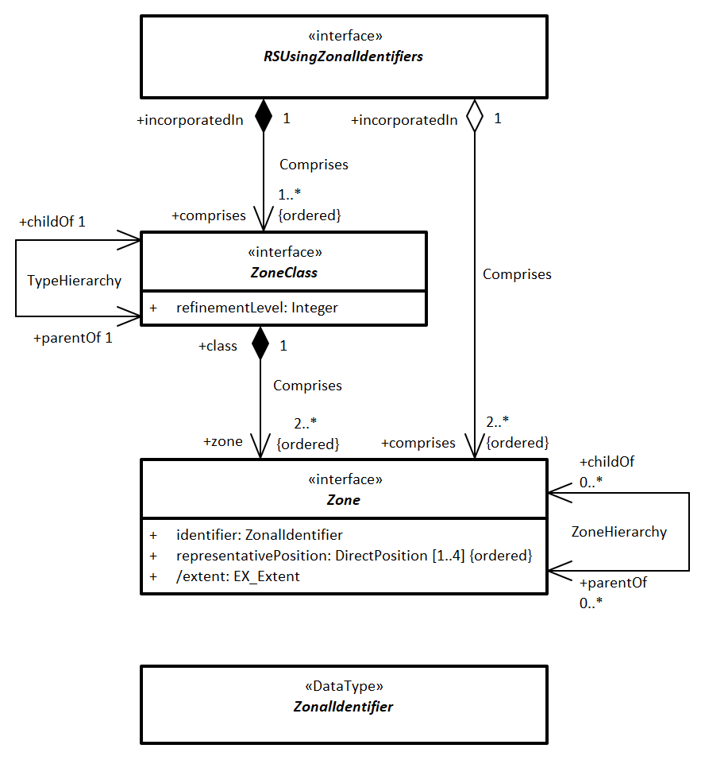
Figure 12 — Reference system Using Zonal Identifiers

7.3.3.2. Defining tables
- Table 25 Elements of Zone::RSUsingZonalIdentifiers
- Table 26 Elements of Zone::RSUsingZonalIdentifiersCompound
- Table 27 Elements of Zone::RSUsingZonalIdentifiersPrimitive
- Table 28 Elements of Zone::ZonalIdentifier
- Table 29 Elements of Zone::ZonalIdentifierComplex
- Table 30 Elements of Zone::ZonalIdentifierPrimitive
- Table 31 Elements of Zone::Zone
- Table 32 Elements of Zone::ZoneClass
- Table 33 Elements of Zone::ZoneClassComplex
- Table 34 Elements of Zone::ZoneClassPrimitive
- Table 35 Elements of Zone::ZoneCompound
- Table 36 Elements of Zone::ZonePrimitive
Table 25 — Elements of Zone::RSUsingZonalIdentifiers class
Name: | RSUsingZonalIdentifiers
Definition: | A Reference system using Zonal Identifiers is either a Reference system using Zonal Identifiers primitive or a compound of one spatial reference system using zonal identifiers and one temporal reference system using period identifiers primitives.
Stereotype: | Interface
Generalisation of: | RSUsingZonalIdentifiersCompound, RSUsingZonalIdentifiersPrimitive
Abstract: | true
Associations: | Association with: | Obligation | Maximum occurence | Provides:
 | Zone (feature type) | M | * | comprises
 |  | M | * | comprises
Public attributes: | (none)
Constraints: | (none)

Table 26 — Elements of Zone::RSUsingZonalIdentifiersCompound class
Name: | RSUsingZonalIdentifiersCompound
Definition: | A Reference system using Zonal Identifiers Compund is a compound of one spatial reference system using zonal identifiers and one temporal reference system using zonal identifiers primitives.
Stereotype: | Interface
Inheritance from: | RSUsingZonalIdentifiers
Abstract: | true
Associations: | Association with: | Obligation | Maximum occurence | Provides:
 | RSUsingZonalIdentifiersPrimitive (feature type) | M | 2 | element
Public attributes: | (none)
Constraints: | (none)

Table 27 — Elements of Zone::RSUsingZonalIdentifiersPrimitive class
Name: | RSUsingZonalIdentifiersPrimitive
Definition: | A Reference system using Zonal Identifiers Primitive is either a spatial Reference system using Geographic Identifiers or a temporal Reference system using Period Identifiers.
Stereotype: | Interface
Inheritance from: | RSUsingZonalIdentifiers
Abstract: | true
Associations: | (none)
Public attributes: | (none)
Constraints: | (none)

Table 28 — Elements of Zone::ZonalIdentifier class
Name: | ZonalIdentifier
Definition: | Spatial, temporal or spatio-temporal reference in the form of a label or code that identifies a zone
Stereotype: | DataType
Generalisation of: | ZonalIdentifierComplex, ZonalIdentifierPrimitive
Abstract: | true
Associations: | (none)
Public attributes: | (none)
Constraints: | (none)

Table 29 — Elements of Zone::ZonalIdentifierComplex class
Name: | ZonalIdentifierComplex
Definition: | Zonal Identifier complex is a complex of two zonal identifier primitives — one geographic identifier and one period identifier
Stereotype: | DataType
Inheritance from: | ZonalIdentifier
Abstract: | true
Associations: | Association with: | Obligation | Maximum occurence | Provides:
 | ZonalIdentifierPrimitive (feature type) | M | 2 | element
Public attributes: | (none)
Constraints: | (none)

Table 30 — Elements of Zone::ZonalIdentifierPrimitive class
Name: | ZonalIdentifierPrimitive
Definition: | Zonal Identifier Primitive is either a geographic identifier or a period identifier
Stereotype: | DataType
Inheritance from: | ZonalIdentifier
Abstract: | true
Associations: | (none)
Public attributes: | (none)
Constraints: | (none)

Table 31 — Elements of Zone::Zone class
Name: | Zone
Definition: | A Zone is a particular spatial, temporal or spatio-temporal place
Stereotype: | Interface
Generalisation of: | ZoneCompound, ZonePrimitive
Abstract: | true
Associations: | (none)
Public attributes: | Name | Definition | Derived | Obligation | Maximum occurence | Data type
 | extent | extent of zone | true | M | 1 | EX_Extent
 | identifier | name or label for the Zone |  | M | 1 | ZonalIdentifier (data type)
 | representativePosition | interior position the Zone |  | M | 4 | DirectPosition
Constraints: | (none)

Table 32 — Elements of Zone::ZoneClass class
Name: | ZoneClass
Definition: | categorisation of zones
Stereotype: | Interface
Generalisation of: | ZoneClassComplex, ZoneClassPrimitive
Abstract: | true
Associations: | Association with: |  |  | Obligation | Maximum occurence | Provides:
 |  |  |  | M | * | zone
Public attributes: | Name | Definition | Derived | Obligation | Maximum occurence | Data type
 | refinementLevel | refinement level used to define the zone class |  | M | 1 | Integer
Constraints: | (none)

Table 33 — Elements of Zone::ZoneClassComplex class
Name: | ZoneClassComplex
Definition: | Zone class complex is a complex of two zone class primitives — one location class and one period class
Stereotype: | Interface
Inheritance from: | ZoneClass
Abstract: | true
Associations: | Association with: | Obligation | Maximum occurence | Provides:
 | ZoneClassPrimitive (feature type) | M | 2 | element
Public attributes: | (none)
Constraints: | (none)

Table 34 — Elements of Zone::ZoneClassPrimitive class
Name: | ZoneClassPrimitive
Definition: | Zone class primitive is either a location class or a period class
Stereotype: | Interface
Inheritance from: | ZoneClass
Abstract: | true
Associations: | (none)
Public attributes: | (none)
Constraints: | (none)

Table 35 — Elements of Zone::ZoneCompound class
Name: | ZoneCompound
Definition: | A ZoneCompound is a compound of two zone Primitives, one spatial location and one temporal period.
Stereotype: | Interface
Inheritance from: | Zone
Abstract: | true
Associations: | Association with: | Obligation | Maximum occurence | Provides:
 | ZonePrimitive (feature type) | M | 2 | element
Public attributes: | (none)
Constraints: | (none)

Table 36 — Elements of Zone::ZonePrimitive class
Name: | ZonePrimitive
Definition: | A Zonal Primitive is either a spatial Location or a temporal Period.
Stereotype: | Interface
Inheritance from: | Zone
Abstract: | true
Associations: | (none)
Public attributes: | (none)
Constraints: | (none)

Requirement 5:
www.opengis.net/spec/DGGS/2.0/req/cc/zone/rsuzi
The common classes for reference systems using zonal identifiers SHALL conform to the data model in Figure 8…Figure 11 and defining tables in Table 25…Table 36.

8. DGGS Core Reference System and Functions Package

8.1. DGGS Core Reference System and Functions
This Clause specifies the DGGS Core Reference system conformance class and the DGGS Core Functions conformance class. These cover.
- Core Reference system — Comprising parent global geometry, base CRS, and Reference system using zonal identifiers with structured geometry;
- Core Functions — Comprising Quantization, Query, and Interoperation.

8.2. DGGS Core Reference system using discrete geometry with zonal identifiers

8.2.1. Reference system data model and base CRS
The DGGS Core Reference Systems Figure 13 is a Reference system using discrete geometry with zonal identifiers for a globe, and it is defined by the attributes of the DGG_ReferenceSystem interface Table 38 and its metadata. In the context of the DGGS, and in particular in the DGGS Core the term globe is used in its most general sense to represent a mathematical model of any planetary body and depending on need, potentially its surroundings out to the orbit of a planet’s outer moons, and for spatio-temporal DGGS over a defined time span. The spatio-temporal extent of the entire globe is referred to as the domain of the DGGS. The core itself is dimension agnostic
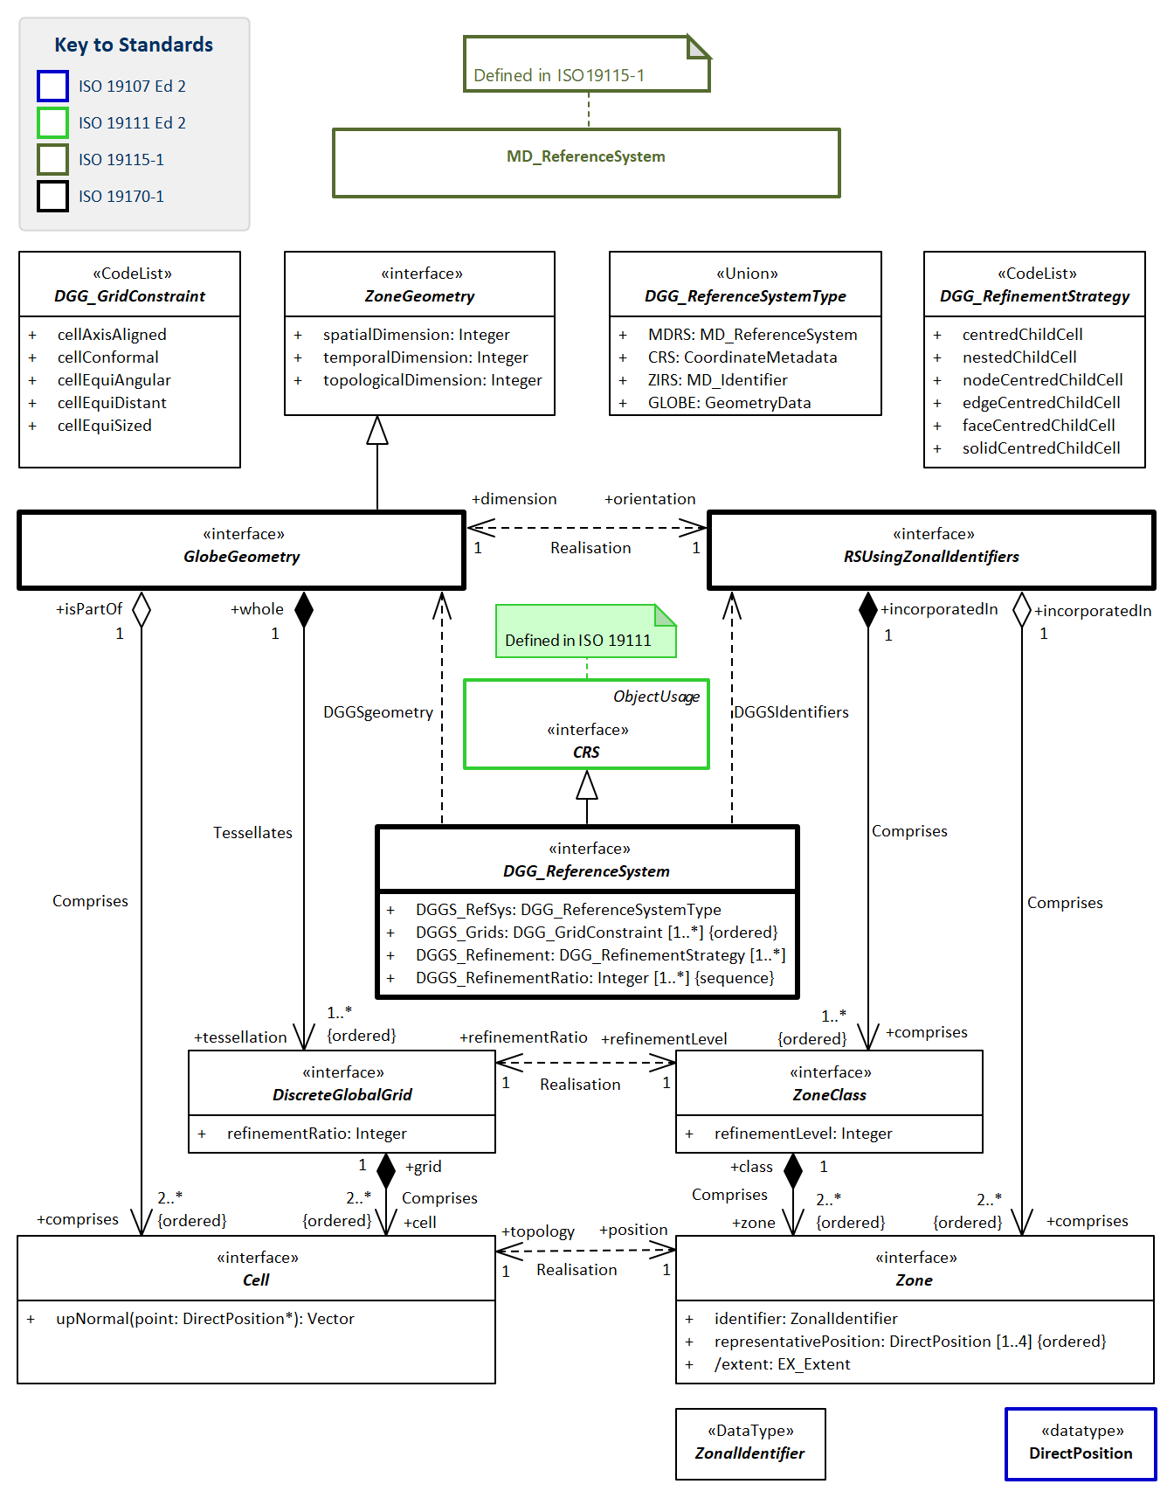
Figure 13 — DGGS Core Reference system using zonal identifiers with structured geometry
The DGGS Core Reference system model in Figure 13 describes a hierarchy of paired elements — at each tier of the hierarchy a geometry element, shown on the left of the figure is paired with a zonal element, shown on the right of the figure.
At the root of the hierarchy, the globe’s reference model and base CRS for the DGGS are defined. A single parent geometry (GlobeGeometry) is defined to coincide with the globe’s reference model. The parent geometry’s dimensionality governs the dimensionality of the DGGS. (cf Clause 8.2.3) The parent global geometry is paired with a Reference System using zonal identifiers.
A sequence of discreteGlobalGrids, each paired with a zoneClass define the lower levels of the hierarchy.
Each discreteGlobaGrid is made up from cells, each known as a zone that belong to their discreteGlobalGrid’s zoneClass. (cf Clause 8.2.5)
The cell provides a zones geometry and has topology, and the zone provides a cell with a name in the form of a zonal identifier and a representative position in the base CRS in the form of a direct position. (cf Clause 8.2.4) Each cell is the child of one or more parents in the discreteGlobalGrid in the level above it in the hierarchy.
Each discreteGlobalGrid’s cells are topologically related to its parent(s) by the collection of refinement strategies defined in DGG_ReferenceSystem(DGGS_Refinement) attribute.
Each cell’s geometry, orientation and size is governed by the constraint defined in DGG_ReferenceSystem(DGGS_Grids) and by the refinement ratio defined in DGG_ReferenceSystem(DGGS_RefinementRatio). If a sequence or refinementRatios is defined the values are applied to each level in the hierarchy in a repeating sequence starting at the top with the first refinementRatio in the sequence, and working down through the levels in order.

8.2.2. Defining tables for Core Reference system sub-package
- Table 37 Elements of Core RS using zonal identifiers with structured geometry::Cell
- Table 38 Elements of Core RS using zonal identifiers with structured geometry::DGG_ReferenceSystem
- Table 39 Elements of Core RS using zonal identifiers with structured geometry::DGG_ReferenceSystemType
- Table 40 Elements of Core RS using zonal identifiers with structured geometry::DiscreteGlobalGrid
- Table 41 Elements of Core RS using zonal identifiers with structured geometry::GlobeGeometry
- Table 42 Defining elements of Core RS using zonal identifiers with structured geometry::DGG_GridConstraint
- Table 43 Defining elements of Core RS using zonal identifiers with structured geometry::DGG_RefinementStrategy
Table 37 — Elements of Core RS using zonal identifiers with structured geometry::Cell class
Name: | Cell
Definition: | Reference system unit of geometry associated with a Zone. As part of GlobeGeometry, it has the same spatial, temporal and topological dimensionality as GlobeGeometry.
Stereotype: | Interface
Abstract: | true
Associations: | (none)
Public attributes: | (none)
Constraints: | (none)

Table 38 — Elements of Core RS using zonal identifiers with structured geometry::DGG_ReferenceSystem class
Name: | DGG_ReferenceSystem
Definition: | Defining characteristics of a Reference system using zonal identifiers with structured geometry.
Stereotype: | Interface
Abstract: | true
Associations: | (none)
Public attributes: | Name | Definition | Derived | Obligation | Maximum occurence | Data type
 | DGGS_Grids | List of characteristics that constraint the grid cells in this DGGS in decreasing order of priority. |  | M | * | DGG_GridConstraint (code list)
 | DGGS_Refinement | List of topological relationships between Parent and Child cells in this DGGS. |  | M | * | DGG_RefinementStrategy (code list)
 | DGGS_RefinementRatio | List of refinement ratios of Parent cell size to Child cell size, in order that they are used in constructing child cells in the DGGS. If the list is shorter than the number of discrete global grids in the DGGS, then it is used as a repeating sequence. |  | M | * | Integer
 | DGGS_RefSys | Reference system metadata |  | M | 1 | DGG_ReferenceSystemType (union data type)
Constraints: | (none)

Table 39 — Elements of Core RS using zonal identifiers with structured geometry::DGG_ReferenceSystemType class
Name: | DGG_ReferenceSystemType
Definition: | Defining metadata elements of the base CRS for this DGGS
Stereotype: | Union
Abstract: | true
Associations: | (none)
Public attributes: | Name | Definition | Derived | Obligation | Maximum occurence | Data type
 | CRS | Metadata required to reference coordinates. |  | M | 1 | CoordinateMetadata
 | GLOBE | GeometryData for the chosen GlobeGeometry that specifies geometry, spatial, temporal and topological dimensionality and domain of the globe for this DGGS. |  | M | 1 | GeometryData
 | MDRS | Reference system information describing this whole DGGS |  | M | 1 | MD_ReferenceSystem
 | ZIRS | Identifier for the Reference system using Zonal Identifiers used by this DGGS |  | M | 1 | MD_Identifier
Constraints: | (none)

Table 40 — Elements of Core RS using zonal identifiers with structured geometry::DiscreteGlobalGrid class
Name: | DiscreteGlobalGrid
Definition: | set of Cells at the same refinement level
Stereotype: | Interface
Abstract: | true
Associations: | Association with: |  |  | Obligation | Maximum occurence | Provides:
 |  |  |  | M | * | cell
Public attributes: | Name | Definition | Derived | Obligation | Maximum occurence | Data type
 | refinementRatio | ratio of the number of cells in the parent DiscreteGlobalGrid to the number in this DiscreteGlobalGrid |  | M | 1 | Integer
Constraints: | (none)

Table 41 — Elements of Core RS using zonal identifiers with structured geometry::GlobeGeometry class
Name: | GlobeGeometry
Definition: | Parent geometry specifying the geometry, dimensionality and domain of the globe for this DGGS.
Stereotype: | Interface
Inheritance from: | ZoneGeometry
Abstract: | true
Associations: | Association with: | Obligation | Maximum occurence | Provides:
 | Cell (feature type) | M | * | comprises
 |  | M | * | tessellation
Public attributes: | (none)
Constraints: | (none)

Table 42 — Elements of Core RS using zonal identifiers with structured geometry::DGG_GridConstraint class
Name: | DGG_GridConstraint
Definition: | CodeList for constraints that are used to define different categories of DGGS. Each constraint is a constraint on the shape, size, or orientation of cells in a DiscreteGlobalGrid.
Stereotype: | CodeList
Abstract: | true
Associations: | (none)
Values: | Name | Definition
 | cellAxisAligned | cell edges are parallel to the base CRS’s coordinate system axes.
 | cellConformal | variation in shape between all the cells in each DiscreteGlobalGrid is minimized.
 | cellEquiAngular | variation in bearing from one cell’s representative position to the next neighboring cell’s representative positions in each DiscreteGlobalGrid is minimized.
 | cellEquiDistant | variation in distance from a cell’s representative position to all of it’s neighboring cell’s representative positions in each DiscreteGlobalGrid is minimized.
 | cellEquiSized | variation in interior size between all cells in each DiscreteGlobalGrid is minimized.

Table 43 — Elements of Core RS using zonal identifiers with structured geometry::DGG_RefinementStrategy class
Name: | DGG_RefinementStrategy
Definition: | CodeList for strategies that are used to define different categories of DGGS. Each strategy defines the topological relationship of one or more elements of cell geometry belonging to a child cell with one or more elements of geometry of its parent cell.
Stereotype: | CodeList
Abstract: | true
Associations: | (none)
Values: | Name | Definition
 | centredChildCell | parent⇐zone.representativePosition() = child⇐zone.representativePosition() for one child.
 | nestedChildCell | parent.boundary = <<set of all parent.child>>.boundary.
 | nodeCentredChildCell | each parent cell has a child⇐zone.representativePosition coincident with each of the parent’s nodes (0D topological boundary element).
 | edgeCentredChildCell | each parent cell of dimension greater than 1 has a child cell who’s cell⇐zone.representativePosition lies on each of the parent’s edges (1D topological boundary element)
 | faceCentredChildCell | each parent cell of dimension greater than 2 has a child cell who’s cell⇐zone.representativePosition lies on each of the parent’s faces (2D topological boundary element)
 | solidCentredChildCell | each parent cell of dimension greater than 3 has a child cell who’s cell⇐zone.representativePosition lies on each of the parent’s solids (3D topological boundary element)

Requirement 6:
www.opengis.net/spec/DGGS/2.0/req/core/rs/harmonised_model
All reference system classes SHALL comply with classes in the Core reference system data model in Figure 13 and definitions in Table 37…Table 43.

Requirement 7:
www.opengis.net/spec/DGGS/2.0/req/core/rs/crs
A DGGS Reference Specification SHALL define a CRS, and comply with requirements for provision of coordinate epoch as specified for MD_ReferenceSystem.

8.2.3. Global Domain
The domain of the DGGS shall be defined as the entire globe, with cells that “exhaustively cover the globe without overlapping or underlapping”. (Goodchild [15]) Applying these criteria to the cells in each discrete global grid, there shall be no gaps between cells and no positions that are covered by more than one cell.
Each cell inherits its dimensionality from the choice of geometry for the GlobalGeometry class, so a reference system that specifies a geometry and domain as the globe’s surface will have 2D cells on the surface of the globe, and one that specifies a geometry and domain as a globe’s volume will have 3D cells filling the globe. A reference system that specifies a linear geometry and domain, for instance for time will result in 1D cells.
Requirement 8:
www.opengis.net/spec/DGGS/2.0/req/core/rs/global_domain
Reference system global domain — the reference system SHALL specify a global domain, and its spatial, temporal and topological dimensionality.

Requirement 9:
www.opengis.net/spec/DGGS/2.0/req/core/rs/global_domain/complete
Reference system domain completeness — the level zero discrete global grid SHALL cover the entire global domain.

Requirement 10:
www.opengis.net/spec/DGGS/2.0/req/core/rs/global_domain/unique
Reference system location uniqueness — every location in the domain of the reference system SHALL be in exactly one cell of the level zero discrete global grid.

8.2.4. Cells and Zones

8.2.4.1. Cell Simple Geometry
Semantically the terms cell and zone refer to different characteristics of the same region of space-time. Cells in a DGGS shall be geometrically simple. Simple geometries have the following properties:
- they do not self-intersect;
- they are topologically the same as a circle, or the circle’s equivalent in the dimension of the cell. e.g. to a sphere in 3D; and
- they enclose a region which is always measurable using a metric of the same dimensionality as the cell.
Requirement 11:
www.opengis.net/spec/DGGS/2.0/req/core/rs/cell/simple
For each successive level of grid refinement, a DGGS specification SHALL define Cells with simple geometry.

8.2.4.2. Cell Position
Each cell’s zone has a fixed representative position in the space of the base CRS, recorded as a direct position.
Requirement 12:
www.opengis.net/spec/DGGS/2.0/req/core/rs/cell/direct_position
All zones in each discrete global grid SHALL be assigned a direct position that is within the zone’s boundary.

8.2.4.3. Cell Address
Each cell’s zone shall be assigned a unique address in the form of a zonal identifier. The value assigned to each address shall be structured on one or more of these four general indexing methods: hierarchy-based, space-filling curve based, coordinate [9] and encoded address schemas (such as those used for IP addresses [18]).
Requirement 13:
www.opengis.net/spec/DGGS/2.0/req/core/rs/cell/address
All zones in all discrete global grids SHALL have a globally unique zonal identifier (or cell index) that provides a spatio-temporal reference.

8.2.5. Discrete Global Grid and its Sequence
Cells at the same level in the tessellation hierarchy are aggregated into discrete global grids. The hierarchy of discrete global grids is an ordered sequence, typically also of decreasing cell size, representing lowest resolution to higher resolutions. The discrete sequence of grids forms a multi-resolution grid hierarchy that is the basis for DGGS Reference System.
Requirement 14:
www.opengis.net/spec/DGGS/2.0/req/core/rs/discrete_global_grid
A DGGS reference system SHALL define discrete global grids as aggregations of all the cells at the same level in the hierarchy.

Requirement 15:
www.opengis.net/spec/DGGS/2.0/req/core/rs/discrete_global_grid/sequence
A DGGS reference system SHALL sort its hierarchy of discrete global grids in order of increasing refinement level.

8.3. DGGS Core Functions

8.3.1. Quantization Functions
A DGGS is defined based on the geometry of the globe in a data agnostic manner. Therefore, a DGGS specification shall define quantisation methods for assigning data to cells so that the data is accessible for future use. Different quantization strategies may be used for sampling content into cells. For example, a single DGGS may be used as a data structure for integrating multiple datasets of different types (e.g. vector and raster datasets) [17] and in different ways (e.g. DGGS cells as data tiles, or one raster pixel per DGGS cell or DGGS cell indices as vector coordinate-pairs). This Abstract Specification makes use of the concepts defined by the Observations and Measurements abstract specification [ISO 19156:2011(E)] to facilitate the association of observations/spatial data to a DGGS cell(s). Some DGGS/polyhedron choices are more efficient for sampling than others (e.g. DGGS based on an icosahedron).
Multiple observation contexts are recognized for quantization, each corresponding to a distinct role for DGGS Cells to play. In any particular DGGS specification, one or more (and potentially all) roles may be described for either internal or external use to support interoperability, as follows:
- Data Tiles: In Data Tile quantization, spatial feature/observations (e.g. point clouds, images, vectors, etc.) are aggregated and clipped to cell boundaries and stored in tiles without any changes made to the feature type parameters. The cells of the DGGS provide a multi-, or single-, resolution tiling schema with the cell index used as the identifier in the tile naming convention. In the context of “Big Data Analytics” ‘asDataTile’ support will likely be the most efficient type of granularity for job submission on HPC/HPD or Cloud ICT infrastructure; particularly for dominantly embarrassingly parallel analyses. It is also likely to be the most efficient granularity for many data transfer requests.
- Data Cells: In Data Cell quantization, the spatial features/observations (e.g. point clouds, images, vectors, etc.) are sampled to each DGGS Cell by assignment of data value(s) using the cell’s geometry to govern the quantization operation.
- Coordinates: In Coordinate quantization, each coordinate tuple from the spatial feature/observation is converted to a cell index of an appropriate level of precision. The cell data package will include appropriate vector topology to preserve the structure of the spatial feature in the context of the DGGS.
- Tags: In Tag quantization, cell index values are “tagged” to data objects in a similar fashion to social media records. The refinement level of the cell index is indicative of the precision with which the location of a spatial feature/observation and/or its spatial extent are known. This can be thought of as a convex hull with the same geometry of the DGGS Cell surrounding the objects to be assigned to that cell.
- Graphic Cells: In Graphic Cell quantization, data is rendered to cells, and refinement levels are leveraged to support corresponding levels of detail or zoom levels.
- Graphic Tiles: In Graphic Tile quantization, graphic cells are tiled, and often cached for delivery to a display system. As with data Tiles, the cell index is used as the identifier in the tile naming convention.
The data assigned to a particular DGGS implementation defines at any time defines its extent, which is likely to vary over its lifecycle as the amount of data assigned to it changes. The domain of the DGGS, is however, always fixed and always defined over the entire surface model of the Earth.
Figure 14 shows the key elements required to perform data quantization operations in a DGGS specification.
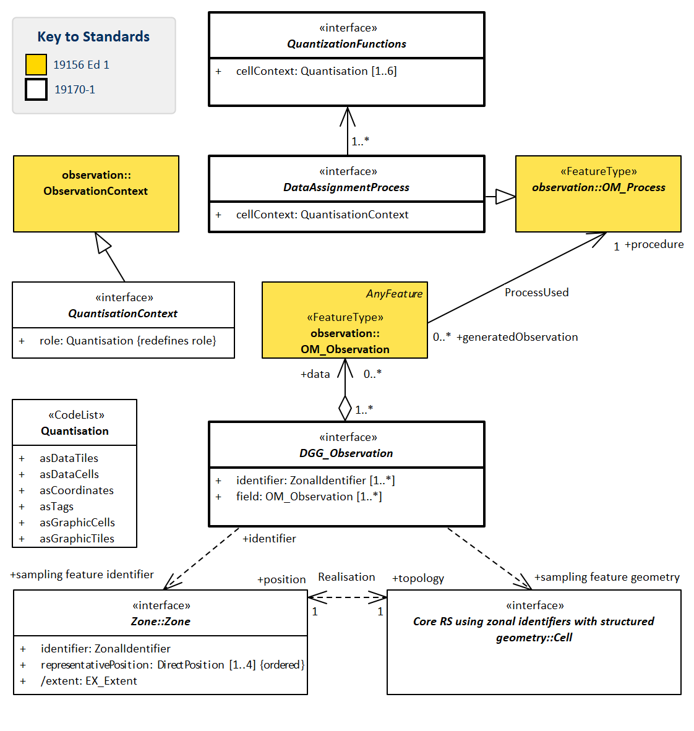
Figure 14 — Quantization function

8.3.2. Defining tables for Core Quantization Functions sub-package
- Table 44 Elements of Core Quantisation Functions::DataAssignmentProcess
- Table 45 Elements of Core Quantisation Functions::DGG_Observation
- Table 46 Elements of Core Quantisation Functions::QuantisationContext
- Table 47 Elements of Core Quantisation Functions::QuantizationFunctions
- Table 48 Elements of Core Quantization Functions::Quantisation
Table 44 — Elements of Core Quantisation Functions::DataAssignmentProcess class
Name: | DataAssignmentProcess
Definition: | The class DataAssignmentProcess is a generalisation of OM_Process, which in turn is an instance of the «metaclass» GF_FeatureType (ISO 19109:2007), which therefore represents a feature type. DataAssignmentProcess is abstract, and has no attributes, operations or associations. It serves as the base class for DataAssignment processes. The purpose of a data assignment process is to generate an assignment result. An instance of DataAssignmentProcess is often a data import function to import data from a pre-existing spatial dataset, but as in OM_Process “it may also be an instrument or sensor, a human observer, a simulator, or a process or algorithm applied to more primitive results used as inputs”.
Stereotype: | Interface
Abstract: | true
Associations: | (none)
Public attributes: | Name | Definition | Derived | Obligation | Maximum occurence | Data type
 | cellContext | roll that cell provides in this DatAssignmentProcess |  | M | 1 | QuantisationContext
Constraints: | (none)

Table 45 — Elements of Core Quantisation Functions::DGG_Observation class
Name: | DGG_Observation
Definition: | DGG_Observation is an abstract class holding zonal identifier, OM_Observation tuples.  In the context of Quantisation, DGG_Observation holds records of Observations made with DataAssignmentProcess in assigning values to cells.
Stereotype: | Interface
Abstract: | true
Associations: | (none)
Public attributes: | Name | Definition | Derived | Obligation | Maximum occurence | Data type
 | field | values that were observed |  | M | * | OM_Observation
 | identifier | cells that were observed |  | M | * | ZonalIdentifier (data type)
Constraints: | (none)

Table 46 — Elements of Core Quantisation Functions::QuantisationContext class
Name: | QuantisationContext
Definition: | ObservationContext for this DataAssignmentProcess.
Stereotype: | Interface
Abstract: | true
Associations: | (none)
Public attributes: | Name | Definition | Derived | Obligation | Maximum occurence | Data type
 | role | defines the role or roles that cells play in the quantisation. |  | M | 1 | Quantisation (code list)
Constraints: | (none)

Table 47 — Elements of Core Quantisation Functions::QuantizationFunctions class
Name: | QuantizationFunctions
Definition: | Process for quantising external data by using a cell’s geometry to sample external data and assign the results to zonal identifiers.  The quantisation CodeList identifies different potential roles for the cell geometry in the quantisation process.
Stereotype: | Interface
Abstract: | true
Associations: | (none)
Public attributes: | Name | Definition | Derived | Obligation | Maximum occurence | Data type
 | cellContext | List of roles that cell geometry is to be used in associated DataAssignmentProcesses |  | M | 6 | Quantisation (code list)
Constraints: | (none)

Table 48 — Elements of Core RS using zonal identifiers with structured geometry::Quantisation class
Name: | Quantisation
Definition: | CodeList for roles that cell geometries may play in a DataAssignmentProcess.
Stereotype: | CodeList
Abstract: | true
Associations: | (none)
Values: | Name | Definition
 | asDataTiles | cell assigned features clipped to the boundary of the cell  Note: features are clipped to the cell boundary and stored as a feature tile.  Note: the cell’s zonal identifier may be used in the naming convention for data tiles
 | asDataCells | cell assigned a data value, either resampled or remapped, from a feature based on the geometry of the cell.
 | asCoordinates | each coordinate tuple in a vector feature’s geometry data is replaced by a zonal identifier. The size of zone is chosen to represent the uncertainty in the knowledge of the position represented by the coordinate tuple.
 | asTags | minimal set of zonal identifiers applied to an object.  Note: The zone operates in this context as a minimum bounding container (similar to a minimum bounding rectangle in 2D) where the boundary of the zone wholly encloses a set of features assigned to that zone.  Note: The refinement level of a zone index used to tag a feature (or set of features) provides an indication of the level of precision and/or the spatial extents of the feature.
 | asGraphicCells | cell assigned color representing a for delivery to a map display system, that represents an attribute value, either sampled or mapped, from a feature.  Note: refinement levels may be aligned with zoom levels or scales in a map display system.
 | asGraphicTiles | tiling scheme used for a map display system using cells to define the tile boundaries.  Note: graphic tiles may be cached or stored and sent to the display system as a map tile.

Requirement 16:
www.opengis.net/spec/DGGS/2.0/req/core/functions/quantization
A DGGS specification SHALL define quantization operations for assigning data from external sources to DGGS cells that conform to the data model in Figure 14 and classes defined in Table 44…Table 48.

8.3.3. Query Functions

8.3.3.1. Overview of zone query functions
The zonal query module implements the DE9IM [13] functionality defined in Query2D and Query3D as specified in (ISO 19107:2019) for the topology of zones. This is achieved through a single interface called ZoneQuery (Figure 16, Table 50), with an optional parameter projectTo that constrains ZoneQuery to a specified reference direction, surface or volume.
Two additional operations based on the temporal concept of relativePosition, called relatePosition and relativePosition. These are generalised for use on any single reference direction specifed by projectTo, not just the temporal direction.
Six additional functions are provided in zoneQuery that leverage the zoneClass hierarchy. These are called parent, child and sibling and parentOF, childOf and siblingOf.
ZoneQuery operations are defined in Figure 16 & Clause 8.3.4. The following parameters are shared by many of the operations as specified in <Table 50
another | type ZonalIdentifier, mandatory.  Specifies the target region for the query. In zonal query a zone’s identifier provides sufficient description of its topology. ZonalIdentifier therefore takes the place of the geometry data used in Query2D and Query3D for both the source and the target.
inheritID | type Boolean, optional, default ⇐ False  When inheritID has a value of True the result <<set>> only contains cells whose IDs have shared inheritance, and a value of False indicates that inheritance is ignored.
projectTo | type directPosition[4], optional, default ⇐ (0,0,0,1) for relatePosition and relativePosition, otherwise (1,1,1,1)  projectTo specifies an optional reference direction, surface or volume for an operation.  Allowed values for each direction are 0, 1, and spatial directions may also have a value of n.  projectTo defines a vector whose starting point is inferred as the point with each projectTo direction whose value is 1 set to 0. It takes one of three forms.  In its 1D form for specifying a reference direction, one direction has a value of 1. For example (0,0,0,1) projects to the temporal axis, and (0,0,1,0) projects to the vertical axis.  In its 2D form for specifying a reference surface, two directions have a value of 1. For example a surface at height n is specified by a projectTo value of (1,1,n,0) representing the vector [ (0,0,n,0), (1,1,n,0) ].  In its 3D form for specifying a reference volume, three directions have a value of 1. For example (1,1,1,0) projects to a spatial volume without reference to time, and (1,1,n,1) projects to a surface spanning all time at height n.  Only the 1D form is supported by relativePosition and relatePosition.  While this construct could be used to implement more complex spatio-temporal queries, that isn’t the intent of Query2D, and isn’t specified for zoneQuery either.
rangeRefine | type refinementLevelRange, optional, default ⇐ [ min(source.refinementLevel,target.refinementLevel) : max(source.refinementLevel,target.refinementLevel) ].  Specifies the range of refinement levels to include in the return <<set>>. The lower and upper bounds in the refinementLevelRange datatype are both included in the range.
levels | type Integer, optional, default ⇐ 1  Levels indicates the relative number of levels in the hierarchy to be traversed in assembling the result <<set>> Figure 15 illustrates the parent, child, sibling suite of functions through examples.

8.3.3.2. Summary of operations in ZoneQuery
The following operations have the same topological meaning as their equivalent operations in Query2D and Query3D: distance, contains, crosses, disjoint, equals, intersects, overlaps, touches, within, withinDistance, difference, intersection, symDiffernce, union, and relate.
- relativePosition: A.relativePosition(B, project), returns the relativePosition enumerator that describes B‘s relative position to A with respect to the direction defined by project.
- relatePosition: A.relatePosition(B, enum, project)) returns whether B has the relative position to A given by enum with respect to the direction project
- parentOf: A.parentOf(B,inherit, project), returns whether A is a parent of B, optionally filtered by inherit and project.
- childOf: A.childOf(B,inherit, project), returns whether A is a child of B, optionally filtered by inherit and project.
- siblingOf: A.siblingOf(B,inherit, project), returns whether A is a sibling of B, optionally filtered by inherit and project.
- parent: A.parent(inherit, project, levels), returns the unique <<set>> of zoneIdentifiers for zones that satisfy A.parentOf(B, inherit, project) applied recursively level times up the parent hierarchy. The <<set>> will have at most 1 member from each level of the hierarchy if inheritID is True, and may have more than 1 if the cell refinementStrategy is not nested.
- child: A.child(inherit, project, levels), returns the unique <<set>> of zoneIdentifiers for zones that satisfy A.parentOf(B, inherit, project) applied recursively level times down the parent hierarchy.
- sibling: A.sibling(inherit, project, levels), returns the unique <<set>> of zoneIdentifiers for zones that satisfy A.parentOf(B, inherit, project) applied recursively level times outward on zones at the same refinement level. Multiple levels of sibling can also be thought of as the children of its parent(s) the specified number of levels up the hierarchy.
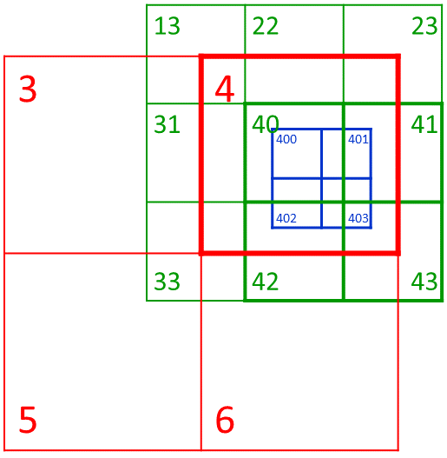
Figure 15 — Examples of parent, child, and sibling query operations
Examples | Parent, sibling & child queries for cell 40, with default _levels:_  40.parent() returns {4}  40.sibling(True) returns {40, 41, 42, 43}  40.sibling(False) returns {13, 22, 23, 31, 40, 41, 42, 43}  40.child(True) returns {400, 401, 402, 403}  Parent, sibling & child tests for cell 40, with default _levels:_  40.parentOf(400) returns True  40.siblingOf(41) returns True  40.siblingOf(31, True) returns False  40.siblingOf(41, False) returns True  40.childOf(4) returns True  Parent & child tests for cells 31 & 33 with multiple parents, with default _levels:_  31.childOf(4, True) returns False  31.childOf(4, False) returnsTrue  31.parent(True) returns {3}  31.parent(False) returns {3, 4}  33.parent(False) returns {3, 4, 5, 6}  Parent & child queries with levels set to a value greater than 1:  400.parent(True, 2) returns {40, 4}  4.child(True, 2) returns {40, 41, 42, 43, 400, 401, 402, 403, 410, 411, 412, 413, 420, 421, 422, 423, 430, 431, 432, 433}  400.sibling(True, 2) returns {400, 401, 402, 403, 410, 411, 412, 413, 420, 421, 422, 423, 430, 431, 432, 433}  While some of these results extend to cells that aren’t drawn in the figure, their cellID meaning should be readily apparent from the pattern.
Since these are 2D examples without any depth or time, projectTo has no influence.
Further query and analysis functions may then be applied to the returned data through additional software bindings. This Abstract Specification does not specify any requirements for the binding or implementation of further, extension, query or analytic functions.
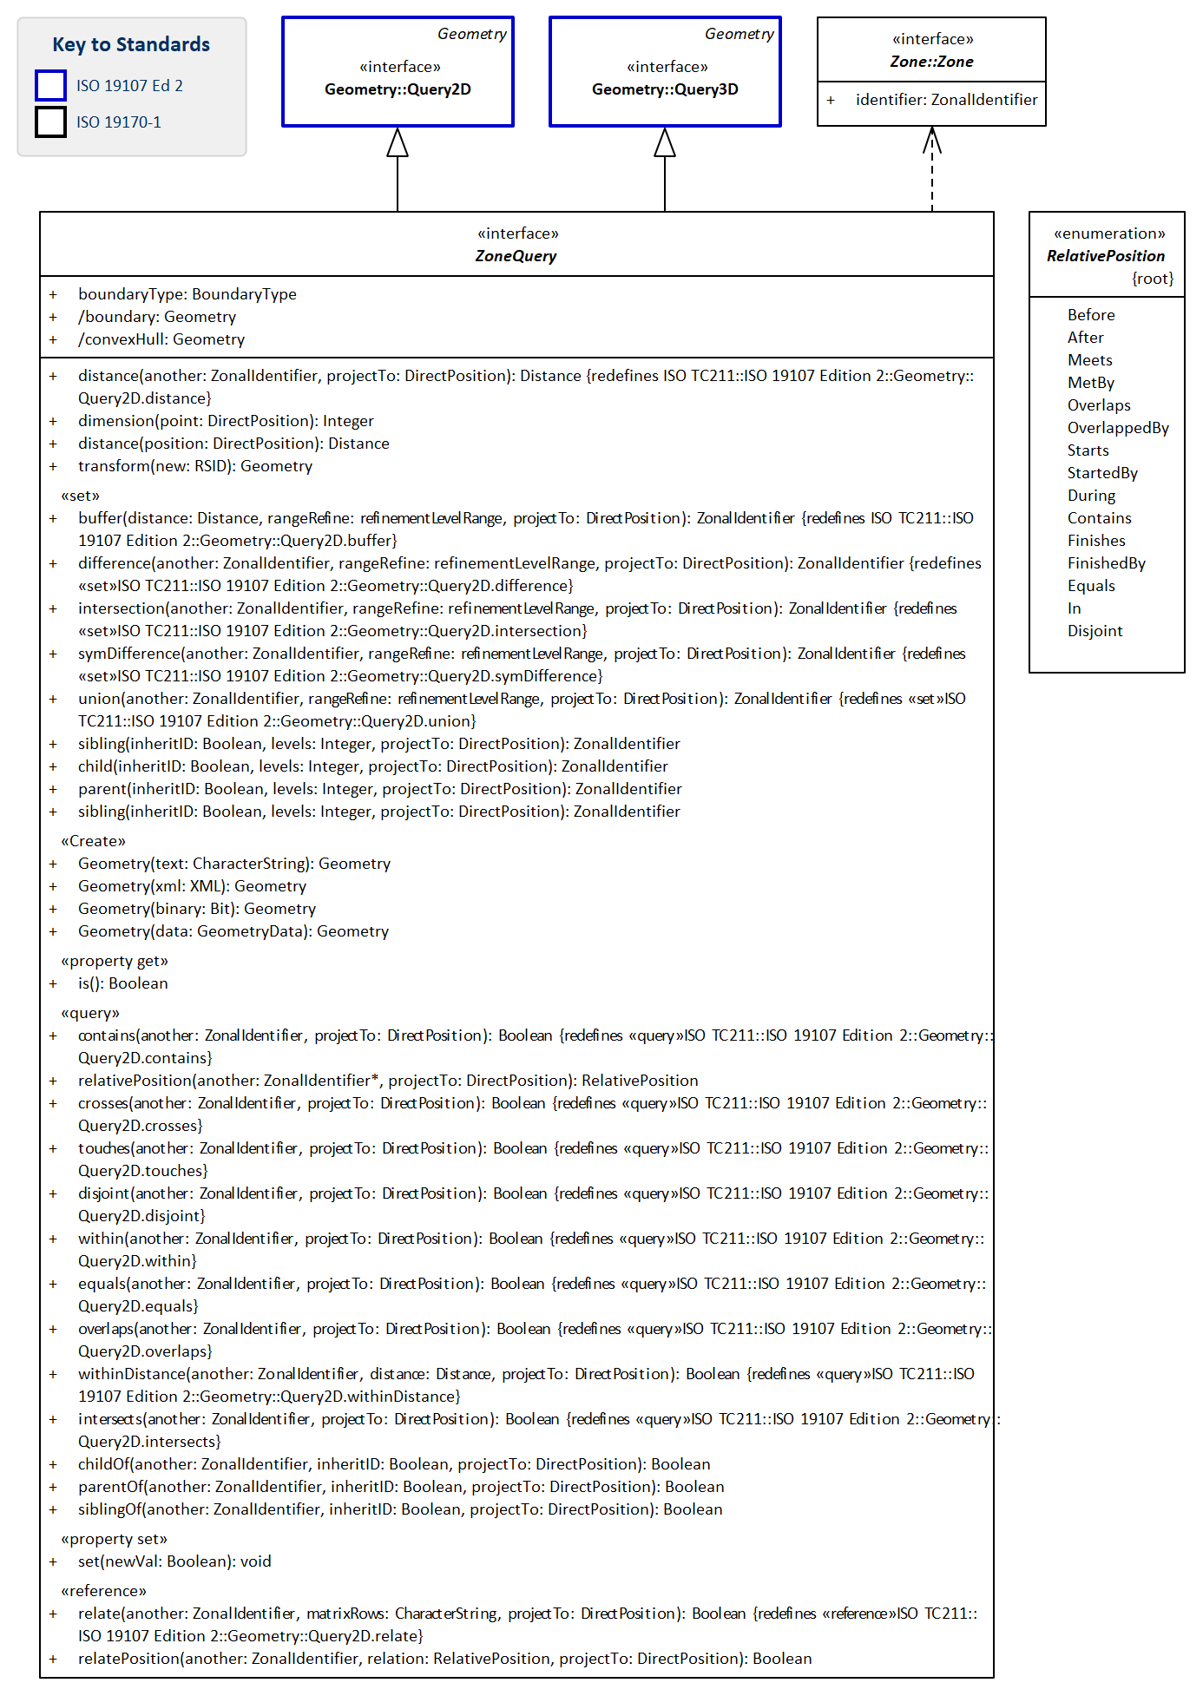
Figure 16 — Query Function

8.3.4. Defining tables for Core Query Functions sub-package
- Table 49 Elements of Core Query Functions::refinementLevelRange
- Table 50 Elements of Core Query Functions::ZoneQuery
- Table 51 Defining elements of Core Query Functions::RelativePosition
Table 49 — Elements of Core Query Functions::refinementLevelRange class
Name: | refinementLevelRange
Definition: | datatype to define a range of refinement levels, specified through a lower- and an upper-bound. Both bounds are included within the range. The range acts as a filter on the ZoneClass’s refinementLevel attribute.
Stereotype: | DataType
Associations: | (none)
Public attributes: | Name | Definition | Derived | Obligation | Maximum occurence | Data type
 | maxRefinementLevel | upper-bound of the refinement level range. |  | M | 1 | Integer
 | minRefinementLevel | lower-bound of the refinement level range. |  | M | 1 | Integer
Constraints: | (none)

Table 50 — Elements of Core Query Functions::ZoneQuery class
Name: | ZoneQuery
Definition: | ZoneQuery redefines the DE9IM operations in Query2D, Query3D and provides relativePosition and relatePosition operations for the topology of zones.
Stereotype: | Interface
Abstract: | true
Associations: | (none)
Public attributes: | Name | Definition | Derived | Obligation | Maximum occurence | Data type
 | boundary | boundary of the combined spatial geometries of the zones in the query | true | M | 1 | Geometry
 | boundaryType | boundary type of the combined spatial geometries of the zones in the query |  | M | 1 | BoundaryType
 | convexHull | convex hull of the combined spatial geometries of the zones in the query | true | M | 1 | Geometry
Operations: | Name | Parameters:ParameterType | Return type | Definition
 | distance | (another:ZonalIdentifier, projectTo:DirectPosition[4])) | Distance | A.distance(B)
<<query>> (1D) | relativePosition | (another:ZonalIdentifier, projectTo:DirectPosition[4]) | RelativePosition | A.relativePosition(B,(0,0,0,1))
<<query>> | contains | (another:ZonalIdentifier, projectTo:DirectPosition[4]) | Boolean | A.contains(B) ⇔ A⊇B
 | crosses | (another:ZonalIdentifier, projectTo:DirectPosition[4]) | Boolean | A.crosses(B)
 | disjoint | (another:ZonalIdentifier, projectTo:DirectPosition[4]) | Boolean | A.disjoint(B) ⇔ A∩B=0
 | equals | (another:ZonalIdentifier, projectTo:DirectPosition[4]) | Boolean | A.equals(B) ⇔ A=B
 | intersects | (another:ZonalIdentifier, projectTo:DirectPosition[4]) | Boolean | A.intersects(B) ⇔ A∩B≠0
 | overlaps | (another:ZonalIdentifier, projectTo:DirectPosition[4]) | Boolean | A.overlaps(B)
 | touches | (another:ZonalIdentifier, projectTo:DirectPosition[4]) | Boolean | A.touches(B)
 | within | (another:ZonalIdentifier, projectTo:DirectPosition[4]) | Boolean | A.within(B) ⇔ B.contains(A)
 | withinDistance | (another:ZonalIdentifier, dist:Distance, projectTo:DirectPosition[4]) | Boolean | A.withinDistance(B) ⇔ A.distance(B)<dist
 | parentOf | (another:ZonalIdentifier, inheritID:Boolean, projectTo:DirectPosition[4]) | Boolean | A.parentOf(B)
 | childOf | (another:ZonalIdentifier, inheritID:Boolean, projectTo:DirectPosition[4]) | Boolean | A.childOf(B)
 | siblingOf | (another:ZonalIdentifier, inheritID:Boolean, projectTo:DirectPosition[4]) | Boolean | A.siblingOf(B)
<<set>> | buffer | (dist:Distance, projectTo:DirectPosition[4]) | ZonalIdentifier | A.buffer(dist)
 | difference | (another:ZonalIdentifier, rangeRefine:refinementLevelRange, projectTo:DirectPosition[4]) | ZonalIdentifier | A.difference(B) ⇔ A-B
 | intersection | (another:ZonalIdentifier, rangeRefine:refinementLevelRange, projectTo:DirectPosition[4]) | ZonalIdentifier | A.intersection(B) ⇔ A∩B
 | symDifference | (another:ZonalIdentifier, rangeRefine:refinementLevelRange, projectTo:DirectPosition[4]) | ZonalIdentifier | A.symDifference(B) ⇔ (A-B)∪(B-A)
 | union | (another:ZonalIdentifier, rangeRefine:refinementLevelRange, projectTo:DirectPosition[4]) | ZonalIdentifier | A.union(B) ⇔ A∪B
 | parent | (inheritID:Boolean, levels:Integer, projectTo:DirectPosition[4]) | ZonalIdentifier | A.parent(B)
 | child | (inheritID:Boolean, levels:Integer, projectTo:DirectPosition[4]) | ZonalIdentifier | A.child(B)
 | sibling | (inheritID:Boolean, levels:Integer, projectTo:DirectPosition[4]) | ZonalIdentifier | A.sibling(B)
<<reference>> (1D) | relatePosition | (another:ZonalIdentifier, relate:RelativePosition, projectTo:DirectPosition[4]) | Boolean | A.relatePosition(B,enum,(0,0,1,0))
<<reference>> | relate | (another:ZonalIdentifier, matrix:CharacterString, projectTo:DirectPosition[4]) | Boolean | A.relate(B,matrix)
Constraints: | (none)

Table 51 — Elements of Core Query Functions::RelativePosition enumeration
Name: | RelativePosition
Definition: | Enumeration for the relative position of two geometries projected to a single uni-directional dimension, e.g. time.  Note: in this specification the relative position names follow those adopted by the OGC 16-071r3 and W3C, more recently than ISO 19108:2002
Stereotype: | Enumeration
Abstract: | true
Associations: | (none)
Values: | Name | Definition:  self and another are two Periods (or 1D projected ZoneGeometries).
 | Before | self.end < another.begin
 | After | self.begin > another.end
 | Meets | self.end = another.begin
 | MetBy | self.begin = another.end
 | Overlaps | self.begin < another.begin AND self.end > another.begin AND self.end < another.end
 | OverlappedBy | self.begin < another.end AND self.end > another.end
 | Starts | self.begin = another.begin AND self.end < another.end
 | StartedBy | self.begin = another.begin AND self.end > another.end
 | During | self.begin > another.begin AND self.end < another.end
 | Contains | self.begin < another. begin AND self.end > another.end
 | Finishes | self.end = another.end AND self.begin > another.begin
 | FinishedBy | self.begin > another.begin AND self.end = another.end
 | Equals | self.begin = another.begin AND self.end = another.end
 | In | self.relativePosion(another) IN [Starts, During, Finishes]
 | Disjoint | self.relativePosion(another) IN [Before, After]

Requirement 17:
www.opengis.net/spec/DGGS/2.0/req/core/functions/query/zonequery
A DGGS specification SHALL implement query operations that conform to the data model in Figure 16 and classes defined in Table 49…Table 51, across its entire domain.

8.3.5. Interoperation Functions

8.3.5.1. Interoperation Functions Overview
While the quantization and query functions enable a DGGS implementation to successfully operate internally; in order to facilitate connectivity with other spatial data infrastructures additional interoperation functions are required. As shown in Figure 17 the interoperation functions are split into two types:
- Interpret and translate external data queries sent to the DGGS implementation; and,
- Convert the result set returned from a DGGS query operation from internal data format(s) (optimized for that DGGS implementation) to format(s) suitable for external data delivery.
This document does not specify the specific interface protocol encodings required to connect a DGGS implementation to an external client and to facilitate the transfer of information into and out of a DGGS. This Abstract Specification makes use of the tools available in the Observations and Measurements Standard [ISO 19156:2011(E)] to facilitate the linkage between external query operations and the data/observations assigned to the DGGS cell(s) of interest. Specific interface encodings are anticipated to be elaborated as extensions to this Abstract Specification.
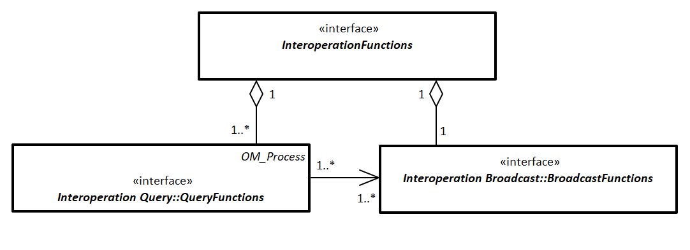
Figure 17 — Interoperation functions

8.3.5.2. Defining tables for Core Interoperation Functions sub-package
- Table 52 Elements of Interoperation::InteroperationFunctions
Table 52 — Elements of Interoperation::InteroperationFunctions class
Name: | InteroperationFunctions
Definition: | Interoperation is modelled as receipt of a query from an external service and broadcast of results
Stereotype: | Interface
Abstract: | true
Associations: | (none)
Public attributes: | (none)
Constraints: | (none)

8.3.5.3. Interoperation Query Functions
External queries may originate from an external client application and range in syntax from “natural language queries” (e.g. ‘Where are the gas pipelines in Western Canada located?’, or, ‘How has the Murray-Darling Basin in Australia changed over the past 27 years?’, or ‘Compute the watershed area of the Kawarau Catchment in New Zealand’), to an OWS ‘GetCapabilities’ or similar type of query, to an SQL (or similar) statement. To support interoperability, a DGGS specification shall define methods to receive, interpret and translate an external data query (or process) request into a form that can be processed by the internal DGGS data retrieval and query functions.
Figure 18 shows the key functional elements required for DGGS to translate and execute a external query or process operations.
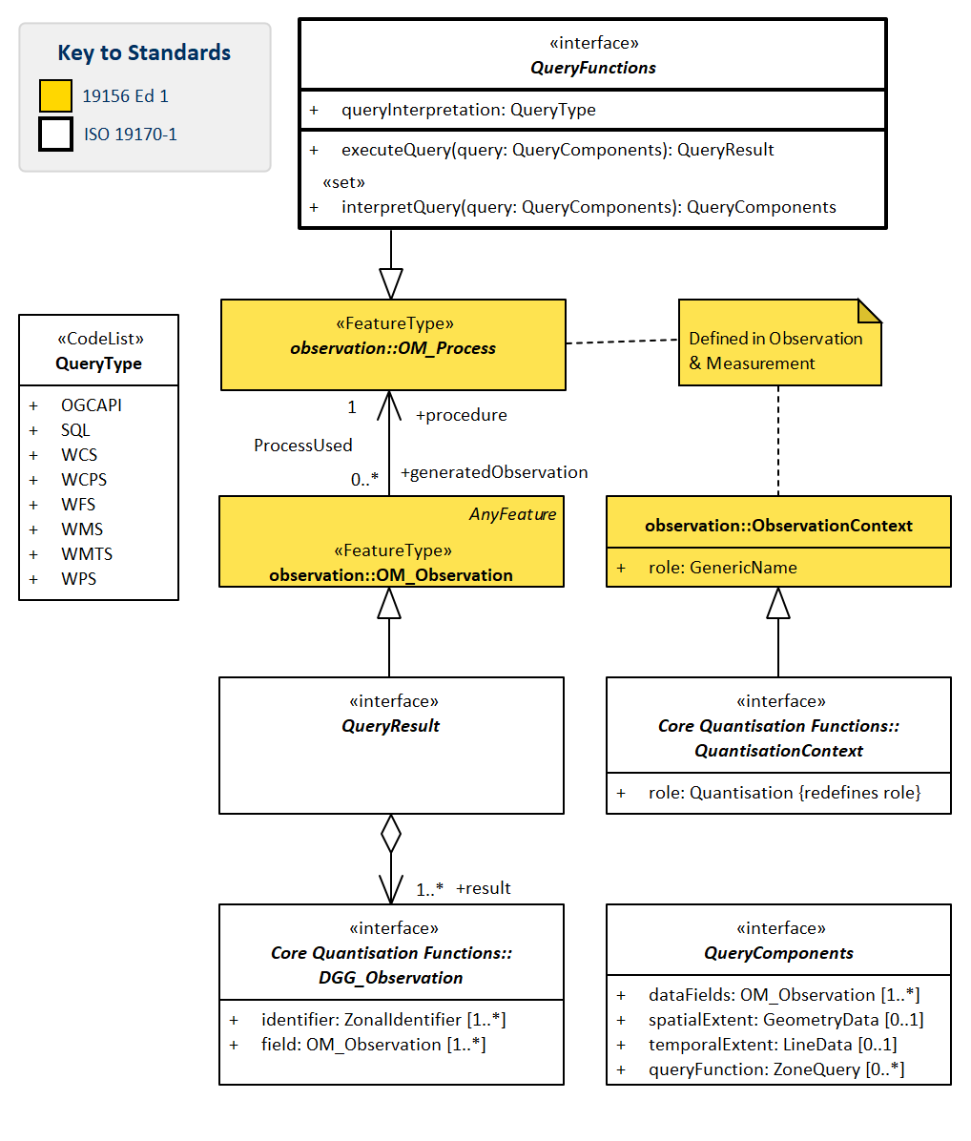
Figure 18 — Interoperation Query

8.3.5.4. Defining tables for Interoperation Query sub-package
- Table 53 Elements of Interoperation Query::QueryComponents
- Table 54 Elements of Interoperation Query::QueryFunctions
- Table 55 Elements of Interoperation Query::QueryResult
- Table 56 Defining elements of Interoperation Query::QueryType
Table 53 — Elements of Interoperation Query::QueryComponents class
Name: | QueryComponents
Definition: | structure to hold parameters for a query
Stereotype: | Interface
Abstract: | true
Associations: | (none)
Public attributes: | Name | Definition | Derived | Obligation | Maximum occurence | Data type
 | dataFields | descriptor of the non-spatial information that is requested from the DGGS. |  | M | * | OM_Observation
 | queryFunction | spatio-temporal extent of the region of interest for the query, expressed as a ZonalAlgebra expression |  | C | * | ZoneQuery
 | spatialExtent | spatial extent of the region of interest for the query, expressed as GeometryData |  | C | 1 | GeometryData
 | temporalExtent | temporal extent of the region of interest for the query, expressed as temporal geometry |  | C | 1 | LineData
Constraints: | (none)

Table 54 — Elements of Interoperation Query::QueryFunctions class
Name: | QueryFunctions
Definition: | QueryFunctions is an interface to receive, interpret, and execute queries from external services.  Queries for broadcast are modelled as OM_Process, that makes an OM_Observation of a set of Cells and their associated DGG_Observations to create a QueryResult.  The ObservationContext:role is selected from the Quantisation CodeList.
Stereotype: | Interface
Abstract: | true
Associations: | (none)
Public attributes: | Name | Definition | Derived | Obligation | Maximum occurence | Data type
 | queryInterpretation | identifies the language type for query. |  | M | 1 | QueryType (code list)
Operations: | Name | Parameters:ParameterType | Return type | Definition
 | interpretQuery | (query:QueryComponents) | QueryComponents | transform query components from external structure to a <<set>> of one or more query components structured for execution by the DGGS.
 | executeQuery | (query:QueryComponents) | QueryResult | execute query to generate a result
Constraints: | (none)

Table 55 — Elements of Interoperation Query::QueryResult class
Name: | QueryResult
Definition: | abstract placeholder for a query result
Stereotype: | Interface
Abstract: | true
Associations: | Association with: | Obligation | Maximum occurence | Provides:
 | DGG_Observation (feature type) | M | * | result
Public attributes: | (none)
Constraints: | (none)

Table 56 — Elements of Interoperation Query::QueryType class
Name: | QueryType
Definition: | CodeList for the structure of an interoperation query.
Stereotype: | CodeList
Abstract: | true
Associations: | (none)
Values: | Name | Definition
 | OGCAPI | OGC API query
 | SQL | Structured Query Language query
 | WCS | Web Coverage Service query
 | WCPS | Web Coverage Processing Service query
 | WFS | Web Feature Service query
 | WMS | Web Map Processing Service query
 | WMTS | Web Map Tile Service query
 | WPS | Web Processing Service query

Requirement 18:
www.opengis.net/spec/DGGS/2.0/req/core/functions/interoperation/query
A DGGS specification SHALL implement operations to read, interpret and execute external data queries that conform to the classes defined in Figure 17, Figure 18 and Table 52…Table 56.

8.3.5.5. Interoperation Broadcast Functions
Just as it is necessary for DGGS to be able to interpret and execute external data queries, DGGS shall also define methods to broadcast results from data queries to external client(s) or data infrastructure(s). External clients are anticipated to be web-based client(s), software client(s) on the same ICT infrastructure as the DGGS, or other DGGS.
Figure 19 shows basic elements required to translate the result set(s) returned from a DGGS data query into a suitable data format for transfer and broadcast the reformatted result set via one or a number of data or information transfer protocols.
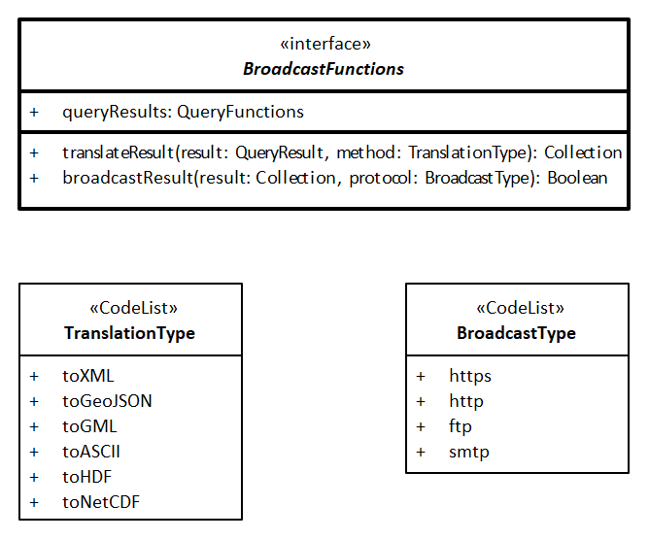
Figure 19 — Interoperation Broadcast

8.3.5.6. Defining tables for Interoperation Broadcast sub-package
- Table 57 Elements of Interoperation Broadcast::BroadcastFunctions
- Table 58 Defining elements of Interoperation Broadcast::TranslationType
- Table 59 Defining elements of Interoperation Broadcast::TranslationType
Table 57 — Elements of Interoperation Broadcast::BroadcastFunctions class
Name: | BroadcastFunctions
Definition: | an interface to translate the results from an Interoperation Query function into the requested format and return it to the client.
Stereotype: | Interface
Abstract: | true
Associations: | (none)
Public attributes: | Name | Definition | Derived | Obligation | Maximum occurence | Data type
 | queryResults | result received from the QueryFunctions ready for processing for export |  | M | 1 | QueryFunctions
 | resultBroadcast |  |  | M | 1 | BroadcastMethod
 | resultTranslation |  |  | M | 1 | ResultTranslationMethod
Operations: | Name | Parameters:ParameterType | Return type | Definition
 | translateResult | (result:QueryResult) | Collection | reformat query result from internal structure to requested format for broadcast.
 | broadcastResult | (result:Collection) | Boolean | broadcast reformatted result to client using designated protocol, and return acknowledgement of success
Constraints: | (none)

Table 58 — Elements of Interoperation Broadcast::BroadcastType class
Name: | BroadcastType
Definition: | CodeList for DGGS interoperation data broadcast protocols
Stereotype: | CodeList
Abstract: | true
Associations: | (none)
Values: | Name | Definition
 | https | broadcast over Hypertext transfer secure protocol
 | http | broadcast over Hypertext transfer protocol
 | ftp | broadcast over File transfer protocol

Table 59 — Elements of Interoperation Broadcast::TranslationType class
Name: | TranslationType
Definition: | CodeList for DGGS interoperation data broadcast translation formats.
Stereotype: | CodeList
Abstract: | true
Associations: | (none)
Values: | Name | Definition
 | toASCII | translate to ASCII format
 | toGeoJSON | translate to GeoJSON format
 | toGML | translate to GML format
 | toHDF | translate to HDF format
 | toNetCDF | translate to NetCDF format
 | toXML | translate to XML format

Requirement 19:
www.opengis.net/spec/DGGS/2.0/req/core/functions/interoperation/broadcast
A DGGS specification SHALL implement operations to translate data results from interoperation queries to standard data formats and broadcast the reformatted result set that conform to Figure 17, Figure 19, Table 52, and Table 57…Table 59.

9. DGGS Equal Area Earth Reference System Package

9.1. DGGS Equal Area Earth Reference System

9.1.1. DGGS Equal Area Earth Reference System Data Model
This Clause specifies the equal area earth reference system (EAERS) class for a DGGS specification.
For a DGGS that is compliant with the DGGS Core to be an Equal Area DGGS it shall satisfy the requirements described in this clause.
The data model supports DGGS EAERS based on either static and dynamic Datums. Care needs to be taken when implementing DGGS with static datums. Static reference systems are by their nature only intended for use on one tectonic plate, however the definition for a DGGS always has a global domain. This apparent conundrum is resolved in two ways:
- Orientation: Noting that some static reference systems have one or more points on the Earth’s surface where the underlying mathematics is poorly behaved, orient the EA_BaseUnitPolyhedron so that areas, centroids, vertices, and edges can be computed; and,
- Precision: On the tectonic plate where the reference frame is static choose the level of DGGS precision to suit the intended use of the DGGS (typically in the range of millimetres to 10s of metres), and in areas of the Earth on plates that are moving with respect to the static reference frame choose the level of DGGS precision to reflect the larger of the constraints imposed by the mathematics and by plate tectonics (typically in the of range 10s to 100,000s of metres).
Figure 20, Figure 21, & Figure 22 show the class structure for the reference frame of a DGGS specification and how the classes relate to each other.
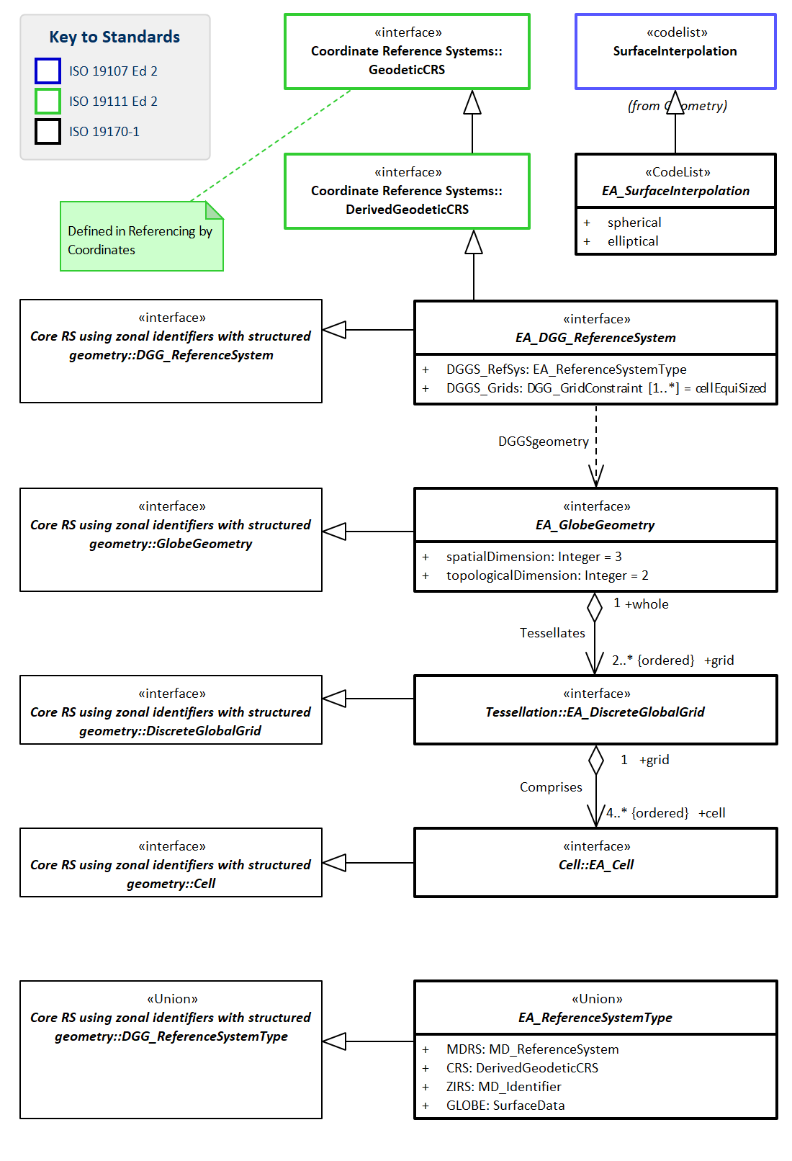
Figure 20 — Context for Equal Area Earth Reference System
Note: cf Clause 9.1.2 for definitions of tables in this Figure 20
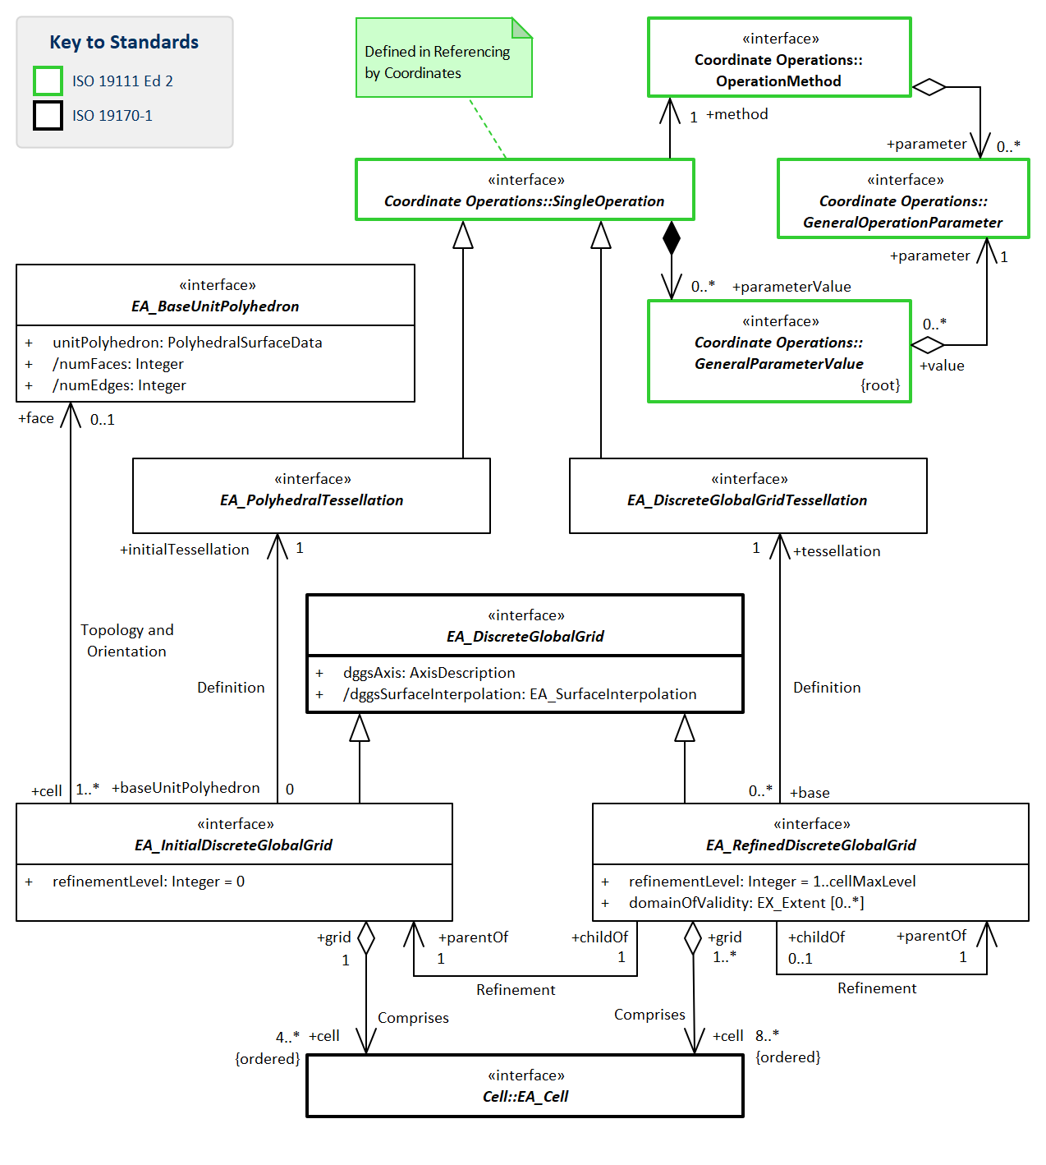
Figure 21 — Equal Area Earth Reference System Tessellations
Note: cf Clause 9.1.4.5 for definitions of tables in this Figure 21
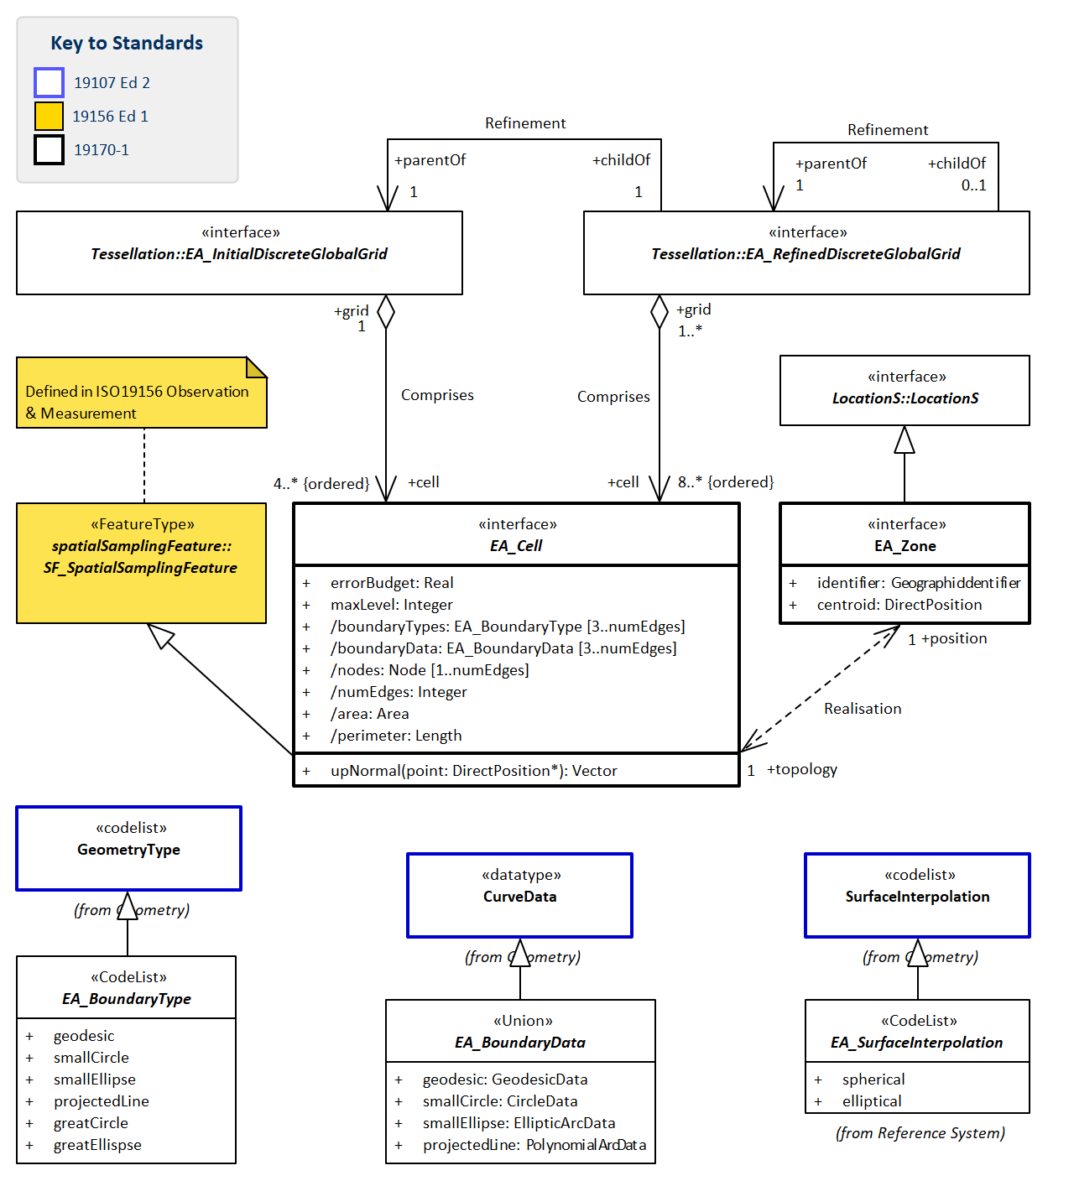
Figure 22 — Equal Area Earth Reference System Cells
Note: cf Clause 9.1.5.4 for definitions of tables in this Figure 22

9.1.2. Defining tables for Equal Area Earth DGG Reference System sub-package
- Table 60 Elements of Reference System::EA_DGG_ReferenceSystem
- Table 61 Elements of Reference System::EA_GlobeGeometry
- Table 62 Elements of Reference System::EA_ReferenceSystemType
- Table 63 Elements of Equal Area Earth DGG Reference System::EA_SurfaceInterpolation
Table 60 — Elements of Reference System::EA_DGG_ReferenceSystem class
Name: | EA_DGG_ReferenceSystem
Definition: | Defining characteristics of an Equal Area Earth Reference system using zonal identifiers with structured geometry.
Stereotype: | Interface
Inheritance from: | DGG_ReferenceSystem
Abstract: | true
Associations: | (none)
Public attributes: | Name | Definition | Derived | Obligation | Maximum occurence | Data type
 | DGGS_Grids | List of characteristics that constraint the grid cells in this DGGS in decreasing order of priority. cellEquiSized SHALL be the first value. |  | M | * | DGG_GridConstraint (code list)
 | DGGS_RefSys | Reference system metadata |  | M | 1 | EA_ReferenceSystemType (union data type)
Constraints: | (none)

Table 61 — Elements of Reference System::EA_GlobeGeometry class
Name: | EA_GlobeGeometry
Definition: | Parent geometry specifying the geometry, dimensionality and domain of the globe for this DGGS.  Geometry of the surface of an Earth Reference Model
Stereotype: | Interface
Inheritance from: | GlobeGeometry
Abstract: | true
Associations: | Association with: |  |  | Obligation | Maximum occurence | Provides:
 | EA_DiscreteGlobalGrid (feature type) |  |  | M | * | grid
Public attributes: | Name | Definition | Derived | Obligation | Maximum occurence | Data type
 | spatialDimension | EA_GlobeGeometry SHALL have a spatialDimension of 3 |  | M | 1 | Integer
 | topologicalDimension | EA_GlobeGeometry SHALL have a topologicalDimension of 2, co-responding to the surface of the Earth |  | M | 1 | Integer
Constraints: | (none)

Table 62 — Elements of Reference System::EA_ReferenceSystemType class
Name: | EA_ReferenceSystemType
Definition: | Defining metadata elements of the base CRS for a DGGS Equal Area Earth Reference System
Stereotype: | Union
Inheritance from: | DGG_ReferenceSystemType
Abstract: | true
Associations: | (none)
Public attributes: | Name | Definition | Derived | Obligation | Maximum occurence | Data type
 | CRS | Metadata required to reference coordinates, Includes CRS ID and coordinate Epoch for dynamic CRS |  | M | 1 | DerivedGeodeticCRS
 | GLOBE | SurfaceData for the chosen EA_GlobeGeometry that specifies geometry, spatial, and topological dimensionality and domain of the globe for this DGGS. |  | M | 1 | SurfaceData
 | MDRS | Reference system information describing this whole DGGS |  | M | 1 | MD_ReferenceSystem
 | ZIRS | Identifier for the Spatial Reference system using Geographic Identifiers used by the DGGS |  | M | 1 | MD_Identifier
Constraints: | (none)

Table 63 — Elements of Equal Area Earth DGG Reference System::EA_SurfaceInterpolation class
Name: | EA_SurfaceInterpolation
Definition: | Subset of Geometry::SurfaceInterpolation (code list) providing permitted interpolation methods for EA_Cell
Stereotype: | CodeList
Abstract: | true
Associations: | (none)
Values: | Name | Definition
 | spherical | The EA_Cell surface is a section of a spherical surface. Note:: for EA_Cells of sufficiently small extent, linear interoplation will be sufficient to meet the EA_Cell.errorBudget for area.
 | elliptical | The EA_Cell surface is a section of an elliptical surface. Note:: for EA_Cells of sufficiently small extent, spherical interoplation will be sufficient to meet the EA_Cell.errorBudget for area. Note:: for EA_Cells of sufficiently small extent, linear interoplation will be sufficient to meet the EA_Cell.errorBudget for area.

Requirement 20:
www.opengis.net/spec/DGGS/2.0/req/ea/ers/harmonised_model
An Equal Area Earth Reference system specification SHALL comply with the data model in Figure 20, Figure 21, & Figure 22 and definitions in Table 60…Table 73.

9.1.3. Global Domain
For a DGGS Reference System to be an EAERS the domain shall be defined as the entire surface of the Earth.
Requirement 21:
www.opengis.net/spec/DGGS/2.0/req/ea/ers/global_domain
Reference system global domain — the domain of an Equal Area Earth Reference System SHALL be the whole surface of the Reference Frame’s Earth Model and the DGG_ReferenceSystem SHALL specify the cellEqualSized as one of the DGGS_Grids constraint values

9.1.4. Tessellation

9.1.4.1. Tessellation Overview
A multiresolution hierarchical tessellation of cells is created by constructing a sequence of discrete global grids, each with successively finer cell resolutions. First an initial discrete global grid is constructed as described in sub-clause Clause 9.1.4.2 The cells of this initial tessellation are then iteratively refined by application of cell refinement method(s) [10] to create finer resolution child cells. The initial tessellation, the cell shape, the refinement methods and indexing methods may all vary for different DGGS.

9.1.4.2. Initial Tessellation
The entire surface of the Earth is partitioned to a finite/discrete set of regions. Most methods initially approximate the Earth’s surface using a simple base unit polyhedron which is scaled so that all vertices are located on the surface model of the Earth, and the edges are warped so they also lie on the surface model. The resulting edges may be any of the types listed in EA_CurveType. These include geodesics, small circles, small ellipses and lines that project to a straight line on a plane. These all result from intersections of a plane and an ellipsoid. The initial discrete global grid tessellation has the same form as the base unit polyhedron. Each EA_Cell of the initial tessellation represents one face of the chosen base unit polyhedron mapped to the chosen surface model of the Earth. This standard refers to the initial tessellation as a “polyhedral tessellation”. The most common choices for an initial base unit polyhedron are discussed in sub-clause Annex C.4 [10].
Requirement 22:
www.opengis.net/spec/DGGS/2.0/req/ea/ers/tessellation/initial
An Equal Area Earth Reference system specification SHALL include an initial tessellation that is defined by equal area cells produced by mapping the faces of a base unit polyhedron to the surface model of the Earth.

9.1.4.3. Tessellation Sequence
DGGS EAERS comprise a discrete sequence of global grids formed from recursive application of a tessellation method to refine the grid cells, so that each global grid has a progressively finer spatial resolution.
Requirement 23:
www.opengis.net/spec/DGGS/2.0/req/ea/ers/tessellation/sequence
An Equal Area Earth Reference system specification SHALL have tessellation operations that generate a sequence of discrete global grids with progressively smaller cells.

Requirement 24:
www.opengis.net/spec/DGGS/2.0/req/ea/ers/tessellation/sequence/max
An Equal Area Earth Reference system specification SHALL specify a limit to the number of iterations in its sequence of discrete global grids, to ensure that the error budget for EA_Cell’s area is not exceeded.

9.1.4.4. Global Area Preservation
Preservation of total surface area throughout the range of hierarchical tessellations is a necessary property of DGGS in order to represent information consistently at successive resolutions. This requirement ensures that each level of grid refinement completely covers the Earth’s surface without cell overlaps.
Requirement 25:
www.opengis.net/spec/DGGS/2.0/req/ea/ers/tessellation/global_area_preservation
For each successive discrete global grid, an Equal Area Earth Reference system specification on a base CRS that includes a

Dynamic Datum | SHALL preserve global domain completeness and position uniqueness.
Static Datum | SHALL preserve domain completeness and position uniqueness for all EA_Cells within their respective discrete global grids.

9.1.4.5. Defining Tables for Tessellation sub-package
- Table 64 Elements of Tessellation::EA_BaseUnitPolyhedron
- Table 65 Elements of Tessellation::EA_DiscreteGlobalGrid
- Table 66 Elements of Tessellation::EA_DiscreteGlobalGridTessellation
- Table 67 Elements of Tessellation::EA_InitialDiscreteGlobalGrid
- Table 68 Elements of Tessellation::EA_PolyhedralTessellation
- Table 69 Elements of Tessellation::EA_RefinedDiscreteGlobalGrid
Table 64 — Elements of Tessellation::EA_BaseUnitPolyhedron class
Name: | EA_BaseUnitPolyhedron
Definition: | EA_BaseUnitPolyhedron  Polyhedron with circumsphere radius of one, specified by the number and faces and edges and
Stereotype: | Interface
Abstract: | true
Associations: | (none)
Public attributes: | Name | Definition | Derived | Obligation | Maximum occurence | Data type
 | numEdges | number of edges in the EA_BaseUnitPolyhedron, | true | M | 1 | Integer
 | numFaces | number of faces on the EA_BaseUnitPolyhedron, corresponds to the number of EA_Cells in the EA_InitialDiscreteGlobalGrid | true | M | 1 | Integer
 | unitPolyhedron | PolygonData for each of the unit Polyhedron’s segment Polygons, expressed in spherical coordinates (theta, phi) with unit radius. |  | M | 1 | PolyhedralSurfaceData
Constraints: | self.vertex.r = 1

Table 65 — Elements of Tessellation::EA_DiscreteGlobalGrid class
Name: | EA_DiscreteGlobalGrid
Definition: | Super class for EA_InitialDiscreteGlobalGrid and EA_RefinedDiscreteGlobalGrid
Stereotype: | Interface
Inheritance from: | DiscreteGlobalGrid
Generalisation of: | EA_InitialDiscreteGlobalGrid, EA_RefinedDiscreteGlobalGrid
Abstract: | true
Associations: | Association with: |  |  | Obligation | Maximum occurence | Provides:
 | EA_Cell (feature type) |  |  | M | * | cell
Public attributes: | Name | Definition | Derived | Obligation | Maximum occurence | Data type
 | dggsAxis | A dggsAxis typically follows a space-filling curve designed to recursively traverse all cells in each tesselation, Cell::identifiers are ordered along the path of the dggsAxis. |  | M | 1 | AxisDescription
 | dggsSurfaceInterpolation | EA_SurfaceInterpolation corresponding to the form of the specified EA_GlobeGeometry. | true | M | 1 | EA_SurfaceInterpolation (code list)
Constraints: | (none)

Table 66 — Elements of Tessellation::EA_DiscreteGlobalGridTessellation class
Name: | EA_DiscreteGlobalGridTessellation
Definition: | The EA_DiscreteGlobalGridTessellation method implements the DGGS_Grids constraint, DGGS_Refinement strategy and DGGS_RefinementRatio, to create a child EA_RefinedDiscreteGlobalGrid from a parent EA_DiscreteGlobalGrid.
Stereotype: | Interface
Abstract: | true
Associations: | (none)
Public attributes: | (none)
Constraints: | (none)

Table 67 — Elements of Tessellation::EA_InitialDiscreteGlobalGrid class
Name: | EA_InitialDiscreteGlobalGrid
Definition: | The EA_InitialDiscreteGlobalGrid is formed by applying the EA_PolyhedralTessellation method to a the EA_BaseUnitPolyhedron.
Stereotype: | Interface
Inheritance from: | EA_DiscreteGlobalGrid
Abstract: | true
Associations: | Association with: |  |  | Obligation | Maximum occurence | Provides:
 | EA_Cell (feature type) |  |  | M | * | cell
 | EA_BaseUnitPolyhedron (feature type) |  |  | C | 1 | face
 | EA_PolyhedralTessellation (feature type) |  |  | M | 1 | initialTessellation
Public attributes: | Name | Definition | Derived | Obligation | Maximum occurence | Data type
 | refinementLevel | EA_InitialDiscreteGlobalGrid has a refinementlevel of 0. |  | M | 1 | Integer
Constraints: | (none)

Table 68 — Elements of Tessellation::EA_PolyhedralTessellation class
Name: | EA_PolyhedralTessellation
Definition: | The EA_PolyhedralTessellation method transforms the EA_BaseUnitPolyhedron in such a way that:  1) surface area of each cell belonging to the EA_InitialDiscreteGlobalGrid is the same,  2) domain completeness is preserved by the EA_InitialDiscreteGlobalGrid, and  3) location uniqueness is preserved by the EA_InitialDiscreteGlobalGrid.
Stereotype: | Interface
Abstract: | true
Associations: | (none)
Public attributes: | (none)
Constraints: | (none)

Table 69 — Elements of Tessellation::EA_RefinedDiscreteGlobalGrid class
Name: | EA_RefinedDiscreteGlobalGrid
Definition: | EA_DiscreteGlobalGrid formed by an EA_DiscreteGlobalGriodTessellation, is a EA_RefinedDiscreteGlobalGrid.
Stereotype: | Interface
Inheritance from: | EA_DiscreteGlobalGrid
Abstract: | true
Associations: | Association with: |  |  | Obligation | Maximum occurence | Provides:
 | EA_Cell (feature type) |  |  | M | * | cell
 | EA_RefinedDiscreteGlobalGrid (feature type) |  |  | M | 1 | parentOf
 | EA_InitialDiscreteGlobalGrid (feature type) |  |  | M | 1 | parentOf
 | EA_DiscreteGlobalGridTessellation (feature type) |  |  | M | 1 | tessellation
Public attributes: | Name | Definition | Derived | Obligation | Maximum occurence | Data type
 | domainOfValidity | For DGGS with a dynamic datum the domainOfValidity is always global. |  | C | * | EX_Extent
 | refinementLevel | The child EA_RefinedDiscreteGlobalGrid has a refinementlevel of one greater than it’s parent. |  | M | 1 | Integer
Constraints: | (none)

9.1.5. Cell

9.1.5.1. Cells are Simple Polygons
EA_Cells are simple polygons formed from an ordered set of boundary curves adhering to the geometric reference surface of the Earth model. EA_Cells are defined in three-dimensional space and are topologically two-dimensional. Different cell shapes can be used, typically triangle, quadrilateral, pentagon, hexagon, and octagon. Cells formed from faces of the five (5) Platonic solids (tetrahedron-triangle, cube-quadrilateral, octahedron-triangles, dodecahedron-pentagons, icosahedron-triangles) all satisfy the requirements for simple cells. Larger numbers of faces and therefore cells at the top of the hierarchy of tessellations, increases the uniformity of the cell shape. The truncated icosahedron, with thirty-two (32) faces is often used for DGGS –- it produces mostly hexagons augmented by twelve (12) pentagons in each tessellation. Each cell shape has its own advantages and disadvantages [10] and it is usually desirable for each refined discrete global grid to have a majority of cells with the same shape [16],[17]. Triangular, quadrilateral and hexagonal cells are common choices used in DGGS on the surface of the Earth. These shapes provide regular tiling of the plane [16], which can be mapped to a curved surface such as a spherical or ellipsoidal Earth surface model.
The cell structures in each successive level of cell refinement are constrained by the properties of the initial tessellation, but do not necessarily have the same geometry as the initial tessellation. Simple 2D cells have the properties that:
- Edges that meet only at the vertices;
- Exactly two edges meeting at each vertex;
- Exactly the same number of edges and vertices; and,
- Enclosing a region which always has a measurable area.
Requirement 26:
www.opengis.net/spec/DGGS/2.0/req/ea/ers/cell/simple/2d_polygon
For each successive discrete global grid, an Equal Area Earth Reference system specification SHALL define EA_Cells that are simple polygons.

9.1.5.2. Cells Referenced at their Centroid
Each EA_Cell shall be referenced at its centroid. This is because the centroid is the only location that will provide a representative point that behaves consistently with shape and is invariant under orientation. The representative point for an EA_Cell needs to lie on the surface of the cell. For curved surfaces, the “centre of gravity” computed in 3D may not actually lie on the surface 6.4.4.8. If however the “centre of gravity” is computed using distances computed along geodesic arcs on the curved surface, then the centroid will lie on the surface. We refer to this as a centroid calculated as the “geodesic centre of surface area” of a EA_Cell.
The centroid enables a dual representation of a DGGS tessellation as both two-dimensional areal cell grids and as point-based lattices of cell reference locations.
Requirement 27:
www.opengis.net/spec/DGGS/2.0/req/ea/ers/cell/direct_position/centroid
An Equal Area Earth Reference system specification SHALL define the direct position of an EA_Cell to be the centroid of the EA_cell.

9.1.5.3. Equal Area Cells
This standard defines a DGGS EAERS based on a hierarchy of equal area tessellations. Equal area cells provide global grids with spatial units that (at multiple resolutions) have an equal probability of contributing to an analysis. Equal area cells also help to minimize the confounding effects of area variations in spatial analyses where the curved surface of the earth is the fundamental reference frame.
In a DGGS reference system the unit of measure is a unit of area, not length as in a cartesian XYZ coordinate system or angle as in an ellipsoidal coordinate system. For angular measures the degree is defined as one 360th integer fraction of a full circle, and by analogy the areal unit of measure of a DGGS coordinate reference system is an integer fraction of the surface area of the chosen ellipsoidal surface model for the earth. For DGGS the integer fraction is the number of cells in the initial discrete global grid. Continuing the angular analogy with minutes being 1/60th of a degree and seconds 1/60th of a minute, for DGGS recursive use of the refinement ratio generates a sequence of smaller areal units, one for each refined discrete global grid.
Standard units of measure are defined through a reference measure with defined precision. The meter unit of length has been redefined a number of times as technology has improved. For example
- From 1793: 1/10,000,000 of the meridian through Paris between the North Pole and the Equator (+/- ~10⁻⁴ m), and,
- From 1983: The length of the path travelled by light in a vacuum in 1/299,792,458th of a second (+/- 10⁻¹⁰ m).
To address the need for transparency of the precision in it’s units of area, this standard uses the concept of a specified error budget. The error budget needs to take into account all sources of variation that are relevant to the particular DGGS, its derivation, and its expected use. For most day to day uses, most of these sources will contribute errors that are significantly smaller than the precision required of the DGGS. However, as technology pushes the limits of available precision, and use-cases demand combining data from highly disparate sources, and users push their expectations it becomes more and more important to know when limits of use are reached.
The sources considered for inclusion in the error budget could include:
- spatial variation: whether the available precision of each source of error is uniform or variable across the DGGS domain,
- datum: precision of the underlying measurements for the datum,
- static datum: precision of the assertion that the coordinates are static both on the tectonic plate the datum is tied to, and away from the static plate,
- earth model: differences between the chosen ellipsoidal or spherical earth model and the real earth’s surface, Spheres lead to faster and more precise computations for the tessellations, but have a less precise fit to the real earth’s surface.
While implementation issues are beyond the scope of this standard, the following sources may contribute to increases in error budgets for an implementation:
- spherical maths: exact solutions are available for solving the required mathematics on the surface of a sphere,
- ellipsoidal maths: solving the required mathematics on the surface of an ellipsoid requires the use of iterative numerical methods which result in approximate solutions with an uncertainty determined by both the method and the number of iterations used to perform the computation,
- data-type precision: most will probably use 64-bit double precision for location, anything less will have a significant impact on the error budget,
- cell edge type: geodesics, small circles, small ellipses, and projected lines each have different solutions with different consequences for their precision and performance. At finer resolutions it may be possible to implement a simpler edge type and still stay within the implementation error budget,
- error propagation: the choice of strategy for implementing the sequence of tessellations.
The error budget puts a limit on the number of iterations in the sequence of refined discrete global grids. This is acknowledged in the requirements.
DGGS may validly comprise more than one cell geometry. This most typically arises for systems based on truncated polyhedra such as the cuboctahedron — with both square and triangular faces, and the truncated icosahedron — with pentagonal and hexagonal faces. In these situations, equal area is interpreted to mean that all the cells of a particular geometry are equal area, and that the ratio of the areas of the two geometries is preserved through the tessellations. For example, in the truncated icosahedron used by ISEA the ratio of pentagonal to hexagonal areas within a tessellation level is always 5/6.
Requirement 28:
www.opengis.net/spec/DGGS/2.0/req/ea/ers/cell/equal_area/error_budget
An Equal Area Earth Reference system SHALL specify error budget(s) for cell area of 1% or less that represents the maximum ratio of a cells area to the theoretical average cell area within a level computed from the number of cells in the level and the surface area of the earth model.

Dynamic Datum | For each successive level of grid refinement, an Equal Area Earth Reference system specification SHALL specify one error budget value.
Static Datum | For each successive level of grid refinement, an Equal Area Earth Reference system specification SHALL specify at least one error budget value for the area of the globe that it is static, and at least one error budget value for the area of the globe that is not static.

Requirement 29:
www.opengis.net/spec/DGGS/2.0/req/ea/ers/cell/equal_area
For each discrete global grid, and for each cell geometry, an Equal Area Earth Reference system specification SHALL define EA_Cells that are equal area within the specified error budget.

9.1.5.4. Defining Tables for Cell sub-package
- Table 70 Elements of Cell::EA_BoundaryData
- Table 71 Elements of Cell::EA_Cell
- Table 72 Elements of Cell::EA_Zone
- Table 73 Elements of Equal Area Earth DGG Cell::EA_BoundaryType
Table 70 — Elements of Cell::EA_BoundaryData class
Name: | EA_BoundaryData
Definition: | Curve data for the permitted boundary types. GreatCircle and greatEllipse boundary types use the same data types as smallCircle and smallEllipse respectively.
Stereotype: | Union
Abstract: | true
Associations: | (none)
Public attributes: | Name | Definition | Derived | Obligation | Maximum occurence | Data type
 | geodesic | Curve data for a geodesic boundary |  | M | 1 | GeodesicData
 | projectedLine | curve data for a projected line boundary |  | M | 1 | PolynomialArcData
 | smallCircle | curve data for a small circle boundary |  | M | 1 | CircleData
 | smallEllipse | curve data for a small ellipse boundary |  | M | 1 | EllipticArcData
Constraints: | (none)

Table 71 — Elements of Cell::EA_Cell class
Name: | EA_Cell
Definition: | Reference system unit of geometry associated with an EA_Zone. As part of EA_GlobeGeometry, it has the same spatial, temporal and topological dimensionality as GlobeGeometry.  Note: As an EA_Cell on the surface of the Earth, its topologicalDimension is 2.
Stereotype: | Interface
Inheritance from: | Cell
Abstract: | true
Associations: | (none)
Public attributes: | Name | Definition | Derived | Obligation | Maximum occurence | Data type
 | area | area of the cell’s surface | true | M | 1 | Area
 | boundaryData | List of EA_BoundaryDara that make up the cells’ boundary, starting with the curve connecting node_0 to node_1, and continuing in a clockwise sequence. | true | M | 1 | EA_BoundaryData (union data type)
 | boundaryTypes | List of EA_CurveTypes that make up the cells’ boundary, starting with the curve connecting node_0 to node_1, and continuing in clockwise sequence. | true | M | 1 | EA_BoundaryType (code list)
 | errorBudget | For DGGS referencing a dynamic datum, cellEqualAreaPrecision will typically be a single value for each tessellation, and therefore most efficiently realised as an attribute of each RefinedDiscreteGlobalGrid. |  | M | 1 | Real
 | maxLevel | For DGGS referencing a dynamic datum, cellMaxLevel will typically be a single value for each tessellation, and therefore most efficiently realised as an attribute of each RefinedDiscreteGlobalGrid. |  | M | 1 | Integer
 | nodes | Ordered sequence of vertices, clockwise round the cell’s boundary | true | M | 1 | Node
 | numEdges | number of edges that make up the cell’s boundary | true | M | 1 | Integer
 | perimeter | length of the cell’s boundary | true | M | 1 | Length
Constraints: | (none)

Table 72 — Elements of Cell::EA_Zone class
Name: | EA_Zone
Definition: | An EA_Cell’s location is an EA_Zone
Stereotype: | Interface
Inheritance from: | LocationS
Associations: | (none)
Public attributes: | Name | Definition | Derived | Obligation | Maximum occurence | Data type
 | centroid | cell’s representative position calculated as the cell’s geodesic centre of surface area, held by the cell’s LocationS |  | M | 1 | DirectPosition
 | identifier | EA_Zone’s unique GeographicIdentifier. Commonly known as the CellID |  | M | 1 | GeographicIdentifier
Constraints: | (none)

Table 73 — Elements of Equal Area Earth DGG Cell::EA_BoundaryType class
Name: | EA_BoundaryType
Definition: | CodeList for permitted curve types as constructors of an EA_Cell boundary.  Note: All EA_BoundaryType curves can be constructed as an intersection of a plane and an ellipsoid. So each of these curve types is a straight line on a designated plane.
Stereotype: | CodeList
Abstract: | true
Associations: | (none)
Values: | Name | Definition
 | geodesic | shortest path between two points on the spherical or ellipsoidal DGGS’s earth reference model. Geodesic curves are defined using the GeodesicData constructor.
 | smallCircle | Curves that are the intersection of a plane and an ellipsoid, where the plane is perpendicular to the axis of rotation of an ellipsoid are in small circles, c.f. greatCircle. Lines of latitude are small circles.
 | greatCircle | The great circle is a special case of small circle where the two focal points of the ellipse are also on the defining plane. On a non-spherical ellipsoid this is the only circle that is also a geodesic.
 | smallEllipse | Curves that are the intersection of a plane and an ellipsoid, where the plane is parallel to the axis of rotation of the ellipsoid, are small ellipses, c.f. greatEllipse.
 | greatEllipse | A greatEllipse is a special case of smallEllipse where the axis of rotation is on the defining plane. GreatEllipses are geodesics. Lines of longitude are greatEllipses.
 | projectedLine | A curve on the surface of an ellipsoid, whose equal-area projection on the projection’s reference plane is a straight line.

Annex A
(normative)
Abstract Test Suite
This Annex specifies an Abstract Test Suite which shall be passed in completeness by any specification claiming conformance with this Abstract Specification.
Tests identifiers below are relative to http://www.opengis.net/spec/DGGS/2.0/

A.1. Conformance Common Spatio-temporal Classes Modules
Table A.1 — Categories of conformance
Category | Requirements
Temporal geometry and topology | Test 1
Temporal reference systems using period identifiers | Test 4
Spatial zone geometry and topology | Test 2
Spatial reference systems using zonal identifiers | Test 3, & Test 5
Spatio-temporal zone geometry and topology | Test 1, & Test 2
Spatio-temporal reference systems using zonal identifiers | Test 3, Test 4, & Test 5

Test 1: Common Spatio-temporal Classes — Temporal — Geometry
Abbreviation | conf/cc/temporal/geometry
Type | Basic
Requirement | Clause 7.2.1.2, Requirement 1: http://www.opengis.net/spec/DGGS/2.0/req/cc/temporal/geometry
Reference Clause | Clause 7.2.1
Test Purpose | To verify the common classes for temporal geometry and topology conform to the data model in Figure 3…Figure 4 and defining tables in Table 2…Table 13.
Test Method | Inspect documentation of the DGGS specification.
Test 2: Common Spatio-temporal Classes — Zone — Geometry
Abbreviation | conf/cc/zone/geometry
Type | Basic
Requirement | Clause 7.2.2.2, Requirement 2: http://www.opengis.net/spec/DGGS/2.0/req/cc/zone/geometry
Reference Clause | Clause 7.2.2
Test Purpose | To verify the common classes for zonal geometry and topology conform to the data model in Figure 5 and defining tables in Table 14…Table 19.
Test Method | Inspect documentation of the DGGS specification.
Test 3: Common Spatio-temporal Classes — Spatial — Location
Abbreviation | conf/cc/spatial/location
Type | Basic
Requirement | Clause 7.3.1.2, Requirement 3: http://www.opengis.net/spec/DGGS/2.0/req/cc/spatial/location
Reference Clause | Clause 7.3.1
Test Purpose | To verify the common classes for spatial location conform to the data model in Figure 6 and defining tables in Table 20.
Test Method | Inspect documentation of the DGGS specification.
Test 4: Common Spatio-temporal Classes — Temporal — Reference system using period identifiers
Abbreviation | conf/cc/temporal/rsupi
Type | Basic
Requirement | Clause 7.3.2.2, Requirement 4: http://www.opengis.net/spec/DGGS/2.0/req/cc/temporal/rsupi
Reference Clause | Clause 7.3.2
Test Purpose | To verify the common classes for reference systems using period identifiers conform to the data model in Figure 6 and defining tables in Table 21…Table 24.
Test Method | Inspect documentation of the DGGS specification.
Test 5: Common Spatio-temporal Classes — Zone — Reference system using zonal identifiers
Abbreviation | conf/cc/zone/rsuzi
Type | Basic
Requirement | Clause 7.3.3.2, Requirement 5: http://www.opengis.net/spec/DGGS/2.0/req/cc/zone/rsuzi
Reference Clause | Clause 7.3.3
Test Purpose | To verify the common classes for reference systems using zonal identifiers conform to the data model in Figure 8…Figure 11 and defining tables in Table 25…Table 36.
Test Method | Inspect documentation of the DGGS specification.

A.2. Core Package
Table A.2 — Categories of conformance
Category | Requirements
Spatial DGGS Core | Test 2, Test 3, Test 5, and  all Core requirements in Test 6…Test 19.
Spatio-temporal DGGS Core | Test 1, Test 2, Test 3, Test 4, Test 5, and  all Core requirement tests in Test 6…Test 19.

A.2.1. Core — Reference System
Test 6: Core — Reference system — Harmonised Model
Abbreviation | conf/core/rs/harmonised_model
Type | Basic
Requirement | Clause 8.2.2, Requirement 6: http://www.opengis.net/spec/DGGS/2.0/req/core/rs/harmonised_model
Reference Clause | Clause 8.2
Test Purpose | To verify that all reference system classes comply with classes in the Core reference system data model in Figure 13 and definitions in Table 37…Table 43.
Test Method | Inspect documentation of the DGGS specification.
Test 7: Core — Reference system — CRS
Abbreviation | conf/core/rs/crs
Type | Basic
Requirement | Clause 8.2.2, Requirement 7: http://www.opengis.net/spec/DGGS/2.0/req/core/rs/crs
Reference Clause | Clause 8.2
Test Purpose | To verify that the DGGS Reference Specification defines a CRS and complies with coordinate epoch requirements as specified for MD_ReferenceSystem.
Test Method | Inspect documentation of the DGGS specification.
Test 8: Core — Reference system — Global Domain
Abbreviation | conf/core/rs/global_domain
Type | Basic
Requirement | Clause 8.2.3, Requirement 8: http://www.opengis.net/spec/DGGS/2.0/req/core/rs/global_domain
Reference Clause | Clause 8.2.3
Test Purpose | To verify a reference system specifies a global domain, and its spatial, temporal and topological dimensionality.
Test Method | Inspect documentation of the DGGS specification.
Test 9: Core — Reference system — Global Domain — Complete
Abbreviation | conf/core/rs/global_domain/complete
Type | Basic
Requirement | Clause 8.2.3, Requirement 9: http://www.opengis.net/spec/DGGS/2.0/req/core/rs/global_domain/complete
Reference Clause | Clause 8.2.3
Test Purpose | To verify reference system domain completeness, with the level zero discrete global grid covering the entire global domain.
Test Method | Inspect documentation of the DGGS specification.

Test 10: Core — Reference system — Global Domain — Unique
Abbreviation | conf/core/rs/global_domain/unique
Type | Basic
Requirement | Clause 8.2.3, Requirement 10: http://www.opengis.net/spec/DGGS/2.0/req/core/rs/global_domain/unique
Reference Clause | Clause 8.2.3
Test Purpose | To verify reference system domain uniqeness, with every location in the domain of the DGGS located in exactly one cell of the level zero discrete global grid.
Test Method | Inspect documentation of the DGGS specification.
Test 11: Core — Reference system — Cell — Simple
Abbreviation | conf/core/rs/cell/simple
Type | Basic
Requirement | Clause 8.2.4.1, Requirement 11: http://www.opengis.net/spec/DGGS/2.0/req/core/cell/simple
Reference Clause | Clause 8.2.4.1
Test Purpose | To verify that all the cells of a DGGS specification have shapes that are simple geometry, where the geometry of the Cell: does not self-intersect; is topologically the same as the equivalent shape of a circle with the cell’s dimensionality; and encloses a region that is measurable in the cell’s metric.
Test Method | Inspect documentation of the DGGS specification.
Test 12: Core — Reference system — Cell — Direct Position
Abbreviation | conf/core/rs/cell/direct_position
Type | Basic
Requirement | Clause 8.2.4.2, Requirement 12: http://www.opengis.net/spec/DGGS/2.0/req/core/cell/direct_position
Reference Clause | Clause 8.2.4.2
Test Purpose | To verify that all zones in each discrete global grid are assigned a direct position that is within the zone’s boundary.
Test Method | Inspect documentation of the DGGS specification.
Test 13: Core — Reference system — Cell — Address
Abbreviation | conf/core/rs/cell/address
Type | Basic
Requirement | Clause 8.2.4.3, Requirement 13: http://www.opengis.net/spec/DGGS/2.0/req/core/cell/address
Reference Clause | Clause 8.2.4.3
Test Purpose | To verify that all zones in all discrete global grids have a globally unique zonal identifier (or cell index) that provides a spatio-temporal reference.
Test Method | Inspect documentation of the DGGS specification.
Test 14: Core — Reference system — Discrete Global Grid
Abbreviation | conf/core/rs/discrete_global_grid
Type | Basic
Requirement | Clause 8.2.5, Requirement 14: http://www.opengis.net/spec/DGGS/2.0/req/core/rs/discrete_global_grid
Reference Clause | Clause 8.2.5
Test Purpose | To verify that a DGGS reference system defines discrete global grids as aggregations of all the cells at the same level in the hierarchy.
Test Method | Inspect documentation of the DGGS specification.
Test 15: Core — Reference system — Discrete Global Grid — Sequence
Abbreviation | conf/core/rs/discrete_global_grid/sequence
Type | Basic
Requirement | Clause 8.2.5, Requirement 15: http://www.opengis.net/spec/DGGS/2.0/req/core/rs/discrete_global_grid/sequence
Reference Clause | Clause 8.2.5
Test Purpose | To verify a DGGS reference system orders its discrete global grids in a sequence of increasing refinement level.
Test Method | Inspect documentation of the DGGS specification.

A.2.2. Core — Functions
Test 16: Core — Functions — Quantization
Abbreviation | conf/core/functions/quantization
Type | Basic
Requirement | Clause 8.3.2, Requirement 16: http://www.opengis.net/spec/DGGS/2.0/req/core/functions/quantization
Reference Clause | Clause 8.3.1
Test Purpose | To verify that a DGGS specification has operations to assign data from external sources to cells that conform the data model in Figure 14 and classes defined in Table 44…Table 48.
Test Method | Inspect documentation of the DGGS specification.

Test 17: Core — Functions — Query — ZoneQuery
Abbreviation | conf/core/functions/query/zonequery
Type | Basic
Requirement | Clause 8.3.4, Requirement 17: http://www.opengis.net/spec/DGGS/2.0/req/core/functions/query/zonequery
Reference Clause | Clause 8.3.3
Test Purpose | To verify that a DGGS specification implements query operations that conform to the data model in Figure 16 and classes defined in Table 49…Table 51, across its entire domain.
Test Method | Inspect documentation of the DGGS specification.
Test 18: Core — Functions — Interoperation — Query
Abbreviation | conf/core/functions/interoperation/query
Type | Basic
Requirement | Clause 8.3.5.4, Requirement 18: http://www.opengis.net/spec/DGGS/2.0/req/core/functions/interoperation/query
Reference Clause | Clause 8.3.5.3
Test Purpose | To verify that a DGGS specification implements operations to read, interpret and execute external data queries that conform to the classes defined in Figure 17, Figure 18 and Table 52…Table 56.
Test Method | Inspect documentation of the DGGS specification.
Test 19: Core — Functions — Interoperation — Broadcast
Abbreviation | conf/core/functions/interoperation/broadcast
Type | Basic
Requirement | Clause 8.3.5.6, Requirement 19: http://www.opengis.net/spec/DGGS/2.0/req/core/functions/interoperation/broadcast
Reference Clause | Clause 8.3.5.5
Test Purpose | To verify that a DGGS specification implements operations to translate data results from interoperation queries to standard data formats and broadcast the reformatted result set that conform to the classes defined in Figure 17, Figure 19, Table 52, and Table 57…Table 59_.
Test Method | Inspect documentation of the DGGS specification.

A.3. Equal Area Earth Reference system Package
Table A.3 — Categories of conformance
Category | Requirements
Equal Area Earth DGGS | Test 2, Test 3, & Test 5, and  all Core requirement tests in Test 6…Test 19, and  all Equal Area Earth RS requirement tests in Test 20…Test 29.

Test 20: Equal Area — Earth Reference System — Harmonised Model
Abbreviation | conf/ea/ers/harmonised_model
Type | Basic
Requirement | Clause 9.1.2, Requirement 20: http://www.opengis.net/spec/DGGS/2.0/req/ea/ers/harmonised_model
Reference Clause | Clause 9.1
Test Purpose | To verify an Equal Area Earth Reference system specification complies with the data model in Figure 20, Figure 21, & Figure 22 and definitions in Table 60…Table 73
Test Method | Inspect documentation for the Equal Area Earth Reference System specification.
Test 21: Equal Area — Earth Reference System — Global Domain
Abbreviation | conf/ea/ers/global_domain
Type | Basic
Requirement | Clause 9.1.3, Requirement 21: http://www.opengis.net/spec/DGGS/2.0/req/ea/ers/global_domain
Reference Clause | Clause 9.1.3
Test Purpose | To verify the domain of an Equal Area Earth Reference System is the whole surface of the Reference Frame’s Earth Model and the DGG_ReferenceSystem cellEqualSized is specified as a DGGS_Grids constraint.
Test Method | Inspect documentation of the Equal Area Earth Reference System specification.
Test 22: Equal Area — Earth Reference System — Tessellation — Initial
Abbreviation | conf/ea/ers/tessellation/initial
Type | Basic
Requirement | Clause 9.1.4.2, Requirement 22 : http://www.opengis.net/spec/DGGS/2.0/req/ea/ers/tessellation/initial
Reference Clause | Clause 9.1.4.2
Test Purpose | To verify that an Equal Area Earth Reference system specification has an initial tessellation comprising equal area cells produced by mapping the faces of a base unit polyhedron to a surface model of the Earth.
Test Method | Inspect documentation of the Equal Area Earth Reference system specification.
Test 23: Equal Area — Earth Reference System — Tessellation — Sequence
Abbreviation | conf/ea/ers/tessellation/sequence
Type | Basic
Requirement | Clause 9.1.4.3, Requirement 23 : http://www.opengis.net/spec/DGGS/2.0/req/ea/ers/tessellation/sequence
Reference Clause | Clause 9.1.4.3
Test Purpose | To verify an Equal Area Earth Reference specification defines tessellation operations that generate a sequence of discrete global grids with progressively smaller cells.
Test Method | Inspect documentation of the Equal Area Earth Reference system specification.
Test 24: Equal Area — Earth Reference System — Tessellation — Sequence — Max
Abbreviation | conf/ea/ers/tessellation/sequence/max
Type | Basic
Requirement | Clause 9.1.4.3, Requirement 24 : http://www.opengis.net/spec/DGGS/2.0/req/ea/ers/tessellation/sequence/max
Reference Clause | Clause 9.1.4.3
Test Purpose | To verify that an Equal Area Earth Reference specification specifies a limit in its sequence of discrete global grids that ensures the error budget for EA_Cell area cannot be exceeded.
Test Method | Inspect documentation of the Equal Area Earth Reference system specification.
Test 25: Equal Area — Earth Reference System — Tessellation — Global Area Preservation
Abbreviation | conf/ea/ers/tessellation/global_area_preservation
Type | Basic
Requirement | Clause 9.1.4.4, Requirement 25 : http://www.opengis.net/spec/DGGS/2.0/req/ea/ers/tessellation/global_area_preservation
Reference Clause | Clause 9.1.4.4
Test Purpose | To verify for EA_Cells in each successive discrete global grid, that Domain completeness and Location uniqueness are preserved, with total area of those EA_Cells the same as the initial global grid and no overlapping DGGS cells.
Test Method | Inspect documentation of the Equal Area Earth Reference system specification.
Test 26: Equal Area — Earth Reference System — Cell — Simple — 2D Polygon
Abbreviation | conf/ea/ers/cell/simple/2d_polygon
Type | Basic
Requirement | Clause 9.1.5.1, Requirement 26: http://www.opengis.net/spec/DGGS/2.0/req/ea/ers/cell/simple/2d_polygon
Reference Clause | Clause 9.1.5.1
Test Purpose | To verify that all of the cells of an Equal Area Earth Reference system specification have shapes that are simple polygons on the surface model of the Earth where: edges only meet at vertices; exactly two edges meet at each vertex; the number of edges and vertices are the same; and the region enclosed always has a measurable area.
Test Method | Inspect documentation of the Equal Area Earth Reference system specification.

Test 27: Equal Area — Earth Reference System — Cell — Direct Position — Centroid
Abbreviation | conf/ea/ers/cell/direct_position/centroid
Type | Basic
Requirement | Clause 9.1.5.2, Requirement 27: http://www.opengis.net/spec/DGGS/2.0/req/ea/ers/cell/direct_position/centroid
Reference Clause | Clause 9.1.5.2
Test Purpose | To verify that the cells defined by an Equal Area Earth Reference System are referenced at the centroid of each cell. This test requires verification that the attribute EA_Cell::centroid returns a direct position on the surface of the cell.
Test Method | Inspect documentation of the Equal Area Earth Reference system specification.
Test 28: Equal Area — Earth Reference System — Cell — Equal Area — Error Budget
Abbreviation | conf/ea/ers/cell/equal_area/error_budget
Type | Basic
Requirement | Clause 9.1.5.3, Requirement 28: http://www.opengis.net/spec/DGGS/2.0/req/ea/ers/cell/equal_area/error_budget
Reference Clause | Clause 9.1.5.3
Test Purpose | To verify that an Equal Area Earth Reference system specification defines error budget(s) of 1% or less that represents the maximum ratio of a cell’s area to the theoretical cell area computed from the number of cells and the surface area of the earth model.
Test Method | Inspect documentation of the Equal Area Earth Reference system specification.
Test 29: Equal Area — Earth Reference System — Cell — Equal Area
Abbreviation | conf/ea/ers/cell/equal_area
Type | Basic
Requirement | Clause 9.1.5.3, Requirement 29: http://www.opengis.net/spec/DGGS/2.0/req/ea/ers/cell/equal_area
Reference Clause | Clause 9.1.5.3
Test Purpose | To verify that the cells in each discrete global grid, and of each cell geometry in a DGGS specification have equal area within the specified error budget.
Test Method | Inspect documentation of the Equal Area Earth Reference system specification, and for each discrete global grid, compare the area of each cell defined by its geometry with the average area of all cells of the same geometry (triangle, quadrangle, pentagon, or hexagon).

Annex B
(informative)
Equal Area Discrete Global Grid System Theory
All Discrete Global Grid Systems (DGGS) are structured for information as distinct from conventional coordinate reference systems originally designed for navigation. For a grid based global spatial information system to operate effectively as an analytical system it should be constructed using cells that represent the surface of the Earth in a uniform way. This ensures that, at each resolutions, all cells have the same probability of contributing to an analysis. An Equal Area DGGS is a spatial reference system that uses a hierarchy of equal area tessellations to partition the surface of the Earth into grid cells or their analogous lattice points. In this way information recorded about phenomena at a location can be easily referenced to the explicit area of the associated cell, integrated with other cell values, and provides statistically valid summaries based on any chosen selection of cells. With equal area partitioning, spatial analysis can be replicated consistently anywhere on the Earth independent of resolution or scale.
Equal Area Earth DGGS reference systems are polyhedral reference systems on the surface of a base unit polyhedron’s circumscribed ellipsoid. The base unit polyhedron’s location and orientation is defined in Earth Centered (EC) coordinates. The initial equal area tessellation of the chosen ellipsoidal Earth model is constructed by scaling a unit polyhedron of defined orientation until its vertices all touch the ellipsoid and connecting adjoining vertices with arcs selected from the set of permitted arcs, the simplest of which are geodesic, small circle or small ellipse arcs. Appropriate differential scaling is applied to the unit polyhedron to ensure an equal area initial tessellation. For the simple case of regular polyhedra and geodesic (i.e. great circle) arcs on its circumscribed spheroid the scaling is uniform. Figure B.1 illustrates their simplest form using a regular spherical polyhedron with a spheroidal circumscribing ellipsoid and geodesic arcs. Small circle arcs are typically used to construct arcs along lines of latitude for both ellipsoids and spheroids. Both small circle and small ellipse arcs are formed from the intersection of a defined plane with the ellipsoid, and in that sense they can be considered equivalent to the “straight” lines of 2D cell boundaries. More complex forms of straight line, such as arcs that project to a straight line in an equal area projection are also allowed.
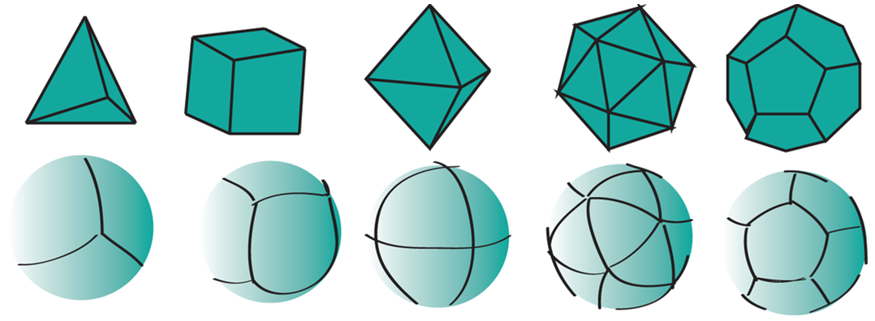
- tetrahedron | - hexahedron (cube) | - octahedron | - icosahedron | - dodecahedron
Figure B.1 — Regular polyhedra (top) and their corresponding initial equal area tessellation (bottom) after [[9], Fig 2]
There is a gap between conventional coordinate reference systems and the reference system needed to define DGGS. This document fills the gap in existing ISO standard reference systems and establishes requirements for globally interoperable equal-area cell- or lattice-based information frameworks.
Existing spatial reference systems (e.g. ECEF [Earth Centered Earth Fixed], WGS 84 or Web Mercator) build grids from projected Cartesian or ellipsoidal coordinate axes. Rectangular planar grids are typically formed by establishing a set of regular ticks on a pair of linear axes with grids cells being formed by the intersection of straight lines drawn normal to the ticks on each axis. Analogous construction techniques can be used to create triangular or hexagonal grids. The properties of grids built this way arise from the premise of planar geometry and not the curved geometry of the surface of a sphere or ellipsoid. While these properties hold true at local scales, in curved geometries they increasingly fail at progressively larger regions of interest (see Figure B.2). Take for example the assumption that a grid cell’s geometric properties are independent of its size or resolution — which is implicit in constructing sets of planar aligned (or ‘nested’) 10 m, 30 m and 90 m grids. As shown in Figure B.3, a 90 m square cell formed from nine 30 m square child cells has the following properties:
- It is also square;
- Its edges are three times the edge length of its 30 m child cells, which in turn all are three times the edge length of their 10 m child cells;
- Its interior angles are all right angles and identical to the interior angles of all of the child cells;
- Its edges follow the shortest linear path between neighbouring cell vertices; and,
- The angles or bearings from centroid to centroid between cells are preserved irrespective of the direction of travel.
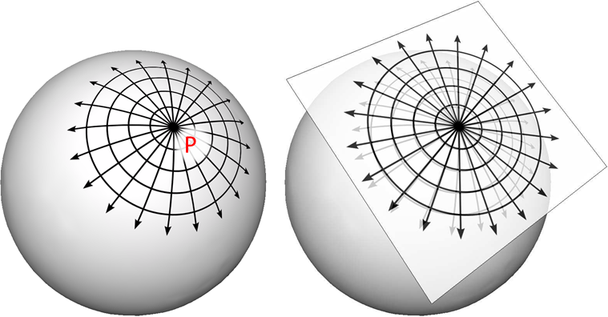
Figure B.2 — Comparison of a grid (in this case radial) represented on both (a) curved and (b) planar surfaces.
Note | With increasing distance away from the point P there is an increasing deviation between the two representations of the grid [[10], Fig. 15; [52], Fig. 3].
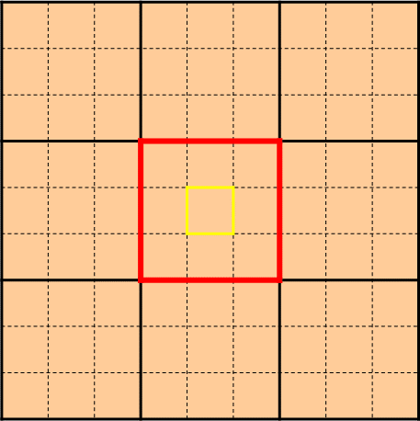
Figure B.3 — Planar square grid with nested child cells.
Note | The red and yellow cells have identical geometry, and in each case the geometry is also shared with all other cells of the same size
On a curved surface, however, this is never the case, and yet we often make the same assumption; that all cells are geometrically identical in, for example, a country, or continental, wide mosaic comprising many satellite images. Consequently, under this paradigm assumption, choosing a fixed cell size for a global grid whose cells represent equal areas and seamlessly fit the earth’s surface is therefore problematic. When this is required, conventional spatial standards enforce latitude-longitude axes to be used and these grids are therefore described in these spherical coordinates. But the cells of these types of (equal-angular) grids do not have the same properties of planar grids. Figure B.4 shows a similar consideration to that of Figure B.3, only the grids are constructed using spherical instead of planar Cartesian coordinates. In this scenario, the largest (parent) cell does not necessarily have the same shape or internal angles as the child cells. Also, its edges do not follow the shortest linear path from corner to corner. Bearing directions between cell centroids, however, are preserved in both planar and curved geometry spaces.
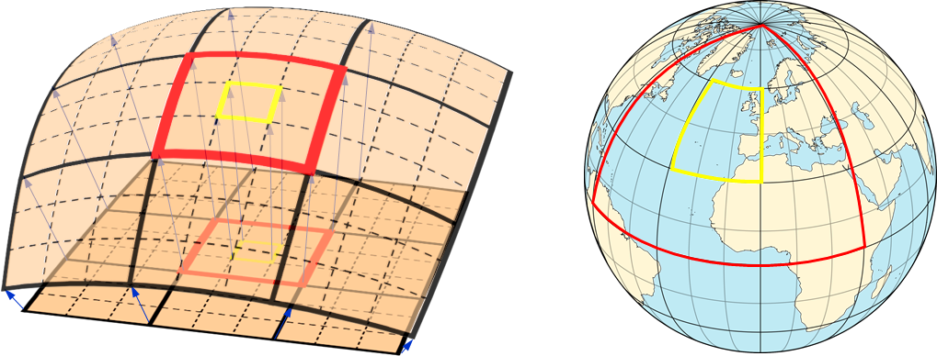
- square grid with nested child cells on a portion of a sphere (projected from the planar grid shown in Figure B.3), | - Latitude-longitude (equal angular) grid, the red cell is 90o x 90o and has nine 30o x 30o child cells (the central child cell is shown in yellow).
Figure B.4 — Square grid with nested child cells on curved surfaces.
In an attempt to address this dichotomy, conventional spatial standards therefore support either small local well-behaved planar grids or global grids that preserve bearings and angular lengths, and do not preserve area; but not both at the same time. This document fills this gap by providing a formal specification for area preserving reference systems based on the surface model of the Earth that respect the accuracy and precision of spatial data at all scales from local to global. These systems use a hierarchical tessellation of the entire Earth to produce equal-area grids. Figure B.5 shows two examples. We anticipate that future extensions the specifications in this document will support higher dimensions, such as the volume of the Earth and its atmosphere, and the Earth through time.
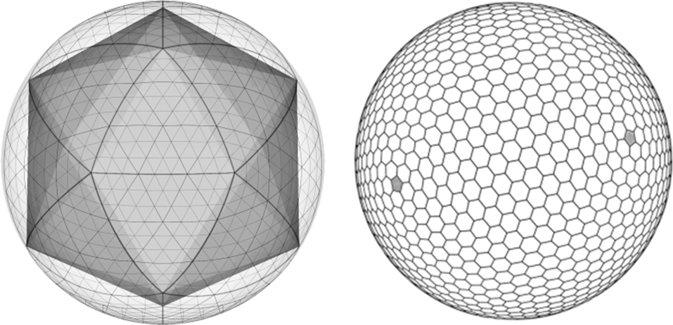
- Triangular cells starting with an icosahedron. Then refining each cell recursively into 9x smaller cells. Shown after two iterations. | - Hexagonal cells with twelve pentagonal cells at the vertices of the initial tessellation
Figure B.5 — Tessellations of the Earth to equal-area cells.
The language and foundations of current geospatial standards are deeply rooted in planar thinking, so while this document leverages as much as it can from existing standards, it also introduces new concepts that are subtly yet fundamentally different from those described by the standards that it draws from. These subtle differences do challenge our thinking. As a consequence, this document is an evolution of both existing raster processing practice and past usage of discrete global grids.
As a specification for an area preserving earth reference system this document defines more than just grids and lattices. The underlying geometry of the cells and the topological relationships between neighboring cells can be used to define globally unique identifiers (GUIDs) for the cells at any resolution.
Earlier we noted that planar grids are formed from the pairs of axes each with regular ticks corresponding to the cell dimension, facilitating a simple topological referencing schema for each cell (usually via a matrix style index for each cell along the axes of the grid — i.e. rows and columns for a 2D grid). With DGGS we introduce a more sophisticated set of cell referencing schemas; such as, space filling curves that traverse all the cells in a manner that is functionally equivalent to the axes. As shown in Figure B.6, cell indices are assigned to cells along the path of the space filling curve. These indices together with the geometry of the space filling curve carry the metrics of the curved surface and the topological relationships between neighbouring cells. The cell indices are explicitly treated as GUIDs.
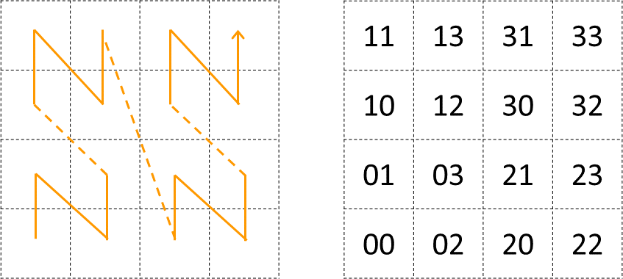
Figure B.6 — Using Morton space filling curve for defining.
Note | Labels of 4×4 square cells. (after [[10], Fig. 25])
The mathematical properties of integers and real numbers on axis pairs in a plane are known implicitly and are therefore not part of any ISO specification for planar grids. The theoretical basis on which the separate disciplines for space filling curves, GUIDs, grids, spatial topology and discrete global grids are also well founded; however, their roles in Discrete Global Grid Systems are not implicitly understood. This document therefore defines these roles and relationships explicitly. This is a necessary departure from previous DGGS work that is needed to ensure a robust spatial reference frame standard. A brief history of DGGS is provided in Annex C for reference.

Annex C
(informative)
Background to DGGS

C.1. DGGS as a Digital Information Medium
Conventional coordinate reference systems address the globe with a continuous field of points suitable for repeatable navigation and analytical geometry. While this continuous field is represented on a computer in a digitized and discrete fashion by tuples of fixed-precision floating point values, it is a non-trivial exercise to relate point observations spatially referenced in this way to areal features on the surface of the Earth. In contrast, a DGGS is designed to be an information grid not a navigation grid. DGGS provide a fixed areal based geospatial reference frame for the persistent location of measured Earth observations, feature interpretations, and modelled predictions. DGGS address the entire planet by partitioning it into a discrete hierarchical tessellation of progressively finer resolution cells. The geometry and location of the cell is the principle aspect of a DGGS. Data integration, decomposition, and aggregation is optimized in the DGGS hierarchical structure and can be exploited for efficient multi-source data processing, storage, discovery, transmission, visualization, computation, analysis, and modeling.

C.2. History
The concept of using polyhedra to model the surface of the Earth is by no means new. In 1509 Lucia Pacioli published “De Devina Proportione” [19] a treatise, illustrated by Leonardo Da Vinci, exploring the mathematical characteristics of the “golden ratio” (also referred to as the “divine proportion”) which included a consideration of the properties of the five platonic solids circumscribed within the sphere and the eminent role of the “golden ratio” in the construction of two of them (the icosahedron and dodecahedron). It is likely that his time studying with Pacioli influenced Da Vinci’s later thinking regarding spherical geometry; evidenced in 1515 by his derivation of the octahedral analysis of the volume of a sphere with various forms of segmentation [20]. This work is suggested to have led to the development of the Reuleaux triangular formulation of the world map (or mappamundi), attributed to Da Vinci [21], and may be considered a precursor to differential calculus formally developed by Newton and Leibniz nearly two centuries later.
In the 1940’s a similar approach was used by R. Buckminster Fuller in the development of the Dymaxion map of the world [22] — a physical model of the Earth mapped onto the planar faces of a polyhedron (first presented as a cuboctahedron [23] and then later as an icosahedron [24]). The aim of the Dymaxion map was to depict the spherical world as a flat surface with true scale, true direction and correct configuration all at the same time. Although a physical model of the Earth, and not strictly a DGGS, it inspired later researchers to produce digital Earth models; which in turn has led to the development of DGGS.
Formal development of DGGS began in the 1950s with the promising value of global analysis coinciding with the increased use of geographic information systems and the availability of global mapping data and positioning systems. Perhaps the first published instance of formalized discrete global grids with application to numerical analysis was described by Vestine et. al. [25] in 1955, where they define and use an equal-area grid based on the mapping of a spherical icosahedron onto the surface of the Earth as a framework to conduct areal based integral and spherical-harmonic analyses of the geomagnetic field. This grid was later used (and re-described) by Sadourny et. al. [26] in 1968 to model equations of atmospheric motion without distortion across the entire globe. Another style of discrete global grid, and perhaps the first application of hierarchical indexing schemas as an analytic cell referencing tool was implemented by Geoffrey Dutton in 1984 [27],[28],[29] at the Laboratory for Computer Graphics and Spatial Analysis at Harvard Graduate School of Design. Dutton’s first global grid was designed for assembling and managing global terrain data on a triangular global grid. His global geodesic elevation model (GEM) [27],[28],[29],[30] started with a cuboctahedron connected into a rhombic dodecahedron (which is its dual polyhedron where the vertices of one corresponds to the center of the faces of the other) and recursively divided the initial 12 triangular faces into refinements of 9 partially nested equilateral triangles. Dutton refined GEM to use only an octahedral basis in the Quaternary Triangular Mesh (QTM) DGGS [27],[28],[29],[31]. QTM is a fourfold hierarchical decomposition of facets of an octahedron into triangles whose edges follow small circles. Elevations were assigned to the centroids of child triangles and to the vertices that coincided with them. Waldo Tobler and Zi-tan Chen [32] imagined the primary purpose for a formal discrete global grid standard would be information exchange and storage. Tobler argued that as a generalized information medium “coverage must be uniform and that every element of area must have an equal probability of entering the system. This suggests that the world should be partitioned into chunks of equal size” [32]. Tobler’s global grid started with a cube as a base unit polyhedron and divided into rectilinear quad-trees to create successive subdivisions with unlimited resolution. Dennis White, Scott Overton, and Jon Kimerling, driven by a need for a statistically valid sampling to integrate aquatic and terrestrial monitoring for the US-EPA, designed a global grid in 1989 using closely packed hexagonal cells that started with a truncated icosahedron as the base unit polyhedron [33].

C.3. Global Grid Taxonomy
There have been numerous methods proposed for achieving a tessellation of the Earth, each with different distortion characteristics [34]. These tessellations can be organized into a limited set of categories that describe a hierarchical taxonomy of global grids Figure C.1, [34],[35]. Only two groups of classes of global grid achieve this [34]: those based on equal area mapping of a base unit polyhedron (such as the Icosahedral Snyder Equal Area [ISEA] projection [36]) and those based on direct surface tessellations using Small Circle Subdivision (e.g. [37],[38]).
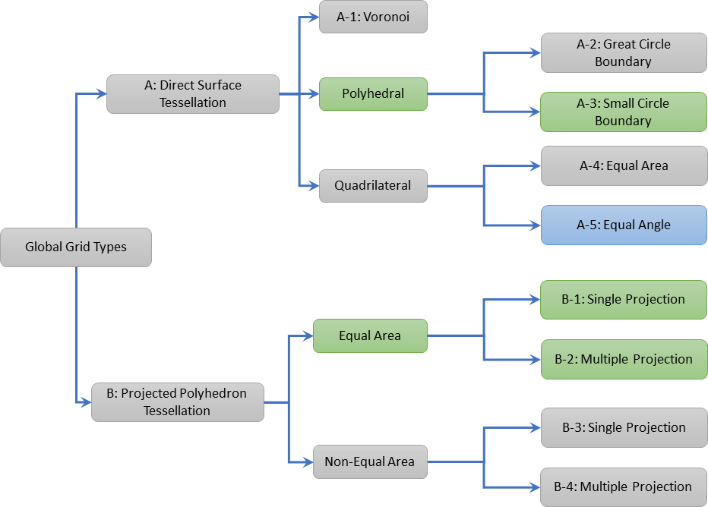
Figure C.1 — Global Grid Taxonomy (after Fig. 4 in [10]).
Key | A: Direct Surface Tessellations  A-1: Voronoi — Hipparchus Geo-positioning [39];  A-2: Polyhedral — Great Circle Boundary [40];  A-3: Polyhedral — Small Circle Boundary [37],[38],[29];  A-4: Quadrilateral — Equal Area [41];  A-5: Quadrilateral — Equal Angle [42],[43],[53],[54].  B: Projected Polyhedron Tessellations  B-1: Equal Area — Single Projection [32],[44];  B-2: Equal Area — Multiple Projection [36],[46],[47];  B-3: Non-Equal Area — Single Projection [45];  B-4: Non-Equal Area — Multiple Projection [48],[49].
Colours | Tessellations suitable for use with this standard are shaded as follows:  green: Equal Area DGGS (Part 1), and  blue: Axis Aligned DGGS (Part 4).

C.4. Criterion
There are many possible DGGS, each with their own advantages and disadvantages. Criteria for a discrete global grid are well developed by both Michael F. Goodchild [15] and Jon Kimerling [34]; the foremost requirements being a tessellation of cells that exhaustively cover the globe with each cell having equal area, and whose centroid represents a single point. The points and cells of the various resolution grids which constitute the grid system form a hierarchy which displays a high degree of regularity [50]. Choices for an appropriate tessellation include properties of shape, adjacency, connectivity, orientation, self-similarity, decomposability, and packing properties. Cell choices generally are taken from the three shapes that uniformly tile a plane — rectilinear, triangular, and hexagonal cells.
While it is possible to map any polyhedral solid to the surface of the earth, the Platonic solids (tetrahedron, cube, octahedron, dodecahedron and icosahedron — see Figure B.1 are the only polyhedral solids that perfectly partition the surface of a sphere into regular, equal area cells [51]. As a result, the Platonic solids are used in the construction of most equal area DGGS, often via a mapping of the polyhedral faces to the surface model of the Earth (some examples are shown in Figure C.2). This method of mapping the faces of a base unit polyhedron to the surface model of the Earth creates a coordinate reference system that is based on a curved geometric framework. GIS and image analysis packages that assume flat earth geometries will need to adapt to support this new construct that more closely represents the earth.
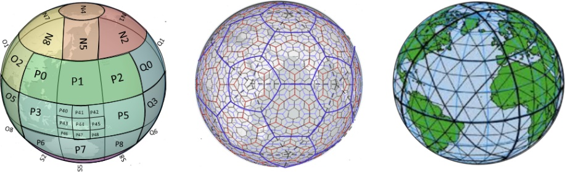
- Quadrilateral cells on an rHealPIX projected hexahedron, levels 0…2 with refinement ratio of 9 | - Hexagonal cells on ISEA projected icosahedron, levels 0…4 with refinement ratio of 3 | - Triangular cells on a Quaternary Triangular Mesh of an octahedron, levels 0…3 with refinement ratio of 4  (QTM — courtesy of G. Dutton).
Figure C.2 — Examples of DGGS based on the mapping of the faces of Platonic solids to the surface model of the Earth:
Any tessellation of the Earth does not necessarily produce a DGGS. Single resolution computational grids are not sufficient to constitute a DGGS. Spatial data structures used to organize map tiles or optimize rapid spatial search cannot be considered to qualify as a DGGS in and of themselves; although DGGS often utilize hierarchical indices to identify a cell, the primary feature of the DGGS is the cell geometry not the optimization of a spatial query. Further, DGGS have data independent geometry — their geometry is not formed to optimize a balanced search like R-Trees or maximal spacing of data as generated by Voronoi diagrams.

C.5. A Digital Spatial Reference System
One way to understand the important difference between a DGGS and a conventional spatial reference system is to consider that a DGGS provides a digital framework for geospatial information. Geospatial information is essentially a signal — that is some variable (e.g. measurement of phenomena) which changes subject to some other independent variable (e.g. spatial location, time, some physical interaction etc…​.). Conventional geospatial data are analog signals as they reference to a continuous space — geographic coordinates on an ellipsoidal datum. Even the discrete pixels of a satellite Earth observation image reference this continuous analog model of Earth; however, these pixels do not observe precisely the same locational area for successive observations. Spatial reference by geographic identifier is described in ISO 19112. DGGS provide this globally in a structured form which is analogous to the ellipsoidal coordinate system described in ISO 19111 — spatial referencing by coordinates, but is based on discrete cells rather than continuous point locations (e.g. [54]).
Sampling and quantization are necessary for a signal to be considered digital. As the name implies the DGGS provides the regular discrete intervals or cell partitioning to which location information (e.g. signal values) are sampled. A well-designed quantization strategy is also an important component of a DGGS that should maintain the fidelity of the original information in the values assigned to each cell. The discrete data values can be sampled from any geospatial data source independent of the original spatial reference, scale, format, type, frequency, or time. A DGGS is a discrete “digital” model of the Earth.

C.6. Application
As each cell in a DGGS is fixed in location, and the location provides an explicit area representation, basic geospatial enquiries, such as — ”Where is it?”, “What is here?”, and “How has it changed?” — are simplified into set theory operations. As any data values referenced to a particular DGGS are, by the nature of the grid, aligned, the high costs of integrating data in traditional systems are dramatically reduced.
A DGGS can even be designed for lossless encoding of vector geometry such that cells, and their integer addressing, predictably converge to the Real number coordinate pairs of each observation with each successive refinement — an essential property of a conventional coordinate system.
DGGS are designed to eliminate requirements for complex data fusion processes. Reducing the reliance on an intermediary integrator or analyst is a key requirement for distributed participatory digital-Earth information systems. “[Digital-Earth] can clearly benefit from developments in discrete global grid, which can provide the georeferencing, the indexing, and the discretization needed for geospatial data sets. They have properties, in particular hierarchical structure, uniqueness, explicit representation of spatial resolution, and consistency, that make them superior to any single alternative.” [15].
A DGGS provides a uniform environment to integrate, aggregate and visualize both vector/point cloud geometries and raster-based geospatial data sources in much the same way that information within a computer graphics pipeline becomes the pixels on a computer screen. Efficiencies are gained through implementing the Dimensionally Extended nine-Intersection Model (DE-9IM) set of fundamental spatial operations [5-8] directly on the DGGS cell structure. This allows for higher order analytics (via bindings to external analytic libraries) to be created on the DGGS structure itself, independent of the data sources.

Annex D
(informative)
Temporal geometry, topology, and temporal referencing by named periods — Context for modelling

D.1. General
This document builds on the spatio-temporal definitions in ISO 19111 (ISO 19111:2019) to achieve a broader integration of spatio-temporal concepts. In addressing alignment with ISO 19108 (ISO 19108:2002), the reader is directed to the discussion in Annex D Temporal referencing by coordinates — Context for modelling (ISO 19111:2019) as a starting point which is adopted in full in this document.

D.2. Geometry and Topology
Time can be represented as an ordered one dimensional geometry with topology. The only significant difference between 1-dimensional spatial and 1-dimensional temporal is the importance of direction, and the topological relationships that explicitly address direction. ISO 19107 (ISO 19107:2019) and ISO 19108 (ISO 19108:2002) define terms for geometric and topological primitives and their complexes that are functionally equivalent but different in structure. To achieve spatio-temporal uniformity this document aligns its definitions with ISO 19107 (ISO 19107:2019). When compared with equivalent terms in ISO 19108 (ISO 19108:2002) this primarily results in differences in class inheritance rather than in underlying meaning. Comparing ISO 19108 (ISO 19108:2002) terms to this document’s terms, while putting the structural differences aside
- TM_GeometricPrimitive and TM_TopologicalPrimitive map to this document’s TemporalGeometricPrimitive, TemporalTopologicalPrimitive respectively,
- TM_TopologicalComplex maps to this document’s TemporalTopologicalComplex,
- this document introduces TemporalGeometricComplex and TemporalGeometricCollection,
- the super classes of TM_Primitive, TM_Complex and TM_Object aren’t implemented and instead this document introduces TemporalGeometry and TemporalTopology,
- TM_Instant and TM_Period map to this document’s Instant and Interval respectively,
- TM_Node and TM_Edge map to this document’s NodeT and EdgeT respectively,
- TM_Duration, and it’s sub-classes TM_PeriodLength and TM_IntervalLength map to this document’s Duration, which encompasses any valid unit on a TemporalCS (ISO 19111:2019), and
- TM_RelativePosition maps to this document’s RelativePosition, which is defined to reflect modern usage by SDWIG and OGC as defined in OWL-time.

D.3. Referencing by named periods
ISO 19108 (ISO 19108:2002) has the concepts of a named Ordinal Era, and Ordinal reference systems which address the needs of geological time. While the topology of Ordinal Era are known, their extent is in general ill-defined. To achieve spatio-temporal uniformity this document aligns itself with ISO 19112 (ISO 19112:2019). Named Periods are introduced as the temporal equivalent of named Locations ISO 19112 (ISO 19112:2019). Periods have well defined extents as well as well as defined topology. Comparing ISO 19108 (ISO 19108:2002) terms with this document’s terms, while acknowledging this difference
- TM_OrdinalEra maps to both Period and PeriodClass in this document depending on context, and
- TM_OrdinalReferenceSystems maps to TemporalReferenceSystemUsingPeriodIdentifers in this document.

Annex E
(informative)
Requirements cross-walk from Topic 21 v1.0 to v2.0
Topic 21 v1.0 has only one conformance class — Equal Area Earth DGGS, Topic 21 v2.0 extends the 2D surface only data model to a potentially 3D+T data model by establishing Common Spatio-temporal Classes, and a dimension agnostic DGGS Core Reference system and dimensionally agnostic Functions for Quantisation, Query, and Interoperability. The conformance for Equal Area Earth DGGS is addressed in terms of conformance to the DGGS Core Functions for the 2D Earth surface and conformance to the Equal Area Earth Reference systems class built on the DGGS Core Reference system.
Requirements in Topic 21 v1.0 are addressed in a number of different ways in Topic 21 v2.0:
- 1:1 with a DGGS Core Requirement,
- 1:1 with an Equal Area Earth DGGS Reference system Requirement,
- many:1 where multiple requirements have been consolidated into a single all inclusive requirement,
- 1:many for example where conformance to the data model was addressed as a single requirement in v1.0 but this is now specifically incorporated into other requirements, and
- 0:1 with a new requirement, either in the Core or in the Equal Area Earth DGGS Reference system.
Even if the correspondence is 1:1, a new number has been assigned in v2.0 since the underlying data model is substantially different, or the definitions of terms used in the requirement have been rephrased, or the scope of the test has been broadened, for instance to include relevant parts of the data model. Requirements introduced in v2.0 appear with their number in brackets in the following list, gouped with other related requirements, and requirements that are only a partial match have their requirement number in italics.
Table E.1 — Requirements cross-walk from Topic 21 v1.0 to v2.0
15-104r5 | Topic 21 v1.0 | 20-040 | Topic 21 v2.0
# | Requirement | # | Requirement
1 | Core Data Model | 38 | Equal Area — Earth Reference System — Harmonised Model
 |  | 34 | Core — Functions — Quantization
 |  | 35 | Core — Functions — Query — ZoneQuery
 |  | 36 | Core — Functions — Interoperation — Query
 |  | 37 | Core — Functions — Interoperation — Broadcast
2 | Reference Frame – Global Domain – Surface Area Equivalence | 39 | Equal Area — Earth Reference System — Global Domain
 |  | 26 | Core — Reference system — Global Domain
 |  | 27 | Core — Reference system — Global Domain — Complete
3 | Reference Frame – Global Domain – Cell Boundary Overlap | 28 | Core — Reference system — Global Domain — Unique
4 | Reference Frame – Tessellation Sequence | 41 | Equal Area — Earth Reference System — Tessellation — Sequence
 |  | 42 | Equal Area — Earth Reference System — Tessellation — Sequence — Max
 |  | (33) | Core — Reference system — Discrete Global Grid — Sequence
5 | Reference Frame — Global Area Preservation | 43 | Equal Area — Earth Reference System — Tessellation — Global Area Preservation
6 | Reference Frame — Cell Shape | 44 | Equal Area — Earth Reference System — Cell — Simple — 2D Polygon
7 | Reference Frame — Equal Area Precision | 46 | Equal Area — Earth Reference System — Cell — Equal Area — Error Budget
8 | Reference Frame — Equal Area Cells | 47 | Equal Area — Earth Reference System — Cell — Equal Area
9 | Reference Frame – Initial Tessellation | 40 | Equal Area — Earth Reference System — Tessellation — Initial
10 | Reference Frame – Cell Refinement | (33) | Core — Reference system — Discrete Global Grid — Sequence
11 | Reference Frame – Cell Addressing | 31 | Core — Reference system — Cell — Address
12 | Reference Frame – Spatial Reference
13 | Reference Frame – Spatial Reference – Cells Referenced at their Centroid | 45 | Equal Area — Earth Reference System — Cell — Direct Position — Centroid
14 | Functional Algorithms – Quantization Operations | 34 | Core — Functions — Quantization
15 | Functional Algorithms – Algebraic Processes – Cell Navigation | 35 | Core — Functions — Query — ZoneQuery
16 | Functional Algorithms – Algebraic Processes – Spatial Analysis
17 | Functional Algorithms – Interoperability Query Operations | 36 | Core — Functions — Interoperation — Query
18 | Functional Algorithms – Interoperability Broadcast Operations | 37 | Core — Functions — Interoperation — Broadcast
Table E.2 — Requirements cross-walk from Topic 21 v2.0 to v1.0
20-040 | Topic 21 v2.0 | 15-104r5 | Topic 21 v1.0
# | Requirement | # | Requirement
19-25 | Common Classes | - | -
26 | Core — Reference system — Global Domain | 2 | Reference Frame – Global Domain – Surface Area Equivalence
27 | Core — Reference system — Global Domain — Complete
28 | Core — Reference system — Global Domain — Unique | 3 | Reference Frame – Global Domain – Cell Boundary Overlap
29 | Core — Reference system — Cells — Simple | - | (this is more general than 6, since it is spatio-temporal)
30 | Core — Reference system — Cell — Direct Position | - | (this is both more general than 13, since it is spatio-temporal and less stringent since it doesn’t enforce the centroid)
31 | Core — Reference system — Cell — Address | 11 | Reference Frame – Cell Addressing
 |  | 12 | Reference Frame – Spatial Reference
32 | Core — Reference system — Discrete Global Grid | - | (this is less stringent than 4)
33 | Core — Reference system — Discrete Global Grid — Sequence | 4 | Reference Frame – Tessellation Sequence
 |  | 10 | Reference Frame – Cell Refinement
34 | Core — Functions — Quantization | 14 | Functional Algorithms – Quantization Operations
 |  | 1 | Core Data Model
35 | Core — Functions — Query — ZoneQuery | 15 | Functional Algorithms – Algebraic Processes – Cell Navigation
 |  | 16 | Functional Algorithms – Algebraic Processes – Spatial Analysis
 |  | 1 | Core Data Model
36 | Core — Functions — Interoperation — Query | 17 | Functional Algorithms – Interoperability Query Operations
 |  | 1 | Core Data Model
37 | Core — Functions — Interoperation — Broadcast | 18 | Functional Algorithms – Interoperability Broadcast Operations
 |  | 1 | Core Data Model
38 | Equal Area — Earth Reference System — Harmonised Model | 1 | Core Data Model
39 | Equal Area — Earth Reference System — Global Domain | 2 | Reference Frame – Global Domain – Surface Area Equivalence
40 | Equal Area — Earth Reference System — Tessellation — Initial | 9 | Reference Frame – Initial Tessellation
41 | Equal Area — Earth Reference System — Tessellation — Sequence | 4 | Reference Frame – Tessellation Sequence
42 | Equal Area — Earth Reference System — Tessellation — Sequence — Max
43 | Equal Area — Earth Reference System — Tessellation — Global Area Preservation | 5 | Reference Frame — Global Area Preservation
44 | Equal Area — Earth Reference System — Cell — Simple — 2D Polygon | 6 | Reference Frame — Cell Shape
45 | Equal Area — Earth Reference System — Cell — Direct Position — Centroid | 13 | Reference Frame – Spatial Reference – Cells Referenced at their Centroid
46 | Equal Area — Earth Reference System — Cell — Equal Area — Error Budget | 7 | Reference Frame — Equal Area Precision
47 | Equal Area — Earth Reference System — Cell — Equal Area | 8 | Reference Frame — Equal Area Cells

Annex F
(informative)
Revision History
Table F.1
Date | Release | Author | Paragraph modified | Description
2018-12-05 | 1.0.0 | Matt Purss | All | Copied OGC Abstract Specification Topic 21 [OGC 15-104r5] into the ISO document template
2019-02-09 | 1.0.1 | Robert Gibb | 3.23, Note 1 | Corrected ‘circule’ → ‘circle’, and changed ‘-’ and ‘ -’ → ‘ — ‘, consistent with usage elsewhere in this document
 |  |  | 5.2.4.2 | Corrected ‘rato’ to ‘ratio’
 |  |  | 5.3.3.1 | Corrected ‘left hand’ to ‘left-hand’
 |  |  | 5.3.3.2 | Corrected ‘right hand’ to ‘right-hand’
 |  |  | Annex A | Expanded width of all tables to the page margins
 |  |  | Annex B.3, caption for Figure B.1 | Inserted reference [48]  Corrected use of hyphen to dash, consistent with other dashes in this caption
 |  |  | Annex B.5 | Corrected hyphen to dash between ‘ISO 19111’ and ‘spatial’  Inserted reference [49]
 |  |  | Annex D Bibliography | [3] Corrected ‘Forth’ to ‘Fourth’  [10] Inserted missing DOI hyperlink  [26] Corrected underlining and blue text and inserted missing DOI hyperlink  [27] Corrected ‘Chen, Z.-t.’ → ‘Chen, Z.’  [41] Inserted DOI missing hyperlink  [42] Inserted DOI missing hyperlink  [43] Inserted DOI missing hyperlink  Added reference [48]
2019-02-12 | 1.0.2 | Matt Purss | Section 5 | Updated width of tables and figures to fill the full width of the page.
2019-02-16 | 1.0.2 | Robert Gibb |  | Submitted to ISO TC211 secretariat for CD vote
2019-05-13 | 1.0.3 | Robert Gibb |  | Received from ISO TC211 secretariat as N5025 for preparation as DIS
2019-05-20 | 1.0.4 | Robert Gibb | 3.16, 3.21 | TMG042, TMG045 Added abbreviations to the terms
2019-05-28 | 1.0.4 | Robert Gibb |  | DK003, DK004, DK014, DK017, TMG019, DK030, DK031, TMG041, DK080, DK081, JP084, DK086, FR087, FR105, FR106, DK109 removed the artifacts of word to pdf conversion referred to in the comments
2019-05-28 | 1.0.4 | Robert Gibb | Title page | CN002 Changed title to ‘ Discrete Global Grid Systems — Part 1 Equal Area Earth Reference System’, this clarifies that purpose of Part 1 of the DGGS Standard, and makes the equal area explicit.
2019-05-28 | 1.0.5 | Robert Gibb | Introduction, Scope, Annex B, Annex C, All | DK010, GB011, GB021 Moved Introduction to a new Annex B — Discrete Global Grid System Theory, and moved all but the second paragraph of the Scope into the Introduction.  Incremented document version from 1.0.4 to 1.0.5 because many section numbers have changed.
2019-05-29 | 1.0.5 | Robert Gibb | Annex B, last para | DK015 Expanded DGGs abbreviation to ‘discrete global grids’ and made other changes to the paragraph to further clarify the distinction between historic DGGS, & DGG work and this standard.
2019-05-29 | 1.0.5 | Robert Gibb | Introduction, Scope | DK022 Changed the first instances of DGGS to Discrete Global Grid System — Equal Area Earth Reference System (DGGS) in Introduction and Scope, this also reflects the change in title.
2019-05-29 | 1.0.5 | Robert Gibb | Introduction, Scope, Bibliography | DK024, DK025 Now in Introduction not Scope, so added references to OWS, WCS, and WCPS. ‘DGGS core Abstract Specification’ (now in Introduction) refers to this document ISO19170. Have made this explicit.
2019-05-29 | 1.0.5 | Robert Gibb | Intro para1, 3.20 Note 1, 5.1, 5.2.1, 5.2.2, 5.2.5.1, 5.2.5.3, 5.2.6, 5.2.6.1, 5.3, 5.3.1 para1,3, 5.3.2, 5.3.3, 5.3.3.1, 5.3.3.2, C.3 | GB020 must adhere → adheres, must represent → represents, be compliant → comply, must define → shall define, and provide → to form, must also include → includes, must be defined → shall be defined, must define → shall define, must be → is, must → shall, must → shall, must → shall, must include → includes, must → shall, mechanisims → quantisation methods, however, must always be fixed and be defined → is however, always fixed and always defined, must → shall, must also be able → shall also define methods, must be able to → needs to.
2019-05-29 | 1.0.5 | Robert Gibb | Foreward | TMG018 Changed the references to ISO/IEC Directives, Part 2, Revision 8, 2018, and added collaboration with OGC.
2019-05-29 | 1.0.5 | Robert Gibb | 3.4, 3.11, 3.26, 3.41, 3.56, 3.57 | TMG029, TMG039, TMG048, TMG062, TMG077, TMG078 Consolidated instances of sources with notes from a different source or modified notes, as recommended by TMG
2019-05-29 | 1.0.5 | Robert Gibb | 3.6, 3.19, 3.30, 3.31, 3.32, 3.38, 3.40, 3.46, 3.47, 3.49 | TMG033, TMG043, TMG051, TMG053, TMG054, TMG061, TMG061, TMG068, TMG069, TMG072 Updated to conform with revision of ISO19107:2019
2019-05-29 | 1.0.5 | Robert Gibb | 3.7, 3.8, 3.12, 3.51 | TMG034, TMG035, TMG040, TMG073 Updated to conform with revision of ISO19111:2019
2019-05-29 | 1.0.5 | Robert Gibb | 3.20, 3.23, 3.243.28, 3.29, 3.33, 3.34, 3.36, 3.43, 3.45, 3.48, 3.55 | TMG044, TMG046, TMG047, TMG049, TMG050, TMG055, TMG057, TMG059, TMG065, TMG067, TMG071, TMG076 Added <DGGS> domain to the definition
2019-05-29 | 1.0.5 | Robert Gibb | 3.2 Para2 | DK027 Changed ‘arenas’ → ‘subject domains’
2019-05-29 | 1.0.5 | Robert Gibb | 3.3 Note2 | DK028 Changed ‘all have unique parents or child cells that may share parents’ to ‘each have a single parent or child cells that have multiple parents’
2019-05-29 | 1.0.5 | Robert Gibb | 3.9, 3.10, 3.33, 3.34 | TMG036, DK037, TMG038, DK056 Added <DGGS> domain to the definition, and deleted the word ‘role’ from the definitions
2019-05-29 | 1.0.5 | Robert Gibb | 3.35 | TMG058 removed reference to 19136, moved source 19123 to after the note
2019-05-29 | 1.0.5 | Robert Gibb | Introduction, 3.45, 3.48 | DK025, TMG066, TMG070 replaced references to this ‘Abstract Specification’ to this ‘document’
2019-05-30 | 1.0.5 | Robert Gibb | Foreword, 2, 3, 4.2 | TMG018, DK079 Acknowledge the role of ISO19104 in the formulation of this document and the associated UML model.
2019-05-30 | 1.0.5 | Robert Gibb | 5.2.4.2, Annex C | Fix a few ISO Style issues e.g. 1m — 1 m, 30m 30 m
2019-05-30 | 1.0.5 | Robert Gibb | Intro, Scope, 5, Annex A, Annex B | CN002, DK104, FR107 Aligned the document and URI structures, and ensured that terminology was consistent across everything that looks like a function, including replacing Core with EA-ERS.
2019-05-30 | 1.0.5 | Robert Gibb | 5.2.1 | DK089 changed ‘defined’ → ‘expressed’
2019-05-30 | 1.0.5 | Robert Gibb | Introduction, 5.2.4.2 | DK096 Inserted a reference to ISO 19112:2019 and clarified use of geodetic identifier to enforce the distinction between the two.
2019-05-30 | 1.0.5 | Robert Gibb | 5.2.1 | DK088 Added a sentence to elaborate the meaning, and recast the Requirements in terms of completeness and uniqueness.
2019-05-31 | 1.0.5 | Robert Gibb | Annex C.4 | DK110, DK111 Changed Criterium → Criteria, and ‘representing a single point’ → ‘whose centroid represents a single point’
2019-05-31 | 1.0.5 | Robert Gibb | Abbreviated terms | DK092, DK103 Added new terms to the Abbreviated Terms list
2019-06-03 | 1.0.5 | Robert Gibb | Fig 8 | DK083, DK085 Split Spatial Reference figure into three figures and update all figures to reflect UML in newer editions of 19107 & 19111, implement HMMG advice.
2019-06-03 | 1.0.5 | Robert Gibb | TermDef | Reviewed Terms and Definitions wrt updates in 19107, 19111, 19112, 19115, 19161-2, introduced internal T&C links, and removed retired terms that retain their previous meaning: curve, object, point, sequence, set, solid, surface
2019-07-22 | 1.0.5 | Robert Gibb | Title page, NormRefs, TermDef | Rename as Part 1 as discussed at June ISO & OGC/TC meetings.
2019-10-18 | 1.0.6 | Robert Gibb | 5, Annex A, All | CN002 As discussed at June ISO & OGC/TC meetings, reordered and restructured Sections 5 and A. Conformance to split into Core and Equal Area Earth Reference System modules, and added specific support for DGGS on static and dynamic datums.  Incremented document version from 1.0.5 to 1.0.6 because many section numbers have changed.
2019-10-26 | 1.0.6 | Robert Gibb | 5.2.2, Annex A | Elaborated the way cellQuery2D differs from Query2D and the described the behaviour of parent, child and sibling functions
2019-10-27 | 1.0.6 | Robert Gibb | 5.3.2.2, Annex A | Introduced error budget as an improved way of deriving and describing equal area precision, changed to the wording of the equal area precision requirement, and added a new requirement for limiting the number of tessellations
2019-10-28 | 1.0.6 | Robert Gibb | NormRefs, TermDef | Updated 19107-FDIS to 19107:2019, and resolved source reference for direct position which has been retired as a term but retained as a data type in 19107:2019
2019-10-28 | 1.0.6 | Robert Gibb | Annex B Fig B.5 | DK013 Fig B.5 (was Fig 5), left hand example replaced with monochrome one.
2019-10-28 | 1.0.6 | Robert Gibb | Annex B para 1 | DK016 removed ‘framework’ from annex B, para 1
2019-10-28 | 1.0.6 | Robert Gibb | TermDef | TMG0443, TMG074, TMG075, terms ‘direct position’, ‘spatial reference system’ and ‘surface’ deleted
2019-10-28 | 1.0.6 | Robert Gibb | 5 | DK082, DK083 all UML diagrams are now monochrome.
2019-10-30 | 1.0.7 | Robert Gibb | Title page, Introduction, Scope, Abbr, 5, 5.1, 5.2, 6 (was 5.3) | Added Reference System to the Core as a new section 5.2.1, and separated it out from 5.3. EAERS is a new conformance class section 6 (from 5.3)  Inserted new Fig 2 and 3, increasing numbers of all following figures in Sect 5 by 2.  DK093, DK094, DK095, DK097, DK098, DK099, DK100, DK101 clarified by new wording  Incremented document version from 1.0.6 to 1.0.7 because many section numbers have changed.
2019-10-30 | 1.0.7 | Robert Gibb | Requirements & Conformance | Renumbered and split as per: 1 to 1, 2..5 to 11..14, 6 to 3, 4 & 15, 7 to 5, 8 to 6, 9..11 to 18..20, 12 to 9, 10 & 21, 13..14 to 22..23, 16 to 2, 17 to 17, 18 to 7 & 8. And reworked wording to match revised 5.2.1 & 5.3.
2019-10-30 | 1.0.7 | Robert Gibb | 5.2.1.2 | DK091 a) ‘not self-intersect’ and b) ‘topologically the same as a circle’ introduced.
2019-11-06 | 1.0.7 | Robert Gibb | Annex A | Insert ‘Requirement n:’ in Requirement line of each conformance test.
2019-11-06 | 1.0.7 | Robert Gibb | Abbreviations | Removed DGGS-RS, & HEALPIX (retaining rHEALPIX), changed DGGS-EAERS to EAERS, and made more use of EAERS
2020-03-20 | 1.0.8 | Robert Gibb | All | Created Spatio-temporal Common Class package with conformance classes for geometry and topology, zones and identifiers, and zonal query, their terms and definitions, conformance classes, requirements, defining tables, and abstract tests. Restructured all preamble sections and the core to accommodate the new common classes. Inserted a new Annex describing the relationship of the temporal classes to ISO19108.
2020-05-30 | 1.0.8 | Robert Gibb |  | Submitted for ISO/DIS ballot, published as N5348
2020-06-02 | 1.0.8 | Robert Gibb | Introduction, Annex E | Restructured for OGC template, added summary of v1.0 to v2.0 changes to Introduction (OGC only), added Annex E — Requirements v1.0 to v2.0 cross-walk tables (OGC only), published to OGC Pending Documents as 20-040
2020-06-11 | 1.0.8 | Robert Gibb | Scope, Table 30, Fig 16; Req 47 URI, Fig C.2, Fig B.4, Annex A | changes submitted as DIS comments: Scope bullet 1.1; add description for extent (in EA); Fig 16 remove duplicate ‘sibling’ (in EA); Requirement 47 insert ‘ea/ers/’ in URI; Fig C.2 b), c), switch labelling; B.4 b) change 30deg to 90deg and 10deg to 30deg, also superscript deg; Annex A prepend ‘conf/’ to all abbreviated URI;
2020-07-20 | 1.0.8 | Robert Gibb | iv, v | Updated lists of Submitters and their Organisations (OGC only), published to OGC Pending Documents as 20-040r1
2020-07-29 | 1.0.8 | Robert Gibb | iv, v | Updated lists of Submitters and their Organisations (OGC only), adding Geoscience Australia & published to OGC Pending Documents as 20-040r2

Bibliography
[1] ISO: ISO 19103:2015, Geographic information – Conceptual schema language. International Organization for Standardization, Geneva (2015).
[2] ISO: ISO 19108:2002, Geographic information – Temporal schema. International Organization for Standardization, Geneva (2002).
[3] ISO: ISO 19101-1:2014, Geographic information – Reference model – Part 1: Fundamentals. International Organization for Standardization, Geneva (2014).
[4] ISO/IEC: ISO/IEC 19501:2005, Information technology – Open Distributed Processing – Unified Modeling Language (UML) Version 1.4.2. International Organization for Standardization and International Electrotechnical Commission, Geneva (2005).
[5] 05-042r2, Best Practices Paper — OpenGIS® web services architecture description. Version 0.1.0, 2005
[6] 16-071r3, “Time Ontology in OWL”, Published jointly by OGC & W3 Edited by Cox, S., Little, C., version 3, 2020, https://www.w3.org/TR/2020/CR-owl-time-20200326/
[7] 17-089r1, OGC® Web Coverage Service (WCS) Interface Standard — Core, version 2.1, 2017
[8] 06-121r9, OGC Web Services common Standard. 2010
[9] Mahdavi-Amiri, A., Samavati, F. F., Peterson, P., 2015, “Categorization and conversions for indexing methods of discrete global grid systems”, ISPRS International Journal of Geo-Information, 4(1), pp 320-n-336. DOI:10.3390/ijgi4010320
[10] Mahdavi-Amiri, A., Alderson, T., & Samavati, F., 2015, “A Survey of Digital Earth Representation and Visualization”, Computers & Graphics, Elsevier Ltd., pp. 95-117. uri: http://hdl.handle.net/1880/50407
[11] Clementini, E., Di Felice, P., van Oosterom, P., 1993. “A small set of formal topological relationships suitable for end-user interaction”. In Abel, David; Ooi, Beng Chin. Advances in Spatial Databases: Third International Symposium, SSD ’93 Singapore, June 23-n-25, 1993 Proceedings. Lecture Notes in Computer Science. 692/1993. Springer. pp 277-n-295. DOI:10.1007/3-540-56869-7_16.
[12] Clementini, E., Sharma, J., Egenhofer, M. J., 1994, “Modelling topological spatial relations: Strategies for query processing”. Computers & Graphics 18 (6), pp 815-n-822. DOI:10.1016/0097-8493(94)90007-8.
[13] Clementini, E., and Di Felice P. A., 1996, “A Model for Representing Topological Relationships between Complex Geometric Features in Spatial Databases.” Information Sciences, 90(1), pp 121-136. DOI:10.1016/0020-0255(95)00289-8
[14] Egenhofer, M.J.; Herring, J.R., 1990, “A Mathematical Framework for the Definition of Topological Relationships”. Fourth International Symposium on Spatial Data Handling Z├╝rich, Switzerland, pp 803-813. http://www.spatial.maine.edu/~max/MJEJRH-SDH1990.pdf
[15] Goodchild, M. F., 2000, “Discrete global grids for digital earth”, International Conference on Discrete Global Grids. Santa Barbara. http://www.ncgia.ucsb.edu/globalgrids/papers/goodchild.pdf
[16] Peterson, P. R., 2017, “Discrete Global Grid Systems.” In The International Encyclopedia of Geography, edited by Douglas Richardson. Malden, Oxford: John Wiley and Sons, Ltd. DOI:10.1002/9781118786352.wbieg1050
[17] Sahr, K., White, D., Kimerling, A. J., 2003, “Geodesic discrete global grid systems”, Cartography and Geographic Information Science, 30 (2), pp 121-n-134. DOI:10.1559/152304003100011090
[18] Postel, J., 1981, “RFC 791: Internet protocol”, Darpa Internet Protocol Specification (September 1981). — https://tools.ietf.org/html/rfc791
[19] Pacioli, L., 1509, “De Davina Proportione” (Illustrated by Leonardo Da Vinci), Venice.
[20] da Vinci, L, 1514, “Manuscript E, 24v-25r (1513-14)”. Pen and ink on paper, 150 x 99 mm. Bibliothéque de l’Institut de France, Paris.
[21] da Vinci, L, 1478-1518, “Codex Atlanticus”. Pen and ink on paper, 61 x 44 cm. (collated by Pompeo Leoni). Biblioteca Ambrosiana, Milan, Italy.
[22] “Life Presents R. Buckminster Fuller’s Dymaxion World”. Life, 1 March 1943, pp 41-45
[23] Fuller, R. B., 1946, Cartography. U.S. Patent 2,393,676. https://www.google.com/patents/US2393676
[24] Fuller, R. B. and Sadao, S., 1954, “Dymaxion Airocean World: The Raleigh Edition of Fuller Projection”. Student Publications of the School of Design, North Carolina State College, Raleigh, North Carolina, USA. (http://www.genekeyes.com/FULLER/BF-5-1954.html)
[25] Vestine, E. H. Sibley, W. L. Kern, J. W. and Carlstedt,J. L. “Integral and Spherical-Harmonic Analyses of the Geomagnetic Field for 1955.0, Part 2,” Journal of Geomagnetism and Geoelectricity, vol. 15, No. 2, Aug. 1963, pp. 73-89.
[26] Sadourny, R.; Arakawa, A.; Mintz, Y. (1968). “Integration of the nondivergent barotropic vorticity equation with an icosahedral-hexagonal grid for the sphere”. Monthly Weather Review 96 (6): 351-n-356.
[27] Dutton, G., 1989, “Modelling location uncertainty via hierarchical tessellation”. In: Accuracy of Spatial Databases, Goodchild, M. and Gopal, S. (eds.), London: Taylor & Francis, pp 125-140.
[28] Dutton, G., 1999, “A hierarchical coordinate system for geoprocessing and cartography”. Lecture Notes in Earth Science 79. Berlin: Springer-Verlag. XIX + 231 pp. 97 figs. 12 plates, 16 tabs. ISSN 0930-0317, ISBN 3-540-64980-8.
[29] Dutton, G., 1984, “Part 4: Mathematical, Algorithmic and Data Structure Issues: Geodesic Modelling Of Planetary Relief”, Cartographica: The International Journal for Geographic Information and Geovisualization, 21(2-3), pp 188-207. DOI:10.3138/R613-191U-7255-082N
[30] Dutton, G., 1996, “Encoding and handling geospatial data with hierarchical triangular meshes”, In Proceeding of 7th International symposium on spatial data handling, 43, Netherlands: Talor & Francis. DOI:10.1.1.461.5603
[31] Dutton, G., 1999, “Scale, Sinuosity, and Point Selection in Digital Line Generalization”, Cartography and Geographic Information Science, 26(1), pp 33-54. DOI:10.1559/152304099782424929
[32] Tobler, W., & Chen, Z.-t., 1986, “A Quadtree for Global Information Storage”, Geographical Analysis, 18(4), pp 360-371. DOI:10.1111/j.1538-4632.1986.tb00108.x
[33] White, D., Kimerling, J., & Overton, W. S., 1992, “Cartographic and geometric components of a global sampling design for environmental monitoring”, Cartography and Geographic Information Systems, 19(1), pp 5-22. DOI:10.1559/152304092783786636
[34] Kimerling, A. J., Sahr, K., White, D., & Song, L., 1999, “Comparing Geometrical Properties of Global Grids”, Cartography and Geographic Information Systems vol. 26, no. 4, pp 271-88. DOI:10.1559/152304099782294186
[35] Dutton, G., 1994, “Geographical grid models for environmental monitoring and analysis across the globe (panel session)”. In: Proceedings of GIS/US’94 Conference, Phoenix, Arizona.
[36] Snyder, J. P., 1992, “An equal-area map projection for polyhedral globes”. Cartographica, 29(1), pp 10-21.
[37] Song, L., 1997, “Small circle subdivision method for development of global sampling grid”, Unpublished Masters Thesis, Oregon State University, 176pp.
[38] Song, L., Kimerling, A. J., and Sahr, K., 2002, “Developing an Equal Area Global Grid by Small Circle Subdivision”. In M. Goodchild and A. J. Kimerling (Eds.), Discrete Global Grids: A Web Book (https://escholarship.org/uc/item/9492q6sm)
[39] Lukatela, H., 1987, “Hipparchus geopositioning model: An overview”, In: Proceedings of Auto Carto 8 Symposium, Baltimore, Maryland. pp 87-96.
[40] Fekete, G., Treinish, L., 1990, “Sphere quadtree: A new data structure to support the visualization of spherically distributed data”. SPIE: Extracting Meaning from complex data: Processing, display, interaction. 1259, pp 242-253.
[41] Bjorke, J. T., Grytten, J. K., Haeger, M., Nilsen, S., 2003, “A Global Grid Model Based on Constant Area Quadrilaterals”, ScanGIS, 3, pp 238-250. DOI: 10.1.1.105.2253
[42] Amante, C. and Eakins, B. W., 2009, “ETOPO1 1 Arc-Minute Global Relief Model: Procedures, Data Sources and Analysis”, NOAA Technical Memorandum NESDIS NGDC-24, 19 pp.
[43] Rees, T., 2002, “`C-Squares` — a new metadata element for improved spatial querying and representation of spatial dataset coverage in metadata records”, in EOGEO 2002 Proceedings, Ispra, Italy.
[44] Loveland, T. R., Merchant, J. W., Ohlen, D., O., Brown, J. F., 1991, “Development of a land-cover characteristics database for the conterminous U.S.”. Photogrammetric Engineering and Remote Sensing, 57(11), pp 1453-1463
[45] Snyder J. P., 1993, “Flattening the Earth: Two Thousand Years of Map Projections”, pp5-8. ISBN 0-226-76747-7)
[46] Gibb, R.G., 2016, “The rHealPIX Discrete Global Grid System” Proceedings of the 9th Symposium of the International Society for Digital Earth (ISDE), Halifax, Nova Scotia, Canada. IOP Conf. Ser.: Earth Env. Sci., 34, 012012. DOI:10.1088/1755-1315/34/1/012012
[47] Ma, T., Zhou, C., Xie, Y., Qin, B., Ou, Y., 2009, “A discrete square global grid system based on the parallels plane projection”. International Journal of Geographical Information Science. 23(10), pp 1297-1313. DOI:10.1080/13658810802344150
[48] Fisher, I., 1943, “A World Map on a Regular Icosahedron by Gnomonic Projection”, Geographical Review, 33(4), pp 605-619, DOI:10.2307/209914
[49] Fuller, R. B., 1982, “Synergetics”, New York.
[50] Clarke, K. C., 2000, “Criteria and Measures for the Comparison of Global Geocoding Systems”, International Conference on Discrete Global Grids. Santa Barbara: University of California, Santa Barbara. http://ncgia.ucsb.edu/globalgrids-book/comparison/
[51] Fitzpatrick, R., 2008. Euclid’s Elements of Geometry. Richard Fitzpatrick. ISBN 978-0-6151-7984-1
[52] Schmidt, R., Grimm, C., Wyvill, B., 2006, Interactive decal compositing with discrete exponential maps, ACM Transactions on Graphics, 25 (3), pp 605-n-613.
[53] Cheng, C., Tong, X., Chen, B., Zhai, W., 2016, “A Subdivision Method to Unify the Existing Latitude and Longitude Grids”, ISPRS International Journal of Geo-Information, 5(9), 161, DOI:10.3390/ijgi5090161
[54] Li, S., Cheng, C., Chen, B., Meng, M., 2016, “Integration and management of massive remote-sensing data based on GeoSOT subdivision model”, J. Appl. Remote Sens. 10(3), 034003, DOI:10.1117/1.JRS.10.034003
[55] Allen, J. F., 1983, “Maintaining Knowledge about Temporal Intervals”, Communications of the ACM, vol. 26 pp. 832-843

OGC Best Practice Papers are available from http://www.opengeospatial.org/docs/as
OGC Interface Standards are available from https://www.opengeospatial.org/standards/

