Open Geospatial Consortium
Submission Date: <yyyy-mm-dd>
Approval Date: <yyyy-mm-dd>
Publication Date: <yyyy-mm-dd>
External identifier of this OGC® document: <http://www.opengis.net/doc/[{doc-type/}]{standard}/{m.n}>
Internal reference number of this OGC® document: 18-095r4
Version: 0.5
Category: OGC® Community Practice
Editor: George Percivall

Geospatial Coverages Data Cube Community Practice

Editng committee final for Public RFC

Copyright notice
Copyright © 2019 Open Geospatial Consortium
To obtain additional rights of use, visit www.opengeospatial.org

Warning
This document is not an OGC Standard. This document is distributed for review and comment. This document is subject to change without notice and may not be referred to as an OGC Standard.
Document type: OGC® Community Practice
Document subtype: if applicable
Document stage: Draft
Document language: English
Recipients of this document are invited to submit, with their comments, notification of any relevant patent rights of which they are aware and to provide supporting documentation.
License Agreement
Permission is hereby granted by the Open Geospatial Consortium, ("Licensor"), free of charge and subject to the terms set forth below, to any person obtaining a copy of this Intellectual Property and any associated documentation, to deal in the Intellectual Property without restriction (except as set forth below), including without limitation the rights to implement, use, copy, modify, merge, publish, distribute, and/or sublicense copies of the Intellectual Property, and to permit persons to whom the Intellectual Property is furnished to do so, provided that all copyright notices on the intellectual property are retained intact and that each person to whom the Intellectual Property is furnished agrees to the terms of this Agreement.
If you modify the Intellectual Property, all copies of the modified Intellectual Property must include, in addition to the above copyright notice, a notice that the Intellectual Property includes modifications that have not been approved or adopted by LICENSOR.
THIS LICENSE IS A COPYRIGHT LICENSE ONLY, AND DOES NOT CONVEY ANY RIGHTS UNDER ANY PATENTS THAT MAY BE IN FORCE ANYWHERE IN THE WORLD.
THE INTELLECTUAL PROPERTY IS PROVIDED "AS IS", WITHOUT WARRANTY OF ANY KIND, EXPRESS OR IMPLIED, INCLUDING BUT NOT LIMITED TO THE WARRANTIES OF MERCHANTABILITY, FITNESS FOR A PARTICULAR PURPOSE, AND NONINFRINGEMENT OF THIRD PARTY RIGHTS. THE COPYRIGHT HOLDER OR HOLDERS INCLUDED IN THIS NOTICE DO NOT WARRANT THAT THE FUNCTIONS CONTAINED IN THE INTELLECTUAL PROPERTY WILL MEET YOUR REQUIREMENTS OR THAT THE OPERATION OF THE INTELLECTUAL PROPERTY WILL BE UNINTERRUPTED OR ERROR FREE. ANY USE OF THE INTELLECTUAL PROPERTY SHALL BE MADE ENTIRELY AT THE USER’S OWN RISK. IN NO EVENT SHALL THE COPYRIGHT HOLDER OR ANY CONTRIBUTOR OF INTELLECTUAL PROPERTY RIGHTS TO THE INTELLECTUAL PROPERTY BE LIABLE FOR ANY CLAIM, OR ANY DIRECT, SPECIAL, INDIRECT OR CONSEQUENTIAL DAMAGES, OR ANY DAMAGES WHATSOEVER RESULTING FROM ANY ALLEGED INFRINGEMENT OR ANY LOSS OF USE, DATA OR PROFITS, WHETHER IN AN ACTION OF CONTRACT, NEGLIGENCE OR UNDER ANY OTHER LEGAL THEORY, ARISING OUT OF OR IN CONNECTION WITH THE IMPLEMENTATION, USE, COMMERCIALIZATION OR PERFORMANCE OF THIS INTELLECTUAL PROPERTY.
This license is effective until terminated. You may terminate it at any time by destroying the Intellectual Property together with all copies in any form. The license will also terminate if you fail to comply with any term or condition of this Agreement. Except as provided in the following sentence, no such termination of this license shall require the termination of any third party end-user sublicense to the Intellectual Property which is in force as of the date of notice of such termination. In addition, should the Intellectual Property, or the operation of the Intellectual Property, infringe, or in LICENSOR’s sole opinion be likely to infringe, any patent, copyright, trademark or other right of a third party, you agree that LICENSOR, in its sole discretion, may terminate this license without any compensation or liability to you, your licensees or any other party. You agree upon termination of any kind to destroy or cause to be destroyed the Intellectual Property together with all copies in any form, whether held by you or by any third party.
Except as contained in this notice, the name of LICENSOR or of any other holder of a copyright in all or part of the Intellectual Property shall not be used in advertising or otherwise to promote the sale, use or other dealings in this Intellectual Property without prior written authorization of LICENSOR or such copyright holder. LICENSOR is and shall at all times be the sole entity that may authorize you or any third party to use certification marks, trademarks or other special designations to indicate compliance with any LICENSOR standards or specifications. This Agreement is governed by the laws of the Commonwealth of Massachusetts. The application to this Agreement of the United Nations Convention on Contracts for the International Sale of Goods is hereby expressly excluded. In the event any provision of this Agreement shall be deemed unenforceable, void or invalid, such provision shall be modified so as to make it valid and enforceable, and as so modified the entire Agreement shall remain in full force and effect. No decision, action or inaction by LICENSOR shall be construed to be a waiver of any rights or remedies available to it.

Contents
1. Scope 8
2. Conformance 8
3. References 8
4. Terms and Definitions 9
5. Conventions 10
6. Objectives for Geospatial Data Cubes 12
7. Information model: Geospatial Coverages 12
8. Data Preparation: Tuning and Metadata 14
9. Analytics: Queries and Access 16
10. Interoperability: APIs and Encodings 18
11. Further developments 22
Annex A: Conformance Class Abstract Test Suite (Normative) 26
A.1 Conformance class: Core Geospatial Data Cube 26
A.2 Conformance class: Analytics Extension 27
A.3 Conformance class: Visualization Extension 27
Annex B: Bibliography 28
Annex C: Data cube implementation examples 30
Annex D: Revision history 37

Table of Requirements

Req 1. A Geospatial Data Cube shall use the Geographic Coverage model as defined in OGC Coverage Implementation Schema (CIS). 12
Req 2. A Geospatial Data Cube Service shall host geospatial data cubes and support services on the data when requested. 14
Req 3. When ingesting data, a Geospatial Data Cube shall provide methods for data storage and access optimizations consistent with the Geospatial Data Cube Information Model. 14
Req 4. A Geospatial Data Cube shall provide metadata for the user that defines the provenance of all source data, data preparation methods applied and data structure of the cube. If applicable, the metadata shall be defined in accordance with ISO 19115. 14
Req 5. A Geospatial Data Cube Service shall support analytics on all domain axes alike, irrespective of the nature of the dimension, e.g spatial or temporal . 15
Req 6. A Geospatial Data Cube Service shall allow efficient trimming and slicing along any number of axes from a data cube in a single request by the user. 15
Req 7. A Geospatial Data Cube Service shall not allow requests that require excessive resources, responding to the user with an estimate of the resource requirements and/or recommendations on how to reduce resources. 16
Req 8. A Geospatial Data Cube Service shall allow tuning of performance to anticipated user query patterns. 16
Req 9. A Geospatial Data Cube Service shall provide server-side analytic processing on the data including composite extraction, processing, filtering, and fusion tasks in an ad-hoc fashion. 17
Req 10. A Geospatial Data Cube service interface for data access shall be compliant with OGC Web Coverage Service (WCS). 18
Req 11. A Geospatial Data Cube shall support encodings that are defined in open consensus standards and that are used by the community targeted. 18
Req 12. A Geospatial Data Cube service interface for data analytics shall support OGC WCS Processing Extension (WCS-P) and/or OGC Web Processing Service (WPS). 18
Req 13. A Geospatial Data Cube service interface for maps shall be compliant with OGC Map Service (WMS) or OGC Web Map Tile Service (WMTS) 19

Abstract
Data cubes for geospatial information provide the means to integrate observations and other types of geospatial data for use in multiple applications through simplified access and efficient analytics. Using the geospatial Coverages data structure, this Community Practice defines requirements for a geospatial data cube infrastructure and guidelines for enhancements and extensions to the basic core.
Keywords
The following are keywords to be used by search engines and document catalogues.
Data Cubes, Coverages, Spatial Analytics, Geospatial
Preface
This Community Practice documents aspects of operational systems that are agreed by the OGC members to be requirements for Geospatial Data Cubes. This document draws from the operational systems as listed in the references section including EarthServer, ESA, Open Data Cube, rasdaman, EOX, and ADAM platforms.
With this paper and other activities, OGC is contributing to the advancement of Geospatial Data Cubes. A recent US NGAC Task Team made this recommendation
The NGAC Task Team recommends that OGC be encouraged to continue work on the standards that support the agile and reliable and consistent use of a data cube approach. This would help address this section’s question about the efficient synergy between public and private sector use to meet customer/client requirements. [NGAC 2018]:
Attention is drawn to the possibility that some of the elements of this document may be the subject of patent rights. The Open Geospatial Consortium shall not be held responsible for identifying any or all such patent rights.
Recipients of this document are requested to submit, with their comments, notification of any relevant patent claims or other intellectual property rights of which they may be aware that might be infringed by any implementation of the standard set forth in this document, and to provide supporting documentation.
Submitters
All questions regarding this submission should be directed to the editor or the submitters:

Name | Affiliation
George Percivall, editor | OGC
David Gavin | Digital Earth Australia
Peter Baumann | Jacobs University and rasdaman
Peter Strobl | EC-JRC
Syed R. Rizvi | ama-inc.com
Andrew Cherry | ama-inc.com
Simone Mantovani | MEEO
Grega Milcinski | Sinergise
Stephan Meissl | EOX

OGC Geospatial Data Cube Community Practice

Scope
This document defines community practices for Geospatial Data Cubes based on several communities that have implemented and are running operational geospatial data cubes. The objective of this document is to promote coordination and common terminology leading to the possibility to federate Geospatial Data Cubes Services.

Conformance
This Community Practice defines requirements for a core Geospatial Data Cube and guidelines for enhancing the core. Requirements are placed in the following Conformance Classes:
- Core
- Analytics Extension
- Visualization Extension
Conformance with this Community Practice shall be checked using all the relevant tests specified in Annex A (normative) of this document. The framework, concepts, and methodology for testing, and the criteria to be achieved to claim conformance are specified in the OGC Compliance Testing Policies and Procedures and the OGC Compliance Testing web site.

References
The following normative documents contain provisions that, through reference in this text, constitute provisions of this document. For dated references, subsequent amendments to, or revisions of, any of these publications do not apply. For undated references, the latest edition of the normative document referred to applies.
[OGC 2006] The OGC Abstract Specification Topic 6: Schema for coverage geometry and functions, OGC Document 07-011, 2006-01-30. (Also available as ISO 19123) http://portal.opengeospatial.org/files/?artifact_id=19820
[OGC 2011] OGC SWE Common Data Model Encoding Standard, OGC Document 08-094r1, version 2.0, Date: 2011-01-04 http://portal.opengeospatial.org/files/?artifact_id=41157
[OGC 2017] OGC Coverage Implementation Schema (CIS) - Implementation Standard, Version 1.1, OGC Document 09-146r6, Publication Date: 2017-09-15. (Also published as ISO 19123-2) http://docs.opengeospatial.org/is/09-146r6/09-146r6.html
[WCS 2012] OGC Web Coverage Service (WCS) 2.1 Interface Standard - Core, version 2.1, OGC Document 17-089r1, Publication Date: 2018-07-16 http://www.opengeospatial.org/standards/wcs
[WCS-P 2014] OGC WCS Interface Standard - Processing Extension (WCS-P), version 2.0, OGC Document 08-059r4, Publication Date: 2014-02-26. https://portal.opengeospatial.org/files/08-059r4
[WCPS 2009] OGC Web Coverage Processing Service (WCPS) Language Interface Standard, version 1.0, OGC Document 08-068r2, 2009-03-25
[WMS 2006] OGC Web Map Service (WMS) Implementation Specification, Version 1.3, OGC Document 06-042, 2006-03-15. (Also published as ISO 19128)
[WMTS 2010] OGC Web Map Tile Service (WMTS) Implementation Standard, version 1.0, OGC Document 07-057r7, 2010-04-06
The versions listed here were current at the time the document was written. Future implementations may use future versions.
Additional citations are in the Bibliography Annex.

Terms and Definitions
This document uses the terms defined in Sub-clause 5.3 of [OGC 06-121r8], which is based on the ISO/IEC Directives, Part 2, Rules for the structure and drafting of International Standards. In particular, the word “shall” (not “must”) is the verb form used to indicate a requirement to be strictly followed to conform to this standard.
For the purposes of this document, the following additional terms and definitions apply.

Data Cube
Multi-dimensional ("n-D") array of values. Even though it is called a 'cube', it can be 1-dimensional, 2-dimensional, 3-dimensional, or higher-dimensional. The dimensions may be coordinates or enumerations, e.g., categories.

Geospatial Coverage Data Cube
A Data Cube established on basis of a Coverage with a specific grid system for geospatial data with at least one dimension of spatial or temporal definition.
Note. This definition is particular to the concept defined in this Community Practice.

Geospatial Data Cube Service
Online service that provides access and analytics on Geospatial Coverage Data Cubes.

Coverage
Feature that acts as a function to return values from its range for any direct position within its spatial, temporal or spatiotemporal domain. [OGC 2006]
Note: Coverages include regular and irregular grids, point clouds, general meshes.

Grid
Network composed of two or more sets of curves in which the members of each set intersect the members of the other sets in an algorithmic way [OGC 2006]
Note: This definition intends to include 1D.

Grid cell
Smallest polygonal area established by the intersecting curves of a grid.

Conventions
This section provides details and examples for any conventions used in the document. Examples of conventions are symbols, abbreviations, use of XML schema, or special notes regarding how to read the document.

Identifiers
The normative provisions in this specification are denoted by the URI
http://www.opengis.net/bp/datacubes/ReqXX
All requirements and conformance tests that appear in this document are denoted by partial URIs which are relative to this base.

Acronyms

API - Application Programming Interface
CEOS - Earth Observation Satellites
CIS - Coverage Implementation Schema
CRS - Coordinate Reference System
DEM - Digital Elevation Model
DGGS - Discrete Global Grid Systems
DIAS - Data and Information Access Services
ECMWF - European Centre for Medium-Range Weather Forecasts
GIS - Geographic Information System
ISO/IEC
NGAC - National Geospatial Advisory Committee
NWP - Numerical Weather Prediction
OGC - Open Geospatial Consortium,
OWS - OGC Web Service
SQL/MDA - Structured Query Language/Multi-Dimensional Arrays
STAC - SpatioTemporal Asset Catalog
SWE - Sensor Web Enablement
UoM - Unit of Measure
URI - Uniform Resource Identifier
WCPS - Web Coverage Processing Service
WCS - Web Coverage Service
WFS - Web Feature Service
WMS - Web Map Service
WMTS - Web Map Tile Service
WPS - Web Processing Service

Objectives for Geospatial Data Cubes
This document codifies a set of community practices based on regarding geospatial coverage data cubes in order to promote development, proliferation and federation of data cubes for the purpose of rendering geospatial data more readily available for analysis and decision support.
Key themes in this document are:
- Multidimensional spatial-temporal data cube structure with interoperable services.
- Geospatial Analytics. A digital infrastructure to manage geospatial data and provide access and analytics services on the data.
- Federation of Data Cubes. Coordination of accessibility and interoperability at multiple, distributed data cubes provided by different organizations. Users should be able to access any data cube in the federation without knowing the location.
Data Cube related technologies are demonstrating to be an efficient technical mean to achieve the needed bridge from large amounts of observational (e.g. remote sensing) and other geospatial data to the wider geospatial domain. Data Cubes technology can support analytics through:
- Providing harmonized, aggregated access to large amounts of geospatial data by offering a logical view of single, multi-dimensional objects;
- Drilling through long time series of different satellite series more efficiently;
- Efficiently merging different information sources (space, airborne, in-situ, GIS)
Historically, geospatial data cubes were introduced some time ago [Baumann 1992]. Recent activity by organizations listed in Annex C provide the support for this Geospatial Coverage Data Cube Community Practice.

Information model: Geospatial Coverages
To support analytics, a data cube shall use an information model that minimizes artifacts of how the data was created or acquired and support analytics on the information model that are of value to analysts. The Geographic Coverage concept provides such an information model. A Geographic Coverage associates positions within a bounded space (its domain) to attribute values (its range). [OGC 2006].
To be clear, this Community Practice defines three related concepts:
- Data Cube
  - Multi-dimensional ("n-D") array of values. Even though it is called a 'cube', it can be 1-dimensional, 2-dimensional, 3-dimensional, or higher-dimensional.
- Geospatial Data Cube
  - A Data Cube established on basis of a Coverage with a specific rectified grid or grid system for geospatial data with at least one dimension of spatial or temporal definition.
- Geospatial Data Cube Service
  - Online service that provides access and analytics on Geospatial Data Cubes.

Although the name “data cube” suggests a 3-dimensional model, the geospatial data cube model is not restricted to that. The spectrum of dimensions includes 1-D sensor data, 2-D imagery, 3-D x/y/t image time-series and x/y/z subsurface voxel data, and 4-D x/y/z/t climate and ocean data cubes.
For the temporal dimension, a temporal coordinate system is required. A temporal coordinate system measures time system based on an interval scale on which distance is measured as a multiple of a single unit of time. Ordinal temporal reference systems and calendars need not be supported.

Requirement
https://opengeospatial.org/bp/datacubes/Req02
- A Geospatial Data Cube shall use the Geographic Coverage model as defined in OGC Coverage Implementation Schema (CIS).

The Coverage Implementation Schema (CIS) specification [OGC 2017] establishes a concrete, interoperable, conformance-testable Coverage. CIS is based on the abstract concepts of OGC Abstract Topic 6 [OGC 2006]. CIS is interoperable in the sense that coverages can be conformance tested, regardless of their data format encoding, down to the level of single “pixels” or “voxels.” CIS provides for grids such as shown in Figure 1: including combinations of regular and irregular axis; and showing grids over time as a vertical axis..
Figure 1. Example Grids consistent with CIS
As defined in CIS, the domain set of a Coverage determines the exact locations of a coverage overall and its set of direct positions. The domain set is defined through an ordered list of axes whose lower and upper bounds establish the extent along each axis. The axis sequence and their meaning is defined by the CRS. This domain set CRS is called the coverage’s Native CRS. CIS supports all CRSs including Euclidean and spherical, and geographic. CRSs maybe defined by identifier and listing in a registry, e.g., EPSG, or by custom definition of the CRS.
Additionally, some redundant information is present in the domain set for efficiency reasons: the number of dimensions, axis labels, and UoM (Unit of Measure) labels simplify parsing the coverage as the parser does not have to retrieve the CRS definition, such as from the OGC CRS resolver at http://www.opengis.net/def/crs and http://www.opengis.net/def/crs-compound.
As defined in CIS, the RangeType component adds a structure description and technical metadata required for an appropriate (however, application independent) understanding of a coverage. For this structure description, the SWE Common DataRecord [OGC 2011] is used. Optionally, interpolation directives can be added.
Coverages can be encoded in any suitable format (such as GML, JSON, GeoTIFF, NetCDF, HDF) and can be partitioned, e.g., for a time-interleaved representation. Coverages are independent from service definitions and, therefore, can be accessed through a variety of OGC services types, such as the Web Coverage Service (WCS) standards suite (see [Baumann et al 2018] for an introduction). The coverage structure can serve a wide range of coverage application domains, thereby contributing to harmonization and interoperability between and across these domains.

Data Preparation: Tuning and Metadata
Data preparation and structuring involves processes that convert raw data into organized information. These processes and resulting structured information enable more effective search, analytics, and visualization. Data structuring is performed mainly to support analytics (See Section 9). Objectives of Data Preparation are summarized in in “Frontiers in Massive Data Analysis” by the US National Academies as:
“Although a picture may be worth a thousand words, a good representation of data is priceless: a single data representation, or sometimes multiple ones, allows one to carry out a large number of data processing and analysis tasks in a manner that is both algorithmically efficient and statistically meaningful.”

Requirement
https://opengeospatial.org/bp/datacubes/Req03
- A Geospatial Data Cube Service shall host geospatial data cubes and support services on the data when requested.

Data store optimization is performed when ingesting data into the Data Cube Service. This preparation may include gridding, tiling, compression, tuning etc. These operations are done in advance of user query and access. This allows administrators to specify any (regular or irregular) spatio-temporal tiling structure, compression, and more settings as tuning parameters; on query level users are not bothered with such internal details, but it may have a substantial impact on performance.

Requirement
https://opengeospatial.org/bp/datacubes/Req04
- When ingesting data, a Geospatial Data Cube shall provide methods for data storage and access optimizations consistent with the Geospatial Data Cube Information Model.

For an example of data store ingest optimization, see the rasdaman storage layout language [Baumann 2010]

Requirement
https://opengeospatial.org/bp/datacubes/Req04
- A Geospatial Data Cube shall provide metadata for the user that defines the provenance of all source data, data preparation methods applied and data structure of the cube. If applicable, the metadata shall be defined in accordance with ISO 19115.

Metadata are crucial to describe the data that are offered by a Data Cube. A user needs information to understand the data, for example, data provider, geospatial and temporal resolution, parameter and its unit. The same applies for data requests. Besides the actual data array, a user is also interested in the accompanied axes information for each data value, as this facilitates further data processing and visualization. [Wagemann, 2017].
Metadata can be defined in two categories: General and Quality [CARD4L]
- General Metadata – Dataset and pixel descriptive information that establish the lineage of the product and provide confidence to the user that it is authoritative, by detailing the steps taken to produce the data in its current state. This includes satellite, instrument, acquisition date and time, spatial boundaries, pixel locations, mode, processing details, spectral or frequency response and grid projection.
- Quality Metadata -Dataset and pixel descriptive information such as quality flags which allow users to make informed decisions about the suitability of the products for a particular use. For example, clouds, cloud shadows, missing data, saturation and accuracy assessments.

Analytics: Queries and Access
The significant value of Geospatial Data Cubes Services is the ability to perform analytics that meet user needs. Key to the value is that the user need not have detailed knowledge of the source data structure and observation artifacts. This section defines data cube analytics in terms of data access methods and queries.

Requirement
https://opengeospatial.org/bp/datacubes/Req05
- A Geospatial Data Cube Service shall support analytics on all domain axes alike, irrespective of the nature of the dimension, e.g. spatial or temporal .

In the past, most standards as well as implementations had dedicated methods for spatial extraction, and different ones for temporal extraction. Data cubes, on the contrary, offer the single concept of spatial-temporal axis described by ornamenting metadata. After such a unifying step, trimming and slicing (see Figure 3) can follow the same syntax along all axes. Note that this is not withstanding different units of measure – Latitude might be measured in degrees like 42°30’, time in days like 2017-06-06, height in flight levels like FL100.

Requirement
https://opengeospatial.org/bp/datacubes/Req06
- A Geospatial Data Cube Service shall allow efficient trimming and slicing along any number of axes from a data cube in a single request by the user.

Requirement
https://opengeospatial.org/bp/datacubes/Req06
- A Geospatial Data Cube Service shall not allow requests that require excessive resources, responding to the user with an estimate of the resource requirements and/or recommendations on how to reduce resources.

Operations on a data cube can be trim or slice operations or other analytics. Users from most Earth Science communities are interested in performing both request types efficiently and fast. [Wagemann, 2017]
- Trimming: a cut-out of the same dimensionality (e.g. a regional subset of a larger multiband image).
- Slice: a subset of reduced dimensionality (e.g. a single band from a multiband image, or a time series of feature values at a single location) and a
- Trimming and slicing can be combined in a single request.
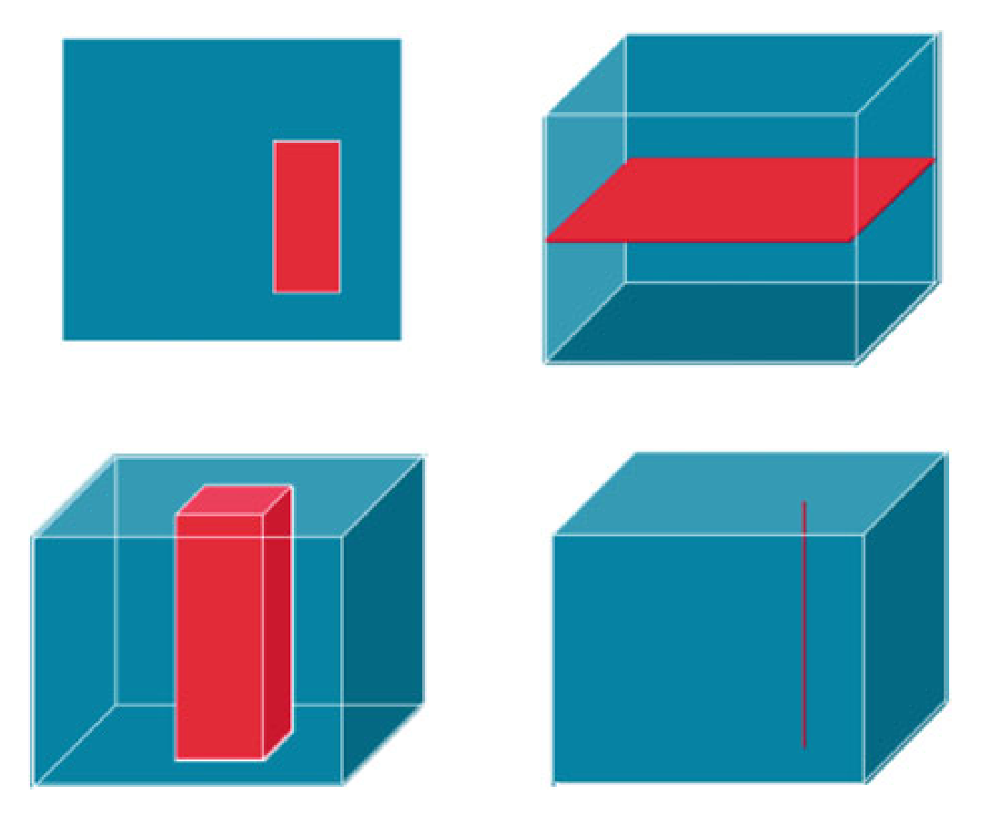
Figure 3. Data cube trimming (left) and slicing (right) [Baumann 2018]

Requirement
https://opengeospatial.org/bp/datacubes/Req07
- A Geospatial Data Cube Service shall allow tuning of performance to anticipated user query patterns.

Traditional storage, for example, has been optimized for horizontal access, penalizing temporal and vertical extraction.
Data cubes should support dimension neutrality: meaning that the complexity of a specific processing request (e.g. a query) does not depend on the dimensions involved in the request. Data cubes should expose the dataset in a way that assure dimension neutrality. [Stefano 2017]
This document makes no quantitative performance requirements. The emphasis is on functionality. Optimization as a capability shall be supported.

Requirement
https://opengeospatial.org/bp/datacubes/Req08
- A Geospatial Data Cube Service shall provide server-side analytic processing on the data including composite extraction, processing, filtering, and fusion tasks in an ad-hoc fashion.

Different Earth Science disciplines require processing operations of different kind. The climate science community, for example, is interested in generating anomalies and averages of data over a certain period of time. For the vegetation community, the query language defined in WCPS is very useful to do band calculation, for example, to calculate on-demand the Normalized Difference Vegetation Index (NDVI) of a satellite image. [Wagemann, 2017]. WCPS is also useful for spatio-temporal statistics, etc.

Data Cubes may need to do regridding and reprojection on the fly based on the datasets and the user requirements. Gridding to a common projection and tiling system comes with loss of original product information. As a single grid may not be suitable for the community’s purposes a datacube service may need to perform a regridding and reprojection on the fly.

Interoperability: APIs and Encodings
Interoperability and scalable fusion of spatial information across different data cubes is crucial and highly dependent on the use of robust international standards governing the access and transfer protocols for communication between client and server as well as among different servers. [Strobl 2017].
For interoperability and federation, data cubes need to provide access and analytics using well known interfaces. To serve the largest communities possible, Application Programming Interfaces (APIs) defined by open consensus standards are needed. The OGC Web Service standards have been implemented by most of the examples listed in Annex C. A Geospatial Data Cube service may provide more than one interface.

Core Access Interoperability

Requirement
https://opengeospatial.org/bp/datacubes/Req09
- A Geospatial Data Cube service interface for data access shall be compliant with OGC Web Coverage Service (WCS).
The primary access method to a geospatial data cube is using the interface defined in the OGC Web Coverage Service, Version 2.1 [WCS 2012]
Compliance of the data cube to the WCS standard shall be certified using the OGC Compliance Test suite. http://www.opengeospatial.org/compliance/getCertified
Data cubes may choose to define a WCS profile for their community, e.g., WCS EO Profile.
Data and other information returned from a data cube to a client may be encoded in a variety of forms. There are many formats suitable for use in Geospatial Data Cubes. Preferences for a specific format tend is related to the community to be served. ARD data choices are based on the analysis needs agreed by their targeted user community. The Data Cube will need to support formats typically used by the ARD community.

Requirement
https://opengeospatial.org/bp/datacubes/Req12
- A Geospatial Data Cube shall support encodings that are defined in open consensus standards and that are used by the community targeted.

To support the variety of data formats, the WCS standard includes extensions mapping the information model to the format, e.g., GeoTIFF, netCDF, JPEG2000, GMLJP2, JPIP, GRIB2

Interoperability for Analysis

Requirement
https://opengeospatial.org/bp/datacubes/Req10
- A Geospatial Data Cube service interface for data analytics shall support OGC WCS Processing Extension (WCS-P) and/or OGC Web Processing Service (WPS).
When a geospatial data cube provides user-specified analytics on the data it holds, the data cube may use the WCS – Processing extension [WCS-P 2014] which extends the WCS using on the Web Coverage Processing Service (WCPS) Language Interface Standard [WCPS 2009].
To support analytics, a data cube may accept requests for analysis via WCPS as it that expresses the analytics or by sending code to the server. Shipping procedural code to a data cube may be undesirable when considering user friendliness, parallelizability, and security. Therefore, some high-level language must be supported where users describe what they want to get, not the detailed algorithm. [Baumann 2017]
ISO IS 9075-15:2018 SQL/MDA (Multi-Dimensional Arrays) adds datacube modeling and querying to the SQL language in a domain-independent manner.
A Web Processing Service (WPS) may be used to run an analysis tool in the Geospatial Data Cube Service, and return the results to the user. The WPS processing on the Data Cube can bring the required information to a user, without having to download entire datasets. For example, WPS can be used to enable on-the-fly time series analysis and derived products. Exposing this functionality through intuitive workflows and reusable, standard interfaces will mean that these services can be consumed and enjoyed by a greater audience.
Analytics using server-side processing supported by Jupyter notebooks may also be used to perform data cube analytics. Further developments are described in Section 11.5.

Interoperability for Visualization

Requirement
https://opengeospatial.org/bp/datacubes/Req11
- A Geospatial Data Cube service interface for maps shall be compliant with OGC Map Service (WMS) or OGC Web Map Tile Service (WMTS)
When a geospatial data cube provides access to maps of the data it holds, the data cube shall use the using the interfaces defined in the OGC Web Map Service [WMS 2006] or the OGC Web Map Tile Service [WMTS 2010].
Data cubes may choose to define a WMS profile for their community, e.g., WMS EO Profile, WMS profile for Time-Dependent or Elevation-Dependent Data.

Further developments
This section identifies topics that may affect the future development of geospatial resources.

Federation of Data Cubes
Geospatial Data Cubes can be an important step toward establishing a common analytical framework to link very large, multi-resolution and multi-domain datasets together for analysis. The Geospatial Data Cube defined in this paper provides the basis for a network of data cubes operating on large geoscientific and geospatial datasets to address global as well as national challenges [Lewis, 2017]
Figure 4. Data Cube Federation envisioned by CEOS [CEOS 2016]
Data Cubes are being established at Global, Regional and National level, as in particular Regional and National data owners are constrained to publish their data on infrastructures on their territory. At the thematic level, it can be expected that different operators will appear and will want to operate their own instance of a data cube. Also, in this distributed scenario, applications shall be able to combine data layers held in different data cube instances, even if based on different technologies.
Federation of datacubes introduces location transparency of data sets hosted by geographically disparate data providers, as well as their processing. This offers several distinct advantages for users:
- Enhanced offering: Users can access the sum of all individual offerings of the participating data providers.
- Location transparency: When accessing a dataset, users can send the request to any federation member – users do not need to know the location of a particular data set. In other words, the federation offers a common, flat information space.
- Remote fusion: When combining two or more data sets in a request (such as a WCPS query) the federation partners determine an efficient way of solving this request and execute the request accordingly, without any extra client intervention. In other words, users get returned only the result requested, without any need for own source data download, reformatting, and processing.
Such federations have been implemented on rasdaman datacubes, demonstrated in EarthServer-2 [EarthServer 2017] on Petascale through intercontinental transparent federation connecting ECMWF/UK and NCI/Australia. Further, the German Sentinel hub, CODE-DE, is federated with an ESA DIAS and continuously being extended with further federation partners, including commercial offerings.
Figure 5. Data Cube Federation implemented with rasdaman [EarthServer 2017]:
query path from EGU Vienna to ECMWF, subquery forked to NCI (center); query path from EGU Vienna to NCI, subquery forked to ECMWF (right); fusion query result (identical for both queries), displayed in NASA WebWorldWind (left)

DGGS for Data Cubes
“Datacubes: A Discrete Global Grid Systems Perspective” [Purss 2019] discusses options and how it is possible to implement a datacube based on discrete global grid systems, while using the same topologies as conventional datacubes. These provide a flexible spatial data infrastructure that leverages the same topological advantages as conventional geospatial datacubes, while reducing barriers to data interoperability of both raster and vector data and providing additional functionality. Also, they potentially provide a very efficient approach to connecting to big data sources in order to extract datasets on demand prior to proceeding to multi-level intelligent big data processing, mining, machine learning, and visualizations.
The OGC DGGS Abstract Specification Topic 21 [DGGS 2017] defines a DGGS as a spatial reference system that uses a hierarchical tessellation of cells to partition and address the globe. DGGS are characterized by the properties of their cell structure, geo-encoding, quantization strategy and associated mathematical functions. The OGC DGGS Abstract Specification supports the specification of standardized DGGS infrastructures that enable the integrated analysis of very large, multi-source, multi-resolution, multi-dimensional, distributed geospatial data.
Data cubes can benefit from an underlying DGGS compliant data tiling and integration scheme as defined by the OGC DGGS specification. A data cube based on a DGGS enforces a more comprehensive set of spatial boundaries to the problem of global spatial data representation and integration. Further developments of DGGS aim to enable data cubes to be federated at a truly global scale, without the spatial limitations and constraints imposed by heterogenous data cubes.

Numerical Weather Prediction (NWP) coverages
Coverages as defined in CIS1.1 can describe the atmosphere (or ocean) as a multidimensional 4D cube that contains parameters, e.g. temperature, wind, humidity (salinity), etc. Coverages are defined by (axis) dimensions that can contain one of more of these meteorological/ oceanographic parameters. A typical Numerical Weather Prediction (NWP) forecast simulation may be expressed as a set of 2D coverages, often, but not always based on rectified grids. A typical model run contains thousands of 2D files. This situation is managed by identifying, where possible, “4D Coverages” from many 2D files, as shown in Figure 4. [Met/Ocean 2018]
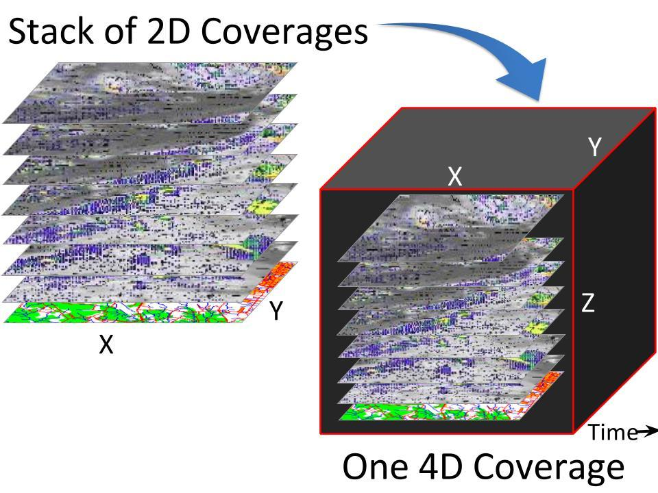
Figure 6. Visualization of a stack of 2D coverages as a 4D coverage data cube.

OGC APIs for geospatial resources
OGC is defining web-friendly APIs that can be used to access geospatial and location information in any domain. This major evolution in the OGC Standards Baseline is underway is currently underway with the development of several standards.:
- OGC API Features
- OGC API Coverages
- OGC API Map Tiles
- OGC API Processing
- OGC API Common
The OGC API standards will define modular API building blocks to spatially enable Web APIs and web-friendly for non-geospatial experts. The APIs are designed to allow developers to reuse and extend the APIs for any domain. The first consensus adoption of the Features API is planned for the second half of 2019.
The OGC APIs are being developed using OpenAPI, GitHub, and Hackathons. OpenAPI is a standard, programming language-agnostic interface description for Web APIs which allows both humans and computers to discover and understand the capabilities of a service. OGC uses GitHub as a collaborative platform for specification development and for OpenAPI artifacts. Hackathons are conducted to implement and test draft API specifications. Along with the Specifications, OGC members are developing Reference Implementations, Compliance Testing, e-Learning and Outreach materials.
Once the OGC APIs specifications have been further developed, their relevance to the Geospatial Data Cubes can be better evaluated.

The STAC specification is being developed in coordination with the OGC APIs. The SpatioTemporal Asset Catalog (STAC) specification aims to standardize the way geospatial assets are exposed online and queried. A 'spatiotemporal asset' is any file that represents information about the earth captured in a certain space and time. The initial focus is primarily remotely-sensed optical imagery (from satellites, but also planes, drones, balloons, etc.), but the core is designed to be extensible to SAR, full motion video, point clouds, hyperspectral, LiDAR and derived data like NDVI, Digital Elevation Models, mosaics, etc.

Array Analytics
Several approaches to APIs for analytics are discussed in section 10.2. In the future, the OGC community will investigate the further development technologies for analytic interoperability, such as:
- Jupyter notebooks and Python scripting language.
- Array Databases, e.g., ISO IS 9075-15 SQL/MDA (Multi-Dimensional Arrays)
- xarray, GeoXarray, ZARR]
- OGC Web Coverage Processing Service (WCPS) Language Interface Standard [WCPS 2009]
- OGC API - Coverages

Annex A: Conformance Class Abstract Test Suite (Normative)

Conformance class: Core Geospatial Data Cube
Implementations claiming Core Conformance shall be conformant with the requirements listed in this clause.
Compliance of the data cube to OGC Web Service Standards shall be certified using the OGC Compliance Test suite. http://www.opengeospatial.org/compliance/getCertified

Req 1. A Geospatial Data Cube shall use the Geographic Coverage model as defined in OGC Coverage Implementation Schema (CIS). 12
Req 2. A Geospatial Data Cube Service shall host geospatial data cubes and support services on the data when requested. 14
Req 3. When ingesting data, a Geospatial Data Cube shall provide methods for data storage and access optimizations consistent with the Geospatial Data Cube Information Model. 14
Req 4. A Geospatial Data Cube shall provide metadata for the user that defines the provenance of all source data, data preparation methods applied and data structure of the cube. If applicable, the metadata shall be defined in accordance with ISO 19115. 14
Req 5. A Geospatial Data Cube Service shall support analytics on all domain axes alike, irrespective of the nature of the dimension, e.g spatial or temporal . 15
Req 6. A Geospatial Data Cube Service shall allow efficient trimming and slicing along any number of axes from a data cube in a single request by the user. 15
Req 7. A Geospatial Data Cube Service shall not allow requests that require excessive resources, responding to the user with an estimate of the resource requirements and/or recommendations on how to reduce resources. 16
Req 8. A Geospatial Data Cube Service shall allow tuning of performance to anticipated user query patterns. 16
Req 9. A Geospatial Data Cube Service shall provide server-side analytic processing on the data including composite extraction, processing, filtering, and fusion tasks in an ad-hoc fashion. 17
Req 10. A Geospatial Data Cube service interface for data access shall be compliant with OGC Web Coverage Service (WCS). 18
Req 11. A Geospatial Data Cube shall support encodings that are defined in open consensus standards and that are used by the community targeted. 18

Conformance class: Analytics Extension
Implementations claiming Analytics Extension Conformance shall be conformant with the requirements listed in the Core Conformance and in this clause.
Compliance of the data cube to OGC Web Service Standards shall be certified using the OGC Compliance Test suite. http://www.opengeospatial.org/compliance/getCertified
Req 12. A Geospatial Data Cube service interface for data analytics shall support OGC Web Coverage Processing Service (WCPS) and/or OGC Web Processing Service (WPS). 18

Conformance class: Visualization Extension
Implementations claiming Visualization Extension Conformance shall be conformant with the requirements listed in the Core Conformance and in this clause.
Compliance of the data cube to OGC Web Service Standards shall be certified using the OGC Compliance Test suite. http://www.opengeospatial.org/compliance/getCertified

Req 13. A Geospatial Data Cube service interface for maps shall be compliant with OGC Map Service (WMS) or OGC Web Map Tile Service (WMTS) 19

Annex B: Bibliography
[Baumann 1992] P. Baumann: Language Support for Raster Image Manipulation in Databases. Proc. Int. Workshop on Graphics Modeling, Visualization in Science & Technology, Darmstadt/Germany, April 13 - 14, 1992, Springer 1993, pp. 236 – 245
[Baumann 2010] P. Baumann, S. Feyzabadi, C. Jucovschi: Putting Pixels in Place: A Storage Layout Language for Scientific Data. Proc. IEEE ICDM Workshop on Spatial and Spatiotemporal Data Mining (SSTDM'10), December 14, 2010, Sydney, Australia
[Baumann 2017] Baumann, P., The Datacube Manifesto, EarthServer Project, 2017. Retrieved from http://www.earthserver.eu/tech/datacube-manifesto
[Baumann 2018] P. Baumann, D. Misev, V. Merticariu, B. Pham Huu: Datacubes: Towards Space/Time Analysis-Ready Data.. In: J. Doellner, M. Jobst, P. Schmitz (eds.): Service Oriented Mapping - Changing Paradigm in Map Production and Geoinformation Management, Springer Lecture Notes in Geoinformation and Cartography, 2018
[CEOS 2016] CEOS and the Australian Geoscience DataCube - Towards Integrated Earth Environmental Information Systems, Presentation by Dr. Alex Held, CSIRO and CEOS Chair Representative, DIAS Symposium, Tokyo, August 2016
[CEOS 2018] Open Data Cube Manual, CEOS. Accessed June 27, 2018. http://datacube-core.readthedocs.io/en/latest/
[DGGS 2017] OGC Discrete Global Grid Systems (DGGS) Abstract Specification Topic 21, OGC Document 15-104r5, Publication Date: 2017-08-01
[EarthServer 2017] P. Baumann, A.P. Rossi, B. Bell, O. Clements, B. Evans, H. Hoenig, P. Hogan, G. Kakaletris, P. Koltsida, S. Mantovani, R. Marco Figuera, V. Merticariu, D. Misev, B. Pham Huu, S. Siemen, J. Wagemann: Fostering Cross-Disciplinary Earth Science Through Datacube Analytics. In. P.P. Mathieu, C. Aubrecht (eds.): Earth Observation Open Science and Innovation - Changing the World One Pixel at a Time, International Space Science Institute (ISSI), 2017, pp. 91 – 119
[ESA 2018] Invitation to Tender: “Data Cube Facility Service 2018–2020” https://eo4society.esa.int/2018/09/06/data-cube-facility-service-2018-2020/
[Misev et al 2018] D. Misev, P. Baumann, V. Merticariu, D. Bellos, S. Wiehle: BigDataCube: Making Big Data a Commodity. Proc. 69th International Astronautical Congress (IAC), Bremen, Germany, 1-5 October 2018
[NGAC 2018] The Feasibility and Utility of Implementing Temporal Data Cubes to support Projection or “Forecast” models and land change trends. A Report of the National Geospatial Advisory Committee (NGAC) Landsat Advisory Group, April 2018
[Purss 2019] Purss, Matt, et.al., Datacubes: A Discrete Global Grid Systems Perspective, Cartographica, Volume 54 Issue 1, Spring 2019, pp. 63-71. DOI: 10.3138/cart.54.1.2018-0017
[RDA 2018] RDA: Array Database Assessment Working Group Report. https://www.rd-alliance.org/groups/array-database-working-group.html
[Stefano 2017] Nativi, Stefano Nativi, et.al., A view-based model of data-cube to support big earth data systems interoperability, Big Earth Data, 1:1-2, 75-99, Published online: 04 Dec 2017. DOI: 10.1080/20964471.2017.1404232
[Strobl 2017] Strobl, Peter, et.al., The Six Faces of the Data Cube, Proc. of the 2017 conference on Big Data from Space (BiDS’17) Toulouse, France 28–30 November 2017 doi: 10.2760/383579
[Tan 2017] Tan, Zhenyu, et.al. An Array Database Approach for Earth Observation Data Management and Processing, ISPRS Int. J. Geo-Inf. 2017, 6, 220; Published: 19 July 2017. doi:10.3390/ijgi6070220
[Vinhas 2016] Vinhas, Lubia, et.al, Web Services for Big Earth Observation Data, Proceedings XVII GEOINFO, November 27-30, 2016, Campos do Jorda ̃o, Brazil
[Wagemann 2017] Wagemann, Julia, et.al., Geospatial web services pave new ways for server- based on-demand access and processing of Big Earth Data, International Journal of Digital Earth, 11:1, 7-25, Published online: 17 Jul 2017. DOI: 10.1080/17538947.2017.1351583

Annex C: Data cube implementation examples

Introduction
This Annex includes non-normative examples of data cube implementations that adhere to most of the items in the body of this document. The implementations are listed in an order that balances historical development and listing data cubes that meet the body of the text higher in the order.

OpenDataCube (Previously the Australian Geoscience Data Cube)
The Open Data Cube provides an integrated gridded data analysis environment for decades of analysis ready earth observation satellite and related data from multiple satellite and other acquisition systems. [CEOS 2018]
The Open Data Cube is a system designed to:
- Catalogue large amounts of Earth Observation data
- Provide a Python based API for high performance querying and data access
- Give scientists and other users easy ability to perform Exploratory Data Analysis
- Allow scalable continent scale processing of the stored data
- Track the provenance of all the contained data to allow for quality control and updates
The Open Data Cube provides these APIs and community developed extensions:
- Loading Data from a Cube
- Searching and Indexing Datasets
- Model
- Bit Masking
- Analytics and Execution Engines
- Array IO on Amazon S3
- WMS and WCS
- WPS
- QGIS integration
- A UI for visualising its contents
- A UI for executing queries
- For Exploratory Data Analysis see Datacube Class for more details
- For Writing Large Scale Workflows see GridWorkflow Class for more details

EarthServer-2 project
The EU FP7 EarthServer and EU H2020-funded EarthServer-2 [EarthServer 2017] projects have set up WCSs for different scientific domains: ocean science, earth observation, climate science and planetary science. The architectural setup follows the web services concept and bases on rasdaman (http://rasdaman.org/), an intelligent array-based server technology, in combination with the OGC standard protocol WCS. Four WCSs are exploring the possibilities and challenges of providing access to data sizes beyond 1 PB of 3D to 4D Earth Science Data: [Wagemann, 2017]
- Marine Science Data Service (http://earthserver.pml.ac.uk/) is developed by the Plymouth Marine Laboratory (PML) and makes available multiple hundred terabytes of ocean colour data, produced by ESA’s climate change initiative (CCI). The service will further offer Sentinel-3 data once the data products are disseminated.
- Climate Science Data Service (http://earthserver.ecmwf.int/) is developed by the ECMWF and will provide access to multiple petabytes of ERA-Interim reanalysis data (Dee et al. 2011) stored in ECMWF’s archive. By serving data from the Meteorological and Archival System (MARS archive) via a web service in a standardized way, reanalysis data will become better accessible in a more tailored format to scientists and technical data users.
- Earth Observation (EO) Data Service (http://eodataservice.org/) is jointly developed by MEEO s.r.l. and the National Computing Infrastructure (NCI) Australia. The service will offer EO data from the Sentinel family, primarily data from Sentinel-2 satellites. NCI will eventually offer a WCS for multiple hundreds of terabytes of Landsat data.
- .Planetary Science Data Service (http://planetserver.eu/) is developed by the Jacobs University Bremen and will provide access to tens of TB of data (topographic, multi- and hyperspectral) of the solar system bodies Mars, Mercury and Moon.
Since 2012, the intercontinental EarthServer initiative (http://www.earthserver.eu) is establishing agile data cube analytics on 3D x/y/t image timeseries and 4D x/y/z/t weather data, based on the rasdaman Array Database System (http://www.rasdaman.org). The largest installation, EO Data Service (www.eodataservice.org), recently has passed the 1 Petabyte. [Strobl 2017]
Data cube assets of 2.5 PB have been federated intercontinentally, and single queries have been parallelized across more than 1,000 cloud nodes. As such, the EarthServer initiative is one of the large-scale proofs of practicality for WCS and, specifically, WCPS.
One success or activity, establishing a private/public datacube partnership, is the German funded project BigDataCube [Misev et al 2018]. Aside from routinely using the rasdaman federation capabilities it puts particular emphasis on versatile access control, down to the level of single pixels.

rasdaman
Following its invention of datacube services [Baumann 1992], the rasdaman team since then has architected the rasdaman scalable datacube engine for cross-domain management and server-side processing of massive n-D arrays. The rasdaman declarative datacube analytics language allows any query, any time, on any size, ready for extraction, filtering, processing, analytics, distributed datacube fusion, and Artificial Intelligence. Through the OGC WMS, WCS, and WCPS standards rasdaman supports regular and irregular spatio-temporal grids. The open-source rasdaman engine is OGC WCS reference implementation, and the rasdaman query language has been standardized in the ISO SQL array extension. As the currently only tool rasdaman supports transparent federation on planetary scale. Individual nodes retain autonomy, with security configurable down to single pixel level.
The rasdaman architecture is a full-stack implementation in fast C++, with every component optimized for arrays. A series of highly effective techniques boosts array query execution, including: adaptive partitioning, just-in-time compilation into machine code, heterogeneous CPU/GPU hardware support, intelligent query optimizations, parallelization and distribution (without single point of failure), and federated processing. Queries have been split across more than 1,000 Amazon cloud nodes.
Storage utilizes transparent tiling into sub-arrays maintained in some database (like PostgreSQL) or directly in the file system (about 2x faster), always using rasdaman’s optimized storage methods. Any tiling can be configured by the admin, as one of the many tuning parameters in an easy-to-use, OGC based ETL tool. Additionally, rasdaman can tap into any pre-existing archive by just registering files rather than copying them.
With Athena Research’s FeMME extension, rasdaman allows integrated data and metadata search, thereby establishing a seamless integration of catalogs with datacubes. Users always remain in the comfort zone of their well-known tools – rasdaman supports a large and growing number of visual and API clients, including OpenLayers, Leaflet, QGIS, ArcGIS, NASA WebWorldWind, Cesium, C++, Java, python, and R.
User-friendly, flexible, fast, scalable, and standards-conformant datacube services become a commodity with rasdaman: providers enjoy simple deployment and maintenance, users enjoy the massively simplified access, visualization, and analysis capabilities not requiring any programming skills. A series of innovation awards, most recently the NATO Defence Innovation Award 2018, acknowledges the rasdaman innovation.
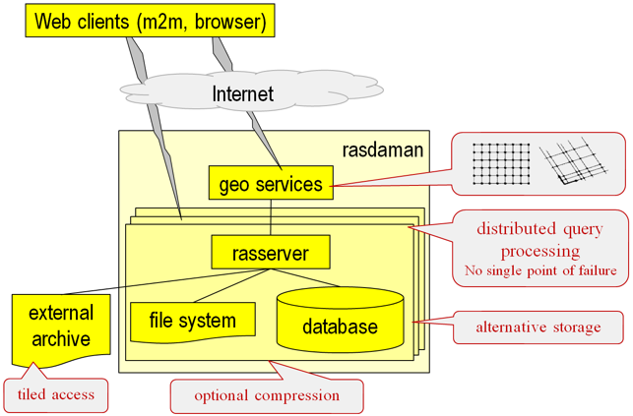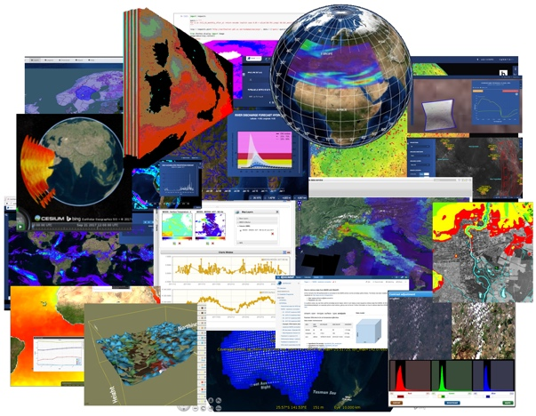
Figure 6. Left: Rasdaman architecture [Misev at al 2018];
right: Kaleidoscope of rasdaman-based datacube portals

EOX Sentinel-2 cloudless
Sentinel-2 cloudless (https://s2maps.eu) is a yearly series of global sunny homogeneous 10m satellite maps. It combines trillions of pixels collected during differing weather conditions over a whole year and merges them into a mosaic, almost free from atmospheric impacts. The mosaics are provided via Web Map Tile Service (WMTS) as well as Web Map Service (WMS) under a Creative Commons license (2016 CC-BY; newer CC-BY-NC-SA). A WCS interface is provided.
Sentinel-2 cloudless is the global visualization product of the EOxCloudless product family (https://cloudless.eox.at) that provides off-the-shelf or custom tailored mosaics as Data Cubes. In its simplest form the mosaics are provided as numerous GeoTIFFs in a
pyramid structure following the WMTS tilematrixset definition (see this blog post for details https://eox.at/2018/01/visualizing-geotiff-tiles-with-openlayers/). Off-the-shelf mosaics contain 4 bands (8- or 16-bits) but custom mosaics may include any number of bands as well as potentially a metadata band allowing tracing back to individual input satellite
images on a per-pixel basis. These GeoTIFFs can be loaded in a simple HTTP server or a more complex server software like the Open Data Cube. The Open Source library geotiff.js (https://geotiffjs.github.io) for example allows exploration and analysis of GeoTIFFs directly in the browser like for example shown in the COG-Explorer (https://geotiffjs.github.io/cog-explorer) demonstration.

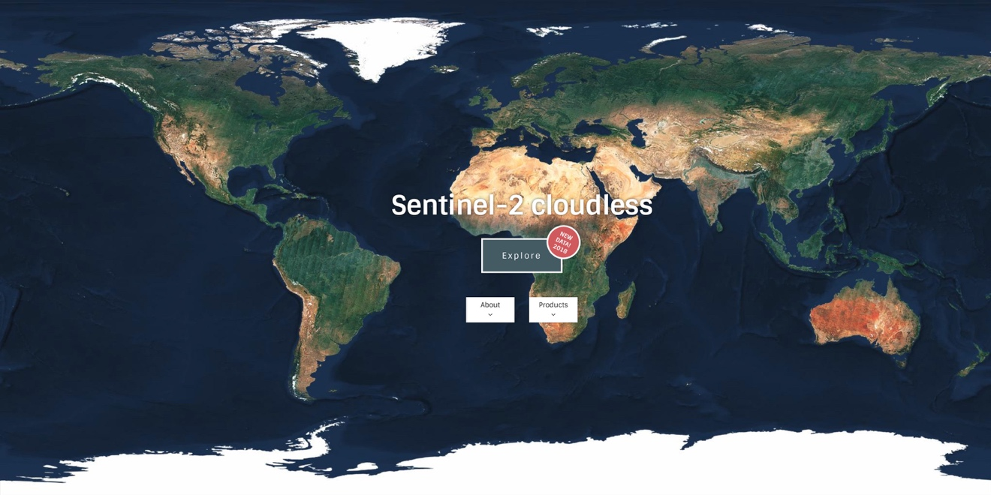

Advanced geospatial Data Management platform (ADAM)
The Advanced geospatial Data Management platform (ADAM) is a platform that implements the Digital Earth concept: ADAM allows accessing to large variety of multi-year global geospatial collections allowing data discovery, visualization, combination, processing and download. ADAM allows exploiting data from global to local scale.
The core of ADAM is a Data Access System (DAS), a software module that manages a large variety of geospatial information featuring different data formats, geographic / geometric and time resolution The DAS exposes OGC standardised Open Search and Web Coverage Service (WCS 2.x) interfaces that allow discovering available collections and subset them in any dimension with a single query. Thus, ADAM provides an effective subsetting functionality that accesses the data only when requested and serves to the client only the data amount that is really needed.
ADAM is a very modular platform: various DAS are deployed on different data sources (e.g. different DIAS, AWS, MEEO Data Facility, …), allowing accessing and subsetting the available collections without downloading / duplicating the data.
ADAM, referred also as a virtual datacube technology, enables seamless access to all available data collections through a single interface; cutting the access barriers to a large variety of data (no need to know the exact for-mat of any of the available products) it saves data preparation time and facilitates the simultaneous use of data coming from different sources.
ADAM exposes three user interfaces to satisfy the needs (and match with the skills) of a large variety of users:
- A web based graphic user interface (Explorer) and a mobile application (ADAM Mobile)
- A web-based notebook (Jupyter Notebook)
- OGC standardised REST interfaces: OpenSearch for data discovery, WCS 2.x for data access)

Sentinel Hub
Sentinel Hub is a satellite imagery processing service, which is capable of on-the-fly gridding, re-projection, mosaicking, compositing and other actions required for efficient fetching of data for end-users, either for integration in web-applications, where pictures are mostly served, or in machine learning and similar analysis processes, where pixel values and statistics are essential. The output is provided over OGC compliant web services. The service works with original satellite data files and does not require replication or pre-processing. It uses cloud infrastructure and innovative methods to efficiently process and distribute data in a matter of seconds.
Service’s main components are:
- Catalogue service, containing all relevant meta-data about all available scenes, allowing efficient identification of scene available in the AOI based on user-defined parameters (time range, cloud coverage, sensor type, etc.).
- Data processing and rendering service, which takes processing configuration (e.g. combination of bands or more complex algorithm) as an input and processes data in real-time:
  - query Catalogue service for chosen AOI, time range, cloud coverage, mission, etc.
  - download necessary data from on-line storage and decompress it
  - creation of mosaic based on priority, cloud replacement, etc.
  - compositing relevant bands to chosen EO product or applying Custom script
  - re-projection to chosen CRS
  - output creation in chosen file type (JPG, PNG, JP2, JPX, GeoTIFF, etc.)
  - compression of the output for faster download, based on user settings
- Custom scripting engine, which allows user to input an algorithm defining pixel-based (and in the future also object-based) data processing. Sinergise maintains open-source Custom scripts library to make it easier for users to start.
- Support for Sentinel-1 GRD, Sentinel-2 (L1C and L2A), Sentinel-3 OLCI (SLSTR being added by end of 2018), Sentinel-5P, Landsat-5, -7, -8, Envisat MERIS and MODIS data. All these products are supported both from technical view (data processing, meta-data, etc.) as well as implementation (operational deployment with access to all available data).
- OGC compliant WMS/WMTS/WCS and POST API interfaces to access the data. Statistical API provides faster access to higher-level information (e.g. max/min/mean values of specific index over time).
- Various data manipulation options (orthorectification of Sentinel-1 GRD, up- and down-scaling options, multi-temporal processing.
- Sentinel Hub is currently operational on CreoDIAS, Mundi Web Services, ONDA and AWS cloud infrastructures. It processes on average 3 million requests per day at the time of the submission of this document.

ESA EO Data Cube Facility
The objective of ESA’s Earth Observation (EO) Datacube facility service is to provide users with functionality to query and exploit large volumes of EO data and information resources based on Data Cube Technologies, with a scheme that promotes open data sharing. The Data Cube Facility Services will ensure the storage and on-line availability of data in the form of multi-dimensional arrays suitable for retrieving, analysing, correlating EO information resources, based on innovative interfaces and interoperability standard. The Facility will ensure to the various user profiles a mechanism for free access to retrieval, analysis and correlation functions and data and to maintain the higher-level resulting information resources accessible for further exploitation. [ESA 2018]

The ESA Data Cube Facility Service is funded under the Earth Observation Envelope Programme-5 (EOEP-5), which is an optional programme of ESA. Presently an ITT is open to economic operators from all ESA Member States participating to the EOEP-5 Programme.

Data Cube infrastructure adoption is dependent on the availability of open interfaces. The ESA EO Data Cube Facility project aims to contribute to adoption and further evolution of OGC standards, e.g.:
- The Web Coverage Service (WCS) offers the most comprehensive suite of functionality on coverages. It is centred around WCS Core (which is mandatory for any implementation) which defines only basic functionality: trimming, slicing, and result encoding.
- Web Coverage Processing Service (WCPS), OGC’s Data Cube query language.

ESA EO Data Cube Facility project aims to be interoperable with the CEOS- supported “Open Data Cube” open source initiative shall be ensured by contributing to the relevant interoperability layers.
Figure 2. ESA EO Data Cube Facility

Annex D: Revision history

Date | Release | Author | Paragraph modified | Description
2019-09-14 | v0.5 | Percivall, et.al. | First public version | Published for Public Request for Comments

www.opengeospatial.org/cite

