Community Standard Justification: 16-123
TITLE: 3D Tiles
CONTRIBUTOR
Name: Patrick Cozzi
Organization: Analytical Graphics, Inc.
Address:
220 Valley Creek Blvd
Exton, PA 19341
Phone: 610-981-8000
Email: pcozzi@agi.com

DATE: August 4, 2016

Introduction
This document provides a justification to the OGC Technical Committee (TC) for consideration of 3D Tiles as a Community standard. This justification, along with the submitted candidate Community standard, will form the basis for TC review and vote to approve the start of the Community standard process for this standard.
The submitters agree to abide by the TC Policies and Procedures and OGC Intellectual Property Rights Policy (http://www.opengeospatial.org/ogc/policies) during the processing of this submission.

Overview of proposed submission

3D Tiles is a publically-available open specification for streaming massive heterogeneous 3D geospatial datasets for visualization. To expand on existing 2D and 2.5D streaming of map tiles and terrain, 3D Tiles support 3D models such as buildings (exterior and interior), trees, point clouds, TIN terrain, and vector data use cases. For examples, see the showcase YouTube video below.

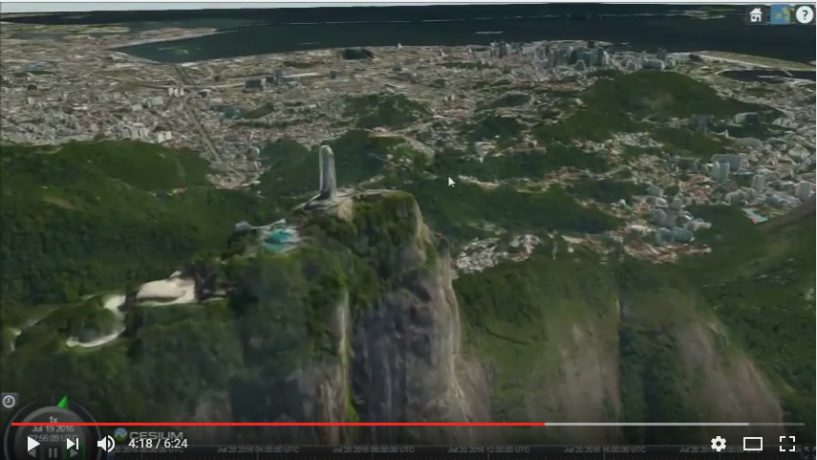
https://youtu.be/KoGc-XDWPDE

Bringing techniques from graphics research, the movie industry, and the game industry to 3D geospatial, 3D Tiles define a spatial data structure and a set of tile formats designed for 3D and optimized for streaming and rendering. The initial tile formats are:
- Batched 3D Models – for buildings, terrain, massive models, etc.
- Instanced 3D Models – for trees, bolts, valves, etc.
- Point Clouds – for massive point clouds
- Vector Data – for 3D points, polylines, and polygons, including extrusions
- Composite – a tile of tiles to allow aggregation

3D Tiles is

- Open - an open specification with an open-source implementation in Cesium available on GitHub.
- Optimized for streaming and rendering - The foundation of 3D Tiles is a Hierarchical Level of Detail (HLOD), which allows only visible tiles to be streamed - and only those tiles which are most important for a given 3D view. Tile payloads can be binary and compressed. The pipeline from receiving a 3D Tile to rendering it with WebGL is streamlined to be fast and simple, and to minimize client-side processing. To reduce the number of WebGL draw calls, tiles may be pre-batched.

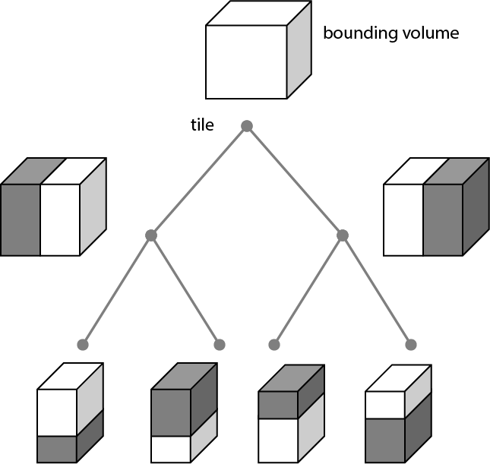

Spatial data structure that enables HLOD.

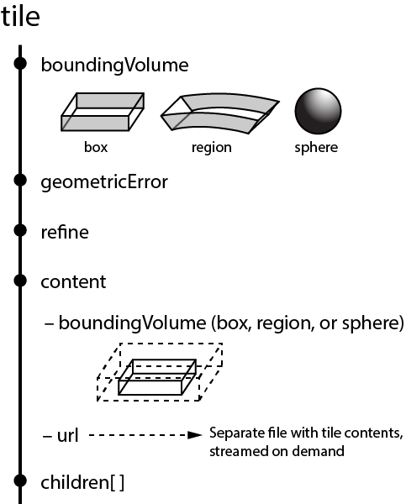
Properties defining a tile.

- Designed for 3D - 3D Tiles is designed for true 3D with a free-roaming camera; they are not limited to cases such as 2.5D perspective. Instead of relying on 2D constructs such as zoom levels, 3D Tiles are based on geometric error for Level-Of-Detail (LOD) selection and a tunable pixel error. This allows performance/visual-quality tuning and is built for multiple “zoom levels” in the same view.
- Interactive – 3D Tiles can contain per-feature attributes used for interaction such as mouseover highlighting, data display, and querying third-party web services.
- Styleable – Per-feature attributes can also be used as input to declarative styling to dynamically change a feature’s appearance. This enables well-known work flows as in established 2D GIS which are widely used by geographic data specialists, which decreases the barrier-to-entry for 3D.

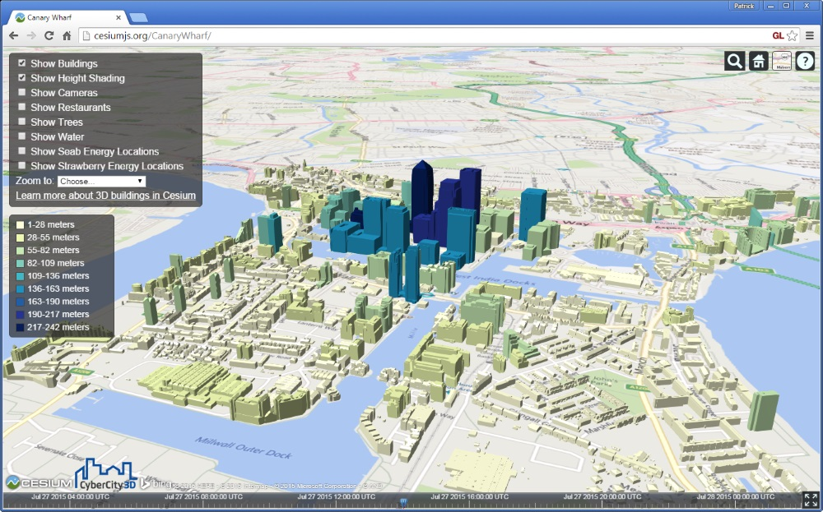
Height-dependent building color demonstrating 3D Tile styling.

- Temporal – Sub-trees in 3D Tiles tilesets can have an expiration time for refresh. There are also longer-term plans to support fully temporal datasets, such as time-dynamic point clouds [1].
- Adaptable - 3D Tiles enable adaptive spatial subdivision in 3D, including k-d trees, quadtrees, octrees, grids, and other spatial data structures. Instead of rigid spatial subdivision, conversion tools can adaptively subdivide a dataset, for example, based on the cost of rendering each model and the distribution of models, resulting in a balanced data structure. A runtime engine like Cesium is generic and works with all subdivision techniques.

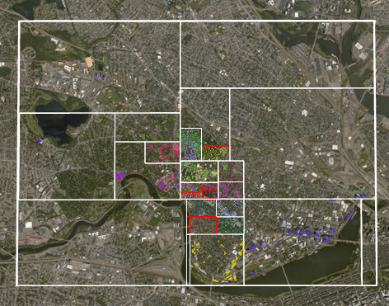
An adaptive quadtree-like subdivision based on the distribution of buildings in Cambridge.

- Flexible - With traditional 2D map tiles, when the user zooms in, the visible map tiles are replaced with new higher-resolution map tiles. This is called refinement. In a sense, a subset of the same content is downloaded again, but at a higher resolution. We call this replacement refinement, and it is a reasonable solution for imagery tiles and even 3D terrain. However, more flexibility is needed for 3D datasets such as buildings and point clouds. For example, instead of essentially downloading the same building multiple times as the viewer zooms in, we can stream just new buildings using additive refinement.
- Heterogeneous - 3D Tiles support heterogeneous datasets by enabling adaptive subdivision, flexible refinement, and an extendable set of tile formats. The heterogeneous nature of 3D Tiles allows discrete levels of detail combined with HLOD so, for example, a 3D building could be a billboard and label at one LOD, an extruded footprint at a higher LOD, a 3D model at the next LOD, and a textured 3D model at the highest LOD.

For a more detailed introduction to 3D Tiles, see [2].

History

The 3D Tiles initiative was announced in August 2015 at the SIGGRAPH conference and garnered significant interest. Since then, the spec [3] and Cesium implementation [4] have been developed in the open on GitHub.

The community immediately saw the need for 3D Tiles and started to adopt the format. This is demonstrated in the eleven implementations highlighted in Section 5 below.

3D Tiles has been presented at several venues including:
- SIGGRAPH, August 2015 [5]
- JS.Geo, October 2015 [6]
- OGC Technical and Planning Committee Meeting Closing Plenary March 2016, [7]
- FOSS4G NA, May 2016 [8]
- Web3D, July 2016 [9]
- SIGGRAPH, July 2016 [10]

In August 2016, Analytical Graphics, Inc. and the University of Pennsylvania started an initiative to develop open-source tools for debugging, analyzing, and validating 3D Tiles tilesets [11]. We expect the validator to be ready by the end of 2016 and that it will help ensure interoperability among exporters, converters, and renderers that implement 3D Tiles.

[1] https://github.com/AnalyticalGraphicsInc/3d-tiles/issues/102
[2] http://cesiumjs.org/2015/08/10/Introducing-3D-Tiles/
[3] https://github.com/AnalyticalGraphicsInc/3d-tiles
[4] https://github.com/AnalyticalGraphicsInc/cesium/issues/3241
[5] http://cesiumjs.org/publications.html#virtual-globes-using-webgl-and
[6] http://cesiumjs.org/publications.html#cesium-and-the-future-of
[7] http://cesiumjs.org/publications.html#3d-tiles-streaming-massive-heterogeneous
[8] http://cesiumjs.org/publications.html#3d-tiles-beyond-2d-tiling
[9] http://cesiumjs.org/publications.html#the-open-cesium-3d-tiles
[10] http://cesiumjs.org/publications.html#virtual-globes-using-webgl-and
[11] https://github.com/AnalyticalGraphicsInc/3d-tiles-tools

Relationship to other OGC standards

3D Tiles do not depend on any OGC standards.

Some 3D Tiles tile formats depend on the glTF standard (GL Transmission Format) by The Khronos Group, similar to how KML depends on COLLADA.

glTF is a fast and small JSON + binary runtime format for 3D models that offers a large and growing open-source software ecosystem, including
- exporters
- converters
- optimization pipelines
- validators
- loaders

glTF open-source software is supported by companies including Autodesk, Oculus, NVIDIA, Microsoft, Google, and Analytical Graphics, Inc. This readily available software for glTF makes it easier to adopt 3D Tiles.

For more on glTF, see https://www.khronos.org/gltf.

Currently, no OGC standards normatively reference 3D Tiles. A proposed best practices paper is being prepared by Fraunhofer-Gesellschaft for presentation at the Orlando OGC meeting that demonstrates OGC 3DPS for data discovery, 3D Tiles for the actual payload sent to the client, and CityGML for the source dataset.

Alignment with OGC Standards Baseline

3D Tiles fit into the OGC ecosystem in several ways:
- As an efficient payload for 3DPS for streaming massive heterogeneous 3D geospatial datasets.
- As an efficient format for streaming massive city datasets, including attributes, originally stored in CityGML.
- As an efficient format for streaming massive 3D vector datasets, including attributes, originally stored in KML or GML Simple Features Profile.
- As a complement to 2D OGC standards such as WMS and WMTS so applications can stream 2D and 3D datasets.
- Using WFS to make queries and then linking the response to features in a 3D Tileset and styling them. See virtualcitySYSTEMS virtualcityMAP (Section 5.3 below).
- Potentially as a research platform for a Tiling SWG to prototype candidate tiling algorithms.

The following figure shows 3D Tiles in the ecosystem, including OGC standards, Khronos standards, and popular formats such as LAS (point clouds).

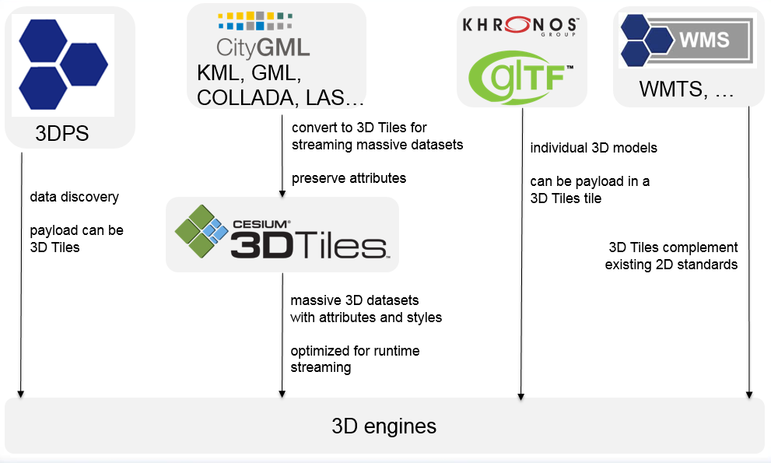

Evidence of implementation
The following implementations use the proposed Community standard.

1. Implementation name: Analytical Graphics, Inc.
Date of most recent version: Ongoing as the 3D Tiles spec finalizes
Implementation description: Open-source Cesium renderer for 3D Tiles. Closed-source tiling pipelines to convert OSM to 3D Tiles and convert CityGML to 3D Tiles. For the linked demo, the source CityGML dataset (http://www1.nyc.gov/site/doitt/initiatives/3d-building.page) is 12.84 GB. The 3D Tiles tileset is 1.85 GB (727 MB gzipped).

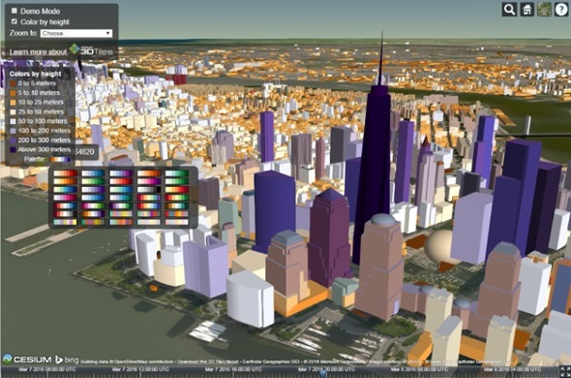

Implementation URL: https://cesiumjs.org/NewYork
Is implementation complete? Yes No
If not, what portions of the proposed Community standard are implemented?

2. Implementation name: CyberCity3D and Analytical Graphics, Inc.
Date of most recent version: Ongoing as the 3D Tiles spec finalizes
Implementation description: Tiling algorithm to convert CyberCity3D’s .csv/COLLADA buildings to 3D Tiles.

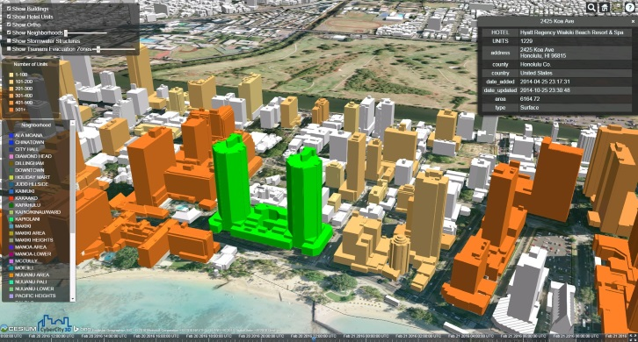

Implementation URL: http://cybercity3d.s3-website-us-east-1.amazonaws.com/?city=Miami. This link is for Downtown Miami; this has also been implemented for dozens of other cities.
Is implementation complete? Yes No
If not, what portions of the proposed Community standard are implemented?

3. Implementation name: virtualcitySYSTEMS virtualcityMAP
Date of most recent version: Ongoing as the 3D Tiles spec finalizes
Implementation description: virtualcitySYSTEMS offers a fully automated pipeline to convert massive 3D city models provided as OGC CityGML or in complementary 3D content formats to 3D Tiles. Based on the open-source 3D City Database (http://www.3dcitydb.org/), our pipeline provides solutions for the creation, storage, management, distribution and 3D visualization of arbitrarily large 3D city data. Not only building models, but any CityGML feature type including bridges, tunnels, railways, city furniture and natural phenomena such as vegetation objects, water bodies and terrain models can be processed and converted to 3D Tiles, taking into account the different CityGML LODs and appearances (e.g., textures or colors) of the features. In order to access thematic attributes or nested feature information about the city objects in the web client, the rich CityGML semantics can be mapped onto static attributes in the Batched 3D Models streaming datasets. This also enables client-side declarative styling of the city objects based on the values of any CityGML attribute, leading to insights about the urban space and its 3D assets. In order to have a dynamic view of features and their attributes, the client additionally allows for issuing live queries against an OGC WFS interface of the 3D City Database using complex spatial and thematic filters. The CityGML-based response can be easily linked to the 3D Tiles datasets in order to visually style the result set
. Moreover, OGC WM(T)S and WFS services offering 2D/3D geospatial data from other resources can be easily linked and integrated. And 3D Tiles allows our client to also visualize 3D datasets such as pointclouds and textured mesh models together with the 3D city objects.
A showcase for our 3D Tiles based virtualcityMAP technology is the official 3D city model of the City of Berlin, one of the largest CityGML models worldwide. 3D Tiles allows us to stream ~550,000 fully textured CityGML LoD2, LoD3 and LoD4 buildings over the web. The publically available application Economic Atlas Berlin gives access to this dataset: http://www.businesslocationcenter.de/wab/maps/main/. Moreover, we provide a free tech demo at http://demo.virtualcitymap.de/.
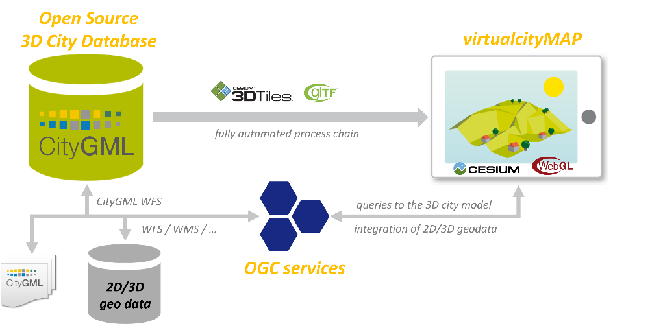
System architecture of virtualcitySYSTEMS spatial data infrastructure

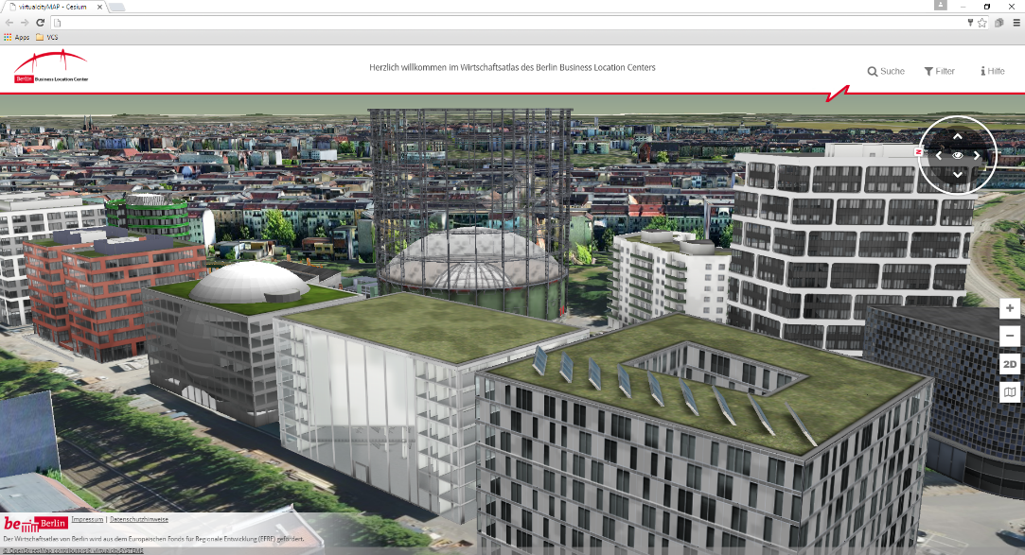
Textured LoD 4 buildings (http://www.businesslocationcenter.de/wab/maps/main/)
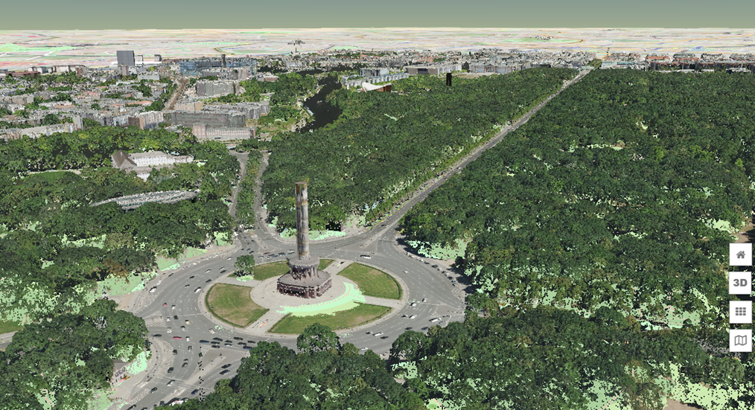
Textured buildings with point clouds (http://demo.virtualcitymap.de/)
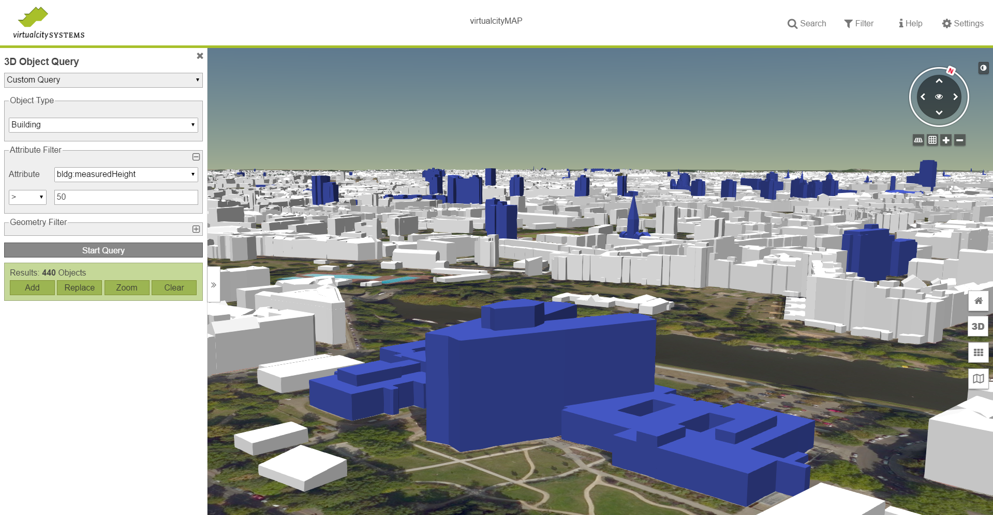
Declarative styling based on the query results of a CityGML based WFS (http://demo.virtualcitymap.de/)

Implementation URL: http://www.virtualcitysystems.de/produkte/virtualcitymap
Is implementation complete? Yes No
If not, what portions of the proposed Community standard are implemented?

4. Implementation name: Cityzenith
Date of most recent version: Ongoing as the 3D Tiles spec finalizes
Implementation description: Pipeline to convert Cityzenith 3D building datasets into 3D Tiles, including prebaking Ambient Occlusion (AO).

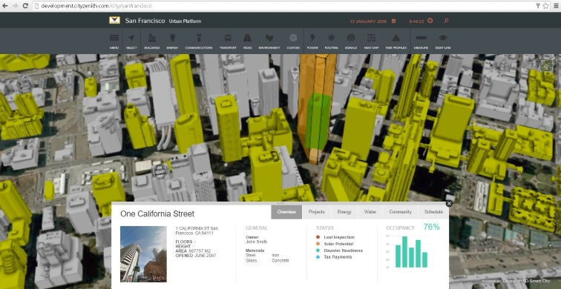

Implementation URL: http://www.cityzenith.com/ (shown in video)
Is implementation complete? Yes No
If not, what portions of the proposed Community standard are implemented?

5. Implementation name: Fraunhofer
Date of most recent version: Ongoing as the 3D Tiles spec finalizes
Implementation description: A flexible pipeline based on Fraunhofer’s “GeoToolbox” combines massive CityGML data with plans of different windpark planners into a 3D Tiles. 3D Tiles enables the exploration and comparison of these different plans for stakeholders. In addition WMS services are used in conjunction with the open quantized-mesh terrain format to drape textures or maps onto the terrain.

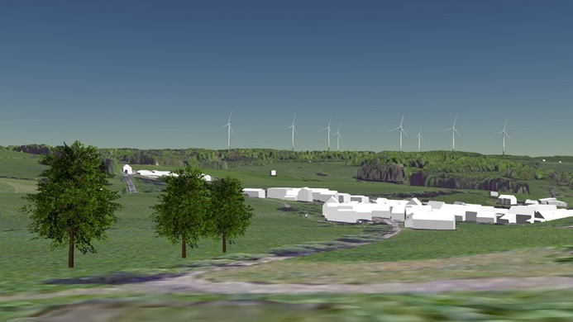

Implementation URL: The data and the planning of the windparks are not available to the public.
Is implementation complete? Yes No
If not, what portions of the proposed Community standard are implemented?

6. Implementation name: Vricon
Date of most recent version: Ongoing as the 3D Tiles spec finalizes
Implementation description: Tiling pipeline to convert high-resolution terrain (including buildings, trees, etc.) generated from images into 3D Tiles.

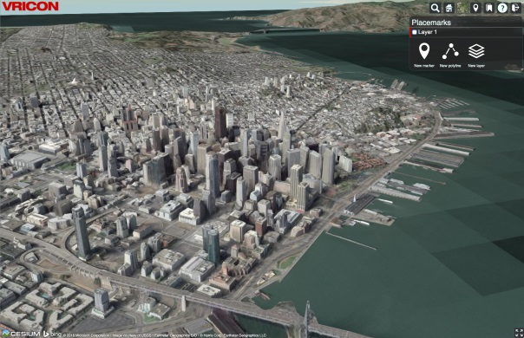

Implementation URL: http://www.vricon.com/ (no public demo yet)
Is implementation complete? Yes No
If not, what portions of the proposed Community standard are implemented?

7. Implementation name: Swisstopo and Analytical Graphics, Inc.
Date of most recent version: Ongoing as the 3D Tiles spec finalizes
Implementation description: Tiling pipeline to convert 1.5 million buildings and vector data (polygons, polylines, and points) to 3D Tiles. The source building dataset is 22.2 GB in KML/COLLADA. The 3D Tiles tileset is 1.5 GB (0.97 GB gzipped).

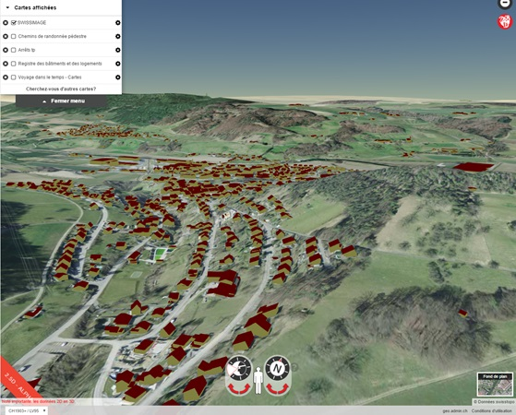
Work in progress. Data thanks to the Federal Office of Topography swisstopo.

Implementation URL: Not public yet
Is implementation complete? Yes No
If not, what portions of the proposed Community standard are implemented?

8. Implementation name: ContextCapture by Bentley Systems, Inc.
Date of most recent version: July 2016
Implementation description: Bentley ContextCapture automates the generation of high-resolution 3D models of real-world assets – in short, reality meshes – from simple photographs. The photographs can come from nearly any source – from a cell phone to a UAV or aerial survey – and the processing can scale to entire cities. The latest release of ContextCapture can generate 3D models with level-of-detail in the 3D Tiles format, for streaming and display in Cesium web applications. ContextCapture optionally generates a base Cesium application which can be directly published to the Web, so that Bentley users can get started with Cesium and 3D Tiles in minutes

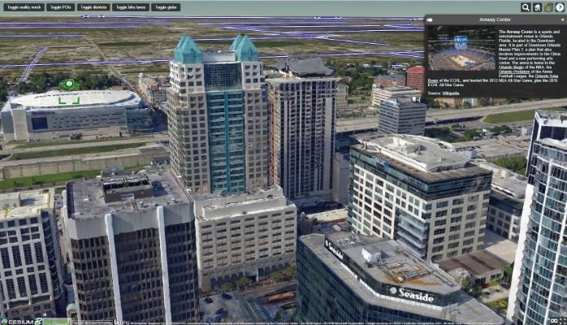

Implementation URL: https://www.linkedin.com/pulse/contextcapture-web-publishing-cesium-aude-camus
Is implementation complete? Yes No
If not, what portions of the proposed Community standard are implemented?

9. Implementation name: Fraunhofer IGD
Date of most recent version: July 2016, in development
Implementation description: An interactive showcase for OGC’s 3D Portrayal Service to demonstrate 3DPS features. The showcase is built on Cesium for the viewer and 3D Tiles as the data format. To serve the geospatial data, a modified version of the open-source software GeoRocket is used. 3D Tiles was chosen for the showcase because its features fits very well to the requirements of 3DPS.

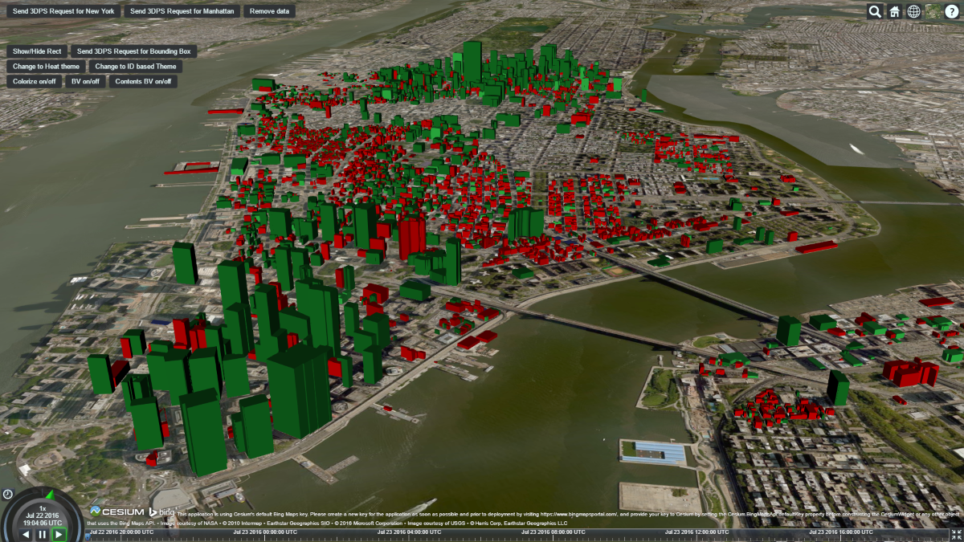
Implementation URL: N/A
Is implementation complete? Yes No
If not, what portions of the proposed Community standard are implemented?

CityGML datasets are converted to 3D Tiles with the “Batched 3D Model” tile format.

10. Implementation name: GameSim Conform
Date of most recent version: Ongoing as the 3D Tiles spec finalizes
Implementation description: GameSim procedurally built a 3D city of Pittsburgh from source feature data, elevation data, point clouds, and imagery using its geospatial visualization tool, Conform (www.gamesim.com/conform). The scene is exported into Cesium. GameSim's Cesium scenes are used to visualize urban planning and civil engineering projects for stakeholders (www.gamesim.com/up).

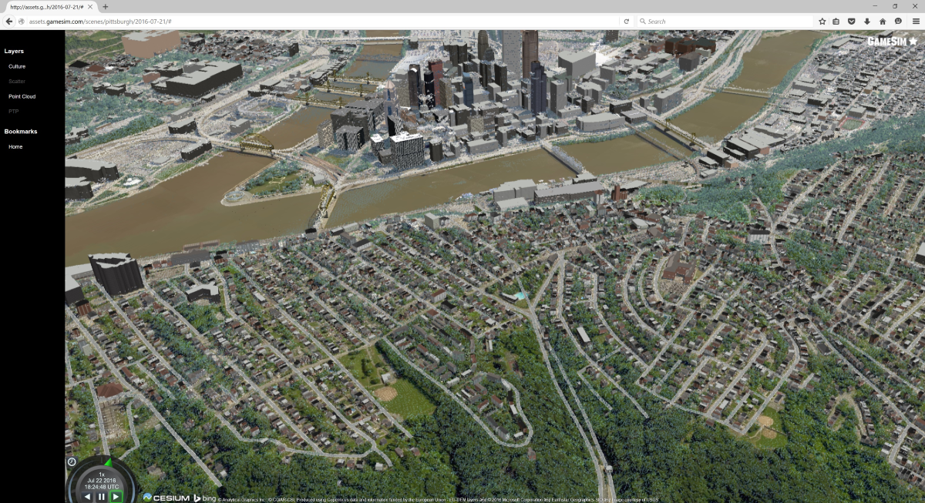

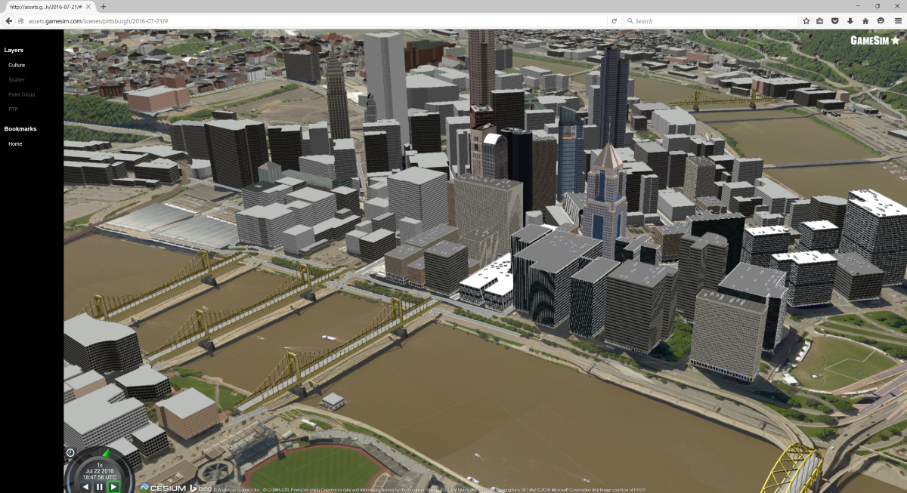

Implementation URL: https://www.gamesim.com/
Is implementation complete? Yes No
If not, what portions of the proposed Community standard are implemented?

11. Implementation name: Bentley MicroStation
Date of most recent version: Ongoing
Implementation description: MicroStation is CAD package for 3D design and drafting, including BIM (Building Information Modeling). It has a work-in-progress 3D Tiles exporter to export massive CAD models such as plants and buildings with interiors for visualization and interactive exploration on the web.
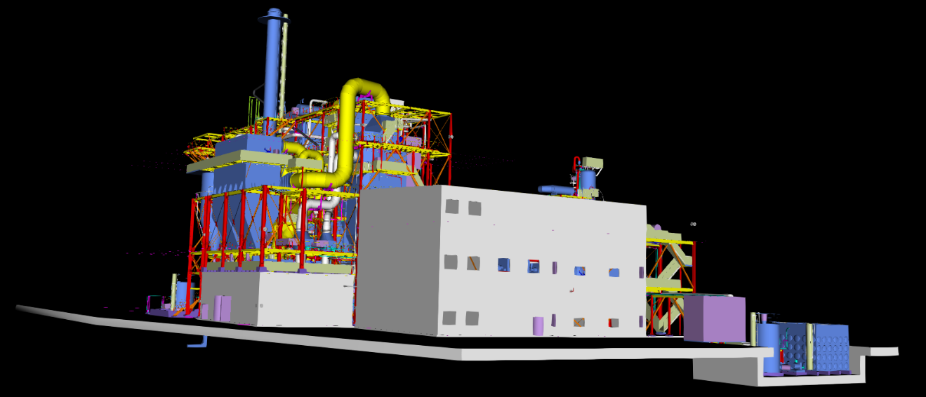

Implementation URL: N/A
Is implementation complete? Yes No
If not, what portions of the proposed Community standard are implemented?

Work-in-progress towards exporting massive CAD models from Bentley MicroStation using 3D Tiles with the “Batched 3D Model” tile format.

Public availability
Is the proposed Community standard currently publicly available? Yes No
URL: https://github.com/AnalyticalGraphicsInc/3d-tiles/blob/master/README.md

Submitting member(s)

- Analytical Graphics, Inc.
- Bentley Systems, Inc.
- Fraunhofer-Gesellschaft
- Hochschule für Technik Stuttgart
- US National Geospatial-Intelligence Agency (NGA)
- virtualcitySYSTEMS GmbH

Intellectual property rights
Will the submitter retain intellectual property rights? Yes No
If yes, the submitter will be required to work with OGC staff to properly attribute the submitter’s intellectual property rights.
If no, the submitter will assign intellectual property rights to the OGC.

