Open Geospatial Consortium

Submission Date: 2016-03-22

Approval Date: 2016-03-10

Publication Date: 2016-mm-dd

External identifier of this OGC® document: [www.opengeospatial.net/doc/PER/{short_doc_name}](http://www.opengeospatial.net/doc/PER/%7bshort_doc_name%7d)

Internal reference number of this OGC® document: OGC 15-116

Category: OGC® Discussion Paper

Editors: Giuseppe Conti, Fabio Roncato

AHA-ML (Active and Healthy Ageing Mark-up Language) an O&M profile - Discussion Paper

**Copyright notice**

Copyright © 2016 Open Geospatial Consortium  
To obtain additional rights of use, visit <http://www.opengeospatial.org/legal/>.

**Warning**

This document is not an OGC Standard. This is an OGC Discussion Paper and is therefore not an official position of the OGC membership. The document is distributed for review and comment. It is subject to change without notice and may not be referred to as an OGC Standard. Further, an OGC Discussion Paper should not be referenced as required or mandatory technology in procurements.

Document type:  OGC® Discussion Paper

Document subtype:

Document stage:  Approved

Document language:  English

License Agreement

Permission is hereby granted by the Open Geospatial Consortium, ("Licensor"), free of charge and subject to the terms set forth below, to any person obtaining a copy of this Intellectual Property and any associated documentation, to deal in the Intellectual Property without restriction (except as set forth below), including without limitation the rights to implement, use, copy, modify, merge, publish, distribute, and/or sublicense copies of the Intellectual Property, and to permit persons to whom the Intellectual Property is furnished to do so, provided that all copyright notices on the intellectual property are retained intact and that each person to whom the Intellectual Property is furnished agrees to the terms of this Agreement.

If you modify the Intellectual Property, all copies of the modified Intellectual Property must include, in addition to the above copyright notice, a notice that the Intellectual Property includes modifications that have not been approved or adopted by LICENSOR.

THIS LICENSE IS A COPYRIGHT LICENSE ONLY, AND DOES NOT CONVEY ANY RIGHTS UNDER ANY PATENTS THAT MAY BE IN FORCE ANYWHERE IN THE WORLD.

THE INTELLECTUAL PROPERTY IS PROVIDED "AS IS", WITHOUT WARRANTY OF ANY KIND, EXPRESS OR IMPLIED, INCLUDING BUT NOT LIMITED TO THE WARRANTIES OF MERCHANTABILITY, FITNESS FOR A PARTICULAR PURPOSE, AND NONINFRINGEMENT OF THIRD PARTY RIGHTS. THE COPYRIGHT HOLDER OR HOLDERS INCLUDED IN THIS NOTICE DO NOT WARRANT THAT THE FUNCTIONS CONTAINED IN THE INTELLECTUAL PROPERTY WILL MEET YOUR REQUIREMENTS OR THAT THE OPERATION OF THE INTELLECTUAL PROPERTY WILL BE UNINTERRUPTED OR ERROR FREE. ANY USE OF THE INTELLECTUAL PROPERTY SHALL BE MADE ENTIRELY AT THE USER’S OWN RISK. IN NO EVENT SHALL THE COPYRIGHT HOLDER OR ANY CONTRIBUTOR OF INTELLECTUAL PROPERTY RIGHTS TO THE INTELLECTUAL PROPERTY BE LIABLE FOR ANY CLAIM, OR ANY DIRECT, SPECIAL, INDIRECT OR CONSEQUENTIAL DAMAGES, OR ANY DAMAGES WHATSOEVER RESULTING FROM ANY ALLEGED INFRINGEMENT OR ANY LOSS OF USE, DATA OR PROFITS, WHETHER IN AN ACTION OF CONTRACT, NEGLIGENCE OR UNDER ANY OTHER LEGAL THEORY, ARISING OUT OF OR IN CONNECTION WITH THE IMPLEMENTATION, USE, COMMERCIALIZATION OR PERFORMANCE OF THIS INTELLECTUAL PROPERTY.

This license is effective until terminated. You may terminate it at any time by destroying the Intellectual Property together with all copies in any form. The license will also terminate if you fail to comply with any term or condition of this Agreement. Except as provided in the following sentence, no such termination of this license shall require the termination of any third party end-user sublicense to the Intellectual Property which is in force as of the date of notice of such termination. In addition, should the Intellectual Property, or the operation of the Intellectual Property, infringe, or in LICENSOR’s sole opinion be likely to infringe, any patent, copyright, trademark or other right of a third party, you agree that LICENSOR, in its sole discretion, may terminate this license without any compensation or liability to you, your licensees or any other party. You agree upon termination of any kind to destroy or cause to be destroyed the Intellectual Property together with all copies in any form, whether held by you or by any third party.

Except as contained in this notice, the name of LICENSOR or of any other holder of a copyright in all or part of the Intellectual Property shall not be used in advertising or otherwise to promote the sale, use or other dealings in this Intellectual Property without prior written authorization of LICENSOR or such copyright holder. LICENSOR is and shall at all times be the sole entity that may authorize you or any third party to use certification marks, trademarks or other special designations to indicate compliance with any LICENSOR standards or specifications.

This Agreement is governed by the laws of the Commonwealth of Massachusetts. The application to this Agreement of the United Nations Convention on Contracts for the International Sale of Goods is hereby expressly excluded. In the event any provision of this Agreement shall be deemed unenforceable, void or invalid, such provision shall be modified so as to make it valid and enforceable, and as so modified the entire Agreement shall remain in full force and effect. No decision, action or inaction by LICENSOR shall be construed to be a waiver of any rights or remedies available to it.

None of the Intellectual Property or underlying information or technology may be downloaded or otherwise exported or reexported in violation of U.S. export laws and regulations. In addition, you are responsible for complying with any local laws in your jurisdiction which may impact your right to import, export or use the Intellectual Property, and you represent that you have complied with any regulations or registration procedures required by applicable law to make this license enforceable

Contents Page

1 Introduction 3

2 References 4

3 Conventions 4

3.1 Abbreviated terms 4

4 Why a specific O&M profile for active and healthy aging is needed 4

5 The overall approach 5

6 The measurements 7

6.1 Affinity 7

6.2 Amount Extent of permanence at bed 8

6.3 Amount of physical exercise 8

6.4 Attention 8

6.5 Basal metabolic rate 8

6.6 Blood glucose 9

6.7 Blood Oxygen Saturation 9

6.8 Blood pressure 9

6.9 Body fat percentage 9

6.10 Body height 10

6.11 Body mass index 10

6.12 Body temperature 10

6.13 Body weight 10

6.14 Bone density 11

6.15 Calories burned 11

6.16 Electroencephalography (EEG) 11

6.17 Engagement 11

6.18 Excitement 12

6.19 Fatigue 12

6.20 Focus 12

6.21 Galvanic Skin Response 12

6.22 Heart rate 13

6.23 Interest 13

6.24 Location 13

6.25 Mini mental state examination score (MMSE) 13

6.26 Falling condition 14

6.27 Relaxation 14

6.28 Respiratory rate 14

6.29 Sleep duration 14

6.30 Sleep quality 15

6.31 Step count 15

6.32 Stress levels 15

6.33 Surprise 15

6.34 Time spent alone 16

6.35 Total body water 16

7 Possible example of use 16

7.1 Scenario 1 16

7.2 Scenario 2 16

8 Conclusions and recommendations 17

OGC® O&M AHA profile (Active and Healthy Ageing profile) Discussion Paper

1. Abstract

This document provides a proposal for a new O&M (Observations and Measurements) profile focused on Active and Healthy Ageing, called AHA-ML (Active and Healthy Ageing Mark-up Language) an O&M profile - Discussion Paper). This document introduces the overall need for such a profile and it discusses the measures which have been identified.

1. Keywords

The following are keywords to be used by search engines and document catalogues.

ogc, o&m, profile, aha-ml, health

1. Preface

Increasingly fast aging population is set to challenge health and care systems. Healthcare costs are set to increase with the future change in demographics of an aging population. In some areas of the world, such as in most European countries, healthcare is the single most expensive budget cost (often beyond 60% of total budget).

By 2060, age distribution in EU27 will change dramatically [2], with average age increasing from 40.4 to 47.9 and average life expectancy increasing from 76.7 to 84.6 (the largest increase planned in the most recent member states). By 2060, life expectancy at 65 will increase by 5 years (22.4 years for man and 25.6 for women) and the number of persons aged 80+ will triple from 23.7 to 62.4 million (EU27), doubling of the “old-age dependency” factor.

In general terms, the effect of this aging trend will be amplified by a growth in population in EU27 countries that will expand until 2035, when it will reach 520.7 million, then to decrease to 505 million by 2060 (Eurostat). As a result of such demographics trend, public health expenditure in EU27 is set to grow from 7.2% of GDP in 2010 to 8.5% in 2060, making current healthcare systems difficult to sustain. This situation is clearly calling for new care and assistance paradigms.

This paper shows the first results of the UNCAP project “Ubiquitous iNteroperable Care for Ageing People” (www.uncap.eu), funded by the Horizon 2020 programme of the European Commission. UNCAP is a pilot-centric innovation action driven by several high-tech Subject Matter Experts (SMEs) that, with support from few research centers, aims to deliver a suite of innovative ready-to-be-marketed Information and Communication Technology (ICT) products and services, based on consumer-grade technologies and open standards, designed to help elderly people with cognitive impairments live a more independent life. To facilitate exchange of comprehensive data regarding psychophysical conditions, UNCAP has identified a set of measurements which have been grouped within a convenient O&M profile.

1. Contributors contact points

All questions regarding this document should be directed to the editor or the contributors:

|  |  |
| --- | --- |
| Name | Organization |
| Giuseppe Conti | Trilogis Srl |
| Leonardo Plotegher | Trilogis Srl |
| Fabio Roncato | Trilogis Srl |
| Claudio Eccher | FBK (Fondazione Bruno Kessler) |

1. Revision history

|  |  |  |  |  |
| --- | --- | --- | --- | --- |
| Date | Release | Editor | Primary clauses modified | Description |
| 2015-10-15 | 1 | Leonardo Plotegher |  | First draft |
| 2016-02-18 | 1.1 | Fabio Roncato |  | Minor revision to include the comments made by Kym Watson and other members of the Health DWG |
| 2016-02-18 | 1.2 | Fabio Roncato |  | Minor change |
| 2016-03-22 | 1.2 | Scott Simmons | All | Preparation for publication |

# Introduction

Given the ongoing demographic changes caused by an ageing population, alternative approaches to controlling inevitably high healthcare costs should be considered. Specifically, work should consider: pressure on pension systems, ageing of the workforce, and health and social care needs increases. UNCAP responds to this challenge through the development of an open ICT infrastructure that leverages on-location and sensor-based technologies to create radically new paradigms for service care delivery.

UNCAP is delivering a suite of innovative ready-to-be-marketed ICT products and services, based on consumer-grade technologies, designed to help elderly people with cognitive impairments live a more independent life. The project, which started on January 2015, will last 3 years and involves 23 partners from 9 countries. The solution that will be developed is composed of a cloud platform used to collect, store, and analyze data coming from a number of different devices and sensors. Those sensors, most of which are wearable or portable, provide a large variety of measurements that have to be shared with the server in order to be processed.

The overall goal of the project is to:

* Improve **effectiveness** of the **health care processes** through more effective **evaluation processes** during the hospital-hospice recovery.
* Enhance home care treatment and prevention, in order to **delay cognitive impairment** of elderly and possibly **postpone the necessity of recovery** at hospitals or hospices.
* Support more **independent living** and improve **quality of life** and **dignity** of **cognitively impaired aging users** by helping them be more independent and for longer time.

From a technical standpoint this is being done through fostering of:

* **Openness**, through release of open specifications and open software components.
* **Scalability,** through use of cloud-centric approaches.
* **User friendliness**, ensuring compliance with all most common usability standards.
* **Privacy and security**, through attention to all related privacy and security aspects.
* **Interoperability and use of open standard,** through support for a range of open standards from the Open Geospatial Consortium (OGC) and beyond (e.g. HL7, Open mHealth [3]) for all key services (e.g. position, sensors, building automation systems, clinical assessment, storage of clinical data etc.) allowing for future extensions in terms of hardware and software.

Starting from this outlook, UNCAP is proposing the definition of a new profile to extend the O&M conceptual model to directly report data related to the Active and Healthy Aging domain, thus called AHA-ML. The conceptual model may then be used to define an XML (or JSON) encoding for the exchange of observations related to this specific domain.

# References

[1] OGC 10-004r3 and ISO 19156:2011, Geographic information - Observations and Measurements, OGC Abstract Specification Topic 20

[2] Empirica and WRC (2005): Various Studies on Policy Implications of Demographic Changes in National and Community Policies. Final Report

[3] Open mHealth. Available online at: <http://www.openmhealth.org/>

[4] UNCAP Project Deliverable “D1.1 - Use cases description, system requirements and PIA/TRVA”, http://www.uncap.eu/downloads

# Conventions

## Abbreviated terms

AHA Active and Healthy Ageing

BMI Body Mass Index

ECG Electrocardiography

EEG Electroencephalogram

JSON JavaScript Object Notation

LOINC Logical Observation Identifiers Names and Codes

MMSE Mini mental state examination score

MeSH Medical Subject Headings

O&M Observations and Measurements

SNOMED CT SNOMED Clinical Terms

UMLS Unified Medical Language System

XML Extensible Markup Language

# Why a specific O&M profile for active and healthy aging is needed

The need for an Active and Healthy Ageing domain-specific profile emerges from the requirement to integrate data and information across multiple systems and sensors. There is a large variety of data and concepts acquired from bio-sensing technologies which are in most cases in a proprietary format. Therefore, it is necessary to identify the concepts shared in different applications and aggregate the semantics of commonly used features under a single definition.

The added value, with respect to other available standards (e.g. Open mHealth [3]), is the integration of the geographic information and the possibility – leveraging on SensorML – of aggregating the information about the specific sensor used and the description of the measurement procedure.

# The overall approach

From the UNCAP project emerged the need to standardize the flow of measurements acquired from a large variety of sensors (bio-sensors and other types).

During the first year of the UNCAP project, we have involved all technologies providers, including those that are part of the consortium, in order to address and specifically identify the list of measures required by their technologies. To that list other measures were added in order to consider the possibility for future integration of new technologies.

Another input was collected from the pilot sites – addressing nursing homes and home care scenarios – by leveraging the use cases collected during the project preparation phase, which involved clinical staff from 11 hospitals and nursing homes from 6 different European Nations (http://www.uncap.eu/scenarios/). Clinicians and specialists described and highlighted a number of requirements to cover their specific needs. Those requirements were then translated into use cases reflecting sensors to be adopted and used for measurements. An example of what is intended as possible use cases is presented in section 7.

We have then identified for each entry a reference to publicly available vocabularies in order to provide a well-defined description of the intended measure. Each vocabulary addresses different objectives. Some examples of those that have been selected as reference for this work are as follows.

* Logical Observation Identifiers Names and Codes (LOINC): a publicly available database specialized on the identification of medical laboratory observations (https://loinc.org/).
* Medical Subject Headings (MeSH): a vocabulary that indexes biomedical scientific literature such as books and articles (https://www.nlm.nih.gov/mesh/).
* Unified Medical Language System (UMLS): a collection of many biomedical vocabularies (https://www.nlm.nih.gov/research/umls/).

The resulting set of measurements includes 35 entries that are reported in the following sections. Each measure will also be related and associated with the geographic location where it was collected.

As per the O&M standard [1], an observation is “*an act associated with a discrete time instant or period through which a number, term or other symbol is assigned to a phenomenon. The phenomenon is a property of an identifiable object, which is the feature of interest of the observation. The observation uses a procedure, which is often an instrument or sensor but may be a process chain, human observer, an algorithm, a computation or simulator. The key idea is that the observation result is an estimate of the value of some property of the feature of interest, and the other observation properties provide context or metadata to support evaluation, interpretation and use of the result.*”

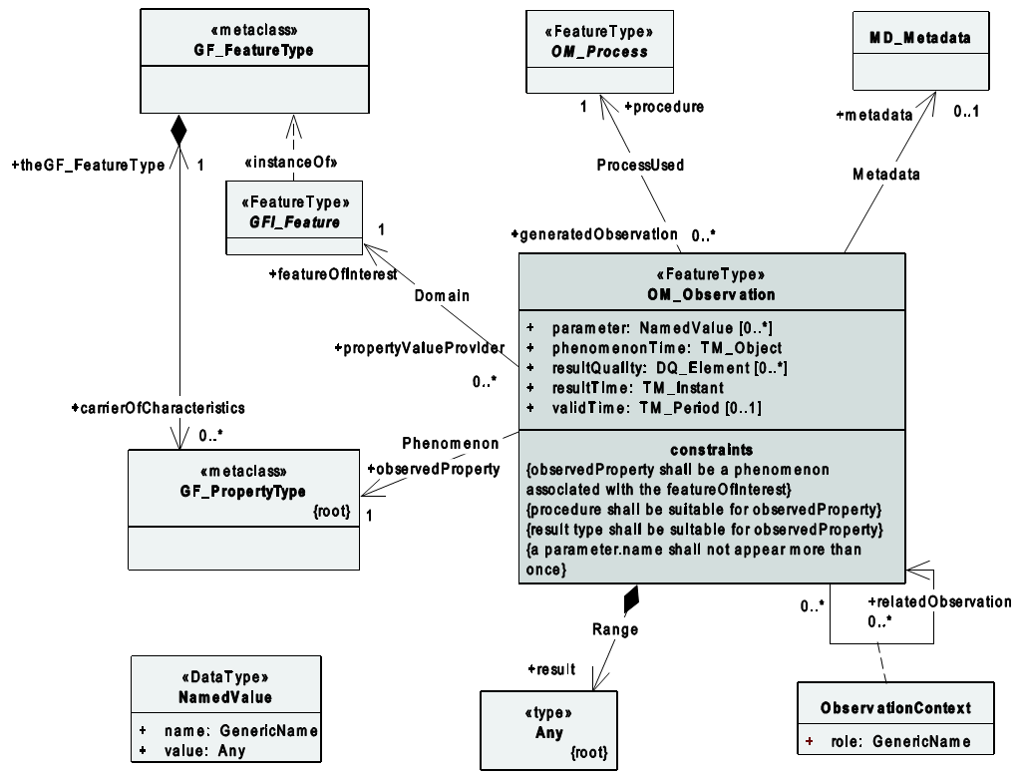

Figure 1: The basic Observation type

The attributes associated with an observation are as follows.

* phenomenonTime: *describes the time that the result applies to the property of the feature-of-interest.* *This is often the time of interaction by a sampling procedure or observation procedure with a real-world feature*. In our case it may refer to the time a blood sample was collected from the patient.
* resultTime: *describes the time when the result became available, typically when the procedure associated with the observation was completed. For some observations, this is identical to the phenomenonTime*. Following the previous example, it reports the time at which the blood sample was analyzed and the value of glucose was extracted.
* validTime: *describes the time period during which the result is intended to be used*. This is an optional attribute. Medical observations often have a period of validity after which the doctor requires that a new observation or measurement is needed. This identifies the time after which the measurement should be repeated. A simple example could be blood pressure or blood glucose levels.
* parameter: *shall describe an arbitrary event-specific parameter. This might be an environmental parameter, an instrument setting or input, or an event-specific sampling parameter that is not tightly bound to either the feature-of-interest or to the observation procedure*. In this specific scenario, this attribute can be used to define the location where body temperature is measured (e.g., mouth).
* resultQuality: *describes the quality of the result. This instance-specific description provides information about the quality of the measurement. This value is strongly related with the sensor adopted and the procedure followed during the acquisition*.

The procedure used during the observation will be described following the SensorML approach. New procedures that adopt different scales for the values or that use different technologies for the acquisition process obviously produce different results. Those variations should be taken into consideration and made available together with the observed value. This document proposes to include this information in the description of the sensor according to SensorML. Taking as an example a simple blood test, there is a variability that depends on the laboratory conducting the exam (variability due to several reasons, the most important of which is the instrumentation used). For this reason, the ranges of some measurements (ranges in terms of “normal value”) have not yet been defined. Ranges are correlated with the procedure implemented during acquisition and the type of technologies that will be used.

The following figure are depicts the possible interactions with other components/standards from OGC for the scenario envisioned:

* Sensor Observation Service (SOS) to manage and retrieve data and metadata from the registered devices by relaying through the O&M standard;
* Sensor Alert Service (SAS) to be used for the detection of anomalies to send alerts to a specific user (e.g. a clinician or next of kin);
* Sensor Alert Service (SAS) to provide asynchronous notification of sensor events; and
* SensorML to describe the sensor and the measurement process.

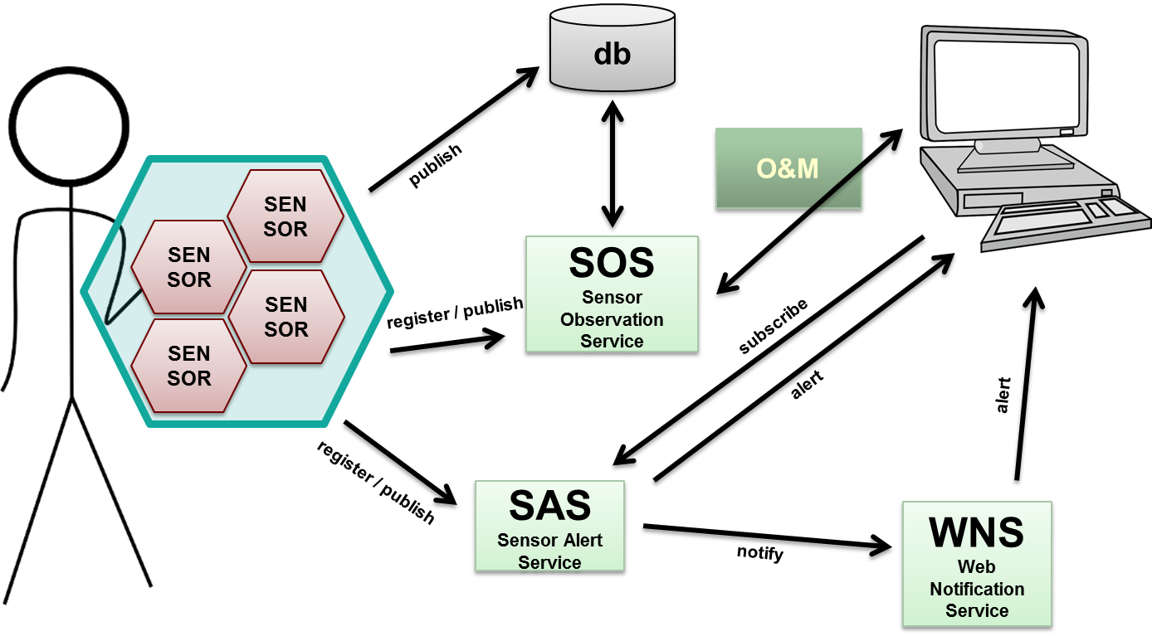

Figure 2: Possible integration with other OGC standards

The observation uses a procedure, which is often an instrument or sensor but may be a human observation in some cases. The observation could be the estimated value of some property observed by a human. Observation properties provide context to support evaluation, interpretation and use of the result.

# The measurements

This section reports the measures identified as relevant to comprehensively represent the psychophysical condition of an elderly person. In general terms, the focus is on those measurements required by the sensors/devices that will be integrated in the UNCAP platform while considering also further measurements which could be relevant in general terms. The following list is therefore non exhaustive and may be extended in the future.

## Affinity

Relates to the emotional state related to a degree of affinity detected by the system in the performing of a given task (e.g., a cognitive game). There is not a specific normative data unit for this measure. Affinity is evaluated during a specific task by an EEG or other device(s) able to acquire and extract such information.

Vocabulary reference: none

Unit of measure: float between 0 and 1

Sensor: portable EEG during a specific activity

## Average time in bed

Represents the numbers of hours that are spent at rest in general (in bed or sleeping in chairs) in an interval of 24 hours with a reference of one day, measured in hours.

Vocabulary reference: none

Unit of measure: hours/day

Sensor: many sensors can produce such information including, but not limited to: accelerometers, smart sensing floor, pressure sensors, solutions based on the use of video cameras, and any device able to detect the position of the user.

## Amount of physical exercise

Represents the time-spent by the user doing physical exercise (i.e., not at rest).

Vocabulary reference: none

Unit of measure: hours/day

Sensor: any sensor capable of monitoring the physical exercise (e.g. accelerometers, pedometers, indoor location based technology).

## Attention

Relates to the emotional state related to a degree of attention detected by the system during performance of a given task (e.g., a cognitive game). There is not a specific normative data unit for this measure. Attention is evaluated during a specific task by an EEG or other device(s) able to acquire and extract such information.

Vocabulary reference: none

Unit of measure: float between 0 and 1.

Sensor: portable EEG during a specific activity

## Basal metabolic rate

Represents the amount of energy (in calories) necessary to maintain the body functioning in normal healthy conditions (e.g., blood circulation, breathing, cell growth, etc.) when at rest.

Vocabulary reference: LOINC 50042-1

Unit of measure: kcal/day

Sensor: usually basal metabolic rate is calculated manually through the following formulas:

* for men: $BMR=10*weight \left(kg\right)+6.25*height\left(cm\right)-5*age\left(years\right)+5$
* for women: $BMR=10*weight \left(kg\right)+6.25*height\left(cm\right)-5*age\left(years\right)-161$

More precise measurements may be achieved through use of direct or indirect calorimetry in a laboratory environment.

## Blood glucose

Levels of glucose found in the blood. It should be related with a time (e.g., on waking) and relation with a meal.

Vocabulary reference: UMLS C0005802

Unit of measure: mmol/L (millimole/liter) or mg/dl

Sensor: glucometers

## Blood Oxygen Saturation

Represents the percentage of hemoglobin saturated with oxygen at the time of the measurement.

Vocabulary reference: UMLS C0523807

Unit of measure: Percentage time series (normal 95%-100%, low <90%, emergency <80%)

Sensor: Pulse oximeter

## Blood pressure

Is the pressure exerted by circulating blood upon the walls of blood vessels defined as diastolic and systolic pressure of the blood. It is a compound measure that should report both values.

Vocabulary reference: UMLS C1271104

Unit of measure: mm Hg (low <90/60), normal from 90/60 to 140/80, high >140/90)

Sensor: blood pressure meter (sphygmomanometer)

## Body fat percentage

Body fat is the amount of fat in the body, compared to the total body mass.

Vocabulary reference: UMLS C0518026

Unit of measure: percentage

Sensor: a smart scale is the simplest (yet least accurate) sensor that can be used. More accurate techniques are available but require a specialist and a laboratory environment.

## Body height

Represents the distance from the bottom of the feet to the top of the head.

Vocabulary reference: UMLS C0005890

Unit of measure: cm

Sensor: Statometer or self- reported

## Body mass index

Body Mass Index (BMI) is a measure of body fat based on height and weight that applies to adult men and women.

Vocabulary reference: UMLS C0578022

Unit of measure: kg/m2

Sensor: smart scale or self- reported

## Body temperature

Body temperature is a measure of the body's ability to generate and get rid of heat. It varies on the basis of the location where the measurement is taken (e.g. mouth, armpit, etc.). The location should be taken into consideration and added as a parameter.

Vocabulary reference: UMLS C0005903

Unit of measure: °C (normal 36.5–37.5 °C)

Sensor: thermometer

## Body weight

Measurement of the body mass weight.

Vocabulary reference: UMLS C0005910

Unit of measure: Kg (normal values depend on many factors such as age, gender and height)

Sensor: smart scale or self- reported

## Bone density

Represents the amount of mineral matter per square centimeter in bones.

Vocabulary reference: UMLS C0005938

Unit of measure: g/cm2

Sensor: smart scale. More accurate techniques are available but require a specialist and a laboratory environment.

## Calories burned

Amount of calories burned during a specific physical activity.

Vocabulary reference: LOINC 41981-2

Unit of measure: kcal

Sensor: can be inferred from the type, duration and intensity of the physical activity

## Electroencephalography (EEG)

It is used to record electrical activity of the brain. A number of generally noninvasive sensors is applied on the scalp to measure voltage variations generated by neurons’ activity.

Vocabulary reference: UMLS C0234550

Unit of measure: voltage [V] time series. It is a time series of multiple measures depending on the number of electrodes applied.

Sensor: EEG device

## Engagement

Relates to the emotional state related to a degree of engagement detected by the system in the performing of a given task (e.g., a cognitive game). There is not a specific normative data unit for this measure. Attention is evaluated during a specific task by an EEG or other device(s) able to acquire and extract such information.

Vocabulary reference: none.

Unit of measure: float between 0 and 1

Sensor: portable EEG during a specific activity

## Excitement

Relates to the emotional state related to a degree of excitement detected by the system in the performing of a given task (e.g., a cognitive game). There is not a specific normative data unit for this measure. Attention is evaluated during a specific task by an EEG or other device(s) able to acquire and extract such information.

Vocabulary reference: none.

Unit of measure: float between 0 and 1

Sensor: portable EEG during a specific activity

## Fatigue

Relates to the emotional and physical state related to a degree of fatigue detected by the system in the performing of a given task (e.g., a cognitive game). There is not a specific normative data unit for this measure. Attention is evaluated during a specific task by an EEG or other device(s) able to acquire and extract such information.

Vocabulary reference: none

Unit of measure: float between 0 and 1

Sensor: portable EEG during a specific activity

## Focus

Relates to the emotional and physical state related to a degree of focus detected by the system in the performing of a given task (e.g., a cognitive game). There is not a specific normative data unit for this measure. Attention is evaluated during a specific task by an EEG or other device(s) able to acquire and extract such information.

Vocabulary reference: none

Unit of measure: float between 0 and 1

Sensor: portable EEG during a specific activity

## Galvanic Skin Response

Galvanic Skin Response is the variation in electricity conductance when external or internal stimuli occur to the user. It can be clearly related with sweating.

Vocabulary reference: UMLS C0016989 - MESH D005712

Unit of measure: mS (Siemens)

Sensor: galvanic skin response meter

## Heart rate

The number of contractions of the heart in a time span (the reference time is generally a minute). Should be considered in relation with the activity carried during the measurement (at rest, walking, etc.).

Vocabulary reference: UMLS C0018810

Unit of measure: bpm (beats per minute) and can be a single measurement or a time series (at rest the following conditions are commonly acknowledged: Tachycardia >100 and Bradycardia <60).

Sensor: chest strap or pulse oximeter

## Interest

Relates to the emotional and physical state related to a degree of interest detected by the system in the performing of a given task (e.g., a cognitive game). There is not a specific normative data unit for this measure. Attention is evaluated during a specific task by an EEG or other device(s) able to acquire and extract such information.

Vocabulary reference: none

Unit of measure: float between 0 and 1

Sensor: portable EEG during a specific activity

## Location

Describes the position of the user/device when the measurement was collected. It should be considered as a parameter associated to any measure. It will be usually an indoor location but this can not be true for some cases.

Vocabulary reference: ISO 19141:2008 (moving features)

Unit of measure: lat/lon and floor number

Sensor: any sensor capable of recovering the geographic positions from different technologies (GPS, Wi-Fi, Bluetooth, etc.).

## Mini mental state examination score (MMSE)

The mini-mental state examination is a test used to evaluate cognitive impairments of a person. It is generally used to address dementia and assess the progression severity of the illness.

Vocabulary reference: UMLS C1532985

Unit of measure: integer between 0 and 30 (normal >25, moderate impairment 18-24, heavy impairment <18)

Sensor: the score id defined upon the completion of a questionnaire

## Falling condition

Reports the event that a user has fallen.

Vocabulary reference: UMLS C0085639

Unit of measure: boolean

Sensor: wearable accelerometers, smart sensing floor, smart video based surveillance, location based system, caregiver reports, etc.

## Relaxation

Relates to the emotional and physical state related to a degree of relaxation detected by the system in the performance of a given task (e.g., a cognitive game). There is not a specific normative data unit for this measure. Attention is evaluated during a specific task by an EEG or other device(s) able to acquire and extract such information.

Vocabulary reference: none.

Unit of measure: float between 0 and 1

Sensor: portable EEG during a specific activity

## Respiratory rate

The number of times a person breathes with the lungs (respiration) per unit time, usually per minute.

Vocabulary reference: MESH D056152

Unit of measure: breaths per minute (bpm) time series

Sensor: specialized chest strap

## Sleep duration

Time spent sleeping in bed per day. The time spent awake in bed should not be taken into consideration. Sleep duration has been identified as a risk factor for cardiometabolic disease and mortality.

Vocabulary reference: UMLS C0424574

Unit of measure: minutes

Sensor: self-reported or using applications extracting information from accelerometers, EEG and more.

## Sleep quality

Quality of the sleep detected using different sensors. It should be related with the duration of the sleep.

Vocabulary reference: SNOMED CT 248254009

Unit of measure: float from 0 to 1

Sensor: self-reported or using external sensors such as EEG monitors, accelerometers, bracelets, etc.

## Step count

Number of steps taken during a time span (generally a day).

Vocabulary reference: LOINC 55423-8

Unit of measure: integer/time

Sensor: pedometer or similar devices based on the use of data collected from accelerometers and GPS receivers.

## Stress levels

Relates to the emotional and physical state related to a degree of stress detected by the system in the performing of a given task (e.g., a cognitive game). There is not a specific normative data unit for this measure. Attention is evaluated during a specific task by an EEG or other device(s) able to acquire and extract such information

Vocabulary reference: none

Unit of measure: float between 0 and 1

Sensor: portable EEG during a specific activity

## Surprise

Relates to the emotional and physical state related to a degree of surprise detected by the system in the performing of a given task (e.g., a cognitive game). There is not a specific normative data unit for this measure. Attention is evaluated during a specific task by an EEG or other device(s) able to acquire and extract such information.

Vocabulary reference: none

Unit of measure: float between 0 and 1

Sensor: portable EEG during a specific activity

## Time spent alone

Amount of time spent alone per day.

Vocabulary reference: none

Unit of measure: minutes/day

Sensor: self-reported or acquired from smart location technologies.

## Total body water

Amount of water content in the body.

Vocabulary reference: UMLS C0429632

Unit of measure: percentage

Sensor: a smart scale is the simplest (yet least accurate) sensor that can be used. More accurate techniques are available but require a specialist and a laboratory environment.

# Possible examples of use

## Scenario 1

Giulia, a 71 years old woman, was diagnosed a chronic cardiac disease. The treatment plan consists of periodical sampling of blood to determine drug levels and ECG monitoring. Each analysis has to be shared with her family doctor and her cardiologist.

Moreover, her family doctor suggested her to periodically participate in nordic walking sessions that the local gym is organizing. Giulia agrees to follow the suggestion and brings with her a smartphone which, connected to a chest strap, measures the heart rate continuously during the session. The information is complemented with the geographic information collected from the GPS module integrated in the smartphone. Giulia shares each session with her family doctor and instructor in order for them to monitor her progresses and react accordingly to adapt the treatment.

## Scenario 2

Luca is a university researcher who is studying the evolution of aging population across Europe. He is trying to correlate the costs in the different health care systems with the lifestyle and health problems in each country. Out of the many parameters he is interested into, there are:

* Physical activity;
* Weight; and
* Sleep quality and duration.

Through his university, he is able to connect to an exposed service from which he can gather those parameters in an **anonymized** and aggregated manner. Data are collected from a vast number of users all across Europe and are shared with Luca in real time. All the data gathered are provided to Luca in way that will protect the participants’ privacy.

# Conclusions and recommendations

This paper presents the proposal for the definition of an O&M profile specifically designed to address Active and Healthy Aging scenarios and it explains the details of the envisioned profile. For each measure a definition is given together with a few examples of devices that are able to collect such measure. This profile is required to address specific scenarios that are otherwise not covered by other standards.

This document will be submitted to the OGC Health Domain Working Group for further actions.

The technical platform of UNCAP (www.uncap.eu) will ensure full implementation of the profile hereby proposed.