Open Geospatial Consortium
Date: 29/07/2015
External identifier of this OGC® document: http://www.opengis.net/doc/is/pubsub-core/1.0
Internal reference number of this OGC® document: OGC 13-131
Version: 1.0
Category: OGC® Implementation Standard
Editors: Aaron Braeckel
Lorenzo Bigagli
Johannes Echterhoff

OGC® Publish/Subscribe Interface Standard 1.0 - Core

Copyright notice
Copyright © 2013 Open Geospatial Consortium
To obtain additional rights of use, visit http://www.opengeospatial.org/legal/.

Warning
This document is not an OGC Standard. This document is distributed for review and comment. This document is subject to change without notice and may not be referred to as an OGC Standard.
Document type: OGC® Implementation Standard
Document subtype: Interface
Document stage: Draft
Document language: English
Recipients of this document are invited to submit, with their comments, notification of any relevant patent rights of which they are aware and to provide supporting documentation.
License Agreement
Permission is hereby granted by the Open Geospatial Consortium, ("Licensor"), free of charge and subject to the terms set forth below, to any person obtaining a copy of this Intellectual Property and any associated documentation, to deal in the Intellectual Property without restriction (except as set forth below), including without limitation the rights to implement, use, copy, modify, merge, publish, distribute, and/or sublicense copies of the Intellectual Property, and to permit persons to whom the Intellectual Property is furnished to do so, provided that all copyright notices on the intellectual property are retained intact and that each person to whom the Intellectual Property is furnished agrees to the terms of this Agreement.
If you modify the Intellectual Property, all copies of the modified Intellectual Property must include, in addition to the above copyright notice, a notice that the Intellectual Property includes modifications that have not been approved or adopted by LICENSOR.
THIS LICENSE IS A COPYRIGHT LICENSE ONLY, AND DOES NOT CONVEY ANY RIGHTS UNDER ANY PATENTS THAT MAY BE IN FORCE ANYWHERE IN THE WORLD.
THE INTELLECTUAL PROPERTY IS PROVIDED "AS IS", WITHOUT WARRANTY OF ANY KIND, EXPRESS OR IMPLIED, INCLUDING BUT NOT LIMITED TO THE WARRANTIES OF MERCHANTABILITY, FITNESS FOR A PARTICULAR PURPOSE, AND NONINFRINGEMENT OF THIRD PARTY RIGHTS. THE COPYRIGHT HOLDER OR HOLDERS INCLUDED IN THIS NOTICE DO NOT WARRANT THAT THE FUNCTIONS CONTAINED IN THE INTELLECTUAL PROPERTY WILL MEET YOUR REQUIREMENTS OR THAT THE OPERATION OF THE INTELLECTUAL PROPERTY WILL BE UNINTERRUPTED OR ERROR FREE. ANY USE OF THE INTELLECTUAL PROPERTY SHALL BE MADE ENTIRELY AT THE USER’S OWN RISK. IN NO EVENT SHALL THE COPYRIGHT HOLDER OR ANY CONTRIBUTOR OF INTELLECTUAL PROPERTY RIGHTS TO THE INTELLECTUAL PROPERTY BE LIABLE FOR ANY CLAIM, OR ANY DIRECT, SPECIAL, INDIRECT OR CONSEQUENTIAL DAMAGES, OR ANY DAMAGES WHATSOEVER RESULTING FROM ANY ALLEGED INFRINGEMENT OR ANY LOSS OF USE, DATA OR PROFITS, WHETHER IN AN ACTION OF CONTRACT, NEGLIGENCE OR UNDER ANY OTHER LEGAL THEORY, ARISING OUT OF OR IN CONNECTION WITH THE IMPLEMENTATION, USE, COMMERCIALIZATION OR PERFORMANCE OF THIS INTELLECTUAL PROPERTY.
This license is effective until terminated. You may terminate it at any time by destroying the Intellectual Property together with all copies in any form. The license will also terminate if you fail to comply with any term or condition of this Agreement. Except as provided in the following sentence, no such termination of this license shall require the termination of any third party end-user sublicense to the Intellectual Property which is in force as of the date of notice of such termination. In addition, should the Intellectual Property, or the operation of the Intellectual Property, infringe, or in LICENSOR’s sole opinion be likely to infringe, any patent, copyright, trademark or other right of a third party, you agree that LICENSOR, in its sole discretion, may terminate this license without any compensation or liability to you, your licensees or any other party. You agree upon termination of any kind to destroy or cause to be destroyed the Intellectual Property together with all copies in any form, whether held by you or by any third party.
Except as contained in this notice, the name of LICENSOR or of any other holder of a copyright in all or part of the Intellectual Property shall not be used in advertising or otherwise to promote the sale, use or other dealings in this Intellectual Property without prior written authorization of LICENSOR or such copyright holder. LICENSOR is and shall at all times be the sole entity that may authorize you or any third party to use certification marks, trademarks or other special designations to indicate compliance with any LICENSOR standards or specifications. This Agreement is governed by the laws of the Commonwealth of Massachusetts. The application to this Agreement of the United Nations Convention on Contracts for the International Sale of Goods is hereby expressly excluded. In the event any provision of this Agreement shall be deemed unenforceable, void or invalid, such provision shall be modified so as to make it valid and enforceable, and as so modified the entire Agreement shall remain in full force and effect. No decision, action or inaction by LICENSOR shall be construed to be a waiver of any rights or remedies available to it.

Contents
1. Scope 10
2. Conformance 10
3. References 13
4. Terms and Definitions 14
5. Conventions 15
5.1 Abbreviations 15
5.2 UML Notation 15
5.3 Referencing Conventions 15
6. Publish/Subscribe Overview 17
6.1 Publish/Subscribe workflow 17
7. Requirements Class: Basic Receiver 20
7.1 Notify operation 20
7.1.1 Request 20
7.1.2 Response 21
7.1.3 Exceptions 21
8. Requirements Class: Basic Publisher 22
8.1 Capabilities metadata 23
8.1.1 FilterCapabilities 23
8.1.2 DeliveryCapabilities 25
8.1.3 Publications 26
8.2 Exception usage 29
8.3 Subscribe operation 30
8.3.1 Subscription 30
8.3.2 Request 33
8.3.3 Response 35
8.3.4 Exceptions 36
8.4 Unsubscribe operation 37
8.4.1 Request 37
8.4.2 Response 38
8.4.3 Exceptions 38
8.5 Renew operation 39
8.5.1 Request 39
8.5.2 Response 40
8.5.3 Exceptions 40
9. Requirements Class – Standalone Publisher extends Basic Publisher 42
9.1 GetCapabilities operation 42
9.1.1 Request 42
9.1.2 Response 43
9.1.3 Exceptions 43
9.2 GetSubscription operation 44
9.2.1 Request 44
9.2.2 Response 44
9.2.3 Exceptions 45
10. Requirements Class – Pausable Publisher extends Basic Publisher 46
10.1 Pause operation 47
10.1.1 Request 47
10.1.2 Response 48
10.1.3 Exceptions 48
10.2 Resume operation 49
10.2.1 Request 49
10.2.2 Response 50
10.2.3 Exceptions 50
11. Requirements Class – Message Batching Publisher extends Basic Publisher 51
11.1 Batching criteria 51
11.2 Exceptions 53
12. Requirements Class – Heartbeat Publisher extends Basic Publisher 54
12.1 Heartbeat criteria 54
12.2 Exceptions 55
13. Requirements Class – Brokering Publisher extends Standalone Publisher 57
13.1 RegisterPublisher operation 58
13.1.1 Request 59
13.1.2 Response 59
13.1.3 Exceptions 60
13.2 RemovePublisher operation 60
13.2.1 Request 60
13.2.2 Response 61
13.2.3 Exceptions 61
13.3 GetCapabilities operation 62
13.3.1 RegisteredPublishers 62
14. Requirements Class – Publication Manager extends Basic Publisher 64
14.1 DerivedPublication 64
14.2 CreatePublication operation 65
14.2.1 Request 65
14.2.2 Response 67
14.2.3 Exceptions 67
14.3 RemovePublication operation 68
14.3.1 Request 68
14.3.2 Response 69
14.3.3 Exceptions 70
15. Requirements Class – Capabilities Filtering extends Basic Publisher 71
15.1 Introduction 71
15.2 Request 71
15.3 Response 72
15.4 Examples 73
15.5 Exceptions 74
Annex A. Abstract Test Suite (Normative) 75
A.1 Conformance class: Basic Receiver 75
A.2 Conformance class: Basic Publisher 75
A.3 Conformance class: Standalone Publisher 85
A.4 Conformance class: Pausable Publisher 87
A.5 Conformance class: Message Batching Publisher 90
A.6 Conformance class: Heartbeat Publisher 93
A.7 Conformance class: Brokering Publisher 95
A.8 Conformance class: Publication Manager 97
A.9 Conformance class: Capabilities Filtering 102
Annex B. Publish/Subscribe Interfaces (Informative) 105
Annex C. Revision history 106

Figures
Figure 1: Relationships between Publish/Subscribe Core Conformance Classes 13
Figure 2: Publish/Subscribe workflow 18
Figure 3: Notify operation message 21
Figure 4: FilterCapabilities 24
Figure 5: DeliveryCapabilities 25
Figure 6: Publications 27
Figure 7: Subscription 30
Figure 8: Subscription lifecycle 32
Figure 9: Subscribe request 33
Figure 10: Subscribe response 35
Figure 11: Unsubscribe request 37
Figure 12: Unsubscribe response 38
Figure 13: Renew request 39
Figure 14: Renew response 40
Figure 15: GetCapabilities request 43
Figure 16: PublisherCapabilities 43
Figure 17: GetSubscription request 44
Figure 18: GetSubscription response 45
Figure 19: Subscription Pausing state 47
Figure 20: Pause request 47
Figure 21: PauseResponse 48
Figure 22: Resume request 49
Figure 23: ResumeResponse 50
Figure 24: BatchingCriteria 51
Figure 25: HeartbeatCriteria 54
Figure 26: Heartbeat Message 55
Figure 27: Broker workflow 58
Figure 28: RegisterPublisher request 59
Figure 29: RegisterPublisher response 59
Figure 30: RemovePublisher request 61
Figure 31: RemovePublisher response 61
Figure 32: Brokering Capabilities 62
Figure 33: RegisteredPublishers metadata 62
Figure 34: DerivedPublication 65
Figure 35: CreatePublication request 66
Figure 36: CreatePublication response 67
Figure 37: RemovePublication request 68
Figure 38: RemovePublication response 69

Tables
Table 1: Conformance Classes 11
Table 2: Notify operation message properties 21
Table 3: FilterLanguage properties 24
Table 4: DeliveryMethod properties 25
Table 5: Publication properties 27
Table 6: Subscription properties 31
Table 7: Subscribe request properties 34
Table 8: Subscribe response properties 36
Table 9: Subscribe Exceptions 36
Table 10: Unsubscribe request properties 37
Table 11: Unsubscribe Exceptions 38
Table 12: Renew request properties 39
Table 13: Renew Exceptions 41
Table 14: GetCapabilities properties 43
Table 15: GetSubscription request properties 44
Table 16: GetSubscription response properties 45
Table 17: GetSubscription Exceptions 45
Table 18: Pause properties 47
Table 19: Pause Exceptions 48
Table 20: Resume properties 49
Table 21: Resume Exceptions 50
Table 22: BatchingCriteria properties 51
Table 23: Message Batching Subscribe Exceptions 53
Table 24: HeartbeatCriteria properties 54
Table 25: Heartbeat Message properties 55
Table 26: Heartbeat Subscribe Exceptions 56
Table 27: RegisterPublisher properties 59
Table 28: RegisterPublisher Exceptions 60
Table 29: RemovePublisher properties 61
Table 30: RemovePublisher Exceptions 61
Table 31: DerivedPublication properties 65
Table 32: CreatePublication properties 66
Table 33: CreatePublication response properties 67
Table 34: CreatePublication Exceptions 67
Table 35: RemovePublication properties 68
Table 36: RemovePublication Exceptions 70
Table 37: Additional request parameters for GetCapabilities operation 72
Table 38: GetCapabilities Filtering Exceptions 74

Abstract
Publish/Subscribe 1.0 is an interface specification that supports the core components and concepts of the Publish/Subscribe message exchange pattern with OGC Web Services. The Publish/Subscribe pattern complements the Request/Reply pattern specified by many existing OGC Web Services. The Publish/Subscribe specification may be used either in concert with, or independently of, existing OGC Web Services to publish data of interest to interested Subscribers.
This specification defines functionality independently of binding technology (e.g., KVP, SOAP, REST). Extensions to this specification may realize these core concepts with specific binding technologies.
Keywords
The following are keywords to be used by search engines and document catalogues.
ogcdoc pubsub core specification
Preface
The OpenGIS® Abstract Specification does not require any changes to accommodate the technical contents of this document.
No future work is currently anticipated.
Attention is drawn to the possibility that some of the elements of this document may be the subject of patent rights. The Open Geospatial Consortium shall not be held responsible for identifying any or all such patent rights.
Recipients of this document are requested to submit, with their comments, notification of any relevant patent claims or other intellectual property rights of which they may be aware that might be infringed by any implementation of the standard set forth in this document, and to provide supporting documentation.
Submitting organizations
The following organizations submitted this Document to the Open Geospatial Consortium Inc.
- National Center for Atmospheric Research (NCAR)
- National Research Council of Italy (CNR)
- International Geospatial Services Institute (iGSI) GmbH
- CubeWerx, Inc.
- Cooperative Institute for Research in the Atmosphere (CIRA)
Submitters
All questions regarding this submission should be directed to the editors or the submitters:
Name | Company
Aaron Braeckel | NCAR
Lorenzo Bigagli | CNR
Johannes Echterhoff | interactive instruments
Panagiotis (Peter) Vretanos | CubeWerx, Inc.
Chris MacDermaid | CIRA

Scope
This OpenGIS interface standard defines core concepts and mechanisms for enabling the Publish/Subscribe messaging pattern with OGC Web Services. Publish/Subscribe may be used independently of or in conjunction with the Request/Reply messaging pattern.
This standard defines a common conceptual framework and functionality, independently and across binding technologies (e.g., KVP, SOAP, REST).
Reliable delivery of messages (i.e. assurance that messages that are sent are actually delivered) is out of scope for this specification, as reliable delivery techniques are dependent on the delivery method. Extensions to this specification may specify requirements and conformance for reliable delivery.
Authorization, authentication, and access control are not addressed in this specification. Extensions to this specification may specify requirements and conformance for security-related functionality.

Conformance
Conformance with this standard shall be checked using the relevant tests specified in Annex A (normative) of this document. The framework, concepts, and methodology for testing, and the criteria to be achieved to claim conformance are specified in the OGC Compliance Testing Policies and Procedures and the OGC Compliance Testing web site.
This standard distinguishes several conceptual roles for entities participating in Publish/Subscribe interactions: Sender, Receiver, Subscriber, and Publisher (defined in Clause 4). However, this standard only defines conformance requirements for the Standardization Target Types:

- Publisher – entity that offers publications to Subscribers.
- Receiver – entity that receives messages from Senders (e.g. a Publisher)
This standard defines the Conformance Classes summarized in Table 1 and shown in Figure 1.

Requirements and conformance test URIs defined in this document are relative to
http://www.opengis.net/spec/pubsub/1.0/.

Table 1: Conformance Classes
Conformance Class Name | Conformance Target | Operation or behavior | Conformance Class URI
Basic Receiver | Receiver | The Receiver shall implement the following operation:  - Notify | /conf/core/basic-receiver
Basic Publisher | Publisher | The Publisher shall implement the following operations:  - Subscribe  - Renew  - Unsubscribe | /conf/core/basic-publisher
Standalone Publisher | Publisher | The Publisher shall implement the Basic Publisher conformance class.  Additionally the Publisher shall implement the following operations:  - GetCapabilities  - GetSubscription | /conf/core/standalone-publisher
Pausable Publisher | Publisher | The Publisher shall implement the Basic Publisher conformance class.  Additionally the Publisher shall implement operations for subscription pausing and resuming:  - Pause  - Resume | /conf/core/pausable-publisher
Message Batching Publisher | Publisher | The Publisher shall implement the Basic Publisher conformance class.  Additionally the Publisher shall enable Subscribers to specify message-batching capabilities on the Subscribe operation.  The Publisher shall follow message batching directives specified by the Subscriber when delivering messages | /conf/core/message-batching-publisher
Heartbeat Publisher | Publisher | The Publisher shall implement the Basic Publisher conformance class.  Additionally the Publisher shall allow Subscribers to specify heartbeat capabilities on the Subscribe operation.  The Publisher shall follow heartbeat directives specified by the Subscriber and send regular heartbeat messages to allow Receivers to detect a failure or communications problem | /conf/core/heartbeat-publisher
Brokering Publisher | Publisher | The Publisher shall implement the Standalone Publisher conformance class.  Additionally the Publisher shall support the management of brokered Publishers:  - RegisterPublisher  - RemovePublisher  - GetPublisher  The Publisher shall receive messages from the brokered Publishers and republish them | /conf/core/brokering-publisher
Publication Manager | Publisher | The Publisher shall implement the Basic Publisher conformance class.  Additionally the Publisher shall support the creation, removal, and subscriptions to user-defined publications:  - CreatePublication  - RemovePublication | /conf/core/publication-manager
Capabilities Filtering | Publisher | The Publisher shall implement the Standalone Publisher conformance class.  Additionally the Publisher shall support filtering of the Publications section (i.e., contents section) of GetCapabilities responses | /conf/core/capabilities-filtering

The relationships between conformance classes are shown below in Figure 1.
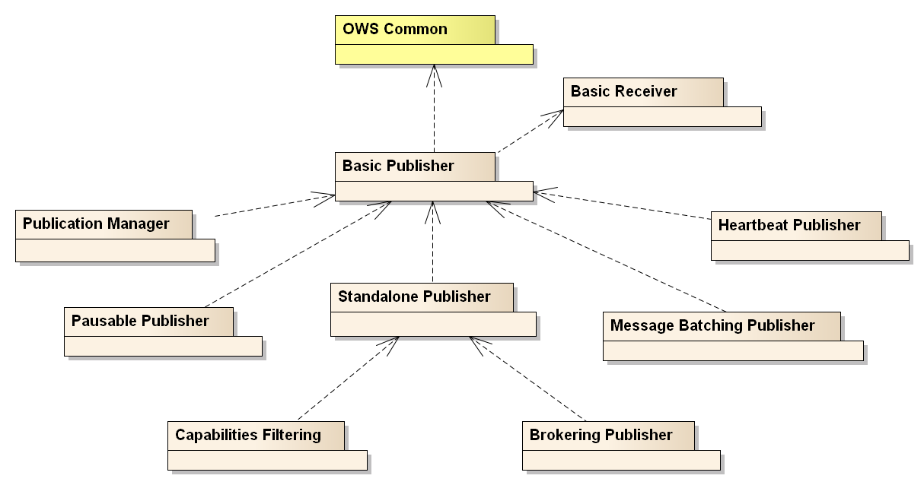
Figure 1: Relationships between Publish/Subscribe Core Conformance Classes
All requirements-classes and conformance-classes described in this document are owned by the standard(s) identified.

References
This OGC Publish/Subscribe 1.0 Core standard consists of the present document. An associated XML Schema is provided for consistency among extensions to this standard. For this standard, the provided XML Schema may be considered informative.
The complete OGC Publish/Subscribe 1.0 specification is identified by OGC URI http://www.opengis.net/spec/pubsub/1.0. It is available for download from http://www.opengeospatial.org/standards/pubsub. The informative XML Schema is posted on-line at http://schemas.opengis.net/pubsub/1.0 as part of the OGC schema repository.
The following normative documents contain provisions, which, through reference in this text, constitute provisions of this document. For dated references, subsequent amendments to, or revisions of, any of these publications do not apply. For undated references, the latest edition of the normative document referred to applies.
ISO/TS 19103:2005, Geographic information — Conceptual schema language
OGC 06-121r3, OGC Web Services Common Specification, OGC® Implementation Standard 1.1.0 (9 February 2007)
W3C XML Schema Part 1, XML Schema Part 1: Structures, W3C Recommendation (2 May 2001)
W3C XML Schema Part 2, XML Schema Part 2: Datatypes, W3C Recommendation (2 May 2001).

Terms and Definitions
This document uses the terms defined in Sub-clause 5.3 of [OGC 06-121r3], which is based on the ISO/IEC Directives, Part 2, Rules for the structure and drafting of International Standards. In particular, the word “shall” (not “must”) is the verb form used to indicate a requirement to be strictly followed to conform to this standard.
For the purposes of this document, the following additional terms and definitions apply.
Message
A container within which data (such as XML, binary data, or other content) is transported. Messages may include additional information beyond data, including headers or other information used for routing or security purposes.
Publication
A uniquely identified aggregation of messages published by a Publisher over time. A Publisher may offer any number of publications that Subscribers may subscribe to.
Publisher
An entity that offers publications to Subscribers; supports subscription management (subscribe, unsubscribe) and is responsible for filtering and matching messages of interest to active subscriptions.
Receiver
An entity that receives messages from Senders; may (but need not) be the original Subscriber.
Sender
Entity that sends messages to Receivers; may (but need not) be the initial creator/producer of the data in the message payload.
Subscriber
Entity that creates a subscription at a Publisher; may (but need not) be the Receiver of delivered messages.
Subscription
Expression of interest in all or part of a publication offered by a Publisher. When a subscription has been created, the Publisher delivers messages that match the subscription criteria to the Receiver defined in the subscription.

Conventions

Abbreviations
In this document the following abbreviations and acronyms are used or introduced:
HTTP Hypertext Transfer Protocol
MEP Message Exchange Pattern
OGC Open Geospatial Consortium
OMG Object Management Group
UML Unified Modeling Language (an object modeling language)
XML eXtensible Markup Language

UML Notation
All symbols used in this document are UML 2 (Unified Modeling Language) as defined by OMG and accepted as a publicly available standard by ISO in its earlier 1.3 version.
All classes in this standard are extensible and may be extended with application- or domain-specific content via Extension blocks.
NOTE The UML shown in this standard is considered conceptual and abstract, and should not be interpreted as an implementation strategy for bindings that extend and implement this standard. For example, TM_Instant from ISO 19108 is used to represent time instants for conceptual clarity, but bindings and implementations of this standard may realize TM_Instant as a GML TimeInstant, an ISO 8601 date string, or any other representation that is consistent with TM_Instant.

Referencing Conventions
This standard references UML classes from other specifications. When referencing UML classes not defined in this standard, the class name will be qualified with the document of origin. For example, a reference to the ISO 19108 TM_Instant is referenced as:
TM_Instant [see ISO/TS 19103:2006]
Many referenced UML classes are instantiated as XML schema, such as the GML realization of ISO TC211 standards. This standard only normatively references UML representations.

Publish/Subscribe Overview
Two primary parties characterize the publish/subscribe model: a Publisher that is publishing information and a Subscriber that is interested in all or part of the published information. The publish/subscribe messaging model is distinguished from the request/reply model by the use of an ongoing, persistent, expression of interest (a subscription) and the asynchronous delivery of messages that match a subscription.
The entity subscribing for published information (the Subscriber) and the entity to which data is delivered (the Receiver) are often one and the same. However, they are distinguished in this standard to allow for these roles to be segregated in cases such as a system component mass-subscribing on behalf of the ultimate Receivers of messages.
Similarly, while the Publisher and Sender roles may be segregated they are often implemented as the same entity. Senders may be unaware of the ultimate recipients of their messages and of the architecture of the system into which they deliver messages, such as with multi-cast delivery or ATOM feeds.
While multiple entities (Publisher, Subscriber, Sender, and Receiver) are distinguished in this Clause, requirements are only allocated against Publishers and Receivers in this standard.

Publish/Subscribe workflow
The publish/subscribe workflow is depicted in Figure 2.
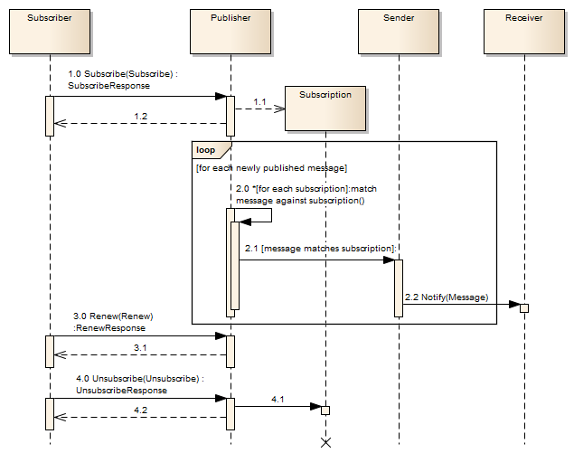
Figure 2: Publish/Subscribe workflow
The first step to initiate a publish/subscribe message exchange is the creation of a subscription. A subscription defines which messages available at the Publisher are of interest to the Subscriber. The Subscriber is an entity that creates a subscription on behalf of a Receiver using the Subscribe operation on a Publisher (1.0). If the Publisher accepts the subscribe request, it creates a subscription (1.1) and returns a response informing the requester of the outcome of its request – either success or an exception (1.2).
When a subscription is submitted, a Subscriber may supply filter criteria. Filter expressions evaluate to a boolean value for each individual message. Those messages that evaluate to true for all filter expressions on a subscription are considered to have matched. Filter criteria can filter by message content (such as XPath or OGC Filter Specification), by message metadata (such as header content), or by other criteria.
Whenever a new message is available to the Publisher, it attempts to match it against each subscription (2.0). If the message matches the filter criteria of a subscription the Publisher initiates Sender delivery to the location and/or Receiver specified for the subscription (2.1). Messages are delivered asynchronously as they become available on the Publisher.
Every subscription has a defined time at which it expires. When that time is reached the Publisher terminates the subscription. The Renew operation may be utilized (3.0) to set a new termination time for a subscription. If the Publisher accepts the request, the new termination time is set on the subscription and the Publisher returns a response (3.1) informing the Subscriber of the outcome of the request.
Termination of a subscription may be requested any time after the subscription was created using the Unsubscribe operation (4.0). If the Publisher accepts the request, it terminates the subscription (4.1) and returns a response (4.2) informing the Subscriber of the outcome of the request.

Requirements Class: Basic Receiver
Requirements Class
http://www.opengis.net/spec/pubsub/1.0/req/core/basic-receiver
Target type | Receiver
Requirement | /req/core/basic-receiver/notify

This Requirements Class specifies the basic operation of a Receiver:
Notify – delivery of a message to the Receiver (in the context of Publish/Subscribe this is often the delivery of a message which matches the filter criteria of a given subscription).

Notify operation
The Notify operation is offered by a Receiver to allow the delivery of a message.
In the context of Publish/Subscribe a Publisher, for example, uses the Notify operation to deliver a message that matches the filter criteria of a subscription to the Receiver associated to that subscription.
Requirement
/req/core/basic-receiver/notify
- A Receiver shall offer the Notify operation

Note that the way the Notify operation is actually realized depends on the binding. In a RESTful binding, for example, a message that matches a subscription filter can be published at a specific URL, from which the ultimate Receiver can retrieve it.

Request
The Notify operation is not actually based on the request-response message exchange pattern. Instead, it is based on the more fundamental datagram pattern, where a single message is sent from one system entity to another (the Receiver), without actually expecting a response.
In a system architecture that is heavily based on request-response the datagram pattern can be represented by a single request message and no corresponding response message. That the message has been successfully delivered can be determined via the communication mechanism that was used for the delivery, or some other mechanism (for example via an additional reliable messaging protocol layer).
The conceptual model of the Notify operation message is shown in and defined in
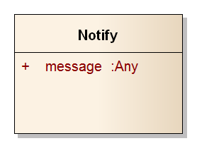
Figure 3: Notify operation message
Table 2: Notify operation message properties
Name | Definition | Data type and values | Multiplicity and use
message | The content of the message. | Any | One  (Mandatory)

Response
No response is expected/defined for the Notify operation.

Exceptions
No exception is defined for the Notify operation.

Requirements Class: Basic Publisher
Requirements Class
http://www.opengis.net/spec/pubsub/1.0/req/core/basic-publisher
Target type | Publisher
Dependency | http://www.opengis.net/doc/IS/OWS/1.1/clause/8
Dependency | http://www.opengis.net/doc/IS/OWS/1.1/clause/10
Requirement | /req/core/basic-publisher/getcapabilities-conf-class-listing
Requirement | /req/core/basic-publisher/getcapabilities-filtercapabilities
Requirement | /req/core/basic-publisher/getcapabilities-unique-filter-languages
Requirement | /req/core/basic-publisher/getcapabilities-deliverycapabilities
Requirement | /req/core/basic-publisher/getcapabilities-unique-delivery-method
Requirement | /req/core/basic-publisher/getcapabilities-publications
Requirement | /req/core/basic-publisher/publication-valid-filter-language
Requirement | /req/core/basic-publisher/publication-bounding-box
Requirement | /req/core/basic-publisher/publication-valid-delivery-method
Requirement | /req/core/basic-publisher/publication-unique-publication-id
Requirement | /req/core/basic-publisher/validating-exceptions
Requirement | /req/core/basic-publisher/exception-version
Requirement | /req/core/basic-publisher/subscribe
Requirement | /req/core/basic-publisher/subscribe-assign-unique-id
Requirement | /req/core/basic-publisher/subscribe-default-termination-time
Requirement | /req/core/basic-publisher/match-active-subscriptions
Requirement | /req/core/basic-publisher/match-inactive-subscriptions
Requirement | /req/core/basic-publisher/interrupt-matching
Requirement | /req/core/basic-publisher/termination
Requirement | /req/core/basic-publisher/subscribe-exceptions
Requirement | /req/core/basic-publisher/unsubscribe
Requirement | /req/core/basic-publisher/unsubscribe-halt-matching
Requirement | /req/core/basic-publisher/unsubscribe-exception-state
Requirement | /req/core/basic-publisher/unsubscribe-exceptions
Requirement | /req/core/basic-publisher/renew
Requirement | /req/core/basic-publisher/renew-update-termination-time
Requirement | /req/core/basic-publisher/renew-exception-state
Requirement | /req/core/basic-publisher/renew-exceptions

This Requirements Class specifies the basic Publish/Subscribe operations of a Publisher:
Subscribe - allows for the creation of subscriptions against publications offered by a Publisher.
Renew - allows for the renewal of a subscription on a Publisher.
Unsubscribe - allows for removal of a subscription on a Publisher.
Additionally this Requirements Class specifies Publish/Subscribe capabilities metadata that is offered in response to a GetCapabilities operation, whether offered as a Publish/Subscribe GetCapabilities as defined in Clause 9 or through a GetCapabilities operation defined by another OGC Web Service - such as the OGC Web Feature Service (WFS). This Requirements Class does not define a GetCapabilities operation, only the capabilities metadata that is offered by a Publish/Subscribe service.
All classes defined in this standard are extensible and may therefore contain additional parameters that can be used and/or defined by an extension.

Capabilities metadata
Capabilities metadata for a Publisher is defined in three parts: filtering capabilities (Clause 8.1.1), delivery capabilities (Clause 8.1.2), and published contents (Clause 8.1.3).
These components are each offered as the result of a GetCapabilities operation, either defined by the Standalone Publisher Requirements Class (Clause 9) or another OGC web service. In the latter case an existing GetCapabilities operation is extended with Publisher metadata.
NOTE This Standard does not specify mechanisms for incorporating Publisher capabilities metadata into other OGC web services
Publish/Subscribe conformance classes are advertised with the Profile section of the ServiceIdentification portion of Capabilities documents.
Requirement
/req/core/basic-publisher/getcapabilities-conf-class-listing
- A Publisher shall advertise conformance classes which are supported by the server. Each supported conformance class shall be identified by a unique value of the Profile property of the ServiceIdentification section of the capabilities document

FilterCapabilities
The FilterCapabilities data type describes the filtering-related capabilities of a Publisher. A Publisher may support specific filter languages, such as the OGC Filter Encoding Spec or XPath that is used by a Subscriber to define a subset of messages of interest on a subscription. In order to support the creation of filtered subscription requests, the Publisher provides metadata about the filter languages it supports, if any.
The FilterLanguage type contains information about the filter languages that the Publisher supports for matching messages against subscriptions.
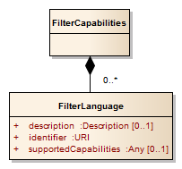
Figure 4: FilterCapabilities
Table 3: FilterLanguage properties
Name | Definition | Data type and values | Multiplicity and use
description | The abstract, title, and other human-readable descriptive information | Description [see  OGC 06-121r3] | Zero or one  (Optional)
identifier^{A} | A unique identifier for the FilterLanguage on this Publisher | URI | One (Mandatory)
supportedCapabilities | Formal definition of the capabilities supported by the service regarding this FilterLanguage. For example, this can include the FES FilterCapabilities, supported operators/operands, filter parameter ranges, etc. | Any | Zero or one  (Optional)
- Example identifiers include “http://www.opengis.net/fes/2.0” and “http://www.opengis.net/wcs/1.1”, the latter indicating support for WCS 1.1 filtering mechanisms

FilterLanguage identifiers are provided to the Subscribe operation along with the actual filter specified in that language. For example, the Subscribe operation can be executed with the XPath filter language identifier (e.g., “http://www.w3.org/TR/xpath”) along with the specific XPath (e.g., “/messageType1”) that defines the messages of interest.
FilterLanguage identifiers are advertised for specific publications as part of the Publications data type. Publishers may choose to support a different set of filter languages for each publication. FilterLanguage identifiers advertised in FilterCapabilities need not be associated with any publication offered by the Publisher, such as cases where no publications are offered or the set of offered publications varies over time.
Requirement
/req/core/basic-publisher/getcapabilities-filtercapabilities
- A Publisher shall return a FilterCapabilities structure within its GetCapabilities response

Requirement
/req/core/basic-publisher/getcapabilities-unique-filter-languages
- A Publisher shall uniquely identify each offered FilterLanguage included in FilterCapabilities

DeliveryCapabilities
A Publisher must support a set of delivery methods that a Subscriber can use to define a method for delivering messages of interest on a subscription. The DeliveryCapabilities type describes the set of delivery methods supported by a Publisher, such as ATOM, AMQP, or SOAP over HTTP.
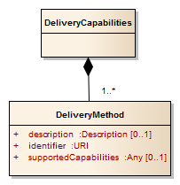
Figure 5: DeliveryCapabilities
The DeliveryMethod type contains information on a single method by which a Publisher can deliver messages.
Table 4: DeliveryMethod properties
Name | Definition | Data type and values | Multiplicity and use
description | The abstract, title, and other human-readable descriptive information | Description [see  OGC 06-121r3] | Zero or one  (Optional)
identifier^{A} | A unique identifier for the DeliveryMethod on this Publisher | URI | One (Mandatory)
supportedCapabilities | The capabilities supported by the service regarding this DeliveryMethod. For example which portions of AMQP are supported, which SOAP version is supported, etc. | Any | Zero or one  (Optional)
- Examples identifiers include “http://schemas.xmlsoap.org/soap/http” and “http://www.w3.org/2005/Atom”

Requirement
/req/core/basic-publisher/getcapabilities-deliverycapabilities
- A Publisher shall return a DeliveryCapabilities structure within its GetCapabilities response

Requirement
/req/core/basic-publisher/getcapabilities-unique-delivery-method
- A Publisher shall uniquely identify each offered DeliveryMethod included in the PublisherCapabilities

Publications
The contents offered by a Publisher are described in the Publications type. The Publications type includes all of the offered publications that Subscribers can subscribe to. The Publication type contains information on an individual publication.
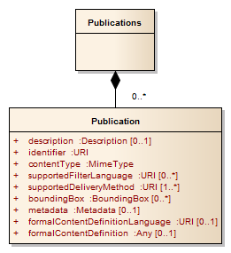
Figure 6: Publications
Table 5: Publication properties
Name | Definition | Data type and values | Multiplicity and use
boundingBox | The area of interest of the published data contents | BoundingBox [see  OGC 06-121r3] | Zero or more (Optional)
contentType | The content type (i.e., mime type) of the published data contents.  Examples: “application/weather+xml”, “text/plain” | MimeType  [see  OGC 06-121r3] | One (Mandatory)
description | A human-readable description | DescriptionType [see  OGC 06-121r3] | Zero or one (Optional)
identifier | A unique identifier | URI | One (Mandatory)
metadata | Additional metadata on this publication | Metadata [see  OGC 06-121r3] | Zero or one (Optional)
supportedDeliveryMethod | The supported delivery methods for this publication | URI | One to many (Mandatory)
supportedFilterLanguage | The filter language identifiers that are offered for filtering | URI | Zero to many (Optional)
formalContentDefinition  Language | The identifier of the language (e.g., "http://www.w3.org/XML/Schema/1.0”) used to describe the formal publication content definition | URI | Zero to many (Optional)
formalContentDefinition | A formal definition of the published data contents. This may take the form of an XML schema or other machine-readable definition for the publication | Any | Zero to many (Optional)

Requirement
/req/core/basic-publisher/getcapabilities-publications
- A Publisher shall return a Publications structure within its GetCapabilities response

Requirement
/req/core/basic-publisher/publication-valid-filter-language
- The supportedFilterLanguage on each Publication shall be one of the FilterLanguage identifiers advertised in the FilterCapabilities

Requirement
/req/core/basic-publisher/publication-bounding-box
- When a Publisher advertises a Publication with BoundingBoxes, the first shall be a WGS84BoundingBox

Requirement
/req/core/basic-publisher/publication-valid-delivery-method
- The supportedDeliveryMethod on each Publication shall be one of the DeliveryMethod identifiers advertised from the DeliveryCapabilities

Requirement
/req/core/basic-publisher/publication-unique-publication-id
- The identifier on each Publication shall be unique among all other Publication identifiers on the Publisher

Exception usage
In the event that a Publisher encounters an error while processing a request or receives an invalid request, it shall generate an OWS Exception indicating that an error has occurred. The form of the error response is specified by the ExceptionReport defined in Clause 8 of the OWS Common Specification [OGC 06-121r3].
Requirement
/req/core/basic-publisher/valid-exceptions
- A Publisher shall issue Exceptions that incorporate an ExceptionReport valid according to Clause 8 of the OWS Common Specification [OGC 06-121r3]

The mandatory version parameter is used to indicate the version of the service exception report, which shall be "1.0.0". The optional language may be used to indicate the language used. The code list for the language parameter is defined in [IETF RFC 4646].
Requirement
/req/core/basic-publisher/exception-version
- A Publisher shall raise Exceptions with the ExceptionReport version set to the value “1.0.0”

Individual exception messages are contained within the OWS ExceptionText. The mandatory code is used to associate an exception code with the accompanying message. The optional locator may be used to indicate where an exception was encountered in the request that generated the error.
Multiple exceptions may be reported in a single exception report so implementations should endeavor to report as many exceptions as necessary to clearly describe a problem.

Subscribe operation
The Subscribe operation is offered by the Publisher to allow Subscribers to subscribe for messages. To invoke the Subscribe operation, a Subscriber sends a Subscribe request message to the Publisher. The Publisher then processes the request and determines if the proposed subscription is acceptable. If so, the Publisher creates a subscription and returns a SubscribeResponse. If it is not acceptable or problems occur while processing the request, the Publisher returns an exception.
Requirement
/req/core/basic-publisher/subscribe
- The Publisher shall offer the Subscribe operation

Subscription
Subscribers express their interest in a specific set of messages that are available to a Publisher with a subscription. When a subscription has been submitted to a Publisher, the Publisher delivers messages that match the subscription criteria to the location defined by the subscription.
A Publisher creates a subscription when it accepts a Subscribe request. The subscription has a well-defined termination time. That time is an absolute point in time in the future.
The termination time defines the point in time at which the Publisher terminates the subscription. A subscription can be terminated at any time by explicitly requesting its termination (see Unsubscribe in Clause 8.3.4). In addition, the termination time of a subscription can be updated to a different time (see Renew in Clause 8.5) at a later point in time.
The subscription filter is used to express the interest in a certain set of messages. The filter itself is an expression evaluating to a boolean value. Filter languages may support logical combinations of filter expressions, such as the OGC Filter Encoding Specification (see ISO 19143 / OGC 09-026).
A subscription has the properties shown in the following figure.
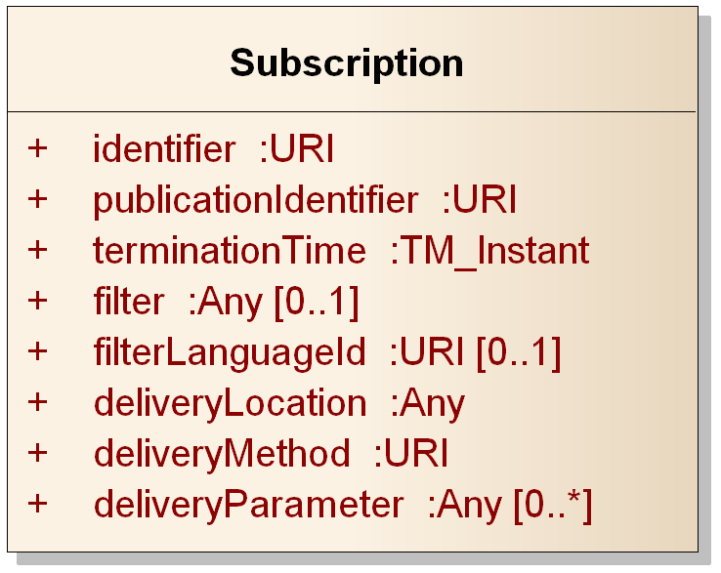
Figure 7: Subscription
Table 6: Subscription properties
Name | Definition | Data type and values | Multiplicity and use
identifier | A unique identifier for the subscription on this Publisher. Assigned by the Publisher when the subscription is created | URI | One (Mandatory)
publicationIdentifier | The identifier of the publication to which this subscription applies | URI | One (Mandatory)
terminationTime | The time at which this subscription is set to terminate | TM_Instant [see ISO/TS 19103:2006] | One (Mandatory)
filter | An expression of interest that evaluates to a Boolean value (true/false) when applied to messages published in a publication. If missing, no messages from the publication are excluded (all messages are delivered for the subscription) | Any | Zero or one (Optional)
filterLanguageId | The identifier (unique in the scope of a Publisher) for the language used to encode the filter | URI | Zero to one  (Optional)  Required if filter is present
deliveryLocation | The location to which messages are delivered | Any | One (Mandatory)
deliveryMethod | The method used to deliver messages. One of the advertised delivery methods for the publication | URI | One (Mandatory)
deliveryParameter | Delivery-related parameter that allows for messages to be delivered to the specified delivery location using the delivery method | Any | Zero or more (Optional)

Requirement
/req/core/basic-publisher/subscribe-assign-unique-id
- A Publisher shall assign a unique identifier to each created subscription

Requirement
/req/core/basic-publisher/subscribe-default-termination-time
- A Publisher shall assign a default terminationTime to created subscriptions if not provided by the Subscriber

The lifecycle of a subscription is shown in Figure 8. The matching process takes place against all active subscriptions whenever a new message is available to the Publisher.
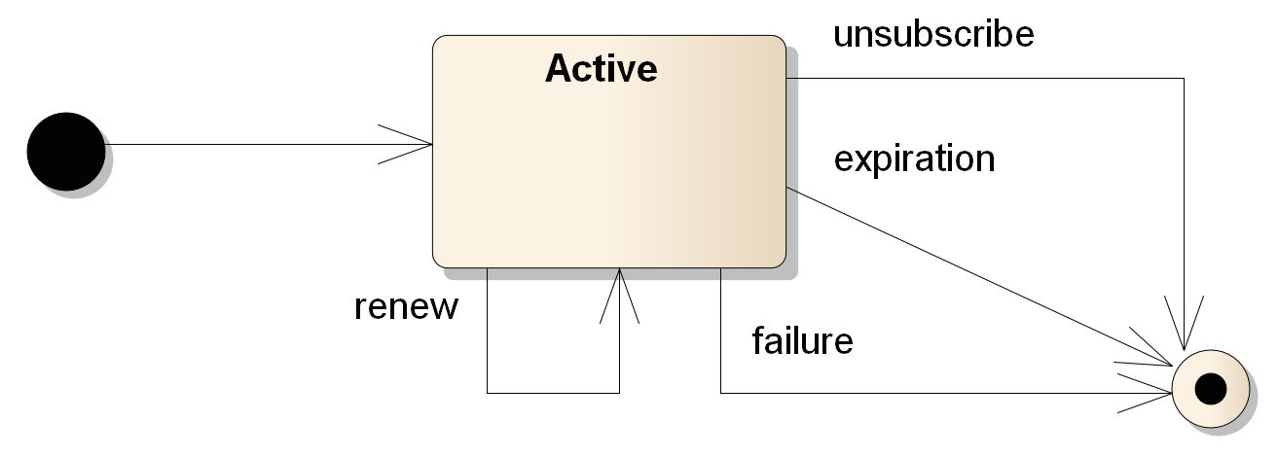
Figure 8: Subscription lifecycle
Requirement
/req/core/basic-publisher/match-active-subscriptions
- A Publisher shall match messages against all active subscriptions

Requirement
/req/core/basic-publisher/match-inactive-subscriptions
- A Publisher shall cease matching and delivery of messages when subscriptions move to an inactive or terminated state

Matching is performed by evaluating the filter against the new message. If the boolean value of the filter evaluates to “true” for a message the message matches the subscription. If no filter is defined, all messages match for the publication defined in the subscription. When a message matches, the Publisher is responsible for delivering it to the Receiver specified in the subscription.
NOTE The Basic Publisher conformance class requires that the Publisher attempt to deliver matching messages once. This does not prevent repeated attempts to deliver the message or the use of additional mechanisms to guarantee the message delivery. The delivery method and/or transport mechanism may provide delivery guarantees for messages.
The Publisher starts matching new messages against a subscription once that subscription has been created. This can happen at any time after it received the request to create that subscription, and must happen before a SubscribeResponse is returned. Therefore, the Receiver specified for a new subscription should be ready to receive incoming messages before the Subscriber has received the SubscribeResponse.
Likewise, the Publisher stops matching new messages against a subscription once it has been terminated. Message matching and message delivery are independent; after termination message matching will cease but messages that have previously matched will be delivered.
Requirement
/req/core/basic-publisher/interrupt-matching
- When a Publisher terminates a subscription it shall interrupt all unfinished matching processes for this subscription

Requirement
/req/core/basic-publisher/termination
- A Publisher shall terminate a subscription when its termination time is reached

Request
A Subscriber sends a Subscribe request to the Publisher in order to create a new subscription.
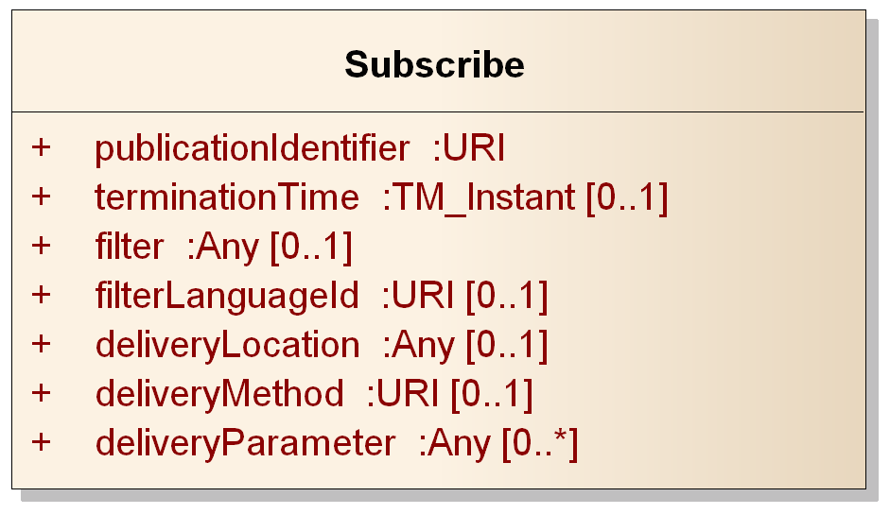
Figure 9: Subscribe request

Table 7: Subscribe request properties
Name | Definition | Data type and values | Multiplicity and use
publicationIdentifier | The publication to which this subscription applies | URI | One  (Mandatory)
terminationTime | The requested termination time for this subscription. Must be in the future | TimeInstant [see ISO/TS 19103:2006] | Zero or one  (Optional)
filter | The filter to be applied to the publication for this subscription | URI | Zero to one  (Optional)
filterLanguageId | The identifier (unique in the scope of a Publisher) for the language used to encode the filter | URI | Zero to one  (Optional)  Required if filter is present
deliveryLocation | The location where information will be delivered. This specifies at most one delivery location | Any | Zero or one  (Optional)
deliveryMethod | The method used to deliver messages for this subscription. Must be from the list of advertised delivery methods for the publication | URI | Zero or one (Optional)
deliveryParameter | Delivery-related parameter that allows for messages to be delivered to the specified delivery location using the specified delivery method | Any | Zero or more (Optional)

The deliveryLocation parameter defines the system endpoint where the Publisher should send messages that match the filter criteria of the requested subscription. The deliveryLocation parameter is optional, as in some cases the Publisher may assign a deliveryLocation to the subscription rather than accept a deliveryLocation from a Subscriber. Extensions to the Basic Publisher conformance class (e.g. bindings) may specialize the use of this parameter.
For example, in WS-BaseNotification it is mandatory to specify an endpoint in a Subscribe request. In a RESTful binding with ATOM-based delivery, the Publisher might create an ATOM feed to which all messages matching a given subscription are sent. In the latter case, the Publisher determines the delivery location.
If the Publisher does not mandate the deliveryMethod parameter, Subscribers must provide this in the subscription. This can mean that the Publisher creates a delivery endpoint to which matching messages will be sent and from which messages may be found. For example, a WS-BaseNotification PullPoint or ATOM feed.
A Subscribe request must specify a delivery method from among those listed in the DeliveryCapabilities section of the PublisherCapabilities document.
The terminationTime parameter defines the requested time when a subscription terminates. That time must be an absolute time in the future. Exactly one termination time may be specified per subscription. The Publisher may choose to reject the requested termination time with an Exception.
The filter parameter in a Subscribe request defines which messages match the requested subscription, i.e., it defines the subset of messages available in a publication that are of interest to the Subscriber.
The filterLanguageId parameter defines the language using for encoding the Filter in the Subscribe request. The acceptable filter languages are advertised in the FilterCapabilities of the service instance. The OGC Filter Encoding Specification (see ISO 19143 / OGC 09-026) is one example of a filter language, and one that is particularly relevant for a Publisher associated with a Web Feature Service (WFS).

Response
If the request is accepted and no Exception is raised, the Publisher creates a new subscription with information from the Subscribe request, determines any other information not provided by the Subscriber (such as delivery location, termination, etc.) and returns a SubscribeResponse. The SubscribeResponse includes the complete and valid subscription that was created.
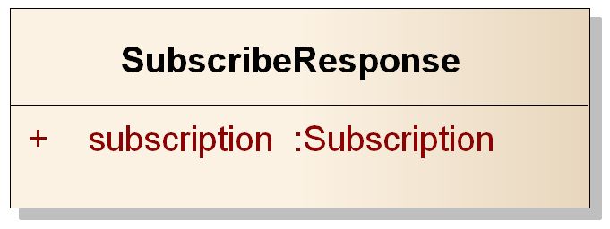
Figure 10: Subscribe response
Table 8: Subscribe response properties
Name | Definition | Data type and values | Multiplicity and use
subscription | The newly created subscription | Subscription | One (Mandatory)

Exceptions
Exceptions raised as a result of the Subscribe operation are described below.
Requirement
/req/core/basic-publisher/subscribe-exceptions
- A Publisher shall raise Exceptions in accordance with Table 9 when executing the Subscribe operation

Table 9: Subscribe Exceptions
Exception Code | Description | Locator Values
InvalidPublicationIdentifier | The referenced publication is unknown to the Publisher. | Comma-separated list of invalid publication identifiers
TerminationUnacceptable | The requested termination time is not acceptable for the Publisher. | Comma-separated list of unacceptable termination times
PastTermination | The requested termination time is in the past. | Comma-separated list of unacceptable termination times
InvalidDeliveryMethod | The DeliveryMethod identifier is not unknown to this Publisher | Comma-separated list of unacceptable DeliveryMethod identifiers
InvalidFilter | The requested filter is not valid for the subscription or Publisher. | XPath to invalid request filter section, or other relevant request location information
MissingParameterValue | Operation request does not include a parameter value, and this server did not declare a default value for that parameter | Name of missing parameter
InvalidParameterValue | Operation request contains an invalid parameter value | Name of parameter with invalid value
NoApplicableCode | No other exceptionCode specified by this service and server applies to this exception | None, omit “locator” parameter

Unsubscribe operation
The Unsubscribe operation allows Subscribers to terminate a subscription. To invoke the Unsubscribe operation, a client sends an Unsubscribe request message to the Publisher. The Publisher then processes the request and determines if it is acceptable. If so, the Publisher terminates the subscription identified in the request and returns an Unsubscribe operation response. If it is not acceptable or problems occur while processing the request, the Publisher returns an exception.
Requirement
/req/core/basic-publisher/unsubscribe
- The Publisher shall offer the Unsubscribe operation

Request
The Unsubscribe request identifies the subscription that the client wants to terminate, as shown in Figure 11.

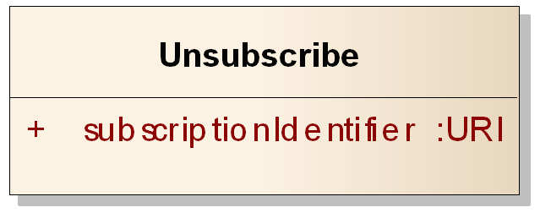
Figure 11: Unsubscribe request
Table 10: Unsubscribe request properties
Name | Definition | Data type and values | Multiplicity and use
subscriptionIdentifier | The identifier of the subscription to be terminated | URI | One (Mandatory)

Response
If the request is accepted and no Exception is raised, the Publisher terminates the subscription and ceases message matching. Undelivered messages that matched before termination may be delivered after termination.
Requirement
/req/core/basic-publisher/unsubscribe-halt-matching
- A Publisher shall cease subscription matching for the subscription identified in the Unsubscribe request

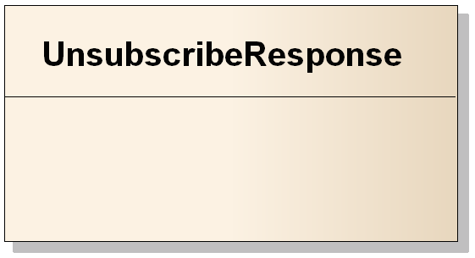
Figure 12: Unsubscribe response

Exceptions
Exceptions raised as a result of the Unsubscribe operation are described below. Unsuccessful Unsubscribe requests do not change any subscription state.
Requirement
/req/core/basic-publisher/unsubscribe-exception-state
- A Publisher shall leave subscription state unchanged when an Exception occurs during the Unsubscribe operation

Requirement
/req/core/basic-publisher/unsubscribe-exceptions
- A Publisher shall raise Exceptions in accordance with Table 11 when executing the Unsubscribe operation

Table 11: Unsubscribe Exceptions
Exception Code | Description | Locator Values
InvalidSubscriptionIdentifier | The requested subscription is unknown to the Publisher. | Comma-separated list of invalid subscription identifiers
NoApplicableCode | No other exceptionCode specified by this service and server applies to this exception | None, omit “locator” parameter

Renew operation
The Renew operation allows subscribers to set the termination time on a subscription to a new time. This new time may be before or after the current termination time.
NOTE A subscription that has already been terminated (either automatically expired or explicitly via the Unsubscribe operation) cannot be renewed.
To invoke the Renew operation, a client sends a Renew request message to the Publisher. The Publisher then processes the request and determines if the proposed termination time is acceptable.
If so, the Publisher updates the subscription and returns a RenewResponse. If it is not acceptable or problems occur while processing the request, the Publisher returns an exception.
Requirement
/req/core/basic-publisher/renew
- The Publisher shall offer the Renew operation

Request
A client sends a Renew request to the Publisher in order to update the termination time of an existing subscription.

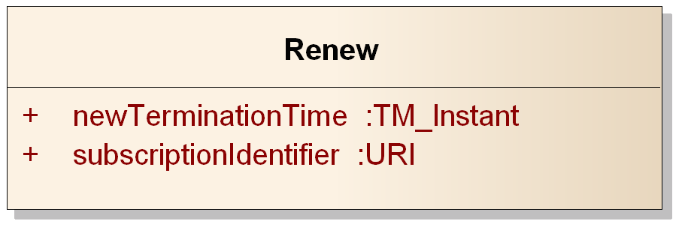
Figure 13: Renew request
Table 12: Renew request properties
Name | Definition | Data type and values | Multiplicity and use
newTerminationTime | The new date and time when the identified subscription is requested to terminate. The new termination time cannot be in the past | TM_Instant [see ISO/TS 19103:2006] | One (Mandatory)
subscriptionIdentifier | Unique identifier for the subscription | URI | One (Mandatory)

Requirement
/req/core/basic-publisher/renew-update-termination-time
- A Publisher shall update the terminationTime on the identified subscription to be the value of newTerminationTime provided as part of a successful Renew operation

Response
If the request is accepted and no Exception is raised, the Publisher accepts the request, updates the termination time of the subscription, and returns a RenewResponse.
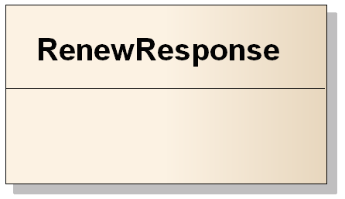
Figure 14: Renew response
NOTE this Requirements Class does not define any content to be returned in a RenewResponse. Extensions may include more information, such as further information about the updated subscription.

Exceptions
Exceptions raised as a result of the Renew operation are described below. Unsuccessful Renew requests do not change any subscription state, in particular termination time.
Requirement
/req/core/basic-publisher/renew-exception-state
- A Publisher shall leave subscription state unchanged when an Exception occurs during the Renew operation

Requirement
/req/core/basic-publisher/renew-exceptions
- A Publisher shall raise Exceptions in accordance with Table 13 when executing the Renew operation

Table 13: Renew Exceptions
Exception Code | Description | Locator Values
InvalidSubscriptionIdentifier | The requested subscription is unknown to the Publisher. | Comma-separated list of invalid subscription identifiers
TerminationUnacceptable | The requested termination time is not acceptable for the Publisher. | Comma-separated list of unacceptable termination times
PastTermination | The requested termination time is in the past. | Comma-separated list of unacceptable termination times
MissingParameterValue | Operation request does not include a parameter value, and this server did not declare a default value for that parameter | Name of missing parameter
InvalidParameterValue | Operation request contains an invalid parameter value | Name of parameter with invalid value
NoApplicableCode | No other exceptionCode specified by this service and server applies to this exception | None, omit “locator” parameter

Requirements Class – Standalone Publisher extends Basic Publisher
Requirements Class
http://www.opengis.net/spec/pubsub/1.0/req/core/standalone-publisher
Target type | Publisher
Dependency | http://www.opengis.net/spec/pubsub/1.0/req/core/basic-publisher
Dependency | http://www.opengis.net/doc/IS/OWS/1.1/clause/7
Requirement | /req/core/standalone-publisher/getcapabilities
Requirement | /req/core/standalone-publisher/getsubscription
Requirement | /req/core/standalone-publisher/getsubscription-all-subscriptions
Requirement | /req/core/standalone-publisher/getsubscription-exceptions

This Requirements Class enables standalone publishing, wherein Publishers offer metadata concerning Publisher capabilities. This Requirements Class requires that a Publisher implement two operations:
GetCapabilities - allows for the discovery of Publisher metadata, including offered publications, service capabilities, and service provider information.
GetSubscription - allows for the retrieval of subscription information.
The Standalone Publisher includes a Publish/Subscribe GetCapabilities operation extended from OWS Common [OGC 06-121r3] that integrates FilterCapabilities, DeliveryCapabilities, and Publications metadata as specified in Clause 8.1.

GetCapabilities operation
The GetCapabilities operation allows clients to retrieve the capabilities metadata (also called the “capabilities document”) of a Publisher. This includes supported functionality (e.g. filter functionality, or functionality defined in other Publish/Subscribe Requirements Classes) requirements for use (e.g. that Subscribers authenticate themselves to the service) and content information (e.g., formal description of published contents).
The Publish/Subscribe GetCapabilities data type derives from the OWS Common GetCapabilities data type (listed in Table 3 of [OGC 06-121r3]).
Requirement
/req/core/standalone-publisher/getcapabilities
- The Publisher shall offer the GetCapabilities operation

Request
The Publish/Subscribe GetCapabilities request extends the OWS Common GetCapabilitiesType with limited information.
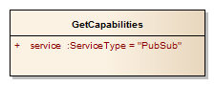
Figure 15: GetCapabilities request
Table 14: GetCapabilities properties
Name | Definition | Data type and values | Multiplicity and use
service | The service type | ServiceType [see  OGC 06-121r3] | One  (Mandatory)  Always the fixed value “PubSub”

Response
If the request is accepted and no Exception is raised, the Publisher returns a PublisherCapabilities. PublisherCapabilities is an extension of the OWS Common Capabilities document that adds filter capabilities, delivery capabilities, and publications/contents metadata. These additional portions of the Capabilities document are specified in the FilterCapabilities, DeliveryCapabilities, and Publication clauses in Clause 8.1.
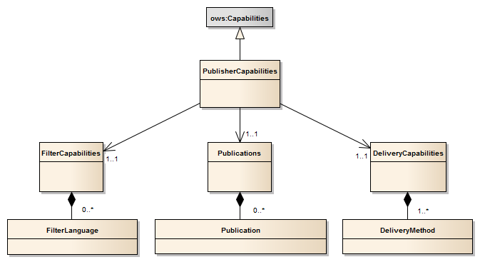
Figure 16: PublisherCapabilities

Exceptions
Exception behavior for the GetCapabilities operation is defined in Table 8 and Clause 8 of the OWS Common Specification [OGC 06-121r3].

GetSubscription operation
A Subscriber invokes the GetSubscription operation in order to retrieve information on one or more subscriptions.
NOTE Terminated subscriptions are not returned. Publishers may return an empty list if all the requested subscriptions have expired or were explicitly terminated via the Unsubscribe operation.
To invoke the GetSubscription operation, a client sends a GetSubscription request message to the Publisher. The Publisher then processes the request and determines if it is acceptable. If so, the Publisher returns a GetSubscription operation response. If it is not acceptable or problems occur while processing the request, the Publisher returns an exception.
Requirement
/req/core/standalone-publisher/getsubscription
- The Publisher shall offer the GetSubscription operation

Request
A client sends a GetSubscription request to the Publisher in order to retrieve the active subscriptions. The Publisher needs to determine if the request is acceptable. In order to do so, the Publisher performs syntactic as well as semantic checks regarding the request.
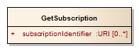
Figure 17: GetSubscription request
Table 15: GetSubscription request properties
Name | Definition | Data type and values | Multiplicity and use
subscriptionIdentifier | The identifier of the subscription(s) to be described. If missing, all subscriptions are requested | URI | Zero to many (Optional)

Response
If the request is accepted and no Exception is raised, the Publisher returns the requested active subscriptions in a GetSubscriptionResponse. If no subscription identifiers are specified in the request, the Publisher returns all active subscriptions (see the state diagram in Figure 8).
Requirement
/req/core/standalone-publisher/getsubscription-all-subscriptions
- A Publisher shall return a GetSubscriptionResponse with all the active subscriptions when no subscription identifiers are provided as part of the GetSubscription request

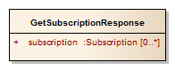
Figure 18: GetSubscription response
Table 16: GetSubscription response properties
Name | Definition | Data type and values | Multiplicity and use
subscription | The requested subscription description | Subscription | One (Mandatory)

Exceptions
Exceptions raised as a result of the GetSubscription operation are described below.
Requirement
/req/core/standalone-publisher/getsubscription-exceptions
- A Publisher shall raise Exceptions in accordance with Table 17 when executing the GetSubscription operation

Table 17: GetSubscription Exceptions
Exception Code | Description | Locator Values
InvalidSubscriptionIdentifier | The requested subscription is unknown to the Publisher. | Comma-separated list of invalid subscription identifiers
NoApplicableCode | No other exceptionCode specified by this service and server applies to this exception | None, omit “locator” parameter

Requirements Class – Pausable Publisher extends Basic Publisher
Requirements Class
http://www.opengis.net/spec/pubsub/1.0/req/core/pausable-publisher
Target type | Publisher
Dependency | http://www.opengis.net/spec/pubsub/1.0/req/core/basic-publisher
Requirement | /req/core/pausable-publisher/pause
Requirement | /req/core/pausable-publisher/pause-halt-delivery
Requirement | /req/core/pausable-publisher/pause-unchanged-paused-subscription
Requirement | /req/core/pausable-publisher/pause-exceptions
Requirement | /req/core/pausable-publisher/resume
Requirement | /req/core/pausable-publisher/resume-resume-delivery
Requirement | /req/core/pausable-publisher/resume-unchanged-active-subscription
Requirement | /req/core/pausable-publisher/resume-exceptions

The Pausable Publisher Requirements Class enables subscription pausing, wherein Publishers may be directed to pause and resume message delivery for a subscription. Message matching for a paused subscription continues unchanged, but matching messages are not delivered until the subscription is resumed. This Requirements Class requires that a Publisher implement two operations:
Pause - allows for the pausing of an unpaused subscription, which pauses message delivery.
Resume - allows for the resumption of a paused subscription, which resumes message delivery.
NOTE Pausing and resuming of subscriptions is independent of subscription termination. Paused subscriptions are subject to subscription termination (through expiry or other means) in an identical manner to active subscriptions
When a paused subscription is resumed, all matched but undelivered messages for the subscription will be delivered. Message delivery (as well as message matching) may also be halted with the Unsubscribe and Subscribe operations, except that matching messages that arrive in between the Unsubscribe and the new Subscribe call will be lost.
In cases of asynchronous message delivery, some messages may be in transit when the Pause operation is executed. When this occurs, message delivery may continue after the Pause operation is successfully completed and the Publisher has ceased initiating the delivery of messages.
The valid subscription states and transitions between states are shown in Figure 19. Execution of the Pause operation is equivalent to executing a pause state transition. Similarly, execution of the Resume operation is equivalent to executing a resume state transition.
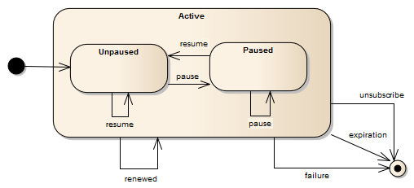
Figure 19: Subscription Pausing state
Paused subscriptions only differ from active subscriptions in terms of message delivery. Therefore they are valid targets and valid responses from all operations that include active subscriptions, such as GetSubscription responses.

Pause operation

Request
The Pause request includes a single property that identifies the subscription to be paused.
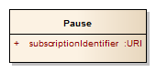
Figure 20: Pause request
Table 18: Pause properties
Name | Definition | Data type and values | Multiplicity and use
subscriptionIdentifier | The identifier of the subscription to be paused | URI | One (Mandatory)

Requirement
/req/core/pausable-publisher/pause
- A Publisher shall offer the Pause operation

Requirement
/req/core/pausable-publisher/pause-halt-delivery
- A Publisher shall cease the initiation of message delivery processes for the subscription when the Pause operation is successfully completed. Message delivery processes already underway continue unchanged

Requirement
/req/core/pausable-publisher/pause-unchanged-paused-subscription
- When a Publisher executes the Pause operation on a subscription that is already paused, no change in subscription matching or subscription state will be made

Response
If the request is accepted and no Exception is raised, the Publisher pauses the subscription and returns a PauseResponse. The PauseResponse is returned when the relevant subscription has been successfully paused.
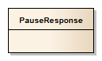
Figure 21: PauseResponse

Exceptions
Exceptions raised as a result of the Pause operation are described below. Unsuccessful Pause requests do not change any subscription state.
Requirement
/req/core/pausable-publisher/pause-exceptions
- A Publisher shall raise Exceptions in accordance with Table 19 when executing the Pause operation

Table 19: Pause Exceptions
Exception Code | Description | Locator Values
InvalidSubscriptionIdentifier | The requested subscription is unknown to the Publisher. | Comma-separated list of invalid subscription identifiers
NoApplicableCode | No other exceptionCode specified by this service and server applies to this exception | None, omit “locator” parameter

Resume operation

Request
The Resume request includes a single property that identifies the subscription to be resumed. All messages that have matched for a subscription but have not yet been delivered will be delivered when the Resume operation is completed.
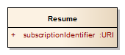
Figure 22: Resume request
Table 20: Resume properties
Name | Definition | Data type and values | Multiplicity and use
subscriptionIdentifier | The identifier of the subscription to be resumed | URI | One (Mandatory)

Requirement
/req/core/pausable-publisher/resume
- A Publisher shall offer the Resume operation

Requirement
/req/core/pausable-publisher/resume-resume-delivery
- A Publisher shall re-start all message delivery processes for the appropriate subscription when the Resume operation is successfully completed

Requirement
/req/core/pausable-publisher/resume-unchanged-active-subscription
- When a Publisher executes the Resume operation on a subscription that is already active, no change in subscription matching or subscription state will be made

Response
If the request is accepted and no Exception is raised, the Publisher resumes the subscription and returns a ResumeResponse. The ResumeResponse is returned when the relevant subscription has been successfully resumed.
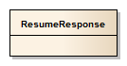
Figure 23: ResumeResponse

Exceptions
Exceptions raised as a result of the Resume operation are described below. Unsuccessful Resume requests do not change any subscription state.
Requirement
/req/core/pausable-publisher/resume-exceptions
- A Publisher shall raise Exceptions in accordance with Table 21 when executing the Resume operation

Table 21: Resume Exceptions
Exception Code | Description | Locator Values
InvalidSubscriptionIdentifier | The requested subscription is unknown to the Publisher. | Comma-separated list of invalid subscription identifiers
NoApplicableCode | No other exceptionCode specified by this service and server applies to this exception | None, omit “locator” parameter

Requirements Class – Message Batching Publisher extends Basic Publisher
Requirements Class
http://www.opengis.net/spec/pubsub/1.0/req/core/message-batching-publisher
Target type | Publisher
Dependency | http://www.opengis.net/spec/pubsub/1.0/req/core/basic-publisher
Requirement | /req/core/message-batching-publisher/subscribe-message-batching
Requirement | /req/core/message-batching-publisher/withheld-delivery
Requirement | /req/core/message-batching-publisher/reset-batching
Requirement | /req/core/message-batching-publisher/subscription-termination
Requirement | /req/core/message-batching-publisher/pausing
Requirement | /req/core/message-batching-publisher/subscribe-exceptions

The Message Batching Publisher Requirements Class specifies capabilities for Subscribers to communicate message-batching directives. Message batching allows Subscribers to specify desired message delivery at a different rate than the messages are natively generated. This includes cases where frequent, small messages are published that can be consumed more efficiently in batches by the Receiver.

Batching criteria
Message-batching criteria are optionally set by providing a BatchingCriteria object to the Subscribe operation. The batching criteria supported include:
- Time period (e.g. every 5 minutes, every hour)
- Batch size (e.g. every 20 messages, every 150 messages)
More than one criterion may be supplied at once. When multiple criteria are supplied, the first criterion that applies triggers the delivery of the batch.
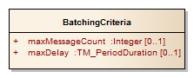
Figure 24: BatchingCriteria
Table 22: BatchingCriteria properties
Name | Definition | Data type and values | Multiplicity and use
maxDelay | The maximum amount of time that may pass between the delivery of message batches | TM_PeriodDuration [see ISO/TS 19103:2006] | Zero or one (Optional)
maxMessageCount | The maximum number of messages accumulated before a batch is delivered | Integer - greater than 0 | Zero or one (Optional)

Messages matching a BatchingCriteria are accumulated and withheld by the Publisher. When either the number of messages equals maxMessageCount or the time passed since the last delivery exceeds maxDelay, all the withheld messages are delivered.
If the maxDelay period is reached without any withheld messages to deliver, no message delivery will take place. No message batch will ever be delivered with more messages than maxMessageCount.
For example, a Subscriber submits may submit a subscription via the Subscribe operation with batching criteria indicating a maxDelay of 10 minutes and a maxMessageCount of 30. The Publisher withholds the messages for this publication until 30 messages arrive or 10 minutes pass, whichever occurs first. Whenever the first of these conditions occur and there is at least one message to deliver, the Publisher would deliver the message batch. Subscription termination will trigger the batch delivery of any withheld (undelivered) messages for that subscription.
Requirement
/req/core/message-batching-publisher/subscribe-message-batching
- A Publisher shall accept MessageBatchingCriteria with other subscription criteria on the Subscribe operation

Requirement
/req/core/message-batching-publisher/withheld-delivery
- A Publisher shall withhold delivery of messages until any of the subscription message batching criteria are met, at which time all withheld messages will be delivered together as a batch

Requirement
/req/core/message-batching-publisher/reset-batching
- A Publisher shall reset tracking information (e.g., last batch delivery time and number of withheld messages) for subscription message batching criteria whenever a message batch is delivered

Requirement
/req/core/message-batching-publisher/subscription-termination
- A Publisher shall deliver withheld messages in a batch when a subscription is terminated

Requirement
/req/core/message-batching-publisher/pausing
- A Publisher shall deliver withheld messages in a batch when a subscription is paused as described in the Pausable Publisher Requirements Class (see Clause 10)

NOTE The use of this conformance class in conjunction with the Heartbeat Publisher conformance class can result in batched heartbeats. Subscribers are recommended to use care when using both message batching and heartbeats in conjunction

Exceptions
Exceptions raised as a result of the Subscribe operation are described below.
Requirement
/req/core/message-batching-publisher/subscribe-exceptions
- A Publisher shall raise Exceptions in accordance with Table 23 when executing the Subscribe operation, in addition to those specified in Section 8.3.4

Table 23: Message Batching Subscribe Exceptions
Exception Code | Description | Locator Values
MissingParameterValue | Operation request does not include a parameter value, and this server did not declare a default value for that parameter | Name of missing parameter
InvalidParameterValue | Operation request contains an invalid parameter value | Name of parameter with invalid value
NoApplicableCode | No other exceptionCode specified by this service and server applies to this exception | None, omit “locator” parameter

Requirements Class – Heartbeat Publisher extends Basic Publisher
Requirements Class
http://www.opengis.net/spec/pubsub/1.0/req/core/heartbeat-publisher
Target type | Publisher
Dependency | http://www.opengis.net/spec/pubsub/1.0/req/core/basic-publisher
Requirement | /req/core/heartbeat-publisher/subscribe-heartbeat
Requirement | /req/core/heartbeat-publisher/publish-heartbeat
Requirement | /req/core/heartbeat-publisher/pausing
Requirement | /req/core/heartbeat-publisher/subscribe-exceptions

The Heartbeat Publisher Requirements Class specifies capabilities to ensure that the Receiver is sent regular notifications of liveness. This Requirements Class enables Receivers to detect outages due to network failures, Publisher failures, or other issues preventing communication of messages for an active subscription. This Requirements Class addresses end-to-end subscription delivery liveness, and as such is a capability that is most useful when the original Publisher or Sender is capable of issuing heartbeats.

Heartbeat criteria
Subscribers may optionally specify to the Publisher a rate for the heartbeat messages.
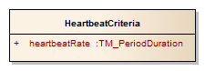
Figure 25: HeartbeatCriteria
Table 24: HeartbeatCriteria properties
Name | Definition | Data type and values | Multiplicity and use
heartbeatRate | The rate at which heartbeat messages should be sent for this subscription | TM_PeriodDuration [see ISO/TS 19103:2006] | One (Mandatory)

Requirement
/req/core/heartbeat-publisher/subscribe-heartbeat
- A Publisher shall accept HeartbeatCriteria with other subscription criteria on the Subscribe operation

HeartbeatMessages are messages sent on a regular period that includes the heartbeat issuance time from the Publisher. The arrival of these messages indicates that the Publisher was able to deliver messages as of that time, as observed by the Publisher clock when it initiated the delivery of the HeartbeatMessage.
NOTE HeartbeatMessages are abstract and may be represented as a header entry, unique message, or other representation depending on the delivery method.

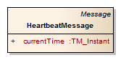
Figure 26: Heartbeat Message
Table 25: Heartbeat Message properties
Name | Definition | Data type and values | Multiplicity and use
currentTime | The time of issuance of the heartbeat message | TM_Instant [see ISO/TS 19103:2006] | One (Mandatory)

Requirement
/req/core/heartbeat-publisher/publish-heartbeat
- A Publisher shall send regular HeartbeatMessages for each subscription as specified by its HeartbeatCriteria

Requirement
/req/core/heartbeat-publisher/pausing
- A Publisher shall cease sending HeartbeatMessages for a subscription when it is paused as described in the Pausable Publisher Requirements Class (see Clause 10)

Exceptions
Exceptions raised as a result of the Subscribe operation are described below.
Requirement
/req/core/heartbeat-publisher/subscribe-exceptions
- A Publisher shall raise Exceptions in accordance with Table 26 when executing the Subscribe operation, in addition to those specified in Section 8.3.4

Table 26: Heartbeat Subscribe Exceptions
Exception Code | Description | Locator Values
MissingParameterValue | Operation request does not include a parameter value, and this server did not declare a default value for that parameter | Name of missing parameter
InvalidParameterValue | Operation request contains an invalid parameter value | Name of parameter with invalid value
NoApplicableCode | No other exceptionCode specified by this service and server applies to this exception | None, omit “locator” parameter

Requirements Class – Brokering Publisher extends Standalone Publisher
Requirements Class
http://www.opengis.net/spec/pubsub/1.0/req/core/brokering-publisher
Target type | Publisher
Dependency | http://www.opengis.net/spec/pubsub/1.0/req/core/standalone-publisher
Requirement | /req/core/brokering-publisher/registerpublisher
Requirement | /req/core/brokering-publisher/registerpublisher-connect
Requirement | /req/core/brokering-publisher/registerpublisher-exceptions
Requirement | /req/core/brokering-publisher/removepublisher
Requirement | /req/core/brokering-publisher/removepublisher-exceptions
Requirement | /req/core/brokering-publisher/getcapabilities-registered-publishers

A Brokering Publisher, or Broker, is an intermediary between Subscribers and other Publishers, which have been previously connected to the Broker itself. The Broker is not the original producer of messages, but only acts as a message middleman, re-publishing messages received from other Publishers and decoupling them from their Subscribers. This Requirements Class requires that a Publisher implement the operations:
RegisterPublisher - allows the connection of an external Publisher to the Broker.
RemovePublisher - allows the disconnection of a Publisher from the Broker.
A broker is a distinct third party that acts as a communication intermediary between the source and the target of a communication, mediating their interfaces and in some cases adding new behavior. A Broker may aggregate the messages into different publications, may provide the same publications with a with different delivery methods, or otherwise process the messages (e.g. converting their format). A broker may also provide advanced messaging features such as load balancing. However, a Broker should not advertise capabilities on behalf of another Publisher, unless the latter provides identical guarantees (e.g. heartbeat).
Examples of Brokering Publisher applications include:
Publisher Aggregation – a Broker subscribes to several Publishers and relays their publications (without modification) to interested Subscribers, acting like a Proxy to multiple Publishers. Optionally, the Broker may adapt the service interface (binding) of the aggregated Publishers.
Publication Aggregation – a Broker receives messages generated by several Publishers (e.g. dumb sensors) and publishes them to the interested Subscribers as a single publication.
This Requirement Class does not mandate any specific behavior to be implemented by a Brokering Publisher, in particular as regards the support to Delivery Capabilities, Filtering Capabilities, and Publications of connected Publishers. Implementations of this Requirement Class are free to interact with the connected Publishers as appropriate for their specific application. Interactions may include subscribing, loading and/or proxying capabilities documents, or other behavior. Future extensions to this Requirement Class may standardize the behavior of Brokering Publishers in specific application scenarios.
NOTE WS-Notification has a similar abstraction, the NotificationBroker, as defined in WS-BrokeredNotification.
Figure 27 illustrates the typical Broker interaction. The Broker behaves like the Publisher in the core Publish/Subscribe. Note, however, that the Broker relays messages received from an external Publisher, which is assumed to have been previously connected to the Broker itself.
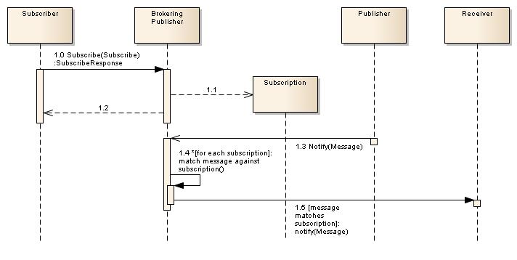
Figure 27: Broker workflow
The Broker provides additional functionalities that support the management of brokered Publishers. The operations described herein allow external Publishers to be connected to and disconnected from the Broker.

RegisterPublisher operation
The RegisterPublisher operation is used to connect the Broker to a given Publisher. As a result of this operation, the Broker capabilities may change (e.g. exposing part or all of the FilterCapabilities, DeliveryCapabilities, and Publications of the brokered Publisher); the specification of such changes is out of the scope of this Requirements Class.
Requirement
/req/core/brokering-publisher/registerpublisher
- A Publisher shall offer the RegisterPublisher operation

Request
The following diagram and table list the request parameters for the RegisterPublisher operation:
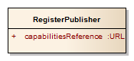
Figure 28: RegisterPublisher request
Table 27: RegisterPublisher properties
Name | Definition | Data type and values | Multiplicity and use
capabilitiesReference | Reference to the capabilities document of the Publisher to be registered | URL | One  (Mandatory)

Response
If the request is accepted and no Exception is raised, the Broker retrieves the capabilities document, verifies that the document is a valid Publish/Subscribe capabilities document, and returns a RegisterPublisherResponse. If there is a failure retrieving or verifying the capabilities document, an Exception is raised.
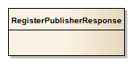
Figure 29: RegisterPublisher response
Requirement
/req/core/brokering-publisher/registerpublisher-connect
- When the RegisterPublisher operation is executed a Publisher shall retrieve the capabilities document of the registered Publisher and verify that it contains integrates FilterCapabilities, DeliveryCapabilities, and Publications sections before returning the RegisterPublisherResponse

Exceptions
Exceptions raised as a result of the RegisterPublisher operation are described below.
Requirement
/req/core/brokering-publisher/registerpublisher-exceptions
- A Publisher shall raise Exceptions in accordance with Table 28 when executing the RegisterPublisher operation

Table 28: RegisterPublisher Exceptions
Exception Code | Description | Locator Values
PublisherRegistrationRejected | Registration of the Publisher was rejected by the Broker | None, omit “locator” parameter
PublisherRegistrationFailed | Registration of the Publisher on the Broker failed | None, omit “locator” parameter
NoApplicableCode | No other exceptionCode specified by this service and server applies to this exception | None, omit “locator” parameter

RemovePublisher operation
The RemovePublisher operation removes a Publisher from the Broker. As a result of this operation, the Broker capabilities may change (e.g. removing the Publications, FilterCapabilities, DeliveryCapabilities of the removed Publisher); the specification of such changes is out of the scope of this Requirements Class.
Requirement
/req/core/brokering-publisher/removepublisher
- A Publisher shall offer the RemovePublisher operation

Request
The following figure and table list the parameters for the RemovePublisher operation:
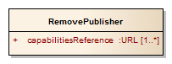
Figure 30: RemovePublisher request
Table 29: RemovePublisher properties
Name | Definition | Data type and values | Multiplicity and use
capabilitiesReference | The Capabilities reference of the Publisher(s) to be removed and disconnected | URL | One to many  (Mandatory)

Response
If the request is accepted and no Exception is raised, the Broker accepts the request, removes the specified Publishers and returns a RemovePublisherResponse.
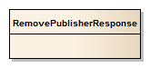
Figure 31: RemovePublisher response

Exceptions
Exceptions raised as a result of the RemovePublisher operation are described below.
Requirement
/req/core/brokering-publisher/removepublisher-exceptions
- A Publisher shall raise Exceptions in accordance with Table 30 when executing the RemovePublisher operation

Table 30: RemovePublisher Exceptions
Exception Code | Description | Locator Values
UnknownPublisher | The Publisher identified by the capabilitiesReference parameter is unknown to the Broker | Comma-separated list of invalid capabilitiesReference parameters
NoApplicableCode | No other exceptionCode specified by this service and server applies to this exception | None, omit “locator” parameter

GetCapabilities operation
In addition to the three parts offered by Standalone Publishers: filtering capabilities (Clause 8.1.1), delivery capabilities (Clause 8.1.2), and published contents (Clause 8.1.3) Brokering Publishers add RegisteredPublishers: the set of registered Publishers.
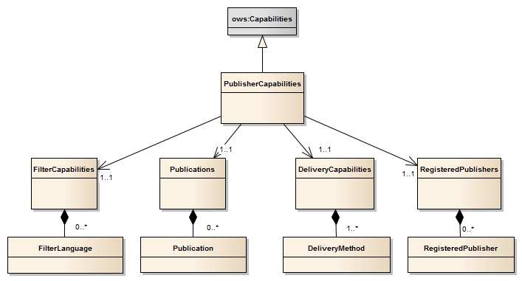
Figure 32: Brokering Capabilities

RegisteredPublishers
The set of registered Publishers on a Broker is described with the RegisteredPublishers type. RegisteredPublishers is returned as part of the PublisherCapabilities type as a result of the GetCapabilities operation.
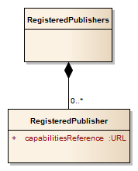
Figure 33: RegisteredPublishers metadata
Requirement
/req/core/brokering-publisher/getcapabilities-registered-publishers
- A Publisher shall return a RegisteredPublishers as part of the PublisherCapabilities type as a result of the GetCapabilities operation

Requirements Class – Publication Manager extends Basic Publisher
Requirements Class
http://www.opengis.net/spec/pubsub/1.0/req/core/publication-manager
Target type | Publisher
Dependency | http://www.opengis.net/spec/pubsub/1.0/req/core/basic-publisher
Requirement | /req/core/publication-manager/createpublication
Requirement | /req/core/publication-manager/createpublication-publication-id
Requirement | /req/core/publication-manager/createpublication-assign-properties
Requirement | /req/core/publication-manager/createpublication-exceptions
Requirement | /req/core/publication-manager/removepublication
Requirement | /req/core/publication-manager/removepublication-nesting
Requirement | /req/core/publication-manager/removepublication-base-publication-removal
Requirement | /req/core/publication-manager/subscribe-derived-publications
Requirement | /req/core/publication-manager/derived-publication-identifiers
Requirement | /req/core/publication-manager/removepublication-exceptions

The Publication Manager Requirements Class supports the creation, removal, and subscriptions to user-defined publications that are derived from an existing publication. This Requirements Class requires that a Publisher implement two operations:
CreatePublication - allows for the creation of a new derived publication based upon an existing publication with an optional filter.
RemovePublication - allows for the removal of a derived publication.
A derived publication is a publication that is created by applying an optional additional filter to the messages aggregated within an existing publication. As with any publication, a Subscriber may subscribe to a derived publication. Derived publications allow subscription filters to be shared among a large number of Subscribers rather than having each Subscriber create a subscription with the same filter. This kind of sharing of filters is especially important in large enterprises where different filtering criteria on publications is required for different sets of Subscribers in order to satisfy policy and/or legal requirements.
This clause describes operations that support the management of derived publications. The operations described herein allow derived publications to be created and removed from the system.

DerivedPublication
The DerivedPublication type is a specialized type of publication. Subscribers may subscribe to DerivedPublications in an identical fashion to that of other publications. Therefore DerivedPublication identifiers are accepted as publication identifiers to all Publish/Subscribe operations and are included among publications results in GetCapabilities and other relevant operation responses.
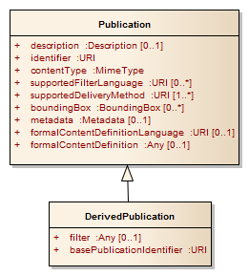
Figure 34: DerivedPublication
Table 31: DerivedPublication properties
Name | Definition | Data type and values | Multiplicity and use
filter | The filter applied to messages produced by the base publication that are available to Subscribers of this publication | Any | Zero or one (Optional)
basePublicationIdentifier | Identifier of the base publication | URI | One  (Mandatory)

CreatePublication operation
The CreatePublication operation is used to create a filtered view of a publication offered by a publisher. The salient parameters for the operation are a base publication identifier and a Filter that is used to identify the active set of messages. In this sense, a derived publication is like a stored query.

Request
The following diagram and table list the request parameters for the CreatePublication operation:
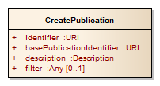
Figure 35: CreatePublication request
Table 32: CreatePublication properties
Name | Definition | Data type and values | Multiplicity and use
identifier | The identifier of the newly-created DerivedPublication | URI | One  (Mandatory)
basePublicationIdentifier | Identifier of the base publication upon which the DerivedPublication is derived | URI | One  (Mandatory)
description | A human-readable description of the DerivedPublication | String | One  (Mandatory)
filter | An expression that evaluates to a Boolean value (true/false) when applied to messages published in the base publication. It determines whether a message from the base publication appears as a message in this DerivedPublication. If a filter is not provided, no filtering is applied | Any | Zero or one  (Optional)

Requirement
/req/core/publication-manager/createpublication
- The Publisher shall offer the CreatePublication operation

Requirement
/req/core/publication-manager/createpublication-publication-id
- The Publisher shall raise an Exception if the basePublicationIdentifier specified in a CreatePublication operation is not a member of the list of offered publications at the time the derived publication is created

Requirement
/req/core/publication-manager/createpublication-assign-properties
- The Publisher shall assign publication properties (contentType, supportedFilterLanguage, supportedDeliveryMethod, boundingBox, formalContentDefinitionLanguage, and formalContentDefinition) from the base publication to the created DerivedPublication when a derived publication is created, excepting the identifier and description properties

Response
If the request is accepted and no Exception is raised, the Publisher creates a new DerivedPublication and returns a CreatePublicationResponse.
Figure 36: CreatePublication response
Table 33: CreatePublication response properties
Name | Definition | Data type and values | Multiplicity and use
publication | The newly created DerivedPublication | DerivedPublication | One (Mandatory)

Exceptions
Exceptions raised as a result of the CreatePublication operation are described below.
Requirement
/req/core/publication-manager/createpublication-exceptions
- A Publisher shall raise Exceptions in accordance with Table 34 when executing the CreatePublication operation

Table 34: CreatePublication Exceptions
Exception Code | Description | Locator Values
InvalidPublicationIdentifier | The requested base publication is unknown to the Publisher. | Comma-separated list of invalid publication identifiers
InvalidFilter | The requested filter is not valid for the subscription or not known to the Publisher. | XPath to invalid request filter section, or other relevant request location information
InvalidParameterValue | Operation request contains an invalid parameter value | Name of parameter with invalid value
NoApplicableCode | No other exceptionCode specified by this service and server applies to this exception | None, omit “locator” parameter

RemovePublication operation
The RemovePublication operation deletes one or more derived publications from the system.

Request
The following figure and table list the parameters for the RemovePublication operation:
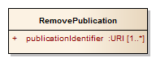
Figure 37: RemovePublication request
Table 35: RemovePublication properties
Name | Definition | Data type and values | Multiplicity and use
publicationIdentifier | The identifiers of the derived publication(s) to be removed | URI | One to many  (Mandatory)

DerivedPublications may be created using other DerivedPublications as the base publication. However, any publications with active DerivedPublications cannot be removed until their child DerivedPublications have first been removed.
Requirement
/req/core/publication-manager/removepublication
- The Publisher shall offer the RemovePublication operation

Requirement
/req/core/publication-manager/removepublication-nesting
- The Publisher shall raise an Exception if the RemovePublication operation specifies a publication that is an active base publication for one or more derived publications

Requirement
/req/core/publication-manager/removepublication-base-publication-removal
- The Publisher shall raise an Exception if the publicationIdentifier parameter to the RemovePublication operation specifies a publication that is not a derived publication

DerivedPublications are publications, and as such the Publisher shall follow normal subscription termination procedures as described in Clause 8.3.4 when a DerivedPublication is removed to which active subscriptions are associated

Response
If the request is accepted and no Exception is raised, the Publisher removes the specified DerivedPublication and returns a RemovePublicationResponse.
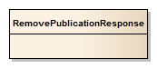
Figure 38: RemovePublication response

Requirement
/req/core/publication-manager/subscribe-derived-publications
- The Publisher shall perform DerivedPublication message matching and message delivery on messages that match on the base publication, but filtered by any filters on the DerivedPublication

Requirement
/req/core/publication-manager/derived-publication-identifiers
- The Publisher shall accept DerivedPublication identifiers as valid publication identifiers to all Publish/Subscribe operations (e.g., the Subscribe operation) and include DerivedPublications among publication results (e.g., the GetCapabilities operation)

Exceptions
Exceptions raised as a result of the RemovePublication operation are described below.
Requirement
/req/core/publication-manager/removepublication-exceptions
- A Publisher shall raise Exceptions in accordance with Table 36 when executing the RemovePublication operation

Table 36: RemovePublication Exceptions
Exception Code | Description | Locator Values
InvalidPublicationIdentifier | The publication identifier is unknown to the Publisher, or the publicationIdentifier parameter is the identifier of a non-derived publication | Comma-separated list of invalid publication identifiers
InvalidParameterValue | Operation request contains an invalid parameter value | Name of parameter with invalid value
NoApplicableCode | No other exceptionCode specified by this service and server applies to this exception | None, omit “locator” parameter

Requirements Class – Capabilities Filtering extends Basic Publisher
Requirements Class
http://www.opengis.net/spec/pubsub/1.0/req/core/capabilities-filtering
Target type | Publisher
Dependency | http://www.opengis.net/spec/pubsub/1.0/req/core/standalone-publisher
Requirement | /req/core/capabilities-filtering/getcapabilities-content-sort
Requirement | /req/core/capabilities-filtering/getcapabilities-content-filter
Requirement | /req/core/capabilities-filtering/getcapabilities-search
Requirement | /req/core/capabilities-filtering/getcapabilities-exceptions

Introduction
Clause 8.1 of this standard and Clause 7.4 of OGC-121r3 define the response to a GetCapabilities request. The response is composed of a number of sections including a Publications section, which lists the publications offered for subscription by a Publisher, otherwise known as a content section. This Publications section can become quite large, hindering the efficient transmission of a capabilities document over the Internet. For example, a Publisher may offer many thousands of publications resulting in a large and cumbersome capabilities document. The content section of OGC web services may include multiple items, in this case individual publications.
This clause defines syntactic and semantic extensions to the GetCapabilities operation in order to support very large Publications sections. Specifically, this clause defines additional parameters for the GetCapabilities request that allow a client to:
- Control the number of items that appear in the Publications section.
- Page through a Publications section that includes a large number of items.
- Specify query predicates, including spatial and temporal predicates, which allow a client to control which items are listed in the Publications section.

Request
Table 3 in Clause 7 of OGC-121r3 defines the standard set of request parameters for the GetCapabilities operation. Table 37 below defines additional parameters for the GetCapabilities operation that enables support for large Publications sections.
The default maximum number of content items returned is 15 unless specified otherwise by the count parameter described in Table 37. As this conformance class addresses the requirements of web services with large numbers of content items, this means that clients executing the GetCapabilities operation will not be overwhelmed by large Capabilities responses before being able to discover the functional capabilities.

Table 37: Additional request parameters for GetCapabilities operation
Name | Definition | Data type and values | Multiplicity and use
searchTerms | A list of terms, one or more of which, matching content items appearing in the capabilities document shall contain. | String | Zero or one (Optional)
count | The maximum number of content items that shall appear in the Publications section of a capabilities document at one time. | Integer (default=15)^{A} | Zero or one (Optional)
startIndex^{B} | The item offset, starting from zero, from which the service shall begin presenting content items in the Publications section of a capabilities document. | Integer (default=0) | Zero or one (Optional)
bbox | A spatial search box as defined in clause 10.2 of OGC-121r3. | BoundingBox [see OGC 06-121r3] | Zero or one (Optional)
start | The starting point of a temporal search range. When omitted, no start time filtering is applied | TM_Instant [see ISO/TS 19103:2006] | Zero or one (Optional)
end | The ending point of a temporal search range. When omitted, no end time filtering is applied | TM_Instant [see ISO/TS 19103:2006] | Zero or one (Optional)
- When no content filtering parameters are provided, the default values apply. Unless the count parameter is provided with the request, at most 15 items are returned in the Publications section by services that implement this conformance class
- See requirement /req/core/basic-publisher/getcapabilities/content/sort

Requirement
/req/core/capabilities-filtering/getcapabilities-content-sort
- A Publisher shall impose a consistent sort order on the items listed in the Publications section. The sorting methodology is not specified by this Standard, but GetCapabilities responses shall present a consistent order between GetCapabilities requests, regardless of filtering criteria

Response
Without the parameters defined in Table 37, the GetCapabilities operation behaves as described in OGC -121r3 and generates a complete Publications section as defined in Clause 9.1.4 of this standard and Clause 7.4 of OGC-121r3. The response to a GetCapabilities filtering query will always be a valid Capabilities document. The parameters in Table 37, if specified, only affect what items appear in the Publications section of the response. Contents filtering will not take effect if the GetCapabilities request excludes the Publications section from appearing in the response via the sections parameter described in OGC-121r3.
Requirement
/req/core/capabilities-filtering/getcapabilities-content-filter
- A Publisher shall filter the items in the Publications section of the Capabilities response in accordance with Clause 15.2 when the parameters from Table 37 are provided in the request

Requirement
/req/core/capabilities-filtering/getcapabilities-search
- When a Publisher receives a GetCapabilities request that causes the Publications section to be excluded from the response, the Publisher shall ignore any of the parameters defined in Table 37

Examples
The following request fragments exemplify (in the KVP encoding) how the parameters in Table 37 affect the behavior of the GetCapabilities operation.
Example 1: Excluded Publications section
…&sections=ServiceIdentification,ServiceProvider&searchTerms=blue,ox&…
In this example, the searchTerms parameter is ignored since the request specifically excludes the Publications section (as specified by sections=ServiceIdentification,ServiceProvider).
Example 2: Publications section paging
…&sections=Publications &count=10&startIndex=11&…
In this example, only the Publications section is presented in the response and the Publications section contains 10 items (i.e., items 11 through 20).
Example 3: Publications section filtering
…&sections=Publications &searchTerms=restaurants&bbox=43.57,-79.64,43.89,-79.12&…
In this example, only the Publications section is presented, and the records that contain the search term “restaurants” and lie within the rough boundary of Toronto, Ontario, Canada.
Example 4: Publications section filtering
…&sections=Contents&searchTerms=javascript&start=01-01-2013&end=06-30-2013&…
In this example, only the Publications section is presented, and the records that contain the search term “javascript” and have a salient date in the first 6 months of 2013.

Exceptions
Exceptions raised as a result of the GetCapabilities operation are described below.
Requirement
/req/core/capabilities-filtering/getcapabilities-exceptions
- A Publisher shall raise Exceptions in accordance with Table 38 when executing the GetCapabilities operation, in addition to those specified in Clause 9.1.3

Table 38: GetCapabilities Filtering Exceptions
Exception Code | Description | Locator Values
MissingParameterValue | Operation request does not include a parameter value, and this server did not declare a default value for that parameter | Name of missing parameter
InvalidParameterValue | Operation request contains an invalid parameter value | Name of parameter with invalid value
NoApplicableCode | No other exceptionCode specified by this service and server applies to this exception | None, omit “locator” parameter

- Abstract Test Suite (Normative)
A Publish/Subscribe implementation must satisfy the following system characteristics to be conformant with this specification.
Test, requirement, requirements class, and conformance class identifiers below are relative to http://www.opengis.net/spec/pubsub/1.0/.
  - Conformance class: Basic Receiver
/conf/core/basic-receiver
Requirements Class | /req/core/basic-receiver

Test: /conf/core/basic-receiver/notify
Requirement | /req/core/basic-receiver/notify
Test Purpose | A Receiver shall offer the Notify operation
Test Method | Execute a Notify operation with test data

  - Conformance class: Basic Publisher
/conf/core/basic-publisher
Dependency | http://www.opengis.net/doc/IS/OWS/1.1/clause/8
Dependency | http://www.opengis.net/doc/IS/OWS/1.1/clause/10
Requirements Class | /req/core/basic-publisher

Test: /conf/core/basic-publisher/getcapabilities-conf-class-listing
Requirement | /req/core/basic-publisher/getcapabilities-conf-class-listing
Test Purpose | A Publisher shall advertise conformance classes which are supported by the server. Each supported conformance class shall be identified by a unique value of the Profile property of the ServiceIdentification section of the capabilities document
Test Method | Execute a GetCapabilities operation against the service that includes the ServiceIdentification section and verify that the service returns a Capabilities document with a ServiceIdentification section with a Profile section with a value starting with “http://www.opengis.net/spec/pubsub/1.0/”

Test: /conf/core/basic-publisher/getcapabilities-filtercapabilities
Requirement | /req/core/basic-publisher/getcapabilities-filtercapabilities
Test Purpose | A Publisher shall return a FilterCapabilities structure within its GetCapabilities
Test Method | Execute a GetCapabilities operation against the service and verify that the service returns a Capabilities document with a FilterCapabilities section

Test: /conf/core/basic-publisher/unique-filter-languages
Requirement | /req/core/basic-publisher/unique-filter-languages
Test Purpose | A Publisher shall uniquely identify each offered FilterLanguage included in FilterCapabilities
Test Method | Execute a GetCapabilities operation on the service, ensure that every FilterLanguage identifier property in the PublisherCapabilities section is unique among all FilterLanguage identifiers

Test: /conf/core/basic-publisher/deliverycapabilities
Requirement | /req/core/basic-publisher/deliverycapabilities
Test Purpose | A Publisher shall return a DeliveryCapabilities structure within its GetCapabilities response
Test Method | Execute a GetCapabilities operation against the service and verify that the service returns a Capabilities document with a DeliveryCapabilities section

Test: /conf/core/basic-publisher/unique-delivery-method
Requirement | /req/core/basic-publisher/unique-delivery-method
Test Purpose | A Publisher shall uniquely identify each offered DeliveryMethod included in the PublisherCapabilities
Test Method | Execute a GetCapabilities operation on the service, ensure that every DeliveryMethod identifier property in the DeliveryCapabilities section is unique among all other DeliveryMethod identifiers

Test: /conf/core/basic-publisher/publications
Requirement | /req/core/basic-publisher/publications
Test Purpose | A Publisher shall return a Publications structure within its GetCapabilities response
Test Method | Execute a GetCapabilities operation against the service and verify that the service returns a Capabilities document with a Publications section

Test: /conf/core/basic-publisher/publication-valid-filter-language
Requirement | /req/core/basic-publisher/publication-valid-filter-language
Test Purpose | The supportedFilterLanguage on each Publication shall be one of the FilterLanguage identifiers advertised in the FilterCapabilities
Test Method | Execute a GetCapabilities operation against the service and verify that each supportedFilterLanguage identifier in each Publication section exactly matches a FilterLanguage identifier

Test: /conf/core/basic-publisher/publication-boundingbox
Requirement | /req/core/basic-publisher/publication-boundingbox
Test Purpose | When a Publisher advertises a Publication with BoundingBoxes, the first shall be a WGS84BoundingBox
Test Method | Execute a GetCapabilities operation against the service and verify that the first BoundingBox for each Publication is of type WGS84BoundingBox

Test: /conf/core/basic-publisher/publication-valid-delivery-method
Requirement | /req/core/basic-publisher/publication-valid-delivery-method
Test Purpose | The supportedDeliveryMethod on each Publication shall be one of the DeliveryMethod identifiers advertised from the DeliveryCapabilities
Test Method | Execute a GetCapabilities operation against the service and verify that each supportedDeliveryMethod identifier in each Publication section exactly matches a DeliveryMethod identifier

Test: /conf/core/basic-publisher/publication-unique-publication-id
Requirement | /req/core/basic-publisher/publication-unique-publication-id
Test Purpose | The identifier on each Publication shall be unique among all other Publication identifiers on the Publisher
Test Method | Execute a GetCapabilities operation on the service, ensure that every Publication identifier property in the Publications section is unique among all other Publication identifiers

Test: /conf/core/basic-publisher/valid-exceptions
Requirement | /req/core/basic-publisher/valid-exceptions
Test Purpose | A Publisher shall issue Exceptions that incorporate an ExceptionReport valid according to Clause 8 of the OWS Common Specification [OGC 06-121r3]
Test Method | Execute a request that raises an exception on the service and ensure that the response message contains a valid ExceptionReport from [OGC 06-121r3]

Test: /conf/core/basic-publisher/exception-version
Requirement | /req/core/basic-publisher/exception-version
Test Purpose | A Publisher shall raise Exceptions with the ExceptionReport version set to the value “1.0.0”
Test Method | Execute a request that raises an exception on the service and ensure that the response Exception message version parameter is “1.0.0”

Test: /conf/core/basic-publisher/subscribe
Requirement | /req/core/basic-publisher/subscribe
Test Purpose | The Publisher shall offer the Subscribe operation
Test Method | Execute a Subscribe operations against a test publication and ensure that the SubscribeResponse includes a valid Subscription

Test: /conf/core/basic-publisher/subscribe-assign-unique-id
Requirement | /req/core/basic-publisher/subscribe-assign-unique-id
Test Purpose | A Publisher shall assign a unique identifier to each created subscription
Test Method | Execute three Subscribe operations against a test publication and ensure that the Subscription identifier is unique among all returned Subscriptions

Test: /conf/core/basic-publisher/subscribe-default-termination-time
Requirement | /req/core/basic-publisher/subscribe-default-termination-time
Test Purpose | A Publisher shall assign a default terminationTime to created subscriptions if not provided by the Subscriber
Test Method | Execute a Subscribe operations against a test publication without an terminationTime parameter and ensure that the returned Subscription terminationTime is set

Test: /conf/core/basic-publisher/match-active-subscriptions
Requirement | /req/core/basic-publisher/match-active-subscriptions
Test Purpose | A Publisher shall match messages against all active subscriptions
Test Method | Execute two Subscribe operations against two different test publications and ensure that matching messages are delivered for each subscription

Test: /conf/core/basic-publisher/match-inactive-subscriptions
Requirement | /req/core/basic-publisher/match-inactive-subscriptions
Test Purpose | A Publisher shall cease matching and delivery of messages when subscriptions move to an inactive or terminated state
Test Method | Execute a Subscribe operation against a test publication with an terminationTime parameter that specifies 1 minute in the future. Ensure that messages are delivered on the subscription for the 1-minute period, and ensure that message delivery ceases shortly after the 1-minute period (i.e., on subscription expiry)

Test: /conf/core/basic-publisher/interrupt-matching
Requirement | /req/core/basic-publisher/interrupt-matching
Test Purpose | When a Publisher terminates a subscription it shall interrupt all unfinished matching processes for this subscription
Test Method | Execute a Subscribe operation against a test publication with an terminationTime parameter that specifies 1 hour in the future. Wait 1 minute and ensure that messages are delivered on the subscription. Execute an Unsubscribe operation against the test subscription, and ensure that message delivery ceases within a brief period

Test: /conf/core/basic-publisher/termination
Requirement | /req/core/basic-publisher/termination
Test Purpose | A Publisher shall terminate a subscription when its termination time is reached
Test Method | Execute a Subscribe operation against a test publication with an terminationTime parameter that specifies 1 minute in the future. Ensure that messages are delivered on the subscription for the 1-minute period, and ensure that message delivery ceases shortly after the 1-minute period (i.e., on subscription expiry)

Test: /conf/core/basic-publisher/subscribe-exceptions
Requirement | /req/core/basic-publisher/subscribe-exceptions
Test Purpose | A Publisher shall raise Exceptions in accordance with Table 9 when executing the Subscribe operation
Test Method | Execute the Subscribe operation with the following scenarios:  - A publicationIdentifier parameter set to “urn:pubsub:ats:InvalidPublication”, and ensure that an InvalidPublicationIdentifier Exception is returned with a locator value of “urn:pubsub:ats:InvalidPublication”  - An terminationTime parameter specifying a point in time a year ago, and ensure that the response is a PastTermination Exception with a locator value set to the requested termination time  - A deliveryMethod parameter of “urn:pubsub:ats:InvalidDeliveryMethod”, and ensure that the response is an InvalidDeliveryMethod Exception with a locator value set to the requested delivery method identifier  - A filter parameter containing the text “Invalid filter”, and ensure that the response is an InvalidFilter Exception  - A missing publicationIdentifier parameter, and ensure that the response is a MissingParameterValue Exception with a locator value set to “publicationIdentifier”  - A deliveryMethod parameter of “not a URN”, and ensure that the response is a InvalidParameterValue Exception with a locator value set to “deliveryMethod”  - An empty request (request sent to the Subscribe endpoint with no content), and ensure that the response is a NoApplicableCode Exception with an empty locator value

Test: /conf/core/basic-publisher/unsubscribe
Requirement | /req/core/basic-publisher/unsubscribe
Test Purpose | The Publisher shall offer the Unsubscribe operation
Test Method | Execute a Subscribe operation against a test publication, record the returned subscription identifier, and execute an Unsubscribe operation with the subscription identifier, and ensure that the response is a valid UnsubscribeResponse

Test: /conf/core/basic-publisher/halt-matching
Requirement | /req/core/basic-publisher/halt-matching
Test Purpose | A Publisher shall cease subscription matching for the subscription identified in the Unsubscribe request
Test Method | Execute a Subscribe operation against a test publication and record the returned subscription identifier, wait for test messages to be received for that subscription, then execute an Unsubscribe operation with the subscription identifier and after a reasonable delay ensure that no further messages are received

Test: /conf/core/basic-publisher/unsubscribe-exception-state
Requirement | /req/core/basic-publisher/unsubscribe-exception-state
Test Purpose | A Publisher shall leave subscription state unchanged when an Exception occurs during the Unsubscribe operation
Test Method | Execute a Subscribe operation against a test publication and record the returned test subscription identifier, wait for test messages to be received for that subscription, then execute an Unsubscribe operation with the subscription identifier “urn:pubsub:ats:invalidSubscriptionId” and ensure that messages continue to be received for the test subscription

Test: /conf/core/basic-publisher/unsubscribe-exceptions
Requirement | /req/core/basic-publisher/unsubscribe-exceptions
Test Purpose | A Publisher shall raise Exceptions in accordance with Table 11 when executing the Unsubscribe operation
Test Method | Execute an Unsubscribe operation with the following cases:  - The subscriptionIdentifier parameter is set to “urn:pubsub:ats:invalidSubscriptionId” and ensure that the response is an InvalidSubscriptionIdentifier Exception with a locator value of “subscriptionIdentifier”  - The body of the Unsubscribe request is empty (missing), and ensure that the response is a NoApplicableCode Exception with a missing locator value

Test: /conf/core/basic-publisher/renew
Requirement | /req/core/basic-publisher/renew
Test Purpose | The Publisher shall offer the Renew operation
Test Method | Execute a Subscribe operation against a test publication with an terminationTime parameter set to one minute after now, record the returned subscription identifier, execute a Renew operation with the subscription identifier with an terminationTime parameter set to two minutes after now, and ensure that the response is a valid RenewResponse

Test: /conf/core/basic-publisher/renew-update-termination-time
Requirement | /req/core/basic-publisher/renew-update-termination-time
Test Purpose | A Publisher shall update the terminationTime on the identified subscription to be the value of newTerminationTime provided as part of a successful Renew operation
Test Method | Execute a Subscribe operation against a test publication with an trminationTime parameter set to one minute after now, record the returned subscription identifier, execute a Renew operation with the subscription identifier and a newTerminationTime parameter set to two minutes after now, ensure that the response is a valid RenewResponse, and ensure that messages continue to arrive for approximately two minutes

Test: /conf/core/basic-publisher/renew-exception-state
Requirement | /req/core/basic-publisher/renew-exception-state
Test Purpose | A Publisher shall leave subscription state unchanged when an Exception occurs during the Renew operation
Test Method | Execute a Subscribe operation against a test publication with an terminationTime parameter set to one minute after now, record the returned subscription identifier, execute a Renew operation with the subscription identifier and a newTerminationTime parameter set to two days before now, ensure that the response is a PastTermination Exception, and ensure that messages cease being delivered after approximately one minute from the initial Subscribe operation call

Test: /conf/core/basic-publisher/renew-exceptions
Requirement | /req/core/basic-publisher/renew-exceptions
Test Purpose | A Publisher shall raise Exceptions in accordance with Table 13 when executing the Renew operation
Test Method | Execute a Subscribe operation against a test publication with an terminationTime parameter set to one minute after now, record the returned subscription identifier, execute a Renew operation with the following scenarios:  - The subscriptionIdentifier parameter is set to “urn:pubsub:ats:InvalidSubscriptionIdentifier”, and ensure that the response is an InvalidSubscriptionIdentifier Exception with a locator value set to “urn:pubsub:ats:InvalidSubscriptionIdentifier”  - The newTerminationTime parameter set to 100 years after now, and ensure that the response is an TerminationUnacceptable Exception with a locator value set to the newTerminationTime parameter value passed in the request  - The newTerminationTime parameter set to 1 day before now, and ensure that the response is a PastTermination Exception with a locator value set to the newTerminationTime parameter value passed in the request  - A missing newTerminationTime parameter (not present in the request), and ensure that the response is an MissingParameterValue Exception with a locator value set to the value “newTerminationTime”  - The newTerminationTime parameter set to the literal value “a day or two”, and ensure that the response is a MissingParameterValue Exception with a locator value set to the value “newTerminationTime”  - An empty request (request sent to the Renew endpoint with no content), and ensure that the response is a NoApplicableCode Exception with an empty locator value

  - Conformance class: Standalone Publisher
/conf/core/standalone-publisher
Dependency | /conf/core/basic-publisher
Dependency | http://www.opengis.net/doc/IS/OWS/1.1/clause/7
Requirements Class | /req/core/standalone-publisher

Test: /conf/core/standalone-publisher/getcapabilities
Requirement | /req/core/standalone-publisher/getcapabilities
Test Purpose | The Publisher shall offer the GetCapabilities operation
Test Method | Execute the GetCapabilities operation with an AcceptVersions section with a single Version parameter set to “1.0.0” and the service parameter set to “PubSub”, and ensure that the response is a valid PublisherCapabilities document

Test: /conf/core/standalone-publisher/getsubscription
Requirement | /req/core/standalone-publisher/getsubscription
Test Purpose | The Publisher shall offer the GetSubscription operation
Test Method | Execute the GetSubscription operation without any subscriptionIdentifier parameters, and ensure that the response is a valid GetSubscriptionResponse document.  For every subscription in the GetSubscriptionResponse, execute the GetSubscription operation with the corresponding subscriptionIdentifier parameter, and ensure that the response is a valid GetSubscriptionResponse document related to that subscription

Test: /conf/core/standalone-publisher/getsubscription-all-subscriptions
Requirement | /req/core/standalone-publisher/getsubscription-all-subscriptions
Test Purpose | A Publisher shall return a GetSubscriptionResponse with all the active subscriptions when no subscription identifiers are provided as part of the GetSubscription request
Test Method | Execute the Subscribe operation on a test publication, record the returned subscription identifier, execute the GetSubscription operation with no subscriptionIdentifier parameters, ensure that the response is a valid GetSubscriptionResponse, and ensure that exactly one subscription with the recorded subscription identifier is present in the response

Test: /conf/core/standalone-publisher/getsubscription-exceptions
Requirement | /req/core/standalone-publisher/getsubscription-exceptions
Test Purpose | A Publisher shall raise Exceptions in accordance with Table 17 when executing the GetSubscription operation
Test Method | Execute the GetSubscription operation with the following scenarios:  - A subscriptionIdentifier parameter set to the value “urn:pubsub:ats:InvalidSubscriptionIdentifier”, and ensure that the response is an InvalidSubscriptionIdentifier Exception with the locator value set to “urn:pubsub:ats:InvalidSubscriptionIdentifier”  - An empty request (request sent to the GetSubscription endpoint with no content), and ensure that the response is a NoApplicableCode Exception with an empty locator value

  - Conformance class: Pausable Publisher
/conf/core/basic-publisher
Dependency | /conf/core/basic-publisher
Requirements Class | /req/core/pausable-publisher

Test: /conf/core/pausable-publisher/pause
Requirement | /req/core/pausable-publisher/pause
Test Purpose | A Publisher shall offer the Pause operation
Test Method | Execute the Subscribe operation on a test publication, record the returned subscription identifier, wait for messages to be received for the subscription, then execute the Pause operation with the subscriptionIdentifier parameter set to the recorded subscription identifier, and ensure that the response is a valid PauseResponse document

Test: /conf/core/pausable-publisher/pause-halt-delivery
Requirement | /req/core/pausable-publisher/pause-halt-delivery
Test Purpose | A Publisher shall cease the initiation of message delivery processes for the subscription when the Pause operation is successfully completed. Message delivery processes already underway continue unchanged
Test Method | Create a test subscription on the service via the Subscribe operation, wait for a message to be delivered, execute the Pause operation to pause the test subscription, and verify that no message is delivered for that subscription within a reasonable period to account for normal delays with delivery processes

Test: /conf/core/pausable-publisher/pause-unchanged-paused-subscription
Requirement | /req/core/pausable-publisher/pause-unchanged-paused-subscription
Test Purpose | When a Publisher executes the Pause operation on a subscription that is already paused, no change in subscription matching or subscription state will be made
Test Method | Create a test subscription on the service via the Subscribe operation, wait for a message to be delivered, execute the Pause operation to pause the test subscription, execute the Pause operation again on the test subscription, and ensure that no messages are delivered

Test: /conf/core/pausable-publisher/pause-exceptions
Requirement | /req/core/pausable-publisher/pause-exceptions
Test Purpose | A Publisher shall raise Exceptions in accordance with Table 19 when executing the Pause operation
Test Method | Create a test subscription on the service via the Subscribe operation, wait for a message to be delivered, execute the Pause operation with the following scenarios:  - A subscriptionIdentifier set to the value “urn:pubsub:ats:InvalidSubscriptionIdentifier”, and ensure that the response is a InvalidSubscriptionIdentifier Exception with a locator value of “urn:pubsub:ats:InvalidSubscriptionIdentifier”  - An empty request (request sent to the Pause endpoint with no content), and ensure that the response is a NoApplicableCode Exception with an empty locator value

Test: /conf/core/pausable-publisher/resume
Requirement | /req/core/pausable-publisher/resume
Test Purpose | A Publisher shall offer the Resume operation
Test Method | Execute the Subscribe operation on a test publication, record the returned subscription identifier, wait for messages to be received for the subscription, execute the Pause operation with the subscriptionIdentifier parameter set to the recorded subscription identifier, execute the Resume operation with the subscriptionIdentifier parameter set to the recorded subscription identifier, and ensure that the response is a valid ResumeResponse document

Test: /conf/core/pausable-publisher/resume-resume-delivery
Requirement | /req/core/pausable-publisher/resume-resume-delivery
Test Purpose | A Publisher shall re-start all message delivery processes for the appropriate subscription when the Resume operation is successfully completed
Test Method | Execute the Subscribe operation on a test publication that publishes messages at a fixed rate (e.g., 1 message per second), record the returned subscription identifier, wait for a message to be received for the subscription, execute the Pause operation on the test subscription, wait until 5 messages will have been produced for the test subscription, execute the Resume operation on the test subscription, ensure that the response is a valid ResumeResponse document, and ensure that the expected 5 messages are received

Test: /conf/core/pausable-publisher/resume-unchanged-active-subscription
Requirement | /req/core/pausable-publisher/resume-unchanged-active-subscription
Test Purpose | When a Publisher executes the Resume operation on a subscription that is already active, no change in subscription matching or subscription state will be made
Test Method | Execute the Subscribe operation on a test publication, wait for messages to be received for the subscription, execute the Resume operation on the test subscription, ensure that the response is a valid ResumeResponse document, and ensure that messages continue to be received on the subscription

Test: /conf/core/pausable-publisher/resume-exceptions
Requirement | /req/core/pausable-publisher/resume-exceptions
Test Purpose | A Publisher shall raise Exceptions in accordance with Table 21 when executing the Resume operation
Test Method | Create a test subscription on the service via the Subscribe operation, wait for a message to be delivered, execute the Pause operation on the test subscription, execute the Resume operation with the following scenarios:  - A subscriptionIdentifier set to the value “urn:pubsub:ats:InvalidSubscriptionIdentifier”, and ensure that the response is a InvalidSubscriptionIdentifier Exception with a locator value of “urn:pubsub:ats:InvalidSubscriptionIdentifier”  - An empty request (request sent to the Resume endpoint with no content), and ensure that the response is a NoApplicableCode Exception with an empty locator value

  - Conformance class: Message Batching Publisher
/conf/core/message-batching-publisher
Dependency | /conf/core/basic-publisher
Requirements Class | /req/core/message-batching-publisher

Test: /conf/core/message-batching-publisher/subscribe-message-batching
Requirement | /req/core/message-batching-publisher/subscribe-message-batching
Test Purpose | A Publisher shall accept MessageBatchingCriteria with other subscription criteria on the Subscribe operation
Test Method | Execute the Subscribe operation to create a test subscription with message batching criteria with the parameter maxMessageCount set to “1”, ensure that the response is a valid SubscribeResponse

Test: /conf/core/message-batching-publisher/withheld-delivery
Requirement | /req/core/message-batching-publisher/withheld-delivery
Test Purpose | A Publisher shall withhold delivery of messages until any of the subscription message batching criteria are met, at which time all withheld messages will be delivered together as a batch
Test Method | Create a test publication that starting the first second of every minute (11:00, 11:01…): produces 10 messages, waits 15 seconds, produces 3 more messages, and produces no further messages for the remainder of each minute.  Execute the Subscribe operation to create a test subscription against the test publication, with message batching criteria with the parameter maxMessageCount set to “5” and the maxDelay parameter set to 30 seconds, ensure that the response is a valid SubscribeResponse, wait 1 minute, ensure that messages were delivered in 3 batches in the following order:  - First batch with the first 5 of 10 messages (messages 1-5)  - Second batch with the second 5 of 10 messages (messages 6-10)  - Third batch with the final 3 messages (messages 11-13)

Test: /conf/core/message-batching-publisher/reset-batching
Requirement | /req/core/message-batching-publisher/reset-batching
Test Purpose | A Publisher shall reset tracking information (e.g., last batch delivery time and number of withheld messages) for subscription message batching criteria whenever a message batch is delivered
Test Method | Create a test publication that starting the first second of every minute (11:00, 11:01…): produces 10 messages, waits 15 seconds, produces 3 more messages, and produces no further messages for the remainder of each minute.  Execute the Subscribe operation to create a test subscription against the test publication, with message batching criteria with the parameter maxMessageCount set to “5” and the maxDelay parameter set to 30 seconds, ensure that the response is a valid SubscribeResponse, wait 1 minute, ensure that messages were delivered in 3 batches in the following order:  - First batch with the first 5 of 10 messages (messages 1-5)  - Second batch with the second 5 of 10 messages (messages 6-10)  Third batch with the final 3 messages (messages 11-13)

Test: /conf/core/message-batching-publisher/subscription-termination
Requirement | /req/core/message-batching-publisher/subscription-termination
Test Purpose | A Publisher shall deliver withheld messages in a batch when a subscription is terminated
Test Method | Create a test publication that produces 10 messages starting the first second of every minute (11:00, 11:01…).  Execute the Subscribe operation to create a test subscription against the test publication with message batching criteria with the parameter maxDelay set to 60 seconds, ensure that the response is a valid SubscribeResponse, wait 30 seconds, ensure no messages were received for the test subscription, execute the Unsubscribe operation on the test subscription, and ensure that 10 messages are received for the subscription

Test: /conf/core/message-batching-publisher/pausing
Requirement | /req/core/message-batching-publisher/pausing
Test Purpose | A Publisher shall deliver withheld messages in a batch when a subscription is paused as described in the Pausable Publisher Requirements Class (see Clause 10)
Precondition | The Pausable Publisher conformance class is supported
Test Method | Create a test publication that produces 10 messages starting the first second of every minute (11:00, 11:01…).  Execute the Subscribe operation to create a test subscription against the test publication with message batching criteria with the parameter maxDelay set to 60 seconds, ensure that the response is a valid SubscribeResponse, wait 30 seconds, ensure no messages were received for the test subscription, execute the Pause operation on the test subscription, and ensure that 10 messages are received for the subscription

Test: /conf/core/message-batching-publisher/subscribe-exceptions
Requirement | /req/core/message-batching-publisher/subscribe-exceptions
Test Purpose | A Publisher shall raise Exceptions in accordance with Table 23 when executing the Subscribe operation, in addition to those specified in Section 8.3.4
Test Method | Execute the Subscribe operation with the following scenarios:  - MessageBatchingCriteria present with missing maxDelay and maxMessageCount parameters, ensure that the response is a MissingParameterValue Exception with a locator value of either “maxDelay” or “maxMessageCount”  - MessageBatchingCriteria present with the maxDelay parameter set to the value “some period”, ensure that the response is a InvalidParameterValue Exception with a locator value of “maxDelay”  - MessageBatchingCriteria present with the maxMessageCount parameter set to the value “-999”, ensure that the response is a InvalidParameterValue Exception with a locator value of “maxMessageCount”

  - Conformance class: Heartbeat Publisher
/conf/core/heartbeat-publisher
Dependency | /conf/core/basic-publisher
Requirements Class | /req/core/heartbeat-publisher

Test: /conf/core/heartbeat-publisher/subscribe-heartbeat
Requirement | /req/core/heartbeat-publisher/subscribe-heartbeat
Test Purpose | A Publisher shall accept HeartbeatCriteria with other subscription criteria on the Subscribe operation
Test Method | Execute the Subscribe operation to create a test subscription with heartbeat criteria with the parameter heartbeatRate set to “1 minute”, ensure that the response is a valid SubscribeResponse

Test: /conf/core/heartbeat-publisher/publish-heartbeat
Requirement | /req/core/heartbeat-publisher/publish-heartbeat
Test Purpose | A Publisher shall send regular HeartbeatMessages for each subscription as specified by its HeartbeatCriteria
Test Method | Execute the Subscribe operation to create a test subscription with heartbeat criteria with the parameter heartbeatRate set to “10 seconds”, ensure that the response is a valid SubscribeResponse, wait 35 seconds, ensure that 3 heartbeat messages were received

Test: /conf/core/heartbeat-publisher/pausing
Requirement | /req/core/heartbeat-publisher/pausing
Test Purpose | A Publisher shall cease sending HeartbeatMessages for a subscription when it is paused as described in the Pausable Publisher Requirements Class (see Clause 10)
Precondition | The Pausable Publisher conformance class is supported
Test Method | Execute the Subscribe operation to create a test subscription against the test publication with heartbeat criteria with the parameter heartbeatDelay set to 10 seconds, ensure that the response is a valid SubscribeResponse, wait 30 seconds, ensure that 3 heartbeat messages were received for the test subscription, execute the Pause operation on the test subscription, wait 30 seconds, ensure that no further messages were received for the subscription

Test: /conf/core/heartbeat-publisher/subscribe-exceptions
Requirement | /req/core/heartbeat-publisher/subscribe-exceptions
Test Purpose | A Publisher shall raise Exceptions in accordance with Table 26 when executing the Subscribe operation, in addition to those specified in Section 8.3.4
Test Method | Execute the Subscribe operation with the following scenarios:  - HeartbeatCriteria present with missing heartbeatRate, ensure that the response is a MissingParameterValue Exception with a locator value of “heartbeatRate”  - HeartbeatCriteria present with the heartbeatRate parameter set to the value “42”, ensure that the response is a InvalidParameterValue Exception with a locator value of “heartbeatRate”

  - Conformance class: Brokering Publisher
/conf/core/brokering-publisher
Dependency | /conf/core/standalone-publisher
Requirements Class | /req/core/brokering-publisher

Test: /conf/core/brokering-publisher/registerpublisher
Requirement | /req/core/brokering-publisher/registerpublisher
Test Purpose | A Publisher shall offer the RegisterPublisher operation
Test Method | Execute the RegisterPublisher operation and ensure that the response is a valid RegisterPublisherResponse

Test: /conf/core/brokering-publisher/registerpublisher-connect
Requirement | /req/core/brokering-publisher/registerpublisher-connect
Test Purpose | When the RegisterPublisher operation is executed a Publisher shall retrieve the capabilities document of the registered Publisher and verify that it contains integrates FilterCapabilities, DeliveryCapabilities, and Publications sections before returning the RegisterPublisherResponse
Test Method | Execute the RegisterPublisher operation with a capabilitiesReference parameter that is resolvable to a valid capabilities document with FilterCapabilities, DeliveryCapabilities, and Publications sections, and ensure that the response is a valid RegisterPublisherResponse

Test: /conf/core/brokering-publisher/registerpublisher-exceptions
Requirement | /req/core/brokering-publisher/registerpublisher-exceptions
Test Purpose | A Publisher shall raise Exceptions in accordance with Table 28 when executing the RegisterPublisher operation
Test Method | Execute the RegisterPublisher operation with the following scenarios:  - A capabilitiesReference parameter containing a URL that is not resolvable, and ensure that the response is an PublisherRegistrationFailed Exception  - An empty request (request sent to the RegisterPublisher endpoint with no content), and ensure that the response is a NoApplicableCode Exception with an empty locator value

Test: /conf/core/brokering-publisher/removepublisher
Requirement | /req/core/brokering-publisher/removepublisher
Test Purpose | A Publisher shall offer the RemovePublisher operation
Test Method | Execute the RegisterPublisher operation and ensure that the response is a valid RegisterPublisherResponse, execute the RemovePublisher operation against the same capabilitiesReference parameter and ensure that the response is a valid RemovePublisherResponse

Test: /conf/core/brokering-publisher/removepublisher-exceptions
Requirement | /req/core/brokering-publisher/removepublisher-exceptions
Test Purpose | A Publisher shall raise Exceptions in accordance with Table 30 when executing the RemovePublisher operation
Test Method | Execute the RemovePublisher operation with the following scenarios:  - A capabilitiesReference parameter containing a “http://ats.opengeospatial.org/invalid-capabilities-reference”, and ensure that the response is an UnknownPublisher Exception  - An empty request (request sent to the RemovePublisher endpoint with no content), and ensure that the response is a NoApplicableCode Exception with an empty locator value

Test: /conf/core/brokering-publisher/getcapabilities-registered-publishers
Requirement | /req/core/brokering-publisher/getcapabilities-registered-publishers
Test Purpose | A Publisher shall return a RegisteredPublishers as part of the PublisherCapabilities type as a result of the GetCapabilities operation
Test Method | Execute the GetCapabilities operation and ensure that the response is a valid Capabilities document with a PublisherCapabilities section with a RegisteredPublishers section.

  - Conformance class: Publication Manager
/conf/core/publication-manager
Dependency | /conf/core/basic-publisher
Requirements Class | /req/core/publication-manager

Test: /conf/core/publication-manager/createpublication
Requirement | /req/core/publication-manager/createpublication
Test Purpose | The Publisher shall offer the CreatePublication operation
Test Method | Create a test publication with a publication identifier of “urn:pubsub:ats:BasePub”.  Execute the CreatePublication operation with the basePublicationIdentifier parameter set to “urn:pubsub:ats:BasePub” and the identifier parameter set to “urn:pubsub:ats:DerivedPub” and the description parameter set to “Test description”, ensure that the response is a valid CreatePublicationResponse document

Test: /conf/core/publication-manager/createpublication-publication-id
Requirement | /req/core/publication-manager/createpublication-publication-id
Test Purpose | The Publisher shall raise an Exception if the basePublicationIdentifier specified in a CreatePublication operation is not a member of the list of offered publications at the time the derived publication is created
Test Method | Execute the CreatePublication operation with the basePublicationIdentifier parameter set to “urn:pubsub:ats:InvalidBasePub” ensure that the response is a InvalidPublicationIdentifier Exception with a locator value of “basePublicationIdentifier”

Test: /conf/core/publication-manager/createpublication-assign-properties
Requirement | /req/core/publication-manager/createpublication-assign-properties
Test Purpose | The Publisher shall assign publication properties (contentType, supportedFilterLanguage, supportedDeliveryMethod, boundingBox, formalContentDefinitionLanguage, and formalContentDefinition) from the base publication to the created DerivedPublication when a derived publication is created, excepting the identifier and description properties
Test Method | Create a test publication with a publication identifier of “urn:pubsub:ats:BasePub”.  Execute the GetCapabilities operation, ensure a publication with an identifier of “urn:pubsub:ats:BasePub” exists in the Publications section, record the contentType, supportedFilterLanguage, supportedDeliveryMethod, boundingBox, formalContentDefinitionLanguage, and formalContentDefinition sections of the test publication.  Execute the CreatePublication operation with the basePublicationIdentifier parameter set to “urn:pubsub:ats:BasePub” and the identifier parameter set to “urn:pubsub:ats:DerivedPub” and the description parameter set to “Test description”, ensure that the response is a valid CreatePublicationResponse document, ensure that the contentType, supportedFilterLanguage, supportedDeliveryMethod, boundingBox, formalContentDefinitionLanguage, and formalContentDefinition sections exactly match those recorded from the “urn:pubsub:ats:BasePub” publication

Test: /conf/core/publication-manager/createpublication-exceptions
Requirement | /req/core/publication-manager/createpublication-exceptions
Test Purpose | A Publisher shall raise Exceptions in accordance with Table 34 when executing the CreatePublication operation
Test Method | Execute the CreatePublication operation with the following scenarios:  - A basePublicationIdentifier parameter set to “urn:pubsub:ats:InvalidPublication”, and ensure that an InvalidPublicationIdentifier Exception is returned with a locator value of “urn:pubsub:ats:InvalidPublication”  - A filter parameter containing the text “Invalid filter”, and ensure that the response is an InvalidFilter Exception  - A identifier parameter set to the value “Not A URI”, ensure that the response is a InvalidParameterValue Exception with a locator value of “publicationIdentifier”  - An empty request (request sent to the CreatePublication endpoint with no content), and ensure that the response is a NoApplicableCode Exception with an empty locator value

Test: /conf/core/publication-manager/removepublication
Requirement | /req/core/publication-manager/removepublication
Test Purpose | The Publisher shall offer the RemovePublication operation
Test Method | Execute the CreatePublication operation with the basePublicationIdentifier parameter set to a test publication identifier, ensure that the response is a valid CreatePublicationResponse document, execute the RemovePublication operation against the newly-created Publication, and ensure that the response is a valid RemovePublicationResponse

Test: /conf/core/publication-manager/removepublication-nesting
Requirement | /req/core/publication-manager/removepublication-nesting
Test Purpose | The Publisher shall raise an Exception if the RemovePublication operation specifies a publication that is an active base publication for one or more derived publications
Test Method | Create a test (base) publication with a publication identifier of “urn:pubsub:ats:BasePublication”. Execute the CreatePublication operation with the basePublicationIdentifier parameter set to “urn:pubsub:ats:BasePublication” and an identifier parameter set to “urn:pubsub:ats:DerivedPublication”. Execute the CreatePublication operation with the basePublicationIdentifier parameter set to “urn:pubsub:ats:DerivedPublication” and an identifier parameter set to “urn:pubsub:ats:NestedDerivedPublication”. Execute the RemovePublication operation with the publicationIdentifier parameter set to “urn:pubsub:ats:DerivedPublication”, and ensure that an InvalidParameterValue Exception is returned with a locator value of “publicationIdentifier”

Test: /conf/core/publication-manager/removepublication-base-publication-removal
Requirement | /req/core/publication-manager/removepublication-base-publication-removal
Test Purpose | The Publisher shall raise an Exception if the publicationIdentifier parameter to the RemovePublication operation specifies a publication that is not a derived publication
Test Method | Create a test (base) publication with a publication identifier of “urn:pubsub:ats:BasePublication”. Execute the RemovePublication operation with the publicationIdentifier parameter set to “urn:pubsub:ats:BasePublication”, and ensure that an InvalidParameterValue Exception is returned with a locator value of “publicationIdentifier”

Test: /conf/core/publication-manager/subscribe-derived-publications
Requirement | /req/core/publication-manager/subscribe-derived-publications
Test Purpose | The Publisher shall perform DerivedPublication message matching and message delivery on messages that match on the base publication, but filtered by any filters on the DerivedPublication
Test Method | Create a test (base) publication with a publication identifier of “urn:pubsub:ats:BasePublication”. Execute the CreatePublication operation with the basePublicationIdentifier parameter set to “urn:pubsub:ats:BasePublication” and an identifier parameter set to “urn:pubsub:ats:DerivedPublication”. Subscribe to both “urn:pubsub:ats:BasePublication” and “urn:pubsub:ats:DerivedPublication” and ensure that messages delivered on the base publication are also delivered to the derived publication.

Test: /conf/core/publication-manager/derived-publication-identifiers
Requirement | /req/core/publication-manager/derived-publication-identifiers
Test Purpose | The Publisher shall accept DerivedPublication identifiers as valid publication identifiers to all Publish/Subscribe operations (e.g., the Subscribe operation) and include DerivedPublications among publication results (e.g., the GetCapabilities operation)
Test Method | Create a test (base) publication. Execute the CreatePublication operation with the basePublicationIdentifier parameter set to the test publication to create a derived publication. Execute a Subscribe operation against the derived publication and ensure messages are delivered. Execute the GetCapabilities operation and ensure that the Publications section of the response includes both the base publication and derived publication identifiers.

Test: /conf/core/publication-manager/removepublication-exceptions
Requirement | /conf/core/publication-manager/removepublication-exceptions
Test Purpose | A Publisher shall raise Exceptions in accordance with Table 36 when executing the RemovePublication operation
Test Method | Execute the RemovePublication operation with the following scenarios:  - A single publicationIdentifier parameter set to “urn:pubsub:ats:InvalidPublication”, and ensure that an InvalidPublicationIdentifier Exception is returned with a locator value of “urn:pubsub:ats:InvalidPublication”  - A single publicationIdentifier parameter containing the text “Not a URI”, and ensure that the response is an InvalidParameterValue Exception with a locator value of “publicationIdentifier”  - An empty request (request sent to the CreatePublication endpoint with no content), and ensure that the response is a NoApplicableCode Exception with an empty locator value

  - Conformance class: Capabilities Filtering
/conf/core/capabilities-filtering-publisher
Dependency | /conf/core/standalone-publisher
Requirements Class | /req/core/capabilities-filtering-publisher

Test: /conf/core/capabilities-filtering-publisher/getcapabilities-content-sort
Requirement | /req/core/capabilities-filtering-publisher/getcapabilities-content-sort
Test Purpose | A Publisher shall impose a consistent sort order on the items listed in the Publications section. The sorting methodology is not specified by this Standard, but GetCapabilities responses shall present a consistent order between GetCapabilities requests, regardless of filtering criteria
Test Method | Execute the GetCapabilities operation without any capabilities filtering parameters. Execute the GetCapabilities operation with a bbox parameter that returns at least three results. Ensure that the order is the same between the contents of the Publications section is consistent between requests (ignoring filtered contents)

Test: /conf/core/capabilities-filtering-publisher/getcapabilities-content-filter
Requirement | /req/core/capabilities-filtering-publisher/getcapabilities-content-filter
Test Purpose | A Publisher shall filter the items in the Publications section of the Capabilities response in accordance with Clause 15.2 when the parameters from Table 37 are provided in the request
Test Method | Execute the GetCapabilities operation without any capabilities filtering parameters. Record the contents of the Publications section.  Execute the GetCapabilities operation with the following scenarios:  - A searchTerms parameter with a single term that is contained in a single advertised publication, ensure the response Publications section contains a single Publication  - A bbox parameter that encompasses a single advertised publication, ensure the response Publications section contains a single Publication  - A count parameter that is set to the value “1”, ensure the response Publications section contains only the first Publication  - A count parameter that is set to the value “1” and a startIndex parameter set to the value “1”, ensure the response Publications section contains only the second advertised Publication

Test: /conf/core/capabilities-filtering-publisher/getcapabilities-search
Requirement | /req/core/capabilities-filtering-publisher/getcapabilities-search
Test Purpose | When a Publisher receives a GetCapabilities request that causes the Publications section to be excluded from the response, the Publisher shall ignore any of the parameters defined in Table 37
Test Method | Execute the GetCapabilities operation with a sections parameter set to “ServiceIdentification” and the count parameter set to “1”, ensure that the response is a valid document with a ServiceIdentification section.

Test: /conf/core/capabilities-filtering-publisher/getcapabilities-exceptions
Requirement | /req/core/capabilities-filtering-publisher/getcapabilities-exceptions
Test Purpose | A Publisher shall raise Exceptions in accordance with Table 38 when executing the GetCapabilities operation, in addition to those specified in Clause 9.1.3
Test Method | Execute the GetCapabilities operation with the following scenarios:  - A count parameter with the value “-1”, ensure that the response is an InvalidParameterValue Exception with a locator value of “count”

- Publish/Subscribe Interfaces (Informative)
This standard defines operations that can be combined in interfaces as follows:
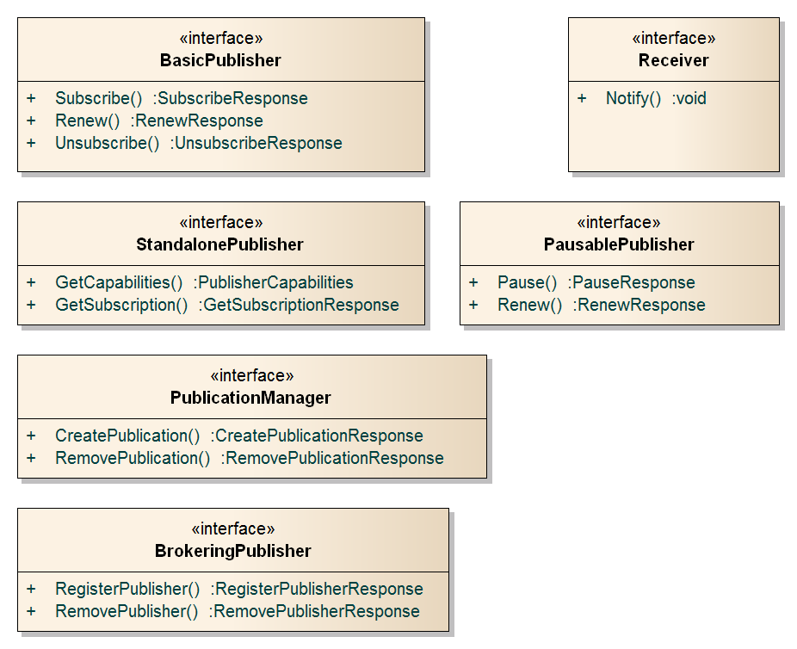
- Revision history
Date | Release | Editor | Paragraph(s) modified | Description
2013-07-25 | 1.0-RC0 | Aaron Braeckel, Lorenzo Bigagli, Johannes Echterhoff | All | First draft for internal SWG review
2013-12-17 | 1.0-RC1 | Aaron Braeckel, Lorenzo Bigagli, Johannes Echterhoff | All | Incorporated comments from PubSub SWG review  Added Basic Receiver
2015-06-26 | 1.0-RC2 | Aaron Braeckel, Lorenzo Bigagli | All | Incorporated edits resulting from the SOAP Binding draft  Second draft for internal SWG review
2015-07-31 | 1.0-RC3 | Aaron Braeckel, Lorenzo Bigagli | All | Revised URIs, revised figures in BasicPublisher
2015-09-08 | 1.0-RC4 | Aaron Braeckel,  Lorenzo Bigagli | All | Incorporated comments from OAB review in preparation for public comment

www.opengeospatial.org/cite
OASIS WS-BaseNotification, Web Services Base Notification, OASIS Standard 1.3 (1 October 2006).
OASIS WS-BrokeredNotification, Web Services Brokered Notification, OASIS Standard 1.3 (1 October 2006).

