Open Geospatial Consortium
Submission Date 2023-04-19
Approval Date: <yyyy-mm-dd>
Publication Date: <yyyy-mm-dd>
External identifier of this OGC® document: <http://www.opengis.net/doc/[{doc-type/}]{standard}/{m.n}>
Internal reference number of this OGC® document: 07-011r1
Version: 2.0
Category: OGC® Abstract Specification
Editor: Peter Baumann

OGC Abstract Specification Topic 6: Schema for Coverage Geometry and Functions – Part 1: Fundamentals

Copyright notice
Copyright © 2024 Open Geospatial Consortium
To obtain additional rights of use, visit http://www.opengeospatial.org/legal/.

Warning
This document is not an OGC Standard. This document is distributed for review and comment. This document is subject to change without notice and may not be referred to as an OGC Standard.
Document type: OGC® Abstract Specification
Document subtype:
Document stage: Draft
Document language: English
Recipients of this document are invited to submit, with their comments, notification of any relevant patent rights of which they are aware and to provide supporting documentation.
License Agreement
Permission is hereby granted by the Open Geospatial Consortium, ("Licensor"), free of charge and subject to the terms set forth below, to any person obtaining a copy of this Intellectual Property and any associated documentation, to deal in the Intellectual Property without restriction (except as set forth below), including without limitation the rights to implement, use, copy, modify, merge, publish, distribute, and/or sublicense copies of the Intellectual Property, and to permit persons to whom the Intellectual Property is furnished to do so, provided that all copyright notices on the intellectual property are retained intact and that each person to whom the Intellectual Property is furnished agrees to the terms of this Agreement.
If you modify the Intellectual Property, all copies of the modified Intellectual Property must include, in addition to the above copyright notice, a notice that the Intellectual Property includes modifications that have not been approved or adopted by LICENSOR.
THIS LICENSE IS A COPYRIGHT LICENSE ONLY, AND DOES NOT CONVEY ANY RIGHTS UNDER ANY PATENTS THAT MAY BE IN FORCE ANYWHERE IN THE WORLD.
THE INTELLECTUAL PROPERTY IS PROVIDED "AS IS", WITHOUT WARRANTY OF ANY KIND, EXPRESS OR IMPLIED, INCLUDING BUT NOT LIMITED TO THE WARRANTIES OF MERCHANTABILITY, FITNESS FOR A PARTICULAR PURPOSE, AND NONINFRINGEMENT OF THIRD PARTY RIGHTS. THE COPYRIGHT HOLDER OR HOLDERS INCLUDED IN THIS NOTICE DO NOT WARRANT THAT THE FUNCTIONS CONTAINED IN THE INTELLECTUAL PROPERTY WILL MEET YOUR REQUIREMENTS OR THAT THE OPERATION OF THE INTELLECTUAL PROPERTY WILL BE UNINTERRUPTED OR ERROR FREE. ANY USE OF THE INTELLECTUAL PROPERTY SHALL BE MADE ENTIRELY AT THE USER’S OWN RISK. IN NO EVENT SHALL THE COPYRIGHT HOLDER OR ANY CONTRIBUTOR OF INTELLECTUAL PROPERTY RIGHTS TO THE INTELLECTUAL PROPERTY BE LIABLE FOR ANY CLAIM, OR ANY DIRECT, SPECIAL, INDIRECT OR CONSEQUENTIAL DAMAGES, OR ANY DAMAGES WHATSOEVER RESULTING FROM ANY ALLEGED INFRINGEMENT OR ANY LOSS OF USE, DATA OR PROFITS, WHETHER IN AN ACTION OF CONTRACT, NEGLIGENCE OR UNDER ANY OTHER LEGAL THEORY, ARISING OUT OF OR IN CONNECTION WITH THE IMPLEMENTATION, USE, COMMERCIALIZATION OR PERFORMANCE OF THIS INTELLECTUAL PROPERTY.
This license is effective until terminated. You may terminate it at any time by destroying the Intellectual Property together with all copies in any form. The license will also terminate if you fail to comply with any term or condition of this Agreement. Except as provided in the following sentence, no such termination of this license shall require the termination of any third party end-user sublicense to the Intellectual Property which is in force as of the date of notice of such termination. In addition, should the Intellectual Property, or the operation of the Intellectual Property, infringe, or in LICENSOR’s sole opinion be likely to infringe, any patent, copyright, trademark or other right of a third party, you agree that LICENSOR, in its sole discretion, may terminate this license without any compensation or liability to you, your licensees or any other party. You agree upon termination of any kind to destroy or cause to be destroyed the Intellectual Property together with all copies in any form, whether held by you or by any third party.
Except as contained in this notice, the name of LICENSOR or of any other holder of a copyright in all or part of the Intellectual Property shall not be used in advertising or otherwise to promote the sale, use or other dealings in this Intellectual Property without prior written authorization of LICENSOR or such copyright holder. LICENSOR is and shall at all times be the sole entity that may authorize you or any third party to use certification marks, trademarks or other special designations to indicate compliance with any LICENSOR standards or specifications. This Agreement is governed by the laws of the Commonwealth of Massachusetts. The application to this Agreement of the United Nations Convention on Contracts for the International Sale of Goods is hereby expressly excluded. In the event any provision of this Agreement shall be deemed unenforceable, void or invalid, such provision shall be modified so as to make it valid and enforceable, and as so modified the entire Agreement shall remain in full force and effect. No decision, action or inaction by LICENSOR shall be construed to be a waiver of any rights or remedies available to it.

Keywords
The following are keywords to be used by search engines and document catalogues.
Ogcdoc, OGC document, Topic 6, coverage
Preface
This document is consistent with the ISO 19123-1:2023, Geographic Information - Schema for coverage geometry and functions - Part 1: Fundamentals. ISO 19123-1:2023 was prepared by Technical Committee ISO/TC 211, Geographic information/Geomatics, in close collaboration with the Open Geospatial Consortium (OGC). This document replaces OGC 07-011.
Attention is drawn to the possibility that some of the elements of this document may be the subject of patent rights. The Open Geospatial Consortium shall not be held responsible for identifying any or all such patent rights.
Recipients of this document are requested to submit, with their comments, notification of any relevant patent claims or other intellectual property rights of which they may be aware that might be infringed by any implementation of the standard set forth in this document, and to provide supporting documentation.
Submitting organizations
The following organizations submitted this Document to the Open Geospatial Consortium (OGC):
Name | Affiliation
Peter Baumann | Constructor University
Lucio Colaiacomo | European Union Satellite Center
Dimitar Misev | rasdaman GmbH
Joan Maso | CREAF
Jimmy Chou | Feng Chia University
All questions regarding this submission should be directed to the editor or the submitters.

Contents
Terms and definitions 10
Abbreviated terms 20
1.1 Notation 20
Interoperability and conformance testing 21
Organization 21
Overview 23
Coverage packages 24
Probing coverages: evaluate() function 25
Domain of a coverage 25
Concept 25
Coordinates 26
Mathematical versus physical coordinates 27
Coordinate reference systems and axes 28
Coverage classification along topological dimensions 30
Range of a coverage 30
Interpolation 31
Concept 31
Discrete and continuous coverages 33
Common point rule 33
Realization variants 34
Overview 34
Geometry/value pair view 34
Domain/range view 35
Partitioned view 37
Functional view 37
Envelope 38
Overview 40
Grids 41
Grid definition 41
Grid axis types 44
Rectified and referenceable grid coverages 48
Grid cells 49
Grid cell concept 49
Pixel-in-centre, pixel-in-corner 50
Grid coverage 51
Further grid coverage types 52
Overview 53
General multi-curve coverages 53
Segmented curve coverages 54
Overview 55
General multi-surface coverages 55
Further surface coverages 56
General 56
Thiessen polygon coverages 56
Triangulated irregular networks (TINs) 57

ISO Foreword
ISO (the International Organization for Standardization) is a worldwide federation of national standards bodies (ISO member bodies). The work of preparing International Standards is normally carried out through ISO technical committees. Each member body interested in a subject for which a technical committee has been established has the right to be represented on that committee. International organizations, governmental and non-governmental, in liaison with ISO, also take part in the work. ISO collaborates closely with the International Electrotechnical Commission (IEC) on all matters of electrotechnical standardization.
The procedures used to develop this document and those intended for its further maintenance are described in the ISO/IEC Directives, Part 1. In particular, the different approval criteria needed for the different types of ISO documents should be noted. This document was drafted in accordance with the editorial rules of the ISO/IEC Directives, Part 2 (see www.iso.org/directives).
Attention is drawn to the possibility that some of the elements of this document may be the subject of patent rights. ISO shall not be held responsible for identifying any or all such patent rights. Details of any patent rights identified during the development of the document will be in the Introduction and/or on the ISO list of patent declarations received (see www.iso.org/patents).
Any trade name used in this document is information given for the convenience of users and does not constitute an endorsement.
For an explanation of the voluntary nature of standards, the meaning of ISO specific terms and expressions related to conformity assessment, as well as information about ISO's adherence to the World Trade Organization (WTO) principles in the Technical Barriers to Trade (TBT), see www.iso.org/iso/foreword.html.
This document was prepared by Technical Committee ISO/TC 211, Geographic information/Geomatics, in collaboration with the European Committee for Standardization (CEN) Technical Committee CEN/TC 287, Geographic Information, in accordance with the Agreement on technical cooperation between ISO and CEN (Vienna Agreement).
This edition cancels and replaces the first edition (ISO 19123:2005), which has been technically revised.
The main changes are as follows:
— The standard has been renamed to be “Part 1: Fundamentals”, since a new “Part 2: Coverage Implementation Schema” has been published.
- The text has been simplified for better understanding.
— Concepts, while in principle unchanged, have been defined more rigorously and some errors have been corrected.
- The approach to standardization taken in the document has been changed. This version of ISO 19123-1 defines a high-level, generic concept of coverages with an interface definition from which many different (not necessarily interoperable) implementation structures can be derived. The previous version of the standard, ISO 19123, defined a single generic data structure for coverages. It remains valid as one of the many possible data structures that can implement the 19123-1 interface. This data structure, which is defined in Annex D, allows for backward compatibility in the sense that standardization targets that referenced ISO 19123 can continue referencing these same classes, although new realizations are not encouraged to do so. Note, however, that the coverage definition terms in Clause 3 which are owned by other standards have been updated to refer to newer versions of the standards (including their definitions) where such newer versions are in place.
- All operations except evaluate() have been removed, for simplification purposes – ISO 19123-3 takes over the operations part.
—
— The scope has been extended to include Mesh.
- The concept of discrete and continuous coverages has been generalized to achieve an improved conceptual basis and allow for coverages which are discrete along some domain axes and continuous along other domain axes. This is achieved by using the coordinate reference system axes as the basis for the definitions so that any axis individually can be discrete or continuous. Since this is a generalization of the previous concept it is backward compatible. As side effect, this reworking has greatly simplified the structure of the document.
— Updates in ISO 19103 have been reflected, and corresponding adjustments have been made where necessary; the informative Annex on “UML notation” has been deleted since this is now described in ISO 19103.
- All coordinate-related definitions are based on ISO 19111, and corresponding adjustments have been made in all places necessary.
- Definition of image CRS has been moved from ISO 19111 to this document.
Definition of interpolation now is based on the interpolation definition of ISO 19107 in order to avoid duplicate and diverging definitions.
- — The UML diagrams have been redrawn for clarity, correcting errors, and to follow the new conventions established in TC211.
The bibliography has been revised to include additional references and has been reformatted.
A list of all parts in the ISO 19123 series can be found on the ISO website.
Any feedback or questions on this document should be directed to the user’s national standards body. A complete listing of these bodies can be found at www.iso.org/members.html.

Introduction
This document defines, at a high, implementation-independent level, the notion of coverages as digital representations of space-time varying phenomena, corresponding to the notion of a field in physics. Such coverages can be discrete or continuous.
Historically, geographic information has been treated in terms of two fundamental types called vector data and raster data.
“Vector data” deals with discrete phenomena, each of which is conceived of as a feature. The spatial characteristics of a discrete real-world phenomenon are represented by a set of one or more geometric primitives (points, curves, surfaces or solids). Other characteristics of the phenomenon are recorded as feature attributes. Usually, a single feature is associated with a single set of attribute values. ISO 19107 provides a schema for describing features in terms of geometric and topological primitives.
“Raster data”, on the other hand, deals with phenomena that vary over space and time, mathematically described by “fields”. It contains a set of values, each associated with one of the elements in an array of points or cells. It is often associated with a method for interpolating values at spatial positions between the points or within the cells.
The coverage concept, originally adopted from the Abstract Specification of the Open Geospatial Consortium (OGC) [15], generalizes these and further data structures, such as point clouds, into a model for representing phenomena that vary continuously over space and time, and possibly over further dimensions such as spectral bands. Formally, a coverage is a function from a spatial (such as horizontal x and y and vertical height or depth), temporal, other (in ISO 19111:2019 nomenclature: parametric) domain or any combination thereof to values of some data type.
A coverage consists of a set of spatio-temporally extended geometric (often geographic) objects, each with associated attribute values. The spatio-temporal locations attribute values are associated with are called “direct positions”.
Formally, a coverage itself is a subtype of feature as defined in ISO 19101. This feature is a set of features all sharing some key properties, such as the same attribute definition and coordinate reference system.
NOTE direct positions can be of different dimensions. For example, in a raster image modelled as a coverage the direct positions will be the grid points; in a multi-solid coverage a direct position is given by the interior of a 3D solid.
In practice, coverages encompass regular and irregular grids, point clouds, and general meshes. Examples include raster data, point clouds, meshes such as triangulated irregular networks, and polygon sets. Coverages are multi-dimensional, including examples like 1D sensor timeseries, 2D satellite images, 3D x/y/t image timeseries and x/y/z geophysical voxel data, and 4D x/y/z/t climate and ocean data. Coordinate axes of such coverages can have spatial, temporal, or any other meaning, and they can be combined freely for n-dimensional coverages.
EXAMPLE The electromagnetic spectrum is an example for an axis with neither spatial nor temporal semantics. Such a spectral axis can be defined as a “parametric CRS” as established in ISO 19111:2019.
A coverage which provides values only at the direct positions is called “a discrete coverage”; if interpolation information is added so that values can be obtained also between the coverage’s direct positions such a coverage is called “a continuous coverage”.
Just as the concepts of discrete and continuous phenomena are not mutually exclusive, their representations as discrete coverages are not mutually exclusive. The same phenomenon can be represented as either a discrete feature or a coverage, dependent on the particular context and requirements. A city can be viewed as a discrete coverage that returns a single value for each attribute, such as its name, area and total population, but it can also be represented as a coverage that returns values such as population density, land value or air quality index for each location in the city.
A coverage, moreover, can be derived by bundling a collection of discrete features sharing a common attribute definition, the values of the coverage at each position being the values of the attributes of the feature located at that position. Conversely, a collection of discrete features can be derived from a coverage by extracting all direct positions with their associated attribute values.
The previous edition of this document, ISO 19123:2005, addressed coverage modelling on both a conceptual and (to some extent) an implementation level, effectively mixing both. Coverage modelling has now been split into two separate, but connected documents: ISO 19123-1 (this document), which establishes an abstract, high-level coverage model, and ISO 19123-2, which establishes an implementation-level model ensuring interoperability, based on the concepts of ISO 19123-1. A corresponding high-level processing model for coverages is defined in ISO 19123-3.

Geographic information — Schema for coverage geometry and functions — Part 1: Fundamentals

Scope
This document defines a conceptual schema for coverages. A coverage is a mapping from a spatial, temporal or spatio-temporal domain to attribute values sharing the same attribute type. A coverage domain consists of a collection of direct positions in a coordinate space that can be defined in terms of spatial and/or temporal dimensions, as well as non-spatio-temporal (in ISO 19111:2019: “parametric”) dimensions. Examples of coverages include point clouds, grids, meshes, triangulated irregular networks, and polygon sets. Coverages are the prevailing data structures in a number of application areas, such as remote sensing, meteorology and mapping of depth, elevation, soil and vegetation. This document defines the coverage concept including the relationship between the domain of a coverage and its associated attribute range. This document defines the characteristics of the domain; the characteristics of the attribute range are not defined in this document, but left to specific implementation standards. Consequently, the standardization target of this document consists of implementation standards, not concrete implementations themselves.

Normative references
The following documents are referred to in the text in such a way that some or all of their content constitutes requirements of this document. For dated references, only the edition cited applies. For undated references, the latest edition of the referenced document (including any amendments) applies.
ISO 19103, Geographic information — Conceptual schema language
ISO 19107, Geographic information — Spatial schema
ISO 19111, Geographic information —Referencing by coordinates

Terms, definitions, abbreviated terms and notation

Terms and definitions
For the purposes of this document, the following terms and definitions apply.
ISO and IEC maintain terminology databases for use in standardization at the following addresses:
— ISO Online browsing platform: available at https://www.iso.org/obp
— IEC Electropedia: available at https://www.electropedia.org

analytical coverage
<coverage> coverage where the mapping function from domain to range is given by an analytical mathematical function

axis
<coordinate geometry> tuple of axis name, axis abbreviation, axis direction, axis unit, and further information as specified in ISO 19123-1
Note 1 to entry: This definition is established in accordance with ISO 19111:2019 Table 26 and Clause 10.4.
Note 2 to entry: Inside a CRS containing several axes the axis names must be pairwise different.
Note 3 to entry: The axis unit (of measure) defines the set of values which can be used as coordinate along this axis. These can be numbers (such as in Latitude and Longitude) or general strings (such as in timestamps or special identifiers like “FL100” in aviation).

cell
<coverage> neighbourhood around a direct position in a coverage grid, not overlapping with any other direct position neighbourhood in the coverage grid
Note 1 to entry: Coverage cell is synonymous to grid cell.
Note 2 to entry: All cells of a grid coverage together establish a tessellation (i.e., complete, overlap-free cover) of the grid space.

continuous coverage
coverage that returns values for both direct positions and positions between direct positions

coordinate
<coverage> one of a sequence of measures designating the position of a point
Note 1 to entry: In a coordinate reference system, the coordinate numbers are usually qualified by units. Some coordinates may use a unit representation, for example date/time conformant with ISO 8601-1. When coordinates are an index (ordinal coordinates) they are unitless (which possibly can be represented by a unit of 1).
[SOURCE: ISO 19111:2019, 3.1.5, modified — Original note 1 to entry has been amended; 8601 part number 1 has been added.]

coordinate reference system
coordinate system that is related to an object by a datum
[SOURCE: ISO 19111:2019, 3.1.9, modified – Notes 1 and 2 have been deleted.]

coordinate system
set of mathematical rules for specifying how coordinates are to be assigned to points
Note 1 to entry: A CS contains an ordered sequence of one or more axes; their names must be pairwise different.
[SOURCE: ISO 19111:2019, 3.1.11, modified – Note 1 has been added.]

coordinate tuple
tuple composed of coordinates
Note 1 to entry: The number of s in the coordinate tuple equals the dimension of the coordinate system; the order of coordinates in the coordinate tuple is identical to the order of the axes of the coordinate system.
[SOURCE: ISO 19111:2019, 3.1.13]

coverage
function which returns values from its range type for any direct position within its domain

coverage CRS
CRS in which all coordinates in a coverage domain are expressed
Note 1 to entry: Sometimes a coverage’s CRS is also referred to as the coverage’s native CRS to express that this is the CRS to which all the coverage’s location data refer to.

coverage dimension
<coordinate geometry> number of separate decisions needed to describe a direct position in a coverage domain
Note 1 to entry: This is equivalent to “the number of axes in the coverage domain CRS”
Note 2 to entry: This definition is based on the term “coordinate dimension” defined in ISO 19107:2019, 3.17.

coverage geometry
domain of a coverage described in terms of geometric objects

Delaunay triangulation
network of triangles such that the circle passing through the vertices of any triangle does not contain, in its interior, the vertex of any other triangle

direct position
<coverage> position inside one of the geometric objects in a coverage described by a coordinate tuple within the coverage coordinate reference system
Note 1 to entry: A direct position is described by an ordered sequence of coordinates. The number of elements in a direct position is established by the number of axes of the coverage CRS.
Note 2 to entry: This is consistent with the definition in ISO 19136-2:2020, 3.1.20

discrete coverage
coverage that returns value only for the direct positions within its domain
Note 1 to entry: Discrete coverages have values only for their direct positions, whereas continuous coverages can be interpolated, thereby providing values between direct positions in addition.

domain
set of geometric objects
Note 1 to entry: Examples of such geometric objects are points, lines, faces, and solids. All elements within a domain (set) are of a single given type.
[SOURCE: ISO 19109:2015, 4.8, modified — Original note 1 to entry has been replaced with a new note to entry.]

external coordinate reference system
coordinate reference system whose datum is independent of the object that is located by it
Note 1 to entry: This term is kept only for backwards compatibility and is not used in nor fundamental to the coverage definition of this document.
[SOURCE: ISO 19130-1:2018, 3.25, modified – Note 1 has been added.]

evaluation
<coverage> determination of the values of a coverage at a direct position within the domain of the coverage

feature
abstraction of real world phenomena
[SOURCE: ISO 19101-1:2014, 4.1.11, modified — Note 1 to entry has been removed.]

feature attribute
characteristic of a feature
Note 1 to entry: The value associated with a direct position. Also known as “feature property” and may support potential attribute, quality, or characteristic of a feature.
[SOURCE: ISO 19101-1:2014, 4.1.12, modified — Original notes to entry have been deleted and a new Note 1 to entry added.]

function
<mathematics, programming> rule that associates each element from a domain (“source domain”, or “domain” of the function) to a unique element in another domain (“target domain”, “co-domain” or “range” of the function)
[SOURCE: ISO 19107:2019, 3.41]

geometric dimension
<geometry, topology> largest number n such that each point in a set of points can be associated with a subset that has that point in its interior and is topologically isomorphic to 𝔼^{n}, Euclidean n-space
[SOURCE: ISO 19107:2019, 3.48 modified — Original notes to entry have been deleted.]

geometric object
<geometry> spatial object representing a geometric set
Note 1 to entry: A geometric object consists of a geometric primitive, a collection of geometric primitives, or a geometric complex treated as a single entity. A geometric object may be the spatial representation of a feature object.
[SOURCE: ISO 19107:2019, 3.49]

geometric set
<geometry> set of direct positions
Note 1 to entry: A geometric set describes a single geometric object. The domain of a coverage consists of a set of such geometric objects. In the case of point clouds and grid data where each geometric set consists of only one single point the domain is a set of these direct positions. For higher-dimensional geometric sets, such as curves, surfaces, and solids, the set can be described through other means than enumeration, such as Boundary Representation or CSG.
[SOURCE: ISO 19136-1:2020, 3.1.32, modified — Original note to entry has been deleted, Note 1 has been added.]

georectified
corrected for positional displacement with respect to the surface of the Earth
Note 1 to entry: This term is kept only for backwards compatibility and is not fundamental to the coverage definition of this document.
[SOURCE: ISO 19115-2:2019, 3.11, modified – Note 1 has been added]

georeferenceable
associated with a geopositioning information that can be used to convert grid coordinate values to values of coordinates referenced to an external coordinate reference system related to the Earth by a datum
Note 1 to entry: This term is kept only for backwards compatibility and is not fundamental to the coverage definition of this document.
[SOURCE: ISO/TS 19163-1:2016, 4.9, modified – Note 1 has been added]

georeferencing
geopositioning an object using a correspondence model mapping coverage domain elements to ground coordinates
[SOURCE: ISO 19130-1:2018, 3.37, modified – generalized for coverages to not only consider images; Note 1 has been added.]

grid
<coverage> covering of a multi-dimensional region using quadrilateral shapes (in the 2D case) or their n-dimensional generation (in the n-D case) with no overlaps and gaps
Note 1 to entry: The term grid originates historically from a 2D view: In 19123:2005 a grid consists of a network composed of one or more sets of curves in which the members of each set intersect the members of the other sets. Meantime, nD grids (including 1D) are known and in use. The “covering” of a region is also known as a tessellation in mathematics.
Note 2 to entry: The 19123:2005 definition is equivalent to the revised definition of this document.

grid coordinate reference system
grid coverage’s coordinate reference system
Note 1 to entry: This is consistent with the definition in ISO 19136-2:2015, 4.2.1

grid coordinates
sequence of coordinates specifying a position on a grid
Note 1 to entry: This is consistent with the definition in ISO 19115-2:2019, 3.15

grid coverage
coverage whose domain is described by a grid

grid point
point of a grid

gridded data
data whose attribute values are associated with positions on a grid coordinate system
Note 1 to entry: In the context of this document, “gridded data” is synonymous to “grid coverage”
[SOURCE: ISO 19115-2:2019, 3.16, modified — Note 1 to entry has been added.]

image coordinate reference system
image CRS
engineering grid coverage CRS
Note 1 to entry: The CRS of a raster image (without georeferencing) is a two-dimensional grid with Cartesian axes; this special case of an index CRS is commonly referred to as image CRS.

index coordinate reference system
index CRS
coverage CRS in which all axes are Cartesian

mesh
geometry with associated topology of dimension greater than zero
Note 1 to entry: Geometry and topology are defined in ISO 19107. Mesh examples include curves, TINs, and solids. Points (and point clouds) resemble geometries with dimension zero.

pixel
smallest element of a digital image to which attributes are assigned
Note 1 to entry: A pixel is the smallest unit of display for a visible image.
Note 2 to entry: This term originated as a contraction of "picture element"
[SOURCE: ISO/TS 19101-2:2018, 3.28, modified — Note 1 to entry has been moved to Note 2 to entry and a new Note 1 to entry has been added.]

point cloud
collection of data points in 3D space
Note 1 to entry: The distance between points is generally non-uniform and hence all three coordinates (Cartesian or spherical) for each point must be specifically encoded.
[SOURCE: ISO/TS 19130-2:2014, 4.51]

point coverage
coverage that has a domain composed of points

polygon coverage
coverage that has a domain composed of polygons

range
<coverage> set of values associated by a function, the coverage, with the domain of a coverage
Note 1 to entry: This is consistent with the more generic definition of range in ISO 19107:2019.
Note 2 to entry: Coverage range types and values correspond to the notion of feature attribute types and values.

raster
rectilinear grid
Note 1 to entry: The term is also used as an imprecise generic term for imagery and gridded coverage data.
Note 2 to entry: Historically, the term derives from the scanning lines display pattern on a cathode ray tube.

rectified grid
grid for which there is an affine transformation between the grid coordinates and the coordinates of an external coordinate reference system
Note 1 to entry: If the coordinate reference system is related to the Earth by a datum, the grid is a georectified grid.
Note 2 to entry: This term is kept only for backwards compatibility and is not used in nor fundamental to the coverage definition of this document.

referenceable grid
grid with an external coordinate reference system whose type is either geodetic or projected
Note 1 to entry: If the coordinate reference system is related to the Earth by a datum, the grid is a georeferenceable grid.
Note 2 to entry: This term is kept only for backwards compatibility and is not used in nor fundamental to the coverage definition of this document.

solid
geometric set with three spatial dimensions
Note 1 to entry: This is consistent with the definition in ISO 19107:2019
Note 2 to entry: A solid may have further dimensions, such as time.

spatial object
<topology, geometry> object used for representing a spatial characteristic of a feature
[SOURCE: ISO 19107:2019, 3.87]

spatio-temporal object
object representing a set of direct positions in space and time

temporal reference system
reference system against which time is measured
Note 1 to entry: For the purpose of this document this term is equivalent to “temporal coordinate reference system”
[SOURCE: ISO 19108:2002, 4.1.35, modified – Note 1 has been added.]

temporal coordinate reference system
coordinate reference system based on a temporal datum
[SOURCE: ISO 19111:2019, 3.1.63]

tessellation
partitioning of a space into a set of conterminous subspaces having the same dimension as the space being partitioned

Thiessen polygon
polygon that encloses one of a set of points on a plane so as to include all direct positions that are closer to that point than to any other point in the set

triangulated irregular network
TIN
tessellation composed of triangles

vector
quantity having direction as well as magnitude
Note 1 to entry: A directed line segment represents a vector if the length and direction of the line segment are equal to the magnitude and direction of the vector. The term vector data refers to data that represents the spatial configuration of features as a set of directed line segments.

Abbreviated terms
1D | one-dimensional
2D | two-dimensional
3D | three-dimensional
4D | four-dimensional
ASCII | American Standard Code for Information Interchange
CCD | Charge-Coupled Device
CRS | coordinate reference system
CSG | Constructive Solid Geometry
DEM | Digital Elevation Model
GIS | geographic information system
OLAP | Online Analytical Processing
TIN | triangulated irregular network
UML | unified modelling language

Conformance

Notation
In this document, conceptual schemas are presented in the Unified Modeling Language (UML). ISO 19103 Conceptual schema language presents the specific profile of UML used in this document.
Several model elements used in this schema are defined in other International Standards developed by ISO/TC 211. UML classes defined in this document have the two-letter prefix of CV. Table 1 lists the other International Standards and packages in which UML classes used in this document have been defined.
Table 1 — Sources of externally defined UML classes
Prefix | International Standard | Package
EX | ISO 19115-1 | Extent
GF | ISO 19109 | General Feature Model
GM | ISO 19107 | Geometry
 | ISO 19111 | Reference Systems

Interoperability and conformance testing
This document being an abstract standard allows for multiple different implementations and does not define a standardized interoperable implementation. The abstract concepts described herein can be implemented in a variety of ways which can potentially not be directly interoperable, that is: the same abstract coverage represented through two different implementation models will not necessarily be identical in their structure, and services following two different implementation models will not necessarily deliver equivalent results on equivalent queries or other operations. The purpose of the abstract description standardized in this document is to provide an underlying consistency at the data model level that makes it possible to establish concretizing, interoperable standards.
Conformance testing is accomplished by manually validating a candidate concretization against all requirements by exercising the tests set out in Annex A.
In an implementation standard based on this abstract specification the semantics defined in this document will normally be cast into a concrete data model (describing data structures to be stored, transferred, ingested, or extracted) and a concrete service model (describing the functionality of a service operating on coverages); such derived models should be designed in an interoperable manner, i.e.: allow concise conformance testing.
This document has a companion standard, ISO 19123-2. Based on this document (ISO 19123-1), ISO 19123-2 defines a concrete coverage model in the sense that interoperability can be guaranteed and interoperability tests (such as the OGC compliance tests on coverages^{[12]}) can be established.
In addition to the main body of this document, Annex D defines a generic coverage data structure. This structure represents one possible data structure that is compatible with the interface defined in this document. This is the structure that was defined in ISO 19123:2005. The purpose of Annex D is to retain backward compatibility because there exist other standards both in ISO and in external organizations that make direct reference to the generic data classes that were defined in the previous version of ISO 19123 and which now may reference the same classes as defined in this Annex. The interface approach is more flexible, but the classes defined in Annex D are one valid structure that may be supported through the interface. A standard referencing this document has to indicate whether it is compliant with either the clauses below or Annex D.

Organization
The coverage schema is organized into the packages shown in , Figure 1 and Table 2. Each package establishes one requirements class. Grouping into these requirements classes has been done with a practical perspective in mind: realizations of this document may be focused on particular structures, such as grid coverages or point clouds, while ignoring all the other options.
The name and contact information of the maintenance agency for this document can be found at www.iso.org/maintenance_agencies.

Table 2 — Conformance classes
Conformance class | Clause | URI
Coverage (Core) | 5 | https://standards.isotc211.org/19123/-1/1/conf/core
Multi-Point Coverage | 6 | https://standards.isotc211.org/19123/-1/1/conf/multi-point
Grid Coverage | 7 | https://standards.isotc211.org/19123/-1/1/conf/grid
Multi-Curve Coverage | 8 | https://standards.isotc211.org/19123/-1/1/conf/multi-curve
Multi-Surface Coverage | 9 | https://standards.isotc211.org/19123/-1/1/conf/multi-surface
Multi-Solid Coverage | 10 | https://standards.isotc211.org/19123/-1/1/conf/multi-solid

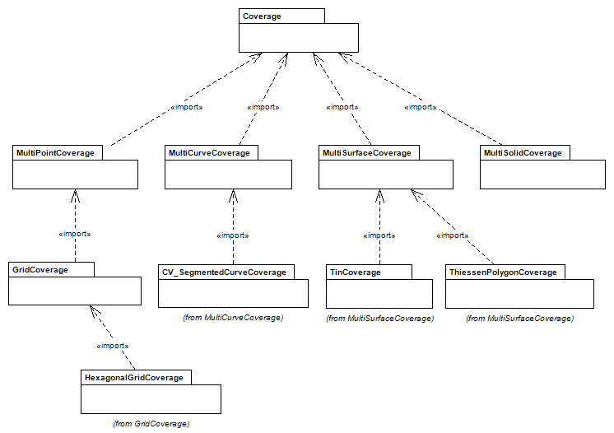
Figure 1 — Packages of the coverage schema

Coverages

Overview
This clause defines conformance class Core of package Coverage.
This document defines the term “coverage”, adopted from the Abstract Specification of the Open GIS Consortium ^{[15]}, to refer to any data representation that assigns values to positions. As such, a coverage conceptually can be viewed as a function which, for every value of its domain, provides a particular value taken from its range set; actually, a coverage may provide a set of values for a particular position.
An equivalent view of a coverage is that of a set of geometric objects, located in some space and equipped with some attribute value. Both views are supported by this document.
Coverages are multi-dimensional by nature – such as 1-D sensor timeseries, 2-D x/y images, 3-D x/y/t image timeseries and x/y/z geophysical information, and 4-D x/y/z/t atmospheric and oceanographic information. Note that “multi-dimensional” here means “1 or more dimensions” following science and engineering nomenclature, rather than the common English understanding of “multi” being “more than one”. The dimension axes spanning the coverage can be of spatial, temporal, or “abstract” nature (where abstract is understood in the sense of being neither spatial nor temporal), or any combination of these. As such, a coverage is particularly suitable for the digital representation of some space/time varying phenomenon.
EXAMPLE Point clouds can be modelled as multi-point coverages. Several observation values can be acquired for a particular location, and reading such a location will result in the set of all values observed. On a grid, on the other hand, it is ensured by definition that every grid location will have exactly one value assigned.
EXAMPLE A satellite image timeseries has two spatial and one temporal axis. A geo-statistical datacube may have a spatial and temporal axis and a population density axis.
The set of locations (in a general sense) where a coverage has objects sitting and, hence, has values to offer is called the coverage’s “domain”, said locations are called “direct positions”. The set of all these values is the coverage’s “range”, described by the “range type”.
Coordinates in a coverage are all expressed in one and the same coordinate reference system (CRS). Based on ISO 19111:2019, such a CRS may either be defined directly (such as in the EPSG collection of CRSs [21]) or it may be composed from several CRS definitions.
EXAMPLE The CRS of a satellite image timeseries consists of two spatial and one temporal axis, in some given order. Coordinates along each axis are expressed accordingly – horizontal spatial coordinates may be expressed in degrees Latitude and Longitude, such as laid down in the EPSG:4326 CRS, while time can be expressed in seconds since epoch or in some calendar, like Proleptic Gregorian.
In terms of common data structures, coverages encompass regular and irregular grids (requirements class “Grid Coverage”), point clouds (requirements class “Multi-Point Coverage”), and general meshes (requirements classes “Multi-Curve Coverage”, “Multi-Surface Coverage”, and “Multi-Solid Coverage”).
Different views on this coverage concept exist. Therefore, several practically relevant and compatible views are explicitly supported:
- In a mathematical view a coverage is defined as a function C: D R with domain D and range set R which delivers some value for each element from D. This view is realized as one variant of coverage modelling in subclass CoverageByDomainAndRange (see 5.8.3).
- Geometrically, a coverage can be seen as a set of geometric objects. This view is provided as another variant in subclass CoverageByValuePair (see 5.8.2).
- In standardization terms, a coverage can be described as a set of “features” (as per ISO 19101-2). Each such feature has a location and attributes, altogether the set of all these pairs defines the coverage’s mapping from location to values. “Geometry” here is understood in the widest possible sense, including all spatial and temporal dimensions and beyond. It is necessary for all features in such a collection forming a coverage to have locations expressed in the same CRS (the coverage’s CRS), and for all attribute values to share the same data type (the coverage’s range type). See 5.8 for details.

Coverage packages
This clause describes package Coverage in terms of interfaces (as per ISO 19103) of its central class, Coverage. It defines a set of requirements for compliance with this interface description, based on the concepts of UML modelling from ISO 19103, Coordinates and Collections from ISO 19107, and coordinate systems from ISO 19111:2019.
- Requirement 1: https://standards.isotc211.org/19123/-1/1/req/core/packages
An instantiation of package Coverage shall have all instances and properties specified for this package, its contents, and its dependencies for Coverage as per Figure 1 and Figure 2.
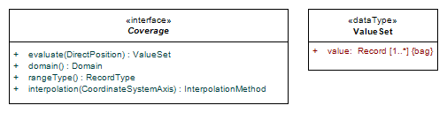
Figure 2 — Coverage central classes

NOTE An concretization may add further features. For example, ISO 19123-2 adds a metadata component.
The UML interface modelling approach allows multiple different data structures to be defined which exhibit the same behaviour through the interface. Standardization targets are specifications concretizing the abstract concepts into implementation standards; one such example is ISO 19123-2 which in turn as standardization target has concrete implementations. Note that in general different realizations of 19123-1 are not necessarily interoperable.
The original (now obsolete) model of 19123:2005 is included as Annex D to this standard, outside the Core conformance class. Any concretization referring to Annex D instead of Clauses 5 through 10 (the conformance classes listed in Table 2 — Conformance classes) shall indicate this clearly in its conformance statement.
- Requirement 2: https://standards.isotc211.org/19123/-1/1/req/core/model
An instantiation of package Coverage shall indicate whether it realizes either Clauses 5 through 10 or Annex D.

Probing coverages: evaluate() function
One way to define the semantics of a coverage is via a probing function which, for some direct position coordinate expressed in the coverage’s CRS, returns the set of values associated with it. This function can be defined, for a coverage C with domain D and value set V of that coverage, as
evaluate_{C}: D V, evaluate_{C}(p) = ∪ _{f∈C} f.contains(p)
based on the contains() probing predicate of ISO 19107.
NOTE This probing function serves for definition purposes only, it is not required to be implemented. In practice, other retrieval functionality is desirable, such as bounding box subsetting in the OGC Web Coverage Service (WCS) ^{[14]} and geo datacube analytics as per ISO 19123-3.
While in general more than one value can possibly be returned for a particular direct position, sometimes exactly one value will be delivered. This can occur in two cases:
EXAMPLE 1 In case of a grid coverage, no two direct positions can share the same coordinates by definition, and so there is always one value available via evaluate().
EXAMPLE 2 More than one value per direct position can occur in several cases, such as in point clouds with two points incidentally sharing the same coordinates, but bearing different values, or in MultiSolid coverages that overlap.

Domain of a coverage

Concept
The coverage domain describes for which positions in the coverage’s multi-dimensional space values are available. Within this multi-dimensional space defined by the domain’s coordinate reference system (CRS) the coverage domain contains a set of geometric objects which together determine the direct positions, i.e.: the locations in this space where the coverage offers a value. This description can be given through direct enumeration of the direct positions (example: point clouds) or through containment descriptions (example: areas and volumes), or some other mechanism (example: Ground Control Points in sensor models). The coverage’s “extent” gives a bounding box – i.e.: lower and upper bounds along every coordinate axis – within which all its direct positions are located so that a quick overview on the footprint of the coverage can be obtained.
All coordinates and coordinate reference systems in this document are based on ISO 19111:2019.
- Requirement 3: https://standards.isotc211.org/19123/-1/1/req/core/coordinates
An instantiation of package Coverage shall make use of ISO 19111 package ReferenceSystem.

NOTE This notion includes temporal reference systems as per ISO 19108:2002), and spatio-temporal reference system as per ISO 19111:2019.
EXAMPLE 1 The space spanned in coverages representing 1D temperature measurement timeseries, 2D x/y images of the Earth surface, 3D x/y/t image timeseries and x/y/z subsurface voxel data, and 4D x/y/z/t atmospheric and ocean data, all are described through some appropriate CRS with the respective dimension.
The geometric objects in a coverage domain are not strictly confined through 3-dimensional physical space. They can be m-dimensional objects where m≤n for an n-dimensional coverage. Coverage subtypes are defined in terms of their domain types in Clause 6 onwards.
EXAMPLE 2 A 3-dimensional x/y/t image timeseries datacube may be composed of 0-dimensional points, its pixels. A coverage domain of dimension 3 may be composed of points, curves, surfaces, or solids, while a domain of dimension 2 may be composed only of points, curves or surfaces.

Coordinates
For an n-dimensional coverage, n>0, points in the coverage domain are addressed through n-tuples of coordinates based on the n-dimensional coverage’s CRS (see Figure 3 — DirectPosition).
Often the unit of measure of an axis is numeric, such as degrees or meters or seconds. However, there may be several representations of coordinate measurements, such as degree/minute/seconds or Proleptic Gregorian calendar time/date strings. Finally, axes without any spatial nor temporal semantics, might be added (such as geo statistics measures). Therefore, in this document DirectPosition defining coverage coordinates takes a broader approach to coordinate values than ISO 19111 class Coordinate and ISO 19107 class DirectPosition by allowing not only numbers, but general strings.
- Requirement 4: https://standards.isotc211.org/19123/-1/1/req/core/directpositions
Domain coordinates in a coverage shall be expressed as DirectPositions as described in Figure 3.

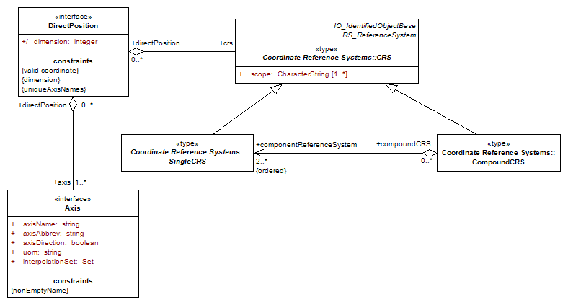
Figure 3 — Class DirectPosition
EXAMPLE The following 4D coordinate tuple illustrates different coordinate types which can possibly describe Latitude, Longitude, time, and height:
( 43.001, 25, “2022-07-24”, “FL100” )

Mathematical versus physical coordinates
A coverage domain can represent physical as well as imaginary nD spaces. For example, geographic data typically have two horizontal axes, possibly one height axis (expressing altitude or depth), and possibly a time axis. Climate modelling adds a second time axis for differentiating model run time from time modelled. By combining one or more of these axes multi-dimensional spatio-temporal objects can be built. Further, axes can represent alternate representations of coordinate measurements. Additionally, “abstract” (in the sense of non-spatio-temporal) axes may occur as well, like in Online Analytical Processing (OLAP) where, e.g., time / product / subsidiary axes are common. Additionally, bands in hyperspectral imagery often appear as a numbered sequence when there are hundreds of such bands, such as the Hyperion instrument on board of EO-1 with its 220 bands. With natural numbers addressing becomes less unwieldy.
NOTE 1 In ISO 19111:2019 non-spatiotemporal CRSs are referred to as “parametric”. CRSs can be composed from other CRSs which can have one or more axes embedded.
NOTE 2 Originally spatial dimensions might become non-spatial at some level of generalization. For example, cities in Europe might be expressed through coordinates in the first place, but at some higher level get abstracted to be in Bavaria, in the Alps region, etc. which is at a symbolic level. This can possibly be represented through dimension hierarchies like in OLAP.

Coordinate reference systems and axes
The n-dimensional space in which a coverage resides is described by its coordinate reference system (CRS). Such CRSs often readily exist (such as in the EPSG catalog) or they can be built by combining existing CRSs into a new, higher-dimensional one (Figure 3). Mechanisms to do so are out of scope of this document; they are defined in ISO 19111:2019.
- Requirement 5: https://standards.isotc211.org/19123/-1/1/req/core/crs
The coverage CRS shall be expressed in accordance with ISO 19111.
NOTE Sometimes there are constraints excluding some combinations; for example, Latitude and Longitude in ISO 19111:2019 always come in pairs and it is not allowed to build CRSs that contain only one of this pair without the other.
Additionally, this document establishes CRS definitions for unitless abstract spaces. The general term “index CRS” refers to a non-georeferenced CRS where all axes are numbers. This induces a family of nD CRSs which, by convention, are named index1D, index2D, index3D, etc.
For backwards compatibility image CRS exists for the non-georeferenced case (class imageCRS in Figure 4).
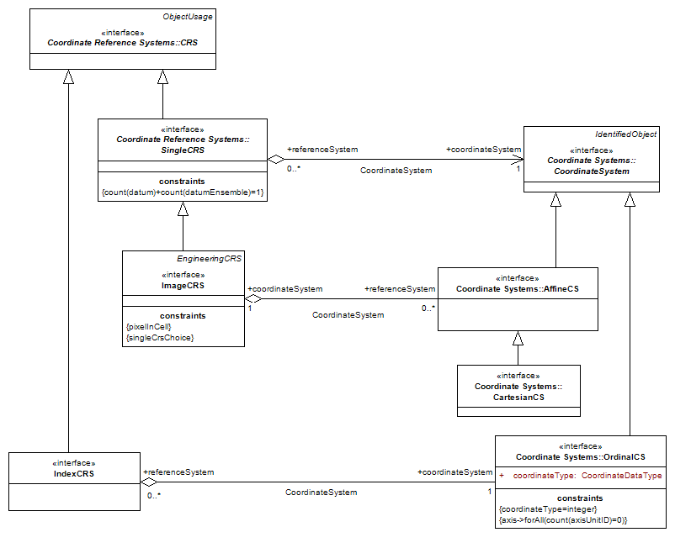
Figure 4 — IndexCRS and ImageCRS classes
EXAMPLE 1 A 4D domain may be described through axes Latitude and Longitude (given by EPSG:4326) combined with a time axis as per ISO 8601 Part 1 combined with an indexCRS2D for spectral bands.
EXAMPLE 2 The direct positions in a coverage’s domain can be enumerated (example: point sets in a multi-point coverage), they can be given implicitly (example: corner points indicating the set of all raster positions in a Rectified grid coverage).
In defining multi-dimensional coverage spaces this document takes an approach where axes are first-class citizens, as opposed to ISO 19111:2019 which operates mainly on CRS level. Both views are consistent and compatible as CRSs describe ordered lists of axes.
For the purpose of coverages, CRS axes are enriched with further properties required for proper modelling of various coverage types, in particular: grid coverages (see Subclause 7.2).
EXAMPLE The following is a non-exhaustive list of possible axes in coverage Domains:
- A CRS consisting of a single time axis can model a timeseries of measurements. Time coordinates can be expressed, among others, in seconds since epoch (often: January 1, 1970) or as time/date strings of the Proleptic Gregorian Calendar defined in ISO 8601 Part 1, such as “2021-05-12”.
- Pressure altitudes, measured in hektopascal (hPa), as well as Flight Levels, expressed in 100 feet steps like “FL150” for 15000 feet above Mean Sea Level, represent “proxies” for altitude used in aviation. In ISO 19111:2019 this can be modelled through parametric CRSs.
- Spectral frequencies can define a coverage axis. In ISO 19111:2019 this can be modelled through parametric CRSs.

Coverage classification along topological dimensions
The coverage concept in this document allows for a wide range of diverging coverage types. One suitable criterion for classification is along the type of feature bundled in a coverage. As feature types commonly are sorted along their topological dimensions – thereby defining points, lines, surfaces, and solids in natural space – this is an appropriate criterion for classifying coverage types. Additionally, there may hold further constraints, such as with grid coverages where the direct positions are supposed to sit on some grid. In Clause 6 onwards coverage types sorted along their topological dimension as defined in ISO 19107.

Range of a coverage
At every direct position a coverage holds a single value or a nonempty set of values. All these values of a coverage together make up the coverage’s range.
EXAMPLE 1 A coverage might assign to each direct position in a county the temperature, pressure, humidity, and wind velocity and direction vector, at a specific time, at that point. The coverage maps every direct position in the county to a record of these fields. In this case, the common type of the coverage range values is a record of components, each of its individual type.
The range type component describes the type of the set of values available for the range. Structures such described can be atomic or a record of named components.
- Requirement 6: https://standards.isotc211.org/19123/-1/1/req/core/record
The range type component shall be of type Record Type as defined in ISO 19103.
- Requirement 7: https://standards.isotc211.org/19123/-1/1/req/core/mininfo
The range type of a coverage at minimum shall provide the information necessary to decode the range set values and process them in a computer system, consisting of (i) data type information in some available typing system, (ii) null values, and (iii) unit of measure.
EXAMPLE 2 RGB images, when modelled as a coverage, have as their range type a record consisting of three components red, green, and blue (in that order), each of them of type unsigned 8-bit integer.
The structure of a range type definition is not specified further in this document because no commonly accepted consensus exists. However, for interoperability reasons it is highly recommended that some description is adopted, for example to differentiate height in meters from height in feet in a DEM (Digital Elevation Model).
- Recommendation 1: https://standards.isotc211.org/19123/-1/1/req/core/measurement
Range type definitions should rely on some commonly agreed system of description and measurement.
NOTE One way of providing this information is via a link pointing to a location that provides this information in a standardized manner. Another way is to provide this information directly as part of the coverage.

Interpolation

Concept
Sensors observing natural phenomena (mathematically: fields) do not collect data only at the exact point of a direct position; rather, they integrate data over some neighbourhood of the direct position and present the result as the value at this position. Generally speaking, observations of the field are aggregated over some region and time. Therefore, it may make sense to invert this quantization to discrete points and derive values for in-between positions from the direct positions available in the coverage.
Through interpolation, range values can be obtained for coordinates within the domain of a coverage which are not direct positions. Basically, a coverage provides values only at its direct positions. Interpolation means applying some algorithm to obtain a range value for locations inside a coverage’s domain which are not direct positions, usually by combining the values of several direct positions in the neighbourhood of the coordinate location under inspection.
Interpolation requires the domain to be in a CRS which allows for expressing “in between” coordinates.
EXAMPLE 1 Index coordinates, representing integer numbers, do not allow expressing any in between value as it would not be an integer any more. Latitude, Longitude, height, and time, conversely allow expressing values between any two given coordinates as they conceptually map to real numbers. The in-between values can be continuous (such as temperature) or discrete (such as land classification).
Depending on the interpolation method, i.e. the algorithm applied, the range type can require providing “in between” values, too. In general, for interpolation it can be necessary that the range type allows for arbitrary such values to be generated, requiring a continuous range type. Therefore, applicability of a particular interpolation method in general also depends on the range type.
EXAMPLE 2 “Nearest neighbour” interpolation does not require new values to be computed as the resulting value is chosen from the available ones taken from the surrounding direct positions. “Linear interpolation”, on the other hand, usually will generate values different from the surrounding ones, based on the arithmetic means computation.
ISO 19107 defines a set of interpolation methods, individually for the particular geometry types, upon which this Document relies.
- Requirement 8: https://standards.isotc211.org/19123/-1/1/req/core/iso19107-interpolation
Interpolation in a coverage shall conform with the interpolation schemes specified in ISO 19107 (extensible with further interpolation types not mentioned there). A reserved value shall indicate that no interpolation is applicable.
NOTE 1 Typical examples of such values include “none” or “undefined” or “nil”. However, these are not defined normatively in this standard (and also not in ISO 19107), but left to concrete instantiations of coverage data structures.
NOTE 2 Aditionally, an exemplary, non-normative set of interpolation methods is presented in Annex B.
Interpolation can be applied along a single axis or along several axes simultaneously. Therefore, interpolation methods on high, conceptual level are defined on axis level. A concretization of this document can potentially bundle interpolation methods to allow only one and the same interpolation method across all (or a subset of) axes.
EXAMPLE 3 In horizontal geographic CRSs interpolation will normally be coupled so that Latitude and Longitude always share the same interpolation, for example. Time and height, on the other hand, will normally be interpolated individually.
- Recommendation 2: https://standards.isotc211.org/19123/-1/1/req/core/interpolation-method
An application should apply only the interpolation methods to a coverage under processing which this coverage indicates.
EXAMPLE In an image timeseries having Latitude, Longitude, and time axes several ways of interpolation are relevant:
- Linear interpolation along latitude and longitude (“bilinear interpolation”), with temporal resolution unchanged (in plain words: all existing timeslices get extracted) and, hence, no interpolation occurring along time.
- Interpolate each pixel’s history (i.e., along time) using linear interpolation, without any spatial interpolation.
- Linear interpolation along latitude, longitude, and time simultaneously (“trilinear interpolation”).
NOTE 2 As this document is a data model and not a processing nor service model use of a particular interpolation method on a given coverage cannot be enforced. Rather, a coverage may provide information on the set of interpolation methods that should be applied whenever, in the course of performing some general processing, interpolation needs to be performed (such as in rescaling a coverage along one or more axes).
NOTE 3 Interpolation methods may require additional control parameters; these are not considered in this document.

Discrete and continuous coverages
The domain characteristics decide in the first place whether interpolation is applicable. The CRS, which defines the set of possible coordinate values, possibly can allow addressing of coordinate values beyond the direct positions. Hence, coverages are possible which allow interpolation along one axis, but not along another.
EXAMPLE 1 A grid coverage with Latitude, Longitude, and an index axis can be interpolated in Latitude and Longitude, but not along the index axis.
An axis is called discrete if every possible interval with finite bounds describes a finite set of values, otherwise such an axis is called continuous.
A coverage is called discrete if its axis list contains only discrete axes. A coverage is called “continuous” if its axis list contains at least one continuous axis.
Coverages can be discrete (or continuous) in their range, in their domain, or in both.
EXAMPLE 2 A map of postal code zones is a coverage which is discrete in its range. The postal code zones cover an entire country and at every location in the country one can evaluate the coverage function and get a value that represents the postal code for that location. Within a postal code zone the value is constant. Such a discrete coverage cannot be interpolated.
EXAMPLE 3 A coverage that maps a set of polygons to the soil type found within each polygon is a coverage which is discrete in its range. More examples of this type of coverage are given in ISO 19144-2 Classification Systems – Part 2 – Land Cover Meta Language (LCML).
EXAMPLE 4 A point set representing a set of measurements that are only valid at the position of each point, and which cannot be interpolated, is a discrete coverage (discrete in domain).
EXAMPLE 5 An image, sampled by a sensor, may be represented as a grid coverage consisting of a set of pixels corresponding to grid cells in the domain of the coverage. A value is associated with each grid cell. However, since the coverage is continuous an interpolation function – such as linear, quadratic, or cubic – may be applied so that a continuously variable value may be determined at any location within the domain extent of the image.
EXAMPLE 6 In a coverage that maps direct positions in San Diego County to their temperature at noon on a specific day, both domain and range may take an infinite number of different values. This continuous coverage would be associated with a discrete coverage that holds the temperature values observed at a set of weather stations (discrete in domain). That is, the measured values correspond to a point set coverage. This point set coverage is discrete because each point can only have one value. The associated continuous coverage uses the point values as driving values for the coverage function and allows interpolation between the points.
EXAMPLE 7 A set of bathymetric soundings is a discrete point set coverage with a single measured water depth value at each point location (discrete in domain). An associated continuous coverage allows one to interpolate between the measured depth soundings to determine the bottom surface of a body of water.
EXAMPLE 8 Evaluation of a triangulated irregular network involves interpolation of values within a triangle composed of three neighbouring point value pairs.

Common point rule
The optional Coverage attribute commonPointRule of type CommonPointRule, carried over from ISO 19123:2005 as deprecated legacy, identifies the procedure to be used for evaluating the Coverage at a position for which more than one range values exist. Its behaviour is defined in Annex D.
NOTE In grid coverages there is only one value per direct position by definition so the common point rule is irrelevant anyway.

Realization variants

Overview
In a coverage, domain and range may be organised in different ways, driven by practical considerations. Possible organizations include:
- Separate representation of domain and range in some serialization; if both use the same serialization scheme then corresponding location/value pairs can be identified through their position in the sequence. This is useful, for example, in image processing when the domain is not needed for the image operation on hand.
- Having an implicit description (rather than an explicit representation) of the domain. This reduces a coverage’s size and, again, allows convenient range processing while avoiding the sometimes unwanted overhead of addressing each value one by one through its direct position.
- A set of position/value pairs. This is a natural representation, for example, for point clouds.
- Partitioning a coverage into smaller units. This is commonly known as tiling. In fact, this concept can be extended to recursively nested coverages.
- A functional, analytic description where domain and range are defined through mathematical expressions.
- Combinations of the above, where feasible.
NOTE One interoperable concretization supporting various such organizations is given by ISO 19123-2 which is identical to OGC CIS ^{[13]}.
In the subclauses below some of the above coverage structures are detailed further. They are summarized in Figure 5.

Geometry/value pair view
The collection of feature objects constituting a coverage can be seen as establishing a mapping from the features’ space to the set of values associated with the features. In case these features and their values get enumerated this naturally leads to a set representation where each set element is a (geometry, value) pair. This is the view supported by the ISO 19107 Collection paradigm, captured in CoverageByPartitioning containing a Partition set consisting of geometry/value pairs (Figure 5). The constraints relevant for this coverage variant are established in 5.8.3.
However, other logical organisations of a coverage, with identical information content, can be constructed. Two of them are established below. Figure 5 gives a synoptic view of all variants discussed.
- Requirement 9: https://standards.isotc211.org/19123/-1/1/req/core/gv-pair
A CoverageByGeometryValuePair shall be structured as described in Figure 5 — .

Domain/range view
Another way of viewing a coverage is as a mapping from a set of direct positions (given by the geometry objects) to a set of values (given by the feature’s associated value payload). In this view, a coverage is defined as a function C: D R with domain D and range R which delivers some value for each element from D. This variant is realized in subclass CoverageByDomainAndRange (Figure 5).
- Requirement 10: https://standards.isotc211.org/19123/-1/1/req/core/domain-range
A CoverageByDomainAndRange shall be structured as described in Figure 5 — .

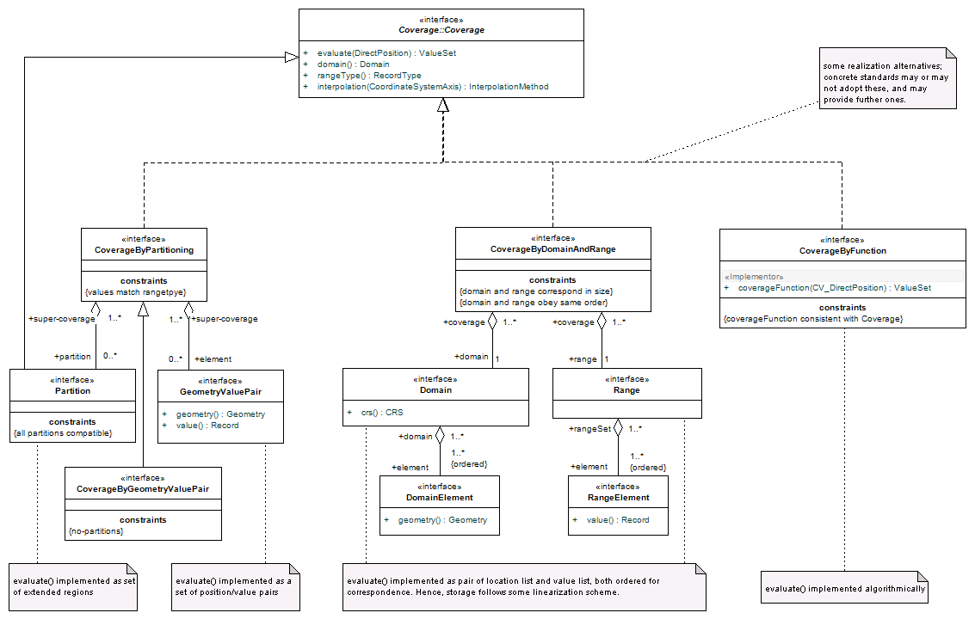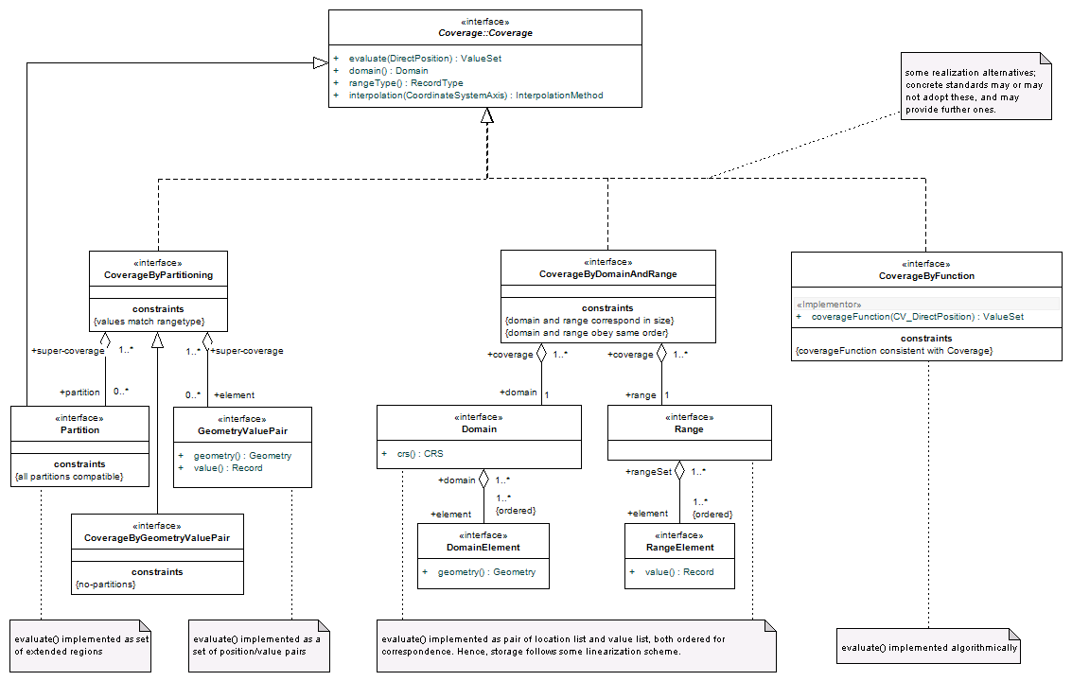
Figure 5 — Class Coverage with multiple variants
NOTE Conceptually, the domain of a coverage consists of all direct positions defined for this coverage. This set can be enumerated (Example: point sets in a multi-point coverage), they can be given implicitly through various schemes like the ones listed in Annex D (Example: corner points indicating the set of all raster positions in a rectified grid coverage as per ISO 19123:2005). Hence, the domain/range view on a coverage is particularly relevant for grid coverages.

Partitioned view
The previously introduced modelling variants resemble two extreme ends of a modelling continuum: In the geometry/value pair representation, the finest possible granularity is adopted by having each single feature object with its value represented together. In the domain/range variant, conversely, the coarsest possible granularity is adopted by having one set of positions which get mapped to one set of values. In the partitioning approach, organizations in between these extremes are gathered. To this end, a coverage gets split into sub-coverages forming partitions of the original coverage. In the coverage model, this is captured by a PartitionSet containing Partitions.
For a coverage set to be aggregated into a larger coverage, some homogeneity constraints are necessary:
- Requirement 11: https://standards.isotc211.org/19123/-1/1/req/core/partitioning
A CoverageByPartitioning shall be structured as described in Figure 5 — .
- Requirement 12: https://standards.isotc211.org/19123/-1/1/req/core/sub-coverages
All sub-coverages in a partition shall share the same CRS and range type; their domains shall fulfil all constraints imposed on the particular coverage type of the super-coverage.
- Requirement 13: https://standards.isotc211.org/19123/-1/1/req/core/cyclefree-hierarchies
A coverage shall not recursively contain itself in a partitioning hierarchy.
NOTE 1 Having only one partition realizes the domain/range variant. Having partitions which contain only one feature object each represents the geometry/value pair variant.
NOTE 2 Partitioned storage organization can massively increase performance of access and processing. In technology such partitioning is also known as tiling and chunking.

Functional view
A coverage can be given by some mathematical descriptions. It is necessary for these descriptions to support the evaluate() function. This document does not explicitly describe any particular mechanism for expressing such functions.
- Requirement 14: https://standards.isotc211.org/19123/-1/1/req/core/by-function
A CoverageByFunction shall be structured as described in Figure 5 — .
EXAMPLE In Constructive Solid Geometry (CSG) objects are built by recursive composition of analytical primitives (such as box, sphere, cylinder, torus, etc.) through (regularized) set operations.

Envelope
For practical purposes it can be convenient for an application reading a coverage that it can quickly determine where approximately direct positions can be expected. Therefore, class Coverage contains an optional component envelope of type Extent (as per ISO 19115-1) giving a simplified summary description of the coverage’s domain. This envelope consists of an enclosing bounding shape which should be close to the actual coverage extent but does not have to be minimal. Further, the envelope can be expressed in any CRS which can be transformed to and from the coverage’s CRS.
EXAMPLE A satellite swath image can contain a bounding box expressed in WGS 84 (Figure 6).
- Recommendation 3: https://standards.isotc211.org/19123/-1/1/req/core/envelope
Coverages should contain an Envelope.
- Requirement 15: https://standards.isotc211.org/19123/-1/1/req/core/envelope-axes
The Envelope of a Coverage shall contain all or a subset of the axes of the corresponding domain.
EXAMPLE In a 3D x/y/t image timeseries datacube the extent may only represent the approximated 2D footprint on the Earth surface, say, in WGS 84, thus ignoring the time axis.
- Requirement 16: https://standards.isotc211.org/19123/-1/1/req/core/envelope-tight
The Envelope of a coverage shall approximate its domain closely, for all axes of the domain present in Extent.
Figure 6 — Satellite image embedded in bounding box
- Requirement 17: https://standards.isotc211.org/19123/-1/1/req/core/envelope-domainset
If a coverage contains an Envelope then this Envelope shall contain the domain of this coverage.
- Requirement 18: https://standards.isotc211.org/19123/-1/1/req/core/iso19111-crs
The CRS component of the coverage shall reference a CRS definition conformant with ISO 19111.
The association coordinate reference system shall link the coverage to the coordinate reference system to which the direct positions in the domain are referenced. Class CRS is specified in ISO 19111:2019.

Multi-point coverages
This clause defines the conformance class package MultiPointCoverage.
A multi-point coverage is a coverage consisting of a collection of points. As points may coincide there can be more than one value correspond to a given direct position, therefore the evaluation function returns a set of values.
- Requirement 19: https://standards.isotc211.org/19123/-1/1/req/multi-point/multi-point
A multi-point coverage shall contain only geometric objects of type ISO 19107 PointData or a subtype thereof, as described by Figure 7.
- Requirement 10: https://standards.isotc211.org/19123/-1/1/req/multi-point/multi-point-evaluate
Function evaluate() shall be defined, for some multi-point coverage c and position p, as
evaluate(p) = { v | ∃ point feature f ∈ c: f.contains(p) } where contains() is defined in ISO 19107.
NOTE An alternative (and different) realization of MultiPointCoverage is given by the ISO 19107 data type PointCloud. MultiPointCoverage is included here for achieving a complete, coherent coverage framework across all topological and geometric dimensions.
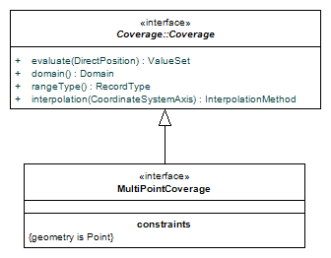
Figure 7 — Class MultiPointCoverage

Grid coverages

Overview
This clause defines conformance class package GridCoverage.
A grid coverage is a special case of multi-point coverage in that all direct positions must sit on a grid. The concept of a multi-dimensional grid is defined in 7.2.
- Requirement 21: https://standards.isotc211.org/19123/-1/1/req/grid/grid-subtype-of-point
A grid coverage shall be defined as in Figure 8.
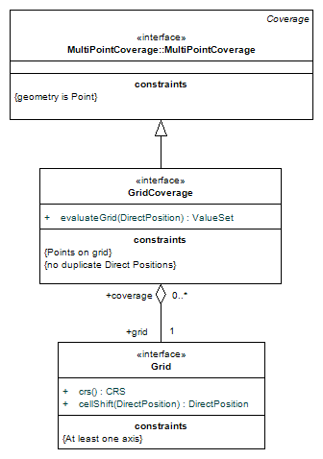
Figure 8 — Class GridCoverage
NOTE Although abstractly grid coverage is a subtype of multi-point coverage, in practice implementation of both types will differ substantially. The regularity of a grid generally allows lookup of direct positions easier than in a point cloud, and often – depending on the degree of regularity of the grid – it is not even required to materialize the coordinates. This entails particularly efficient storage and processing methods.

Grids

Grid definition
In a grid coverage, the grid serves to determine the direct positions of the domain by forcing alignment with thespecific points given by the grid definition. The grid’s CRS is the CRS of the coverage incorporating that grid.
Grids generally can be constructed based on triangles, rectangles, or hexagons. In the context of coverages, rectangular grids are modelled through grid coverages, hexagonal grids can be mapped to grid coverages (Clause 7.6), and triangular grids are modelled through meshes, i.e., multi-surface (Clause 9) or multi-solid coverages (Clause 10). Therefore, in this document the term “grid” is always understood as a rectangular grid.
NOTE 1 In the nD case grids become n-gons.
NOTE 2 As opposed to a mesh (in Computational Fluid Dynamics also called “unstructured grid”) where a vertex (i.e.: cell) can be connected with any number of neighbouring vertices a coverage grid has a regular structure based on some given number of neighbourhood vertices; therefore such a grid sometimes is referred to as a “structured grid” for clarity.
Intuitively speaking, in a rectangular grid every direct position (except at the rim of the grid) has exactly one nearest neighbour with a lower coordinate and exactly one nearest neighbour with a higher coordinate along each axis (Figure 9). This neighbourhood establishes the grid topology; the grid geometry is determined by the concrete coordinate values, which in this document is described by the axis types (next subclause).
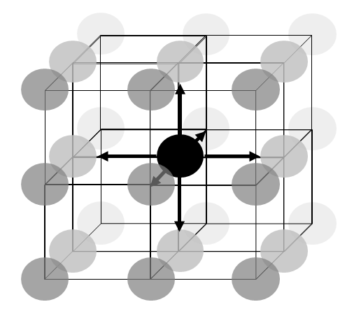
Figure 9 — Multi-dimensional neighbourhood in a grid
Rectangular grids in general do not need to have equidistant spacing between the direct positions. Figure 11 and Figure 12 illustrate some cases of regular and irregular grids.
If the values along each axis are regularly spaced this induces a regular grid, otherwise the grid is irregular. NOTE 3 Often rectangular grids are illustrated through curve bundles (in case of index, regular, and irregular axes: lines), one per axis, whose intersections establish the direct positionsThis construction method explains grids intow or more dimensions; however, 1D grids are explicitly covered by this document.
The grid notion can be generalized to the situation that nD grids can be embedded in some (n+m)D space for some m > 0.

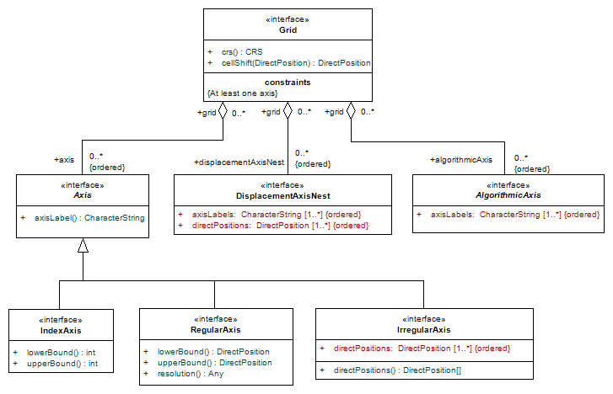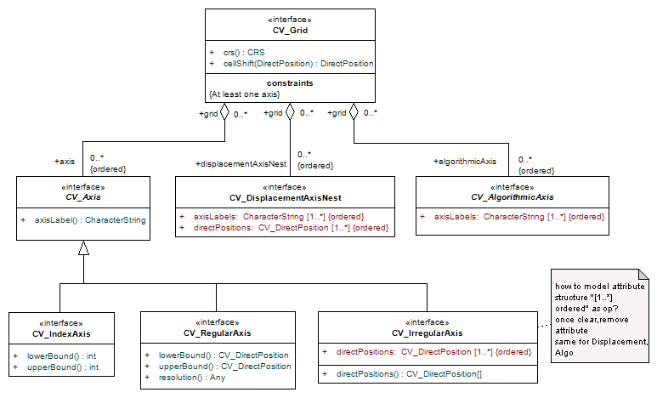
Figure 10 — Class Grid
As opposed to a general multi-point coverage, a grid coverage enforces that all grid cells have their unique position. Therefore, the evaluation function will always return exactly one value per direct position.
- Requirement 22: https://standards.isotc211.org/19123/-1/1/req/grid/single-point-value
In a grid coverage, every direct position shall have associated exactly one value (taken from the coverage’s range type) associated, i.e.: | evaluate(p) | = 1 for all direct positions p.
The direct positions of a grid can be described in several ways, depending on the nature of the grid. This document specifies several alternatives, based on the nature of the coordinate distribution along the grid axes. This is described in Figure 10 and Subclause 7.2.
- Requirement 23: https://standards.isotc211.org/19123/-1/1/req/grid/grid-structure
In a grid coverage, the set of its direct positions shall be given by its grid as described by Figure 10.

Grid axis types

General
The axes of a coverage grid can be classified along the degree of regularity of the coordinate distribution along the axis. In this document, the classification is done per axis so that each axis can be characterized individually, allowing combinations such as regular spatial with irregular temporal axes.
Intuitively speaking, in a grid every direct position (except at the rim) have exactly one nearest neighbour with a lower coordinate and exactly one nearest neighbour with a higher coordinate, in all dimensions. This neighbourhood establishes the topology; the geometry is determined by the concrete coordinate values, which in this document is described by the axis types:
- In the simplest case the direct position coordinates are given by integers, such as in a bare array; this is referred to as “index axis”.
- Often, also georeferenced data (such as ortho images) have their coordinates distributed equally along an axis; such a so-called “regular axis” can be described by the single common distance between adjacent points on the axis, commonly called “resolution”.
- More generally, the direct position coordinates along the axis can be distributed irregularly, leading to the concept of an “irregular axis”.
- Even more generally, each direct position can have coordinates not aligned with any other direct position, leading to a “warped nest” (while still respecting the topological neighbourhood property illustrated in Figure 9).
- In the extreme case, coordinates are not available directly at all, but rather determined from some opaque data structure fed into some algorithm; therefore, this is called an “algorithmic axis”. Figure 11 through Figure 15 illustrate several of these cases.
NOTE This axis classification establishes several ways to describe the coordinates of the direct positions, not the grid CRS which contains the axis definitions.

Figure 11 — Sample regular 2D grid
Figure 12 — Sample 2D irregular grid
Figure 13 — Sample 2D warped nest grid
Figure 14 — Sample 3D grid representing the combination
of regular Lat/Long with irregular time
Figure 15 — Sample 3D grid representing the combination
of a warped nest with irregular time

Index, Regular, and Irregular Axes
An index axis is a 1D unit-less axis (in ISO 19111:2019 named “Cartesian axes”); there is no georeference, and admissible coordinates are at discrete, integer positions.
- Requirement 24: https://standards.isotc211.org/19123/-1/1/req/grid/index-axis
In class Grid, an index axis shall be given by an axis identifier as defined in the grid CRS, lower and upper bounds lo and hi with lo, hi ∈ Z and lo ≤ hi. Direct positions shall be defined for every coordinate tuple where the coordinate value of the index axis on hand is from the closed interval S = { x ∈ Z | lo ≤ x ≤ hi }.
NOTE 1 The unit of measure of an index axis is 1, i.e. coordinate values are unitless.
NOTE 2 A standard concretizing this abstract coverage standard can define further unit-less axes using real-valued coordinates, in addition to the integer-based index axis.
NOTE 3 Quadrilateral grids can be represented efficiently as arrays in programming languages, which leads to a preferred storage technique for coverages where the range is modelled as an array based on certain implementation-dependent linearization scheme (such as row-major or column-major arrangement) – see Annex C for sample sequencing rules. This allows, for example, image processing tools to ignore the real-world coordinates and operate efficiently on the array.
A Regular axis has an equi-distant spacing like an index axis, but is continuous and not constrained to integer positions and distances. It can be georeferenced, i.e. it can have a spatial or temporal semantics attached.
- Requirement 25: https://standards.isotc211.org/19123/-1/1/req/grid/regular-axis
In class Grid, a Regular axis shall be given by the axis identifier as defined in the grid CRS, lower and upper bounds lo and hi with lo, hi ∈ C and lo ≤ hi, a resolution r ∈ C where C denotes the coordinate value set defined for this axis in the grid CRS. Direct positions shall be defined for every coordinate tuple where the coordinate value of the Regular axis on hand is from the set S = { x ∈ C | lo ≤ x*r ≤ hi } for some r≠0.
NOTE 4 Further relevant information of an axis, such as anit of measure as well as datum are defined in the CRS.
The next level of generalization is an Irregular axis. It is continuous, possibly georeferenced, and its distances are irregular (but non-zero). Such an axis can be georeferenced, i.e.: it can have a spatial or temporal semantics attached.
- Requirement 26: https://standards.isotc211.org/19123/-1/1/req/grid/irregular-axis
In class Grid, an Irregular axis shall be given by an axis identifier as defined in the grid CRS and a set of positions P = { p₁, …, p_{n} } ⊆ C where C denotes the coordinate value set defined for this axis in the grid CRS. Direct positions shall be defined for every coordinate tuple where the coordinate value of the Irregular axis on hand is from P.
Mathematically, an n-dimensional grid as discussed in this subclause is a tessellation of the grid coverage’s domain defining a set of direct positions through geometric rules as follows. For some n > 0 let A = (a₁, …, a_{n}) be a finite ordered set of axes where each axis a_{i} = { v_{i,1}, …, v_{i,mi} } is a totally ordered set of m_{i} > 0 values. This induces a grid G = a₁ ×…× a_{n} as the cross product. G can be interpreted as a set of coordinates yielding direct positions, G = { (x₁, …, x_{n}) | x_{i} ∈ a_{i} for 1 ≤ i ≤ n }.

Displacement axis nest
A displacement axis nest (or warped nest) is a set of continuous, possibly georeferenced axes forming a subset of the CRS’s axes. Relative to a regular grid, each direct position is shifted by some individual offset within the CRS space spanned by the axes participating.
- Requirement 27: https://standards.isotc211.org/19123/-1/1/req/grid/displacement-axis-nest
In class Grid, a displacement axis nest shall be given by a list of axis identifiers as defined in the grid CRS forming a non-empty subset of the axes contained in the grid CRS. Direct positions shall be defined for every coordinate tuple where the coordinate value of each axis participating in the displacement axis nest on hand is in the coordinate value set of this axis.

Algorithmic axis
- In the most general case, coordinates of the direct positions are not stored explicitly, but obtained algorithmically from certain implementation-dependent parameters. Such Algorithmic Axes are given by a set of discrete or continuous, possibly georeferenced axes, forming a subset of the CRS’s axes where the direct positions have to be derived algorithmically from some otherwise abstract parameters (hence, the alternative name “transformation model”). Requirement 28: https://standards.isotc211.org/19123/-1/1/req/grid/algorithmic-axis
In class Grid, an Algorithmic axis set shall be given by a list of n > 0 axis identifiers as defined in the grid CRS and a parameter set P. Direct positions shall be given through some algorithm parametrized with P resulting in coordinate values consistent with the definition of the axes involved.
NOTE The structure and meaning of P is not specified further in this document.
EXAMPLE A satellite image timeseries might define geographic pixel coordinates through Ground Control Points acting as input to the orthorectification pipeline, whereas the time axis might be regular or irregular.

Combinations
By combining all the above axis types freely, any type of grid can be modelled. The list of possible axis types is not exhaustive, some standard or application may define their own additional axis types. Figure 11 through Figure 14 show some sample grid types combining different axis types defined in this document.

Rectified and referenceable grid coverages
Superseded ISO 19123:2005 makes use of the terms “rectified grid coverage” and “referenceable grid coverage”. These terms can be defined as special cases of the concepts introduced above.
EXAMPLE Figure 16 shows a two-dimensional grid in the 3-space determined by the axes X, Y, and Z. The grid origin is at O. There are two offset vectors labelled V1 and V2 which specify the orientation of the grid axes and the spacing between the grid lines. The coordinates of the grid points are of the form: O + aV1 + bV2.

 |  | 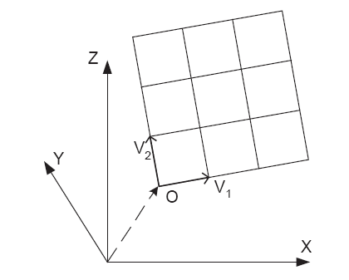
Key
X, Y, Z | axes to determine 3-space
V1, V2 | offset vectors
O | grid origin

Figure 16 — Geometry of a rectified grid
Rectified grids can be mapped to a Cartesian grid through an affine transformation; for referenceable grids, this transformation does not have to be affine. Therefore, the term (geo) referencable grid encompasses all (geo) referenced cases beyond (geo) rectified grids. In the terminology of this document this means the grid can contain irregular, warped, or algorithmic axes.
In summary, therefore, the terms “rectified grid coverage” and “referenceable grid coverage”, which have been used in earlier coverage standard versions but are obsolete now, can be described through the conceptualization used in this document as follows (Figure 17):
- A rectified grid coverage is a grid coverage where every axis is either an index axis or a regular axis;
- A referenceable grid coverage is a grid coverage where at least one axis is neither an index axis nor a regular axis.
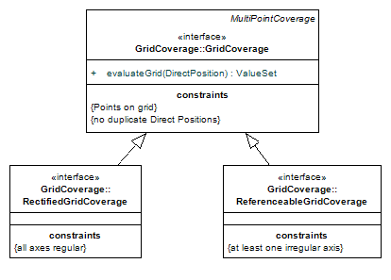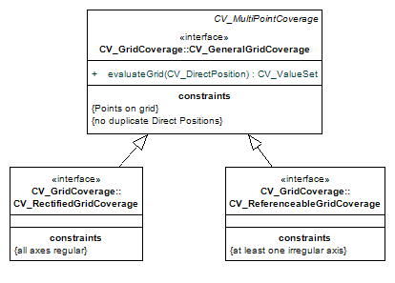
Figure 17 — Rectified and referenceable grid coverages vs. general grid coverage

Grid cells

Grid cell concept
Common practice is to consider the information stored at a direct position (such as radiance energy) not concentrated in the zero-extent point, but distributed over some area around this direct position.
EXAMPLE In Charge-Coupled Device (CCD) sensor arrays each individual sensor collects photons on some finite surface, hence the electrical charge delivered is representative not only for the direct position, but represents an aggregated value for the whole area seen by the CCD sensor.
This concept is captured by the notion of a “grid cell” which, in its full generality, is given by a neighbourhood around a direct position. Cells are constrained in that they do not overlap, while “empty” space not covered by any cell may exist within a coverage’s domain extent. Cells may have different shapes, including a circular shape around the direct position, a rectangle where the direct position sits in the geometric center or in some corner of the cell.
One way to define cells is based on the grid shape. Taking the (imaginary) grid lines yields minimal boxes between adjacent direct positions (Figure 18 and following). In case of regular grids with cell shapes defined as the rectangles between neighbouring direct positions all of the grid cells share the same shape and size, otherwise the grid cells in general are not equal in size and shape.
Optional function cellShift() in class grid allows specifying a particular position of a cell relative to some input position. If no such function is indicated then a 0 offset is applied.
- Requirement 29: https://standards.isotc211.org/19123/-1/1/req/grid/cell-shift
In class Grid, function cellShift() shall indicate the relative cell offset against the original direct position of the cell, with default being no offset (i.e., a 0 vector).
NOTE 1 This function can be realized in various ways, including a code list for common offsets such as pixel-in-centre in regular grids.
NOTE 2 The concept of grid cells is related to interpolation.

Pixel-in-centre, pixel-in-corner
Intuitively, by default cells are assumed to extend around their direct position as the geometric center (Figure 18). If cells are positioned in a way that the direct positions corresponding to a cell sit in its centre then this is commonly referred to as “pixel in centre”.
If cells are positioned such that the corresponding direct positions sit in the “upper-left”, “lower-left”, etc. of the cell’s corners is called “pixel in corner”. Figure 18 through Figure 20 show both situations for a regular 2D grid.
In case of a regular grid, all cell positions can be obtained from a natural “pixel in centre” case by applying a translation by half the grid distance along each axis affected. Technically, this can be expressed as a derived CRS in which the deriving conversion is (in mathematical terms) an affine transformation. The skewed grid retains the datum of its base CRS. Irregular grids require special treatment, up to keeping individual offsets for each direct position.
EXAMPLE In the Atmospheric science community the Arakawa grid system is used for grid offset handling.
NOTE 1 The choice between pixel-in-corner and pixel-in-centre potentially has dramatic effects on the data interpretation. For example, a half-pixel geographic offset in a 1° resolution grid can correspond to a shift in the order of around 100 km. A half-pixel offset on a temporal resolution of one year corresponds to six months, like June versus December.NOTE 2 In 19111:2007 where the image CRS originally resided before incorporation in 19123-1 class ImageDatum had a codelist attribute PixelInCell with possible values cellCenter and cellCorner. The code cellCorner however was ambiguous because an n-dimensional cell has 2^{n} corners. In 19123-1 the cell shift mechanism has been generalized to capture all possible situations, and also is applicable now to all kind of grids irrespective of the CRS used. By changing dependency references from 19111:2007 to 19111:2019 the new definitions of 19111 are adopted.

Grid coverage
A grid coverage is a multi-point coverage with the specific restriction that the direct positions are not arbitrary, but given by some underlying grid as defined in 7.2; this holds recursively also for grid coverages built from partitions.
- Requirement 30: https://standards.isotc211.org/19123/-1/1/req/grid/sub-coverage
The sub-coverage partitions contained in a given gridgrid coverage shall, in their entirety, satisfy all requirements established in 7.2 and Figure 10.
- Requirement 31: https://standards.isotc211.org/19123/-1/1/req/grid/grid-evaluate
Function evaluate() shall be defined, for some grid coverage c and position p, as
evaluate(p) = v for the corresponding point feature f ∈ c with f.contains(p), where contains() is defined in ISO 19107.
NOTE By construction, direct positions in a grid are pairwise disjoint. Hence, there can be only one associated value for any given direct position.
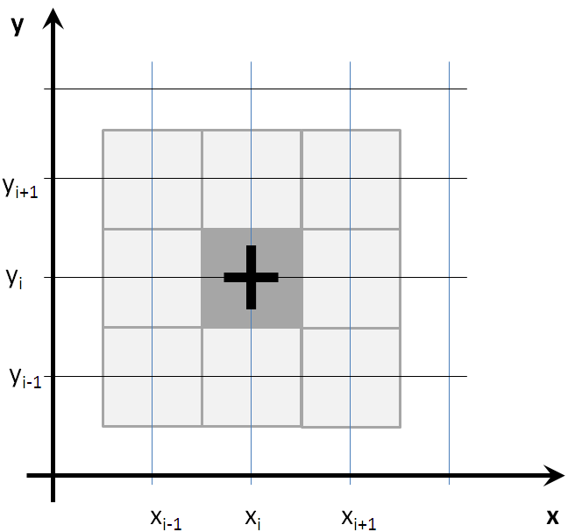
Figure 18 — Grid cell with “pixel-in-center”
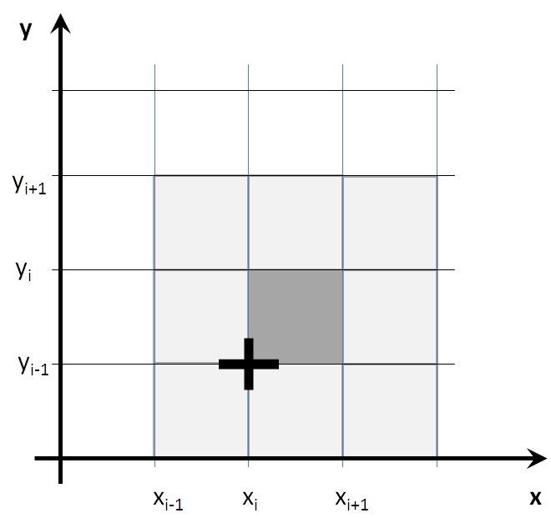
Figure 19 — Grid cell with “pixel-in-corner” sitting “lower-left”
with direct position (xi,yi) and corresponding grid cell marked with upward y axis
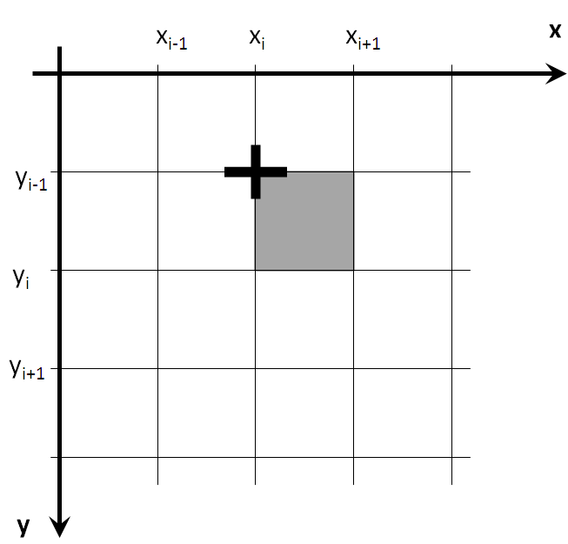
Figure 20 — Grid cell with “pixel-in-corner” sitting “lower-left”
with direct position (xi,yi) and corresponding grid cell marked with downward y axis

Further grid coverage types
Aside from the quadrilateral tiling used in the grid coverages discussed so far there are two more regular tilings in the 2-dimensional Euclidean plane, triangular and hexagonal. More generally, n-dimensional tiling is addressed by the theory of n-honeycombs.
One example is constituted by hexagonal gridgrid coverages which are given by tessellations composed of regular hexagons. Such tessellations are usually called hexagonal grids. The centres of a set of regular hexagons that form such a tessellation correspond to the grid points of a quadrilateral grid (Figure 21). That grid can be described as a rectified grid in which the two offset vectors are of equal length but differ in direction by 60°. The length of a side of the hexagon is L = S tan 30°, where S is the length of the offset vector. This means that the values in the coverage range can be stored in a computer as a multi-dimensional array. The hexagons are the Thiessen polygons that are generated around the grid points.
NOTE 1 A set of Thiessen polygons generated from the grid points of any two-dimensional rectified grid described by two offset vectors that are equal in length but not orthogonal will be a set of congruent hexagons. The hexagons will be irregular – and, hence, out of scope – unless the offset vectors differ in direction by exactly 60°.
Figure 21 — Sample hexagonal grid
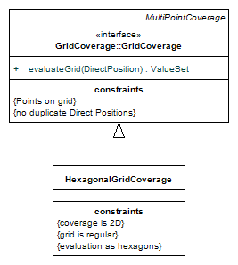
Figure 22 — Hexagonal grid coverage
A hexagonal grid coverage (Figure 22) evaluates a coverage at direct positions within a network of hexagons centred on a set of grid points. Evaluation is based on interpolation between the centres of the value hexagons surrounding the input position.

Multi-curve coverages

Overview
This clause defines conformance class package MultiCurveCoverage.

General multi-curve coverages
A multi-curve coverage is a coverage consisting of a collection of curves.
EXAMPLE A coverage that assigns a route number, a name, a pavement width and a pavement material type to each segment of a road network can be represented as a multi-curve coverage.
- Requirement 32: https://standards.isotc211.org/19123/-1/1/req/multi-curve/multi-curve
A multi-curve coverage shall contain only geometric objects of type ISO 19107 CurveData or a subtype thereof, as described by Figure 23.
- Requirement 33: https://standards.isotc211.org/19123/-1/1/req/multi-curve/multi-curve-evaluate
Function evaluate() shall be defined, for some multi-curve coverage c and position p, as
evaluate(p) = { v | ∃ curve feature f ∈ c: f.contains(p) } where contains() is defined in ISO 19107.
NOTE For the avoidance of doubts, a multi-curve coverage can contain additional dimensions (such as time).

Segmented curve coverages
Segmented curve coverages are used to model phenomena that vary continuously or discontinuously along curves, which may be elements of a network. The domain of a segmented curve coverage is described by a set of curves and includes all the direct positions in all of the curves in the set (Figure 25).
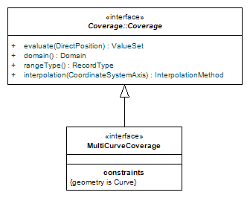
Figure 23 — Class MultiCurveCoverage
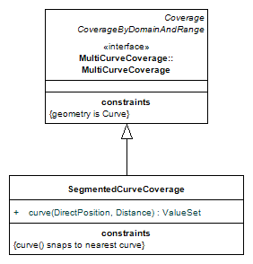
Figure 24 — Class SegmentedCurveCoverage

Multi-surface coverages

Overview
This clause defines conformance class package MultiSurfaceCoverage.

General multi-surface coverages
A MultiSurfaceCoverage is a coverage consisting of a collection of surfaces.
EXAMPLE A coverage that represents soil types typically has a spatial domain composed of surfaces with irregular boundaries.
- Requirement 34: https://standards.isotc211.org/19123/-1/1/req/multi-surface/multi-surface
A MultiSurfaceCoverage shall contain only geometric objects of type ISO 19107 SurfaceData or a subtype thereof, as described by Figure 25.
- Requirement 35: https://standards.isotc211.org/19123/-1/1/req/multi-surface/multi-surface-evaluate
Function evaluate() shall be defined, for some multi-surface coverage c and position p, as
evaluate(p) = { v | ∃ surface feature f ∈ c: f.contains(p) } where contains() is defined in ISO 19107.
There are various practically relevant subtypes of multi-surface coverages, including polyhedral surfaces and their special case of Triangulated Irregular Networks (TINs). While in the previous version of ISO 19123 TIN coverages were modelled separately they now can be obtained through subtyping of ISO 19107 Surface.
NOTE For the avoidance of doubts, a MultiSurfaceCoverage can contain additional dimensions (such as time).
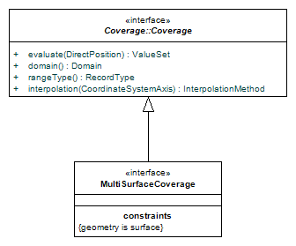
Figure 25 — Class MultiSurfaceCoverage

Further surface coverages

General
So far surface coverages have been considered which represent a bundle of surfaces not constrained further. Some applications consider surfaces establishing tessellations.

Thiessen polygon coverages
A Thiessen polygon network (see Figure 27 for an example) is a tessellation of a 2D space into surfaces bounded by Thiessen polygons. A finite collection of points on a plane determines a partition of the plane into a collection of polygons equal in number to the collection of points. A Thiessen polygon is generated from one of a defining set of points by forming the set of direct positions that are closer to that point than to any other point in the defining set. The specific point is called the centre of the resulting polygon. The boundaries between neighbouring polygons are the perpendicular bisectors of the lines between their respective centres. Each polygon shares each of its edges with exactly one other polygon. Each polygon contains exactly one point from the defining set. Thiessen polygons are also known as Voronoi Diagrams or Proximal Sets.
EXAMPLE Figure 27 shows a collection of points with their (x, y) coordinates, the perpendicular of the lines that would be drawn between them, and the resultant polygons.
Evaluation of a Thiessen polygon coverage involves two steps. The first is to find the Thiessen polygon that contains the input direct position; the second is to interpolate the feature attribute values at the direct position from the geometry/value pairs at the centres of the surrounding Thiessen polygons.
Technically, a Thiessen polygon coverage is a specialization of MultiSurfaceCoverage as shown in Figure 25.
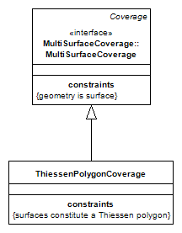
Figure 26 — Class ThiessenPolygonCoverage

Figure 27 — Sample Thiessen polygon coverage

Triangulated irregular networks (TINs)
Class TinCoverage is shown in Figure 28. The basic idea of a TIN is to partition the points in the spatio-temporal domain of a discrete point coverage into a computationally unique set of non-overlapping triangles. Each triangle is formed by three of the points in the spatio-temporal domain of the discrete point coverage (Figure 29). The Delaunay triangulation method is commonly used to produce TIN tessellations with triangles that are optimally equiangular in shape, and are generated in such a manner that the circumscribing circle containing each triangle contains no point of the discrete point coverage other than those at the vertices of the triangle.

Multi-solid coverages
This clause defines conformance class package MultiSolidCoverage.
A multi-solid coverage is a coverage consisting of a collection of solids.
- Requirement 36: https://standards.isotc211.org/19123/-1/1/req/multi-solid/multi-solid
A multi-solid coverage shall contain only geometric objects of type ISO 19107 SolidData or a subtype thereof, as described by Figure 30.
- Requirement 37: https://standards.isotc211.org/19123/-1/1/req/multi-solid/multi-solid-evaluate
Function evaluate() shall be defined, for some multi-solid coverage c and position p, as
evaluate(p) = { v | ∃ solid feature f ∈ c: f.contains(p) } where contains() is defined in ISO 19107.
NOTE For the avoidance of doubts, a multi-solid coverage can contain additional dimensions (such as time).
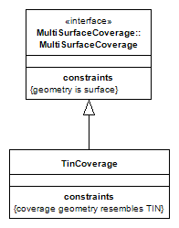
Figure 28 — Class TinCoverage

Figure 29 — Sample TIN coverage

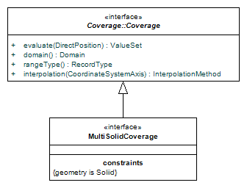
Figure 30 — Class MultiSolidCoverage

- (normative)
Conformance tests
The common base URI for the conformance tests in this document is
https://standards.isotc211.org/19123/-1/1/conf/ .
  - Conformance classes
This document defines six conformance classes: Coverage Core (specification target: Coverage), multi-point coverage (specification target: MultiPointCoverage), grid coverage (specification target: GridCoverage), multi-curve coverage (specification target: MultiCurveCoverage), multi-surface coverage (specification target: MultiSurfaceCoverage), and multi-solid coverage (specification target: MultiSolidCoverage).
Standardization targets are specifications containing provisions for coverages. A specification claiming conformance to this document shall implement the conformance class relevant to that specification target.
Conformance with this document shall be assessed using all the relevant conformance test cases specified in this annex.
  - Conformance class Coverage Core
Conformance test | https://standards.isotc211.org/19123/-1/1/conf/core/allRequirements
Reference | All normative statements in requirements class: Coverage Core
Test purpose: | Verify that the specification under test conforms to all requirements of this conformance class
Test method: | Evaluate the following tests for every requirement in turn; the overall test passes if every single test passes:  - Requirement 1: https://standards.isotc211.org/19123/-1/1/req/core/packages  - Requirement 2: https://standards.isotc211.org/19123/-1/1/req/core/model  - Requirement 3: https://standards.isotc211.org/19123/-1/1/req/core/coordinates  - Requirement 4: https://standards.isotc211.org/19123/-1/1/req/core/directpositions  - Requirement 5: https://standards.isotc211.org/19123/-1/1/req/core/crs  - Requirement 6: https://standards.isotc211.org/19123/-1/1/req/core/record  - Requirement 7: https://standards.isotc211.org/19123/-1/1/req/core/mininfo  - Requirement 8: https://standards.isotc211.org/19123/-1/1/req/core/ iso19107-interpolation  - Requirement 9: https://standards.isotc211.org/19123/-1/1/req/core/gv-pair  - Requirement 10: https://standards.isotc211.org/19123/-1/1/req/core/domain-range  - Requirement 11: https://standards.isotc211.org/19123/-1/1/req/core/partitioning  - Requirement 12: https://standards.isotc211.org/19123/-1/1/req/core/sub-coverages  - Requirement 13: https://standards.isotc211.org/19123/-1/1/req/core/cyclefree-hierarchies  - Requirement 14: https://standards.isotc211.org/19123/-1/1/req/core/by-function  - Requirement 15: https://standards.isotc211.org/19123/-1/1/req/core/envelope-axes  - Requirement 16: https://standards.isotc211.org/19123/-1/1/req/core/envelope-tight  - Requirement 17: https://standards.isotc211.org/19123/-1/1/req/core/envelope-domainset  - Requirement 18: https://standards.isotc211.org/19123/-1/1/req/core/iso19111-crs
Test type: | Basic
  - Conformance class Multi-Point Coverage
Conformance test | https://standards.isotc211.org/19123/-1/1/conf/multi-point/allRequirements
Reference | All normative statements in requirements class: Multi-Point Coverage
Test purpose: | Verify that the specification under test conforms to all requirements of this conformance class
Test method: | Evaluate the following tests for every requirement in turn; the overall test passes if every single test passes:  - Requirement 19: https://standards.isotc211.org/19123/-1/1/req/multi-point/multi-point  - Requirement 20: https://standards.isotc211.org/19123/-1/1/req/multi-point/multi-point-evaluate
Test type: | Basic
  - Conformance class Grid Coverage
Conformance test | https://standards.isotc211.org/19123/-1/1/conf/grid/allRequirements
Reference | All normative statements in requirements class: Grid Coverage
Test purpose: | Verify that the specification under test conforms to all requirements of this conformance class
Test method: | Evaluate the following tests for every requirement in turn; the overall test passes if every single test passes:  - Requirement 21: https://standards.isotc211.org/19123/-1/1/req/grid/grid-subtype-of-point  - Requirement 22: https://standards.isotc211.org/19123/-1/1/req/grid/single-point-value  - Requirement 23: https://standards.isotc211.org/19123/-1/1/req/grid/grid-structure  - Requirement 24: https://standards.isotc211.org/19123/-1/1/req/grid/index-axis  - Requirement 25: https://standards.isotc211.org/19123/-1/1/req/grid/regular-axis  - Requirement 26: https://standards.isotc211.org/19123/-1/1/req/grid/irregular-axis  - Requirement 27: https://standards.isotc211.org/19123/-1/1/req/grid/displacement-axis-nest  - Requirement 28: https://standards.isotc211.org/19123/-1/1/req/grid/algorithmic-axis  - Requirement 29: https://standards.isotc211.org/19123/-1/1/req/grid/cell-shift  - Requirement 30: https://standards.isotc211.org/19123/-1/1/req/grid/sub-coverage  - Requirement 31: https://standards.isotc211.org/19123/-1/1/req/grid/grid-evaluate
Test type: | Basic
  - Conformance class Multi-Curve Coverage
Conformance test | https://standards.isotc211.org/19123/-1/1/conf/multi-curve/allRequirements
Reference | All normative statements in requirements class: Multi-Curve Coverage
Test purpose: | Verify that the specification under test conforms to all requirements of this conformance class
Test method: | Evaluate the following tests for every requirement in turn; the overall test passes if every single test passes:  - Requirement 32: https://standards.isotc211.org/19123/-1/1/req/multi-curve/multi-curve  - Requirement 33: https://standards.isotc211.org/19123/-1/1/req/multi-curve/multi-curve-evaluate
Test type: | Basic
  - Conformance class Multi-Surface Coverage
Conformance test | https://standards.isotc211.org/19123/-1/1/conf/multi-surface/allRequirements
Reference | All normative statements in requirements class: Multi-Surface Coverage
Test purpose: | Verify that the specification under test conforms to all requirements of this conformance class
Test method: | Evaluate the following tests for every requirement in turn; the overall test passes if every single test passes:  - Requirement 34: https://standards.isotc211.org/19123/-1/1/req/multi-surface/multi-surface  - Requirement 35: https://standards.isotc211.org/19123/-1/1/req/multi-surface/multi-surface-evaluate
Test type: | Basic
  - Conformance class Multi-Solid Coverage
Conformance test | https://standards.isotc211.org/19123/-1/1/conf/multi-solid/allRequirements
Reference | All normative statements in requirements class: Multi-Solid Coverage
Test purpose: | Verify that the specification under test conforms to all requirements of this conformance class
Test method: | Evaluate the following tests for every requirement in turn; the overall test passes if every single test passes:  - Requirement 36: https://standards.isotc211.org/19123/-1/1/req/multi-solid/multi-solid  - Requirement 37: https://standards.isotc211.org/19123/-1/1/req/multi-solid/multi-solid-evaluate
Test type: | Basic

- (informative)
Interpolation methods
  - General
Evaluation of a continuous coverage involves interpolation between known feature attribute values associated with geometric objects in the spatio-temporal domain of the discrete coverage that is provided as control for the continuous coverage. There are several interpolation methods. Each is used in the context of specified geometric configurations (Table B.1).
The enumerated data type InterpolationMethod includes the following methods: nearest neighbour, linear, quadratic, cubic, lost area, and barycentric. These are described in B.2 through B.10. A specific value, none, is reserved to express that no interpolation is applicable on the coverage holding this interpolation setting.
A set of interpolation methods which also apply to coverages is given in ISO 19107. This document defines further interpolation techniques below; some of these are identical to interpolations defined in ISO 19107, but are still kept to introduce them under the name that has been established by earlier versions of this document. Generally, an application or standard may define additional ways of interpolation.
Since InterpolationMethod is a CodeList (Figure B.1) it may be extended in an application schema that specifies additional interpolation methods.
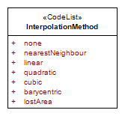
Figure B.1 — Interpolation method codelist

Table 3 — Interpolation methods
Method | Coverage type | Coverage Dimension | Subclause
None | Any | Any | B.1
Nearest neighbour | Any | Any | B.2
Linear | Any | Any | B.3
Quadratic | Any | Any | B.4
Cubic | Any | Any | B.5
Lost area | Thiessen polygon, hexagonal grid | 2 | B.6
Barycentric | TIN | 2 | B.7
  - Nearest neighbour interpolation
Nearest neighbour interpolation can be applied to any coverage. It generates a feature attribute value at a direct position by assigning it the feature attribute value associated with the nearest direct position in the spatio-temporal domain of the coverage. Nearest neighbour interpolation extends a discrete coverage to a step function defined on the convex hull of the domain objects in the domain of the coverage. Nearest neighbour interpolation is the only interpolation method described in this document that can be used to interpolate nominal or ordinal range values.
  - Linear interpolation
Linear interpolation serves to compute values between direct positions in any-dimensional domains through a linear polynom. The mathematical principle is shown for the one-dimensional and two-dimensional cases.
1-D linear interpolation is commonly used to interpolate along curves. It is based on the assumption that feature attribute values at different positions along the curve differ in proportion to the distances between those positions:
Given two point value pairs (ps, vs) and (pt, vt), where ps is the start point and pt is the end point of a value segment, and vs and vt are the range values associated with those points, the range value v associated with the direct position x is shown in Formula (B.1):
v(x) = vs + (vt − vs) ((x − ps)/(pt − ps)) (B.1)
Bilinear interpolation is used to compute range values at direct positions in two dimensions. Given a direct position p contained in a grid cell whose vertices are V, V + V1, V + V2, and V + V1 + V2, and with range values at these vertices of w1, w2, w3, and w4, respectively, there are unique numbers x and y, with 0 < x < 1, and 0 < y < 1 such that p = V + xV1 + yV2. The range value at p is shown in Formula (B.2):
w(x,y) = (1-x)(1-y) w1 + x(1-y) w2 + y(1-x) w3 + x y w4 (B.2)
NOTE In a Cartesian grid, V1 and V2 are the unit vectors (0,1) and (1,0).
  - Quadratic interpolation
Quadratic interpolation serves to compute values between direct positions in any-dimensional domains through a quadratic polynom. The mathematical principle is shown for the one-dimensional and two-dimensional cases.
1D quadratic interpolation is used to interpolate along curves. It is based on the quadratic polynomial which coefficients a through c as shown in Formula (B.3):
v(x) = a + bx + cx2 (B.3)
where
 | a | is the range value at the start of a value segment; and
 | v | is the range value at distance x along the curve from the start.
Three point value pairs are needed to provide control values for calculating the coefficients of the function.
Biquadratic interpolation is used to compute range values at direct positions in two dimensions. It is based on the biquadratic polynomial as shown in Formula (B.4):
v = a + bx + cy + dx2 + exy + fy2 + gx2y + hxy2 + ix2y2 (B.4)
  - Cubic interpolation
1D cubic interpolation serves to compute values between direct positions in any-dimensional domains through a cubic polynom. The mathematical principle is shown for the one-dimensional and two-dimensional cases.
Cubic interpolation is used to interpolate along curves. It is based on the cubic polynomial, based on coefficients a through d as shown in Formula (B.5):
v(x) = a + bx + cx2 + dx3 (B.5)
where
 | a | is the range value at the start of a value segment; and
 | v | is the range value at distance x along the curve from the start.
Bicubic interpolation is used to compute range values at direct positions in two dimensions. Bicubic interpolation uses the following formula, based on coefficients a0 through a15 as shown in Formula (B.6):
v(x) = a0 + a1x + a2y + a3x2 + a4xy + a5y2 + a6x2y + a7 x y2 + a8 x2 y2 + a9 x3 + a10 y3 + a11 x3 y + a12 x y3 + a13 x3 y2 + a14 x2 y3 + a15 x3 y3 (B.6)
  - Lost area interpolation
Lost area interpolation extends a Multi Point coverage to a continuous function, f, defined on the convex hull of the domain of the point coverage.
Let D = {x1, x2, …, xn} be the domain of the point coverage, and let {V1, V2, …, Vn} be the Thiessen polygons generated by the set D.
Suppose it is desired to calculate f(q), where q is a direct position in the convex hull of D. Begin by forming the Thiessen polygons generated by D; then add p to the D and form the Thiessen polygons for the set of n+1 points: {x1, x2, …, xn, p}. The two sets of polygons are identical, except that each of the polygons coterminous with the polygon containing q “loses area” to the new polygon containing p.
The interpolation forms the weighted average such that each feature attribute value contributes to the feature attribute value at p according to the amount of area its polygon lost to the polygon at p. More formally:
- Suppose that the discrete point coverage is characterized by the point value pairs: {(x1, v1), (x2, v2), …, (xn, vn)}.
- Among the Thiessen polygon set formed by {x1, x2, …, xn, p}, those coterminous with the polygon containing p are {V1, V2, …, Vk}.
- The corresponding Thiessen polygons from the set generated by {x1, x2, …, xn} are {V’1, V’2, … , V’k}.
- The area lost by the ith polygon is V’i – Vi.
- The total area lost is Σ (V’i - Vi) where the sum is over i from 1 to k (that is, the sum is over all polygons that lost area to the polygon containing q). Note that this sum is the same as the area of the Thiessen polygon containing p.
- Then the interpolated feature attribute value at p is:
f(p) = (Σ vi * (V′i - Vi)) / Σ (V′i - Vi) where the summations are over the same range: i = 1, …, k.
  - Barycentric interpolation
Let P, Q, and R denote the vertices of a triangle. For any direct position, S, in the triangle, there is a unique triple of numbers, i, j, and k, with 0 ≤ i ≤ 1, 0 ≤ j ≤ 1, and 0 ≤ k ≤ 1, and with i + j + k = 1, such that as in Formula (B.7)
S = iP + jQ + kR (B.7)
The numbers (i, j, k) are the barycentric coordinates of S.
The name “barycentric” comes from the fact that using the equation above, S is the centre of mass of a triangle with point masses of size i, j, and k at the corners P, Q and R respectively. As one allocates mass to the three corners, the centre of mass can occupy any direct position in the triangle.
Given a value triangle composed of the PointValuePairs (p1, v1), (p2, v2), and (p3, v3), and a direct position, S, inside it, the barycentric coordinates of S are (i, j, k), where S = ip1 + jp2 + kp3 and the feature attribute value at S is v = iv1 + jv2 + kv3.
  - Other
Other interpolation methods may be defined in an Application Schema that makes use of this document.
- (informative)
Sequential enumeration
  - General
Linearization of coverage range values (and their pertaining direct positions), such as for storage, is a choice of implementation (and storage format) and as such out of scope of this abstract standard. For reasons of backward compatibility with ISO 19123:2004 this informative annex discusses it, based on the original classes of ISO 19123:204. Such a linearization will follow a “sequence rule” that assigns order to space (Figure C.1). The rule can be as simple as Row then Column, or it can be more complex. Complex rules allow for Quadtrees, or more general structures in Riemann hyperspace, Hilbert space and other patterns. An example is a spiral search pattern that may be used in Search and Rescue. SequenceRule is a data type that describes the mapping of grid coordinates to a position to attribute values along axis. SequenceType is a code list that identifies methods for sequential enumeration of the grid points. Sample methods for sequential enumeration are described in this Annex C.
Figure C.1 – Sequence Rule structure and codelist
A sequential enumeration specifies a traversal order of a coverage domain. Two or more axis may be coded together to provide one linear order on a space. Such ordering is sometimes of value because it may provide properties to the number space that are or use in some operations on the data. For example, Riemann hyperspace is traversed by Morton order. This allows for variable size cells (such as in a quadtree in 2 dimensions) and obeys the Riemann criteria where values that are close together in the Morton order are also close together in physical space. Technically this is an extension of the Pythagorean theorem into hyperspace. SequenceType provides a list of codes for identifying types of sequencing methods. This annex explains those types in greater detail.
There are several sequencing rules based on incrementing or decrementing grid coordinate values in a simple fashion. More complex space filling curves can also be used. Space filling curves are generated by progressively subdividing a space in a regular way and connecting the elements resulting from each subdivision according to some rule. They can be used to generate a grid, but they can also be used to assign an ordering to the grid points or grid cells in a separately defined grid. They lend themselves more readily than simple incrementing methods to sequencing in grids that have irregular shapes or cells of variable size.
In every case, ordering of the grid cells starts by incrementing coordinates along one grid axis. At some point in the process, it begins to increment coordinates along a second grid axis, then a third, and so on until it has progressed in the direction of each of the grid axes. The figures in this annex provide examples. The attribute SequenceRule.scanDirection provides a list of signed axis names that identifies the order in which scanning takes place. The list may include an additional element to support interleaving of feature attribute values (see C.8 for a more detailed discussion of interleaving).
Ordering is continuous if consecutive pairs of grid cells in the sequence are maximally connected. It is semi-continuous if consecutive pairs of grid cells are connected, but less than maximally connected, and discontinuous if consecutive pairs of cells are not connected.
EXAMPLE In the 2-dimensional case, a quadrilateral grid cell is connected to the eight cells with which it shares at least one corner. It is maximally connected to the four cells with which it shares an edge and two corners. In the three-dimensional case, a cell is maximally connected to those cells with which it shares a face.
NOTE In the example diagrams of this annex, continuous segments of scan lines are shown as solid lines, and discontinuous segments are shown as dashed lines.
  - Linear scanning
In linear scanning (Figure C.2 through C.5), feature attribute value records are assigned to consecutive grid points along a single grid line parallel to the first grid axis listed in scanDirection. Once scanning of that row is complete, assignment of feature attribute value records steps to another grid line parallel to the first and continues to step from grid line to grid line in a direction parallel to the second axis. If the grid is 3-dimensional, the sequencing process completes the assignment of feature attribute value records to all grid points in one plane, then steps to another plane, then continues stepping from plane to plane in a direction parallel to the third axis of the grid. The process can be extended to any number of axes. Linear scanning is continuous only along a single grid line.
NOTE The axes of 2-dimensional grids are often called “row” (horizontal) and “column” (vertical). In this case, scanning in (x,y) order is sometimes called row or row-major scanning.
Figure C.2 — Examples of linear scanning in a 2-dimensional grid in (x,y) order
Figure C.3 — Examples of linear scanning in a 2-dimensional grid in (y,x) order
Figure C.4 — Examples of linear scanning in a 2-dimensional grid in (x,-y) order
Figure C.5 — Examples of linear scanning in a 2-dimensional grid in (-y,-x) order
  - Boustrophedonic scanning
In a variant of linear scanning, known as boustrophedonic or byte-offset scanning, the direction of the scan is reversed on alternate grid lines (Figure C.6 through C.9). In the case of a 3-dimensional grid, it will also be reversed in alternate planes. Boustrophedonic scanning is continuous.
Figure C.6 — Examples of boustrophedonic scanning in a 2-dimensional grid in (x,y) order
Figure C.7 — Examples of boustrophedonic scanning in a 2-dimensional grid in (y,x) order
Figure C.8 — Examples of boustrophedonic scanning in a 2-dimensional grid in (x,-y) order
Figure C.9 — Examples of boustrophedonic scanning in a 2-dimensional grid in (-y,-x) order
  - Cantor-diagonal scanning
Cantor-diagonal scanning, also called zigzag scanning, orders the grid points in alternating directions along parallel diagonals of the grid (Figure C.10 through C.13). The scan pattern is affected by the direction of the first step. Like linear scanning, Cantor-diagonal scanning can be extended to grids of three or more dimensions by repeating the scan pattern in consecutive planes. Cantor-diagonal scanning is semi-continuous within a single plane.
Figure C.10 — Examples of Cantor-diagonal scanning in a 2-dimensional grid in (x,y) order
Figure C.11 — Examples of Cantor-diagonal scanning in a 2-dimensional grid in (y,x) order
Figure C.12 — Examples of Cantor-diagonal scanning in a 2-dimensional grid in (x,-y) order
Figure C.13 — Examples of Cantor-diagonal scanning in a 2-dimensional grid in (-y,-x) order
  - Spiral scanning
Spiral scanning (Figure C.14 through C.16) can begin either at the centre of the grid (outward spiral), or at a corner (inward spiral). Like linear or Cantor-diagonal scanning, spiral scanning can be extended to grids of three or more dimensions by repeating the scan pattern in consecutive planes. Spiral scanning is continuous in any one plane, but continuity in grids of more than two dimensions can only be maintained by reversing the inward/outward direction of the scan in alternate planes.
Figure C.14 — Examples of spiral scanning in a 2-dimensional grid in (x,y) order
Figure C.15 — Examples of spiral scanning in a 2-dimensional grid in (y,x) order
Figure C.16 — Examples of spiral scanning in a 2-dimensional grid in (x,-y) order
Figure C.16 — Examples of spiral scanning in a 2-dimensional grid in (-y,-x) order
  - Morton order
Morton ordering is typically based on a space-filling curve generated by progressively subdividing a space into quadrants and ordering the quadrants in a Z pattern as shown in Figure C.17 through C.20. The ordering index for each grid point is computed by converting the grid coordinates to binary numbers and interleaving the bits of the resulting values. Given the list of the grid axes specified by SequenceRule.scanDirection, the bits of the coordinate corresponding to an axis are less significant than those of the coordinate corresponding to the next axis in the list. Morton ordering can be extended to any number of dimensions. Morton ordering is discontinuous.
NOTE Because of the shape of the curve formed by the initial ordering of quadrants, Morton ordering is also known as Z ordering.
Figure C.17 — Examples of Morton ordering in a 2-dimensional grid in (x,y) order
Figure C.18 — Examples of Morton ordering in a 2-dimensional grid in (y,x) order
Figure C.19 — Examples of Morton ordering in a 2-dimensional grid in (x,-y) order
Figure C.20 — Examples of Morton ordering in a 2-dimensional grid in (-y,-x) order
A grid generated with the Morton ordering technique described will be square and its size in each direction will be a multiple of a power of two. However, the bit interleaving technique for generating an index can be used to order the grid points in any grid, including grids that are irregular in shape or have grid cells of different sizes (Figure C.23 through Figure C.25).
Morton ordering can also be used with subdivisions of higher order than 2×2. A 3×3 subdivision for example, or any other odd number, preserves the location of the central cell in systems with hierarchical subdivisions (Figure C.23 through Figure C.25). For 3×3 subdivision the ordering index for each grid point is computed by converting the grid coordinates to base3 digits and interleaving the base3 digits of the resulting values. In the 2-dimensional case pairs of base3 digits can be combined to form a base 9 digit, in 3- or 4-dimensions groups of 3- or 4- base3 digits can be combined to form base 27 or base 81 digits, any of which can be coded as a single ASCII digit.
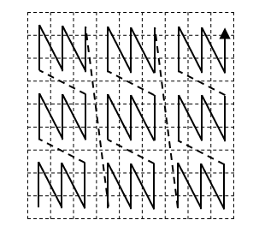
Figure C.21 — Examples of Morton ordering in irregular grids: 3×3 grid
Figure C.22 — Examples of Morton ordering in irregular grids: 9×9 grid
Figure C.23 — Examples of Morton ordering in irregular grids: irregular shape
Figure C.24 — Examples of Morton ordering in irregular grids: variable size cells
  - Hilbert order
Like Morton ordering, Hilbert ordering is based on a space-filling curve generated by progressively subdividing a space into quadrants, but the initial pattern of subdivision is different for Hilbert curves. Further subdivision involves replacement of parts of the curve by different patterns (Figure C.26), unlike the simple replication of a single pattern as in Morton ordering. There are two sets of patterns. The left-hand column of the figure includes those for which the sense of the scan directions is the same – both are positive or both negative. The right-hand column of the figure includes those for which the sense of the scan directions is opposite – one is positive and one is negative. A Hilbert curve can only be constructed with patterns from the same set; it uses all the patterns in that set.
NOTE Because of the shape of the curve formed by the initial ordering of quadrants, Hilbert ordering is also known as Pi ordering.
Computation of the ordering index is more complicated for Hilbert ordering than for Morton ordering. Algorithms for the 2-dimensional case (Figure C.27) are described in [27]Error! Reference source not found. and [19]. 3-dimensional Hilbert curves are discussed in [18]. Hilbert ordering is continuous.
  - Interleaving of feature attribute values
When the range of a grid coverage includes more than one feature attribute, the feature attribute values may be interleaved in various ways within a list. Such interleaving can be described by including an element for the range in the list of axes provided by the scanDirection attribute of SequenceRule. The index for the record of attributes is then incremented in the same way as the coordinates.
EXAMPLE Consider the 2 × 2 grid in Figure C.28. It has a range (r) of two attributes, A and B. Assuming a linear scan positive first in the x and then in the y direction, the scan order can be selected to access the feature attribute values in the different ways shown in Table C.1.
Figure C.25 — Replacement patterns for generating a Hilbert curve

Figure C.26 — Examples of Hilbert ordering in a 2-dimensional grid

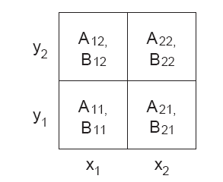
Figure C.27 — Example of a 2-dimensional grid with a range type having two attributes

Table 4 — Examples of interleaving
Order | Scan direction
Order | r, x, y | x, y, r | x, r, y
1 | A₁₁ | A₁₁ | A₁₁
2 | B₁₁ | A₂₁ | A₂₁
3 | A₂₁ | A₁₂ | B₁₁
4 | B₂₁ | A₂₂ | B₂₁
5 | A₁₂ | B₁₁ | A₁₂
6 | B₁₂ | B₂₁ | A₂₂
7 | A₂₂ | B₁₂ | B₁₂
8 | B₂₂ | B₂₂ | B₂₂

- (normative)
Legacy data-centric coverage specification
  - Overview
This annex summarizes the original coverage specification of ISO 19123:2005 which has been reshaped in this document according to ISO’s current modelling approach. This document (ISO 19123-1) establishes an abstract conceptual coverage model. Annex D is intended to instantiate the abstract concepts described in Clauses 5 to 10 in accordance with the legacy specifications contained in ISO 19123:2005.
Modelling approaches in ISO have evolved over time. In the past, data structures were described. More recently, ISO has moved to specifying interfaces instead because this better hides implementation details. Such a step of abstraction is particularly important in the context of separating the original, single International Standard, ISO 19123:2005, into two parts: an abstract specification in 19123-1 (this document) and implementation guidance in ISO 19123-2.
The interface-centric approach to coverage modelling is adopted in Clauses 5 through 10. At the same time it normatively retains the data-centric coverage description from ISO 19123 as Annex D. As such, the coverage data structures of ISO 19123:2005 represent one valid generic data structure out of many possible realizations satisfying the interface of ISO 19123-1. Specifically, the ISO 19123:2005 coverage structure specification is retained for compatibility with realizations that have realized these generic classes, albeit in their individual ways. This annex is not a retention of the old elements from ISO 19123:2005, but rather a definition of equivalent classes in terms of the new ISO 19123-1 structure to satisfy the backward compatibility requirement.
ISO 19123:2005 defined generic data classes which could be specialized by the developers of more detailed product specifications which could then be implemented. External organizations reference these generic data classes. These classes are realized in these external standards. Since references to these classes exist in external standards it is important that equivalent generic data classes be maintained in this edition of the document.
This edition of ISO 19123-1 takes a different approach. It defines an interface which provides a standardized window through which a variety of different data structures could produce the same result. In that way it is more flexible than the previous approach. But it is not in conflict with the previous approach. The previous generic data classes are still valid, and the external standards or product specifications that referenced them also remain valid. The new edition of ISO 19123-1 is simply more flexible allowing many different implementation structures, not just the defined generic data classes presented in this annex.
This annex specifies the equivalent abstract data classes from ISO 19123:2005 that are developed in this version to retain compatibility. These form a compliant data structure that can be interpreted through the interface structure defined in ISO 19123-1. The classes and attributes are mapped from the older structure to the new interface structure.
No XML Schema is provided for the instantiated structures defined in Annex D.
  - Generic Data Structure Coverage Schema
    - Generic Data Structure Package
This annex is described in a separate package from the rest of the model in this document in order to ensure that the namespace is unique. That is, the class name CV_Coverage <<interface>> is used both to describe the root class of the interface structure, and the class name CV_Coverage <<featureType>> is used in this annex to describe the root class of the generic data structure. CV_Coverage <<featureType>> realizes CV_Coverage <<interface>>. The names are used this way to ensure backward compatibility. A mapping is shown from the generic data structure classes to the new interface classes CV_Coverage Feature Type Generic Data Class.
    - Class CV_Coverage as a Data Structure Template
      - Class description
The class CV_Coverage <<featureType>> is an instance of the <<metaclass>> GF_FeatureType (ISO 19109), which therefore represents a feature type. CV_Coverage <<featureType>> supports five attributes, one operation and three associations. This is illustrated in Figure D.1.
      - Attributes
        - domainExtent
The attribute domainExtent: EX_Extent[1..*] contains the extent of the domain of the coverage. The data type EX_Extent is defined in ISO 19115-1 Extents may be specified in space, time or space-time. The attribute domainExtent has been generalized in ISO 19123-1. This older narrower extent has been retained for backward compatibility.
        - rangeType
The attribute rangeType: RecordType describes the range of the coverage. The data type RecordType is defined in ISO 19103. It consists of a list of attribute name/data type pairs. A simple list is the most common form of rangeType, but RecordType can be used recursively to describe more complex structures. The rangeType for a specific coverage shall be specified in an application schema.
        - commonPointRule
The optional attribute commonPointRule: CV_CommonPointRule identifies the procedure to be used for evaluating the CV_Coverage at a position that falls either on a boundary between geometric objects or within the boundaries of two or more overlapping geometric objects, where the geometric objects are either CV_DomainObjects or CV_ValueObjects. This attribute is optional and takes the default value of the attribute as “average”. The attribute is not required in the case when there is only one extent per coverage; that is, when geometric objects do not overlap.
        - interpolationType
The optional attribute interpolationType: CV_InterpolationMethod is a code that identifies the interpolation method that shall be used to derive a feature attribute value at any direct position within the CV_ValueObject. The attribute is optional. The default value is “nearestNeighbor”. No value is needed for an analytical coverage (one that maps direct position to attribute value by using a mathematical function rather than by interpolation). Interpolation methods are described in 5.6 and in Annex B. The code list identifying the interpolation method is shown in Figure D.3.

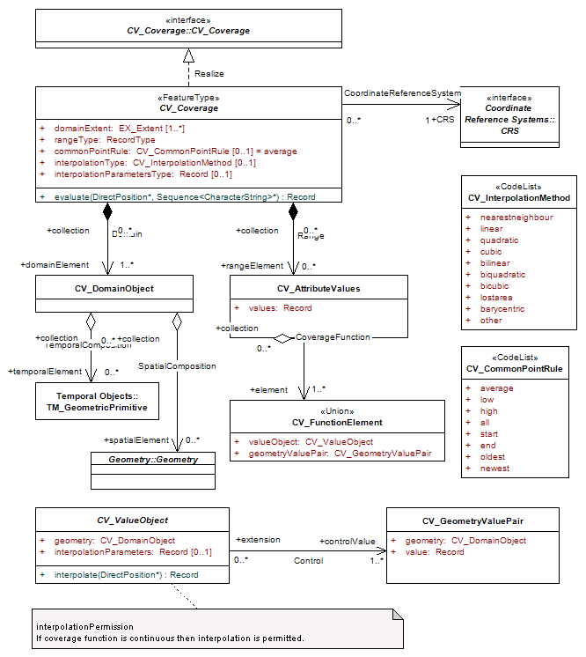
Figure D.1 — CV_Coverage
        - interpolationParameterTypes
Although many interpolation methods use only the values in the coverage range as input to the interpolation function, there are some methods that require additional parameters. The optional attribute interpolationParameterTypes specifies the types of parameters that are needed to support the interpolation method identified by interpolationType. The data type RecordType is specified in ISO 19103. It is a dictionary of names and data types.
      - Operation
        - evaluate
The operation evaluate: (DirectPosition, Sequence <CharacterString>): Record accepts a DirectPosition as input and return a set of Records of feature attribute values for that direct position. The parameter list is a sequence of feature attribute names each of which identifies a field of the rangeType. If list is null, the operation returns a value for every field of the rangeType. Otherwise, it returns a value for each field included in list. Class DirectPosition is defined in ISO 19107; the data type Record is defined in ISO 19103. If the direct position passed is not in the domain of the coverage, then an error message shall be generated. If the input DirectPosition falls within two or more geometric objects within the domain, the operation shall return records of feature attribute values computed according to the value of the attribute commonPointRule.
The operation evaluate as defined in this annex represents a subset of the capability of the probing function evaluate as specified in 5.3. This version of the evaluate function is retained for backward compatibility.
NOTE Normally, the operation will return a single record of feature attribute values.
      - Associations
        - Coordinate Reference System
The association coordinate reference system links the CV_Coverage to the coordinate reference system to which the objects in its domain are referenced. The class CRS is specified in ISO 19111. The multiplicity of the CRS role in the coordinate reference system association is one. This means that a coverage with the same range but with its domain defined in a different coordinate reference system is a different coverage.
        - Domain
The association Domain links the CV_Coverage to the set of CV_DomainObjects in the domain.
NOTE The Domain and range associations used here correspond to the CV_CoverageByDomainAndRange as specified in 5.8.
        - Range
The association range links the CV_Coverage to the set of CV_AttributeValues in the range. The range of a CV_Coverage shall be a homogeneous collection of records. That is, the range has a constant dimension over the entire domain, and each field of the record provides a value of the same attribute type over the entire domain.
NOTE This document does not specify how the Domain and range associations are to be implemented. The relevant data can be generated in real time, it can be held in persistent local storage, or it can be electronically accessible from remote locations.
    - CV_DomainObject
      - Class description
CV_DomainObject represents an element of the domain of the CV_Coverage. It is an aggregation of objects that may include any combination of GM_Objects (ISO 19107), TM_GeometricPrimitives (ISO 19108), or spatial or temporal objects defined in other standards, such as the CV_GridPoint defined in this document.
      - Associations
        - TemporalComposition
The association TemporalComposition associates a CV_DomainObject to the set of TM_GeometricPrimitives of which it is composed.
        - SpatialComposition
The association SpatialComposition associates a CV_DomainObject to the set of GM_Object of which it is composed.
    - CV_AttributeValues
      - Class description
CV_AttributeValues represents an element from the range of the CV_Coverage. It has one attribute values that takes on the value Record, where Record is a single or list of numeric arguments.
      - Attribute
        - values
The attribute values is a Record containing one value (single or set of arguments) for each attribute.
EXAMPLE A coverage with a single (scalar) value (such as elevation). A coverage with a series (array/tensor) of values all defined in the same way (such as brightness values in different parts of the electromagnetic spectrum).
      - Associations
        - CoverageFunction
The association CoverageFunction associates a CV_AttributeValues object to the set of CV_FunctionalElement of which it is an element.
    - CV_FunctionalElement
      - Class description
CV_FunctionalElement represents the result of the coverage function. It is the union of both the attribute value and the domain element geometry value pair that controls the location of the value. It has two attributes valueObject and geometryValuePair. Both of these attributes are represented as separate classes related by a Control relationship.
      - Attributes
        - valueObject
The attribute valueObject corresponds to the class CV_ValueObject.
        - geometryValuePair
The attribute geometryValuePair corresponds to the class CV_ GeometryValuePair.
    - CV_ValueObject
      - Class description
CV_ValueObject provides a basis for interpolating feature attribute values within a continuous CV_Coverage.
CV_ValueObjects may be generated in the execution of an evaluate operation, and need not be persistent.
      - Attributes and operations
        - geometry
The attribute geometry: CV_DomainObject is a CV_DomainObject constructed from the CV_DomainObjects of the CV_GeometryValuePairs that are linked to this CV_ValueObject by the association Control.
        - interpolationParameters
The optional attribute interpolationParameters:Record shall hold the values of the parameters required to execute the interpolate operation, as specified by the interpolationParameterType attribute of CV_Coverage (cf. Annex B).
      - interpolate
The operation interpolate (DirectPosition*): Record shall accept a DirectPosition as input and return the record of feature attribute values computed for that DirectPosition.
      - Associations
        - Control
The association Control shall link this CV_ValueObject to the set of CV_GeometryValuePairs that provide the basis for constructing the CV_ValueObject and for evaluating a continuous CV_Coverage at DirectPositions within this CV_ValueObject.
    - CV_GeometryValuePair
      - Class description
The class CV_GeometryValuePair describes an element of a set that defines the relationships of a discrete coverage. Each member of this class consists of two parts: a domain object from the domain of the coverage to which it belongs and a record of feature attribute values from the range of the coverage to which it belongs.
CV_GeometryValuePairs may be generated in the execution of an evaluate operation, and need not be persistent. CV_GeometryValuePair is subclassed to restrict the pairing of a feature attribute value record to a specific subtype of domain object.
      - Attributes
        - geometry
The attribute geometry: CV_DomainObject shall hold the CV_DomainObject that is a member of this CV_GeometryValuePair.
        - value
The attribute value: Record shall hold the record of feature attribute values associated with this CV_DomainObject.
    - CV_CommonPointRule
      - Class description
The code list CV_CommonPointRule is a list of codes that identify methods for handling cases where the DirectPosition input to the evaluate operation falls within two or more of the geometric objects. The interpretation of these rules differs between discrete and continuous coverages attributes. In the case of a discrete coverage range attribute, each CV_GeometryValuePair provides one value for each attribute. The rule is applied to the set of values associated with the set of CV_GeometryValuePairs that contain the DirectPosition. In the case of a continuous coverage, a value for each attribute shall be interpolated for each CV_ValueObject that contains the DirectPosition. The rule shall then be applied to the set of interpolated values for each attribute.
      - Code List
The code list CV_CommonPointRule takes on the values shown in Figure D.2 and given in Table D.1.
Table D.1 — Semantics of CV_CommonPointRule
Value | Meaning (with respect to position p)
average | Arithmetic average over the set returned by evaluate(p)
low | Minimum value of the set returned by evaluate(p)
high | Maximum value of the set returned by evaluate(p)
all | The complete set returned by evaluate(p)
start | Start Value of the second CV_ValueSegment (only applicable to Multi-Curve Coverages)
end | End Value of the first CV_ValueSegment (only applicable to Multi-Curve Coverages)

Figure D.2 — Class CV_CommonPointRule codelist
Requirement D1: For a given CV_Coverage,
- In case of no Common Point Rule provided and more than one range value existing for a direct position p, evaluate(p) shall return the set of all these values.
- In case of a discrete coverage with a Common Point Rule provided, evaluate() shall provide one range value for each direct position, selected from the set of available range values in accordance with the Common Point Rule value.
- In case of a continuous coverage (i.e., when at least one interpolation method is indicated in the coverage, see 5.6) with a Common Point Rule provided, a value for each attribute shall be obtained by applying one of the interpolation methods provided for each geometric object in the coverage that contains the direct position, and a range value shall be selected in accordance with the Common Point Rule value.
Requirement D2: The semantics of a CV_CommonPointRule shall be given by Figure D.2 and Table D.1, but may be extended with further values whose interpretation is implementation-defined.
    - CV_InterpolationMethod
      - Class description
The code list CV_InterpolationMethod (see Figure D.3) is a list of codes that identify interpolation methods that may be used for evaluating continuous coverages.
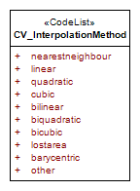
NOTE This list is deprecated and superseded by Requirement 9 of Clause 5.6.3.
Figure D.3 — Class CV_InterpolationMethod
      - Code List
The code list CV_ InterpolationMethod takes on the values shown in Figure B.1 and given in Table B.1 of Annex B. The previous version, ISO 19123:2005, contained the following three additional interpolation methods: bilinear, biquadratic, bicubic that are not included in this version of the standard any longer as they represent the 2D special cases of their n-D counterparts, linear, quadratic, and cubic, respectively. Implementers of the standard may extend their implementations to include these or other methods.
  - Coverage types
    - Discrete and Continuous Coverages
ISO 19123:2005 made a major distinction between Discrete and Continuous coverages and organized the subtypes of coverage based on these types. ISO 19123-1 has generalized the concept. Any axis may be discrete or continuous. Since this is a generalization of the concept it is fully backward compatible with the older approach. Therefore this annex has simplified the description and no longer organizes coverages as Discrete or Continuous. The defined generic subtypes of CV_ValueObject and CV_GeometryValuePair are simply listed as subtypes. Each has a use in a particular type of coverage. This is shown below:
- CV_ValueCurve and CValueSegment together with CV_PointValuePair and CV_CurveValuePair are used in a Segmented Curve Coverage
- CV_ThiessenValuePolygon together with CV_PointValuePair are used in a Thiessen Polygon Coverage
- CV_ValueTriangle together with CV_PointValuePair are used in a TIN Triangle Coverage
- CV_ValueHexagon together with CV_GridPointValuePair are used in a Hexagon Grid coverage
- CV_GridValueCell together with CV_GridPointValuePair are used in a Grid coverage
    - Multi-Point Coverages
A point coverage is characterized by a finite domain consisting of points which may be regularly or irregularly distributed. A point coverage may be discrete in the domain; that is, valid only at the location of the points. Such as discrete point coverage provides a basis for continuous coverage functions through a control relationship, where the evaluation of the continuous coverage function is accomplished by interpolation between the points of the discrete point coverage. Most interpolation algorithms depend upon a structured pattern of spatial relationships between the points. This requires either that the points in the spatial domain of the discrete point coverage be arranged in a regular way, or that the spatial domain of the continuous coverage be partitioned in a regular way in relation to the points of the discrete point coverage. Grid coverages employ the first method; Thiessen polygon and TIN coverages employ the second.
EXAMPLE A set of hydrographic soundings is a discrete point coverage. Interpolation between the points establishes a bathymetric surface, which is a continuous coverage.
The classes CVPointValuePair and CV_GridPointValuePair provide values for Multi-point Coverages.
The requirements for a multi-point coverage are described in Clause 6.
    - Multi-Curve Coverage
A curve coverage is characterized by a finite spatial domain consisting of curves. In a discrete curve coverage the curves represent features such as roads, railroads or streams. They may be elements of a network.
EXAMPLE A discrete curve coverage assigns a route number, a name, a pavement width and a pavement material type to each segment of a road system. The curve is discrete in the domain and each domain element is associated with a single value in the range.
A continuous curve coverage assigns a value to locations along a curve. This is a coverage with a one dimensional domain. An example is a measurement of pavement thickness along a road. Such a continuous coverage may be interpolated.
The classes CV_ValueCurve and CV_ValueSegment provide values for Multi-curve Coverages. They reference CV_PointValuePair for the geometry of the points at the ends of curve segments.
The requirements for a multi-point coverage are described in Clause 8.
    - Multi-Surface Coverage
A Multi- surface Coverage is a coverage whose domain consists of a collection of surfaces. In most cases, the surfaces that constitute the domain of a coverage are mutually exclusive and exhaustively partition the extent of the coverage. Surfaces or their boundaries may be of any shape. The boundaries of component surfaces often correspond to natural phenomena and are highly irregular.
EXAMPLE A discrete multi-surface coverage that represents soil types typically has a spatial domain composed of surfaces with irregular boundaries.
Any set of polygons can be used as a spatial domain for a discrete Multi- surface Coverage. Spatial domains composed of congruent polygons are very common. Often, these domains are composed of congruent rectangles or regular hexagons. The geometry of such a tessellation may be described in terms of a quadrilateral grid or a hexagonal grid. The spatial domain of a discrete surface coverage may also consist of the triangles that compose a TIN, or the polygons of a Thiessen polygon network. Based on the control points, a surface coverage may be interpolated at locations on the surface. That is, the control points at the corners of a TIN triangle may be used to drive an interpolation function that allows one to determine a value at any location on the TIN value triangle. Equivalently this may be done for a Thiessen value polygon where interpolation is based on interpolation between the centres of the CV_ThiessenValuePolygons surrounding the input position, or a grid value cell, value hexagon or general mesh where other interpolation methods may be applied. The geometric value of a surface is defined by the class CV_SurfaceValuePair.
The requirements for a multi-point coverage are described in Clause 9.
    - Multi-Solid Coverage
A Multi-solid Coverage is a coverage whose domain consists of a collection of solids. Solids or their boundaries may be of any shape. Generally, the solids that constitute the domain of a coverage are mutually exclusive and exhaustively partition the extent of the coverage, but this is not required.
EXAMPLE Buildings in an urban area could be represented as a set of unconnected solids each with attributes such as building name, address, floor space and number of occupants.
As in the case of surfaces, the spatial domain of a discrete solid coverage may be a regular or semi-regular tessellation of the extent of the coverage. The tessellation can be defined in terms of a three-dimensional grid, where the set of grid cells is the spatial domain of the coverage.
Based on the control points, a solid coverage may be interpolated at locations within the solid. That is, the control points along the edges of the solid may be used to drive an interpolation function that allows one to determine a value at any location within the solid. Additional control points may also be defined within the solid to drive an interpolation. The geometric value of a solid is defined by the class CV_SolidValuePair.
The requirements for a multi-point coverage are described in Clause 10.
    - Grid Coverage
A mesh is a network composed of two or more sets of curves in which the members of each set intersect the members of the other sets. A grid is a type of mesh which is regular in some algorithmically defined manner. Grid coverages employ a systematic tessellation of the domain. The principal advantage of such tessellations is that they support a sequential enumeration of the elements of the domain.
The class CV_Grid describes the geometric characteristics of a quadrilateral grid. CV_GridValuesMatrix is a subclass of CV_Grid that ties feature attribute values to grid geometry. It holds a sequence of records associated with a sequencing rule that specifies an algorithm for assigning records of feature attribute values to grid points. CV_SequenceRule is a data type that contains information for mapping grid coordinates to a position within the sequence of records of feature attribute values.
The requirements for a multi-point coverage are described in Clause 7.
  - Subclassing CV_GeometryValueObject
    - General
A series of template generic data models are defined in this annex that correspond to the coverage models that were defined in ISO 19123:2005. These new models are compliant data structures that can be interpreted through the interface structure defined in ISO 19123-1.
Figure D.4 illustrates the subtyping of CV_GeometryValueObject and the associated CV_GeometryValuePair object.
    - CV_ValueCurve
      - Class description
A CV_ValueCurve is composed of a Curve with additional information that supports the determination of feature attribute values at any position on that curve. CV_ValueCurves depend upon the arc-length parameterization operations defined for Curve in ISO 19107.
      - Attributes and operations
      - geometry
The attribute geometry: Curve shall be the Curve (as per ISO 19107) that is the basis of this CV_ValueCurve.
      - segment
The operation segment (DirectPosition*, Distance*): Set<CV_ValueSegment> shall accept a DirectPosition as input and return the set of CV_ValueSegments nearest to that DirectPosition. This operation shall invoke the parameterForPosition operation defined for Curve (per ISO 19107) to obtain the Distance parameter corresponding to the input.
DirectPosition. The operation parameterForPosition returns the parameter value for the position on the Curve closest to the input DirectPosition. In certain cases, the parameterForPosition may return more than one parameter value. The operation segment will normally return a single CV_ValueSegment. There are two cases for which it could return multiple CV_ValueSegments:
- The CV_ValueCurve is not simple. The position on the curve that is closest to the input DirectPosition is a point of self-intersection. The operation parameterForPoint returns two or more parameter values. In this case, the operation segment shall raise an exception.
- There are two or more positions on the CV_ValueCurve that are at the same minimal distance from the input DirectPosition. The operation parameterForPoint returns two or more parameter values. In this case, the operation segment shall raise an exception.
    - CV_CurveValuePair
      - Class description
CV_CurveValuePair is the subtype of CV_GeometryValuePair that has Curve (per ISO 19107) as the value of its geometry attribute.
      - Attribute
        - geometry
The attribute geometry: Curve shall be the Curve (as per ISO 19107) that is the basis of this CV_ValueCurve. A curve may either be expressed as a set of curves or as a set of CV_ValueSegment that are terminated by points at their ends.
    - CV_ValueSegment
      - Class description
A segment is a 1-dimensional geometric object that has a beginning (start) and end point. The limits of a CV_ValueSegment are specified by two values of the arc-length parameter of the Curve (as per ISO 19107) underlying its parent CV_ValueCurve.
      - Attributes
      - startParameter
The attribute startParameter: Distance is the value of the arc-length parameter of the parent curve at the start of this CV_ValueSegment.
        - endParameter
The attribute endParameter: Distance is the value of the arc-length parameter of the parent curve at the end of this CV_ValueSegment.
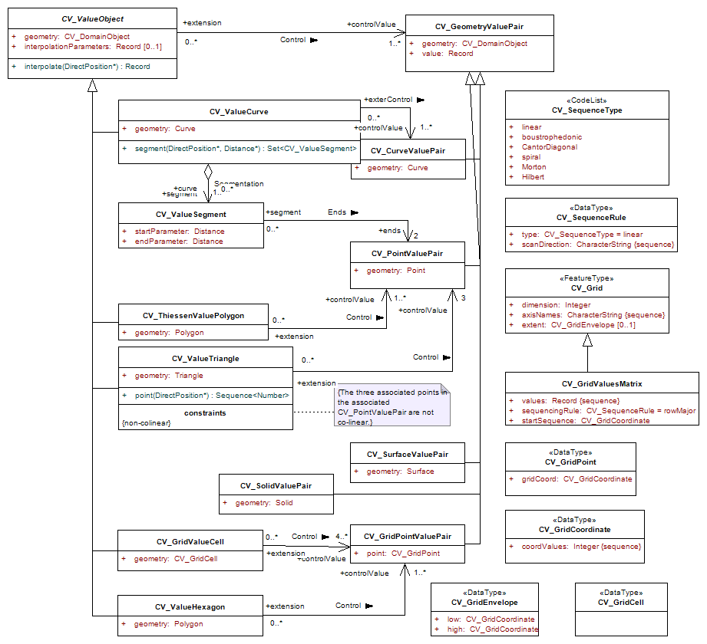
Figure D.4 — Class CV_ValueObject subtypes
      - Associations
        - Control
The association Ends links the CV_ValueSegment to the CV_PointValuePair that provide control values for interpolation. Linear interpolation requires a minimum of two control values, usually those at the beginning and end of the CV_ValueSegment. Additional control values are required to support interpolation by higher order functions.
    - CV_PointValuePair
      - Class description
CV_PointValuePair is the subtype of CV_GeometryValuePair that has a Point (as per ISO 19107) as the value of its geometry attribute.
      - Attribute
        - geometry
The attribute geometry: Point shall hold the geometry of the CV_PointValuePair.
      - Class description
CV_ThiessenValuePolygon is a subclass of CV_ValueObject. Individual CV_ThiessenValuePolygons may be generated during the evaluation of a CV_ThiessenPolygonCoverage, and need not be persistent. A Thiessen polygon is a polygon whose boundaries define the area consisting of points that are closer to the center point than any other point in the defining set. The boundaries are the perpendicular bisectors of the lines between the points in the dual TIN. These are also referred to as Voronoi Diagrams.
    - CV_ThiessenValuePolygon
      - Class description
CV_ThiessenValuePolygon is a subclass of CV_ValueObject. Individual CV_ThiessenValuePolygons may be generated during the evaluation of a CV_ThiessenPolygonCoverage, and need not be persistent. A Thiessen polygon is a polygon whose boundaries define the area consisting of points that are closer to the centre point than any other point in the defining set. The boundaries are the perpendicular bisectors of the lines between the points in the dual TIN. Also referred to as Voronoi Diagrams.
      - Attributes
        - 7.3.2 geometry
The attribute geometry: Polygon shall hold the geometry of the Thiessen polygon centred on the CV_PointValuePair identified by the association Control.
      - Associations
        - Control
The association Control links a CV_ThiessenValuePolygon to the CV_PointValuePair at its centre.
    - CV_ValueTriangle
      - Class description
CV_ValueTriangle is a subclass of CV_ValueObject that consists of three CV_PointValuePairs where the Points (per ISO 19107) are non-collinear. CV_ValueTriangles are used for interpolation of a coverage. A CV_ValueTriangle is defined by three non-colinear points and associated values used in interpolation of a coverage function. Usually associated with a TIN or a Triangulated Spline.
      - Attributes and operations
      - geometry
The attribute geometry:Triangle holds the Triangle (per ISO 19107) that defines the relative position of the three CV_PointValuePairs at its vertices.
      - point
The operation point:(DirectPosition):Sequence<Number> accepts a direct position inside a CV_ValueTriangle and returns the barycentric coordinates of the position as a sequence of numbers.
Constraint: {non-colinear: The three associated points in the associated CV_PointValuePair are not co-linear.}
      - Association
        - Control
The association Control shall link this CV_ValueTriangle to the CV_PointValuePair at its verticies.
    - CV_ValueHexagon
      - Class description
CV_ValueHexagon is a subclass of CV_ValueObject that describes a value object of hexagon shape.
      - Attribute
      - geometry
The attribute geometry:Polygon (as per ISO 19107) shall hold the geometry of the CV_ValueHexagon centred on the CV_GridPointValuePair identified by the association Control.
      - Association
        - Control
The association Control links a CV_ValueHexagon to the CV_GridPointValuePair at its centre.
    - CV_GridValueCell
      - 8.12.1 Class description
CV_GridValueCell is a subclass of CV_ValueObject that supports interpolation within a CV_GeneralGridCoverage. A CV_GridValueCell is a collection of CV_GridPointValuePairs with a geometric structure defined by a CV_GridCell.
      - Attribute
        - geometry
The attribute geometry:CV_GridCell holds the CV_GridCell that defines the structure of the CV_GridPointValuePairs that support the interpolation of a feature attribute value at a DirectPosition within the CV_GridCell.
      - Association
        - Control
The association Control links a CV_GridValueCell to the CV_GridPointValuePairs at its corners.
    - CV_GridPointValuePair
      - Class description
CV_GridPointValuePair is a subclass of CV_GeometryValuePair composed of a CV_GridPoint and a point attribute value Record.
      - Attribute
        - point
The attribute point: CV_GridPoint shall be the geometry member of the CV_GridPointValuePair. It shall be one of the CV_GridPoints linked to the CV_ValuesMatrix inherited from CV_Grid.
    - CV_GridCell
      - Class description
A CV_GridCell is delineated by the grid lines of CV_Grid. Its corners are associated with the CV_GridPoints at the intersections of the grid lines that bound it.
    - CV_CurveValuePair
      - Class description
CV_CurveValuePair is the subtype of CV_GeometryValuePair that has Curve (as per ISO 19107) as the value of its geometry attribute.
      - Attribute
        - geometry
The attribute geometry: Curve shall be the geometry member of the CV_CurveValuePair. It shall be one of the CV_GridPoints linked to the CV_ValuesMatrix inherited from CV_Grid.
    - CV_SurfaceValuePair
      - Class description
CV_SurfaceValuePair is the subtype of CV_GeometryValuePair that has Surface (as per ISO 19107) as the value of its geometry attribute. Used in the definition of discrete (step function) surface coverage functions.
      - Attribute
        - geometry
The attribute geometry: Surface shall hold the geometry of the CV_SurfaceValuePair.
    - CV_SolidValuePair
      - Class description
CV_SolidValuePair is the subtype of CV_GeometryValuePair that has a Solid (per ISO 19107) as the value of its geometry attribute.
      - Attribute
        - geometry
The attribute geometry: Solid shall hold the geometry of the CV_SolidValuePair.
    - CV_Grid
      - Class description
The class CV_Grid contains the geometric characteristics of a quadrilateral grid.
      - Attributes
        - dimension
The attribute dimension: Integer shall identify the dimensionality of the grid.
        - axisNames
The attribute axisNames: CharacterString(Sequence) shall list the names of the grid axes.
        - extent
The optional attribute extent: CV_GridEnvelope shall specify the limits of a section of the grid.
    - GridEnvelope
      - Class description
CV_GridEnvelope is a data type that provides the grid coordinate values for the diametrically opposed corners of the CV_Grid. It has two attributes.
      - Attributes
        - low
The attribute low: CV_GridCoordinate shall be the minimal coordinate values for all grid points within the CV_Grid.
        - high
The attribute high: CV_GridCoordinate shall be the maximal coordinate values for all grid points within the CV_Grid.
    - CV_GridPoint
      - Class description
CV_GridPoint is the class that represents the intersections of the grid lines.
      - Attribute
        - gridCoord
The attribute gridCoord : CV_GridCoordinate holds the set of grid coordinates that specifies the location of the CV_GridPoint within the CV_Grid.
    - CV_GridCoordinate
      - Class description
CV_GridCoordinate is a data type for holding the grid coordinates of a CV_GridPoint.
      - Attribute
      - coordValues
The attribute coordValues: Integer(sequence) holds one integer value for each dimension of the grid. The ordering of these coordinate values shall be the same as that of the elements of CV_Grid.axisNames. The value of a single coordinate shall be the number of offsets from the origin of the grid in the direction of a specific axis.
    - CV_GridValuesMatrix
      - Class description
CV_GridValuesMatrix is a subclass of CV_Grid that ties feature attribute values to grid geometry. It has three attributes. It holds a sequence of records associated with a sequencing rule that specifies an algorithm for assigning records of feature attribute values to grid points. The geometry represented by the various offset vectors is in the image plane of the grid. For example, for orthorectified grids, these vectors are in a spatial reference system.
      - Attributes
      - values
The attribute values: Record(sequence) shall be a sequence of N feature attribute value records where N is the number of grid points within the section of the grid specified by the attribute extent from.CV_Grid.
      - sequencingRule
The attribute sequencingRule: CV_SequenceRule shall describe how the grid points are ordered for association to the elements of the sequence values. Default is row major.
      - startSequence
The attribute startSequence: CV_GridCoordinate shall identify the grid point to be associated with the first record in the values sequence.
    - CV_GridCell
      - Class description
A CV_GridCell is delineated by the grid lines of CV_Grid. Its corners are associated with the CV_GridPoints at the intersections of the grid lines that bound it.
    - CV_SequenceRule
      - Class description
CV_SequenceRule is a data type that contains information for mapping grid coordinates to a position within the sequence of records of feature attribute values.
      - Attributes
      - type
The attribute type: CV_SequenceType identifies the type of sequencing method that shall be used. The default value shall be “linear”.
      - scanDirection
The attribute scanDirection: CharacterString(sequence) is a list of signed axisNames that indicates the order in which grid points shall be mapped to position within the sequence of records of feature attribute values. An additional element may be included in the list to allow for interleaving of feature attribute values.
    - CV_SequenceType
CV_SequenceType is a code list that identifies methods for sequential enumeration of the grid points. Methods for sequential enumeration are described in Annex C.

Bibliography
- ISO/IEC, ISO/IEC 19501:2005, Information technology ― Open Distributed Processing ― Unified Modeling Language (UML) Version 1.4.2
- ISO/IEC, ISO 19108:2002, Geographic information — Temporal schema
- IS/IEC, ISO 19109:2015, Geographic information — Rules for application schema
- ISO/IEC, ISO 19115-1, Geographic information — Metadata — Part 1: Fundamentals
- P. Baumann: A General Conceptual Framework for Multi-Dimensional Spatio-Temporal Data Sets. Environmental Modelling and Software (2021), https://doi.org/10.1016/j.envsoft.2021.105096
- ISO/IEC, ISO 19144-1:2009 Classification Systems — Part 1: Classification system structure
- ISO/IEC, ISO 19144-2:2012 Classification Systems — Part 2: Land Cover Meta Language (LCML)
- ISO/IEC, ISO 19101-1:2014, Geographic information — Reference model — Part 1: Fundamentals
- ISO/IEC, ISO 19123-2:2018, Geographic information — Schema for coverage geometry and functions — Part 2: Coverage implementation schema
- IETF RFC 3986 Internet Engineering Task Force, Uniform Resource Identifier (URI): Generic Syntax, 2005. Available at: https://tools.ietf.org/html/rfc3986
- Object Management Group, Unified Modeling Language, Version 2.0, Needham, Massachusetts, USA, 2005. Available at: https://www.omg.org/spec/UML/2.0/
- Open Geospatial Consortium, Compliance Navigation. Available at: http://www.opengeospatial.org/compliance
- Open Geospatial Consortium, OGC Coverage Implementation Schema, OGC 09-146r6. Available at: http://docs.opengeospatial.org/is/09-146r6/09-146r6.html
- Open Geospatial Consortium, The OGC® WCS (Web Coverage Service) 2.0 Interface Standard- Core, OGC 09-110r4. Available at: http://www.opengeospatial.org/standards/wcs
- Open Geospatial Consortium, The OpenGIS Specification: Abstract Specification Topic 6, Schema for coverage geometry and functions. Available at: http://www.opengeospatial.org/docs/as
- Open Geospatial Consortium, The OpenGIS Specification: Abstract Specification Topic 21, Discrete Global Grid Systems, OGC 15-104r5. Available at: http://www.opengeospatial.org/docs/as
- Baumann, P., A General Conceptual Framework for Multi-Dimensional Spatio-Temporal Data Sets, Environmental Modelling and Software, 2021
- Gilber, W., A Cube-filling Hilbert Curve, Mathematical Intelligencer 6(3), 1984
- Goodchild, M. F. and Grandfield, A. W., Optimizing Raster Storage: An Examination of Four Alternatives, Auto-Carto 6, 1983
- Hilton, P. J. and Wylie, S., Homology Theory, an Introduction to Algebraic Topology, Cambridge University Press, 1960
- International Association of Oil & Gas Producers, EPSG Geodetic Parameter Dataset. Available at: http://www.epsg.org/
- ISO/TS 19101-2:2018, Geographic information — Reference model — Part 2: Imagery
- Kidner, D.B., Higher-order interpolation of regular grid digital elevation models, International Journal of Remote Sensing Vol. 24, No. 14, July 2003, pp. 2981-2987
- ISO/IEC 19103:2015, Geographic information — Conceptual schema language
- ISO/IEC 19107:2019, Geographic information — Spatial schema
- ISO/IEC 19111:2019, Geographic information — Referencing by coordinates
- Laurini, R., and D. Thompson, Fundamentals of Spatial Information Systems, Academic Press, 1992

